User's Guide

1. When the application is opened from the top there will be available operations Illustration 1.1

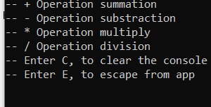

Illustration 1.1(Available operations)

1. You can write an example that you want to solve in the line Illustration 1.2. Then press Enter and the example will be solved.

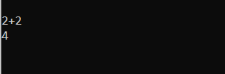

Illustration 1.2(Solution of the example)

1. You can also continue to solve new examples Illustration 1.3



Illustration 1.3(Example)

1. If you need to supplement the solution, then you can write the instructions on another line, as in Illustration 1.4

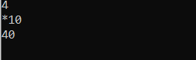

Illustration 1.5(Continuation of the solution)

1. If you want to start writing the example again, you need to enter the letter C (Figure 1.4)

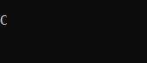

Illustration 1.4(Clear)

1. After step 5, you can solve new examples again