User's Guide

1. To use the calculator, you need to go to the url - <https://localhost:44376/Home>

2. On the page you will see an input field Illustration 1.1. In it you can write your example using the keyboard, as well as use the auxiliary buttons figure 1.2



Illustration 1.1(Input field)

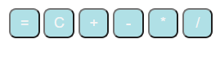

Illustration 1.2(Helper button)

3. After you have entered your example, you should click the ( = ) or press enter on your keyboard (Illustration button 1.3)

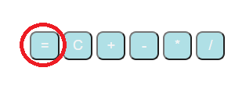

Illustration 1.3(Button)

4. After you click this button, the result will appear Illustration 1.4. Then you can continue the calculations with this result or use the C button, which will clear your calculations (Illustration 1.5), and then you can create a new example



Illustration 1.4(Result)

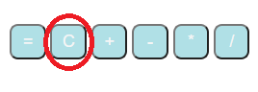

Illustration 1.5(Button clear)

5. Also on this page there is an instruction that will help you in compiling examples, Illustration 1.6

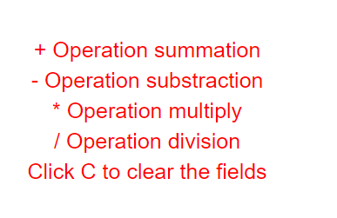

Illustration 1.6(Instruction)