**1. To determine the product and average of any two given numbers.**

**Source code:-**

a, b = eval(input("Enter two numbers separated by a comma: "))

product = a * b

average = (a + b) / 2

print("Product:", product)

print("Average:", average)

**Output:-**

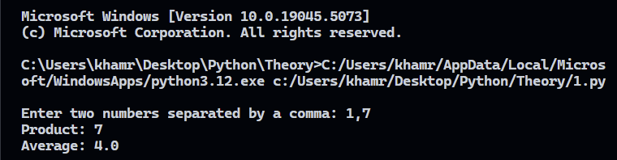

**2. To determine the simple interest on a given amount of money at a given rate of interest for a given period of time.**

**Source code:-**

principal, rate, time = eval(input("Enter principal, rate, and time separated by commas: "))

simple_interest = (principal * rate * time) / 100

print("Simple Interest:", simple_interest)

**Output:-**

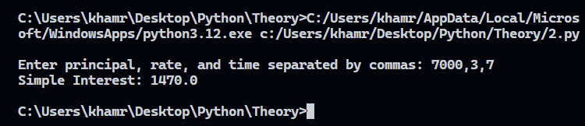

**3. To determine wage of workers for certain hours of work at a given hourly rate.**

**Source code:-**

hourly_rate, hours_worked = eval(input("Enter hourly rate and hours worked separated by a comma: "))

wage = hourly_rate * hours_worked

print("Wage:", wage)

**Output:-**

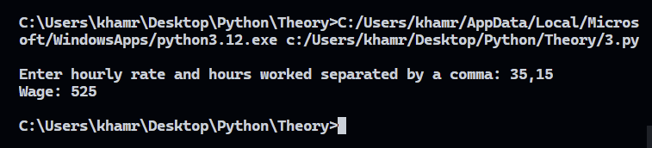

**4. To determine the stock value of a store of certain item on the basis of its unit cost and quantities held in the stock.**

**Source code:-**

unit_cost, quantity = eval(input("Enter unit cost of item and quantity in stock separated by a comma: "))

stock_value = unit_cost * quantity

print("Stock Value:", stock_value)

**Output:-**

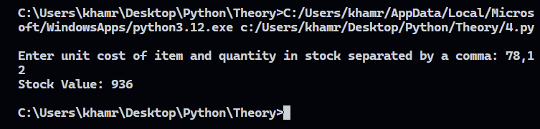

**5. To determine the remainder when one number is divided by another number.**

**Source code:-**

num1, num2 = eval(input("Enter dividend and divisor separated by a comma: "))

remainder = num1 % num2

print("Remainder:", remainder)

**Output:-**

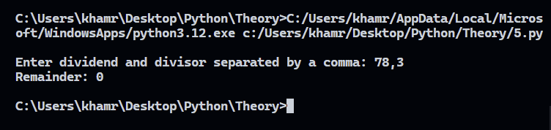

**6. To determine the value of an exponential expression of the form ab on the basis of a given base and the power to be raised.**

**Source code:-**

base, exponent = eval(input("Enter base and exponent separated by a comma: "))

result = base ** exponent

print("Result of a^b:", result)

**Output:-**

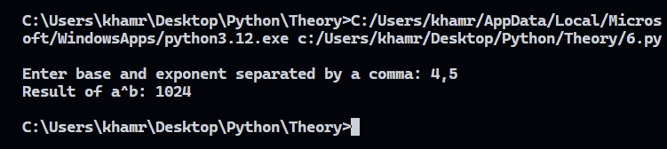

**7. To determine the area of a parallelogram.**

**Source code:-**

base_length, height = eval(input("Enter base length and height of parallelogram separated by a comma: "))

area_parallelogram = base_length * height

print("Area of Parallelogram:", area_parallelogram)

**Output:-**

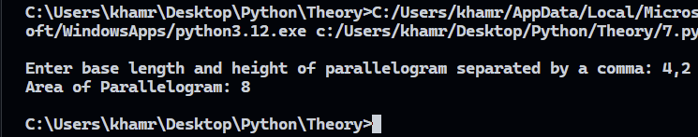

**8. To determine the area of the walls of a rectangular room and hence the cost of its painting on the basis of charge per square unit.**

**Source code:-**

length, width, height, cost_per_unit_area = eval(input("Enter length, width, height of room, and cost per square unit separated by commas: "))

wall_area = 2 * height * (length + width)

painting_cost = wall_area * cost_per_unit_area

print("Area of Walls:", wall_area)

print("Cost of Painting:", painting_cost)

**Ouput:-**

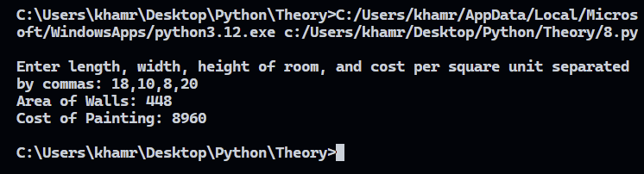

**9. To determine the area of a cone.**

**Source code:-**

radius, slant_height = eval(input("Enter radius and slant height of cone separated by a comma: "))

import math

area_cone = math.pi * radius * slant_height

print("Area of Cone:", area_cone)

**Output:-**

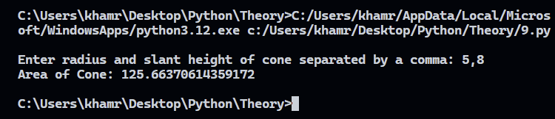

**10. To determine the perimeter of a triangular plot.**

**Source code:-**

side1, side2, side3 = eval(input("Enter the lengths of the three sides of the triangle separated by commas: "))

perimeter_triangle = side1 + side2 + side3

print("Perimeter of Triangle:", perimeter_triangle)

**Output:-**

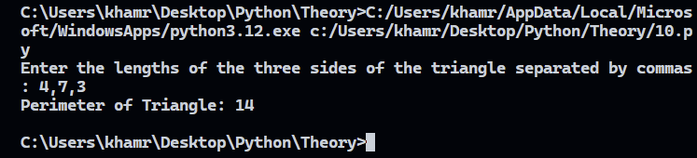

**11. To determine the area and perimeter of a square.**

**Source code:-**

side = eval(input("Enter the side length of the square: "))

area_square = side * side

perimeter_square = 4 * side

print("Area of Square:", area_square)

print("Perimeter of Square:", perimeter_square)

**Output:-**

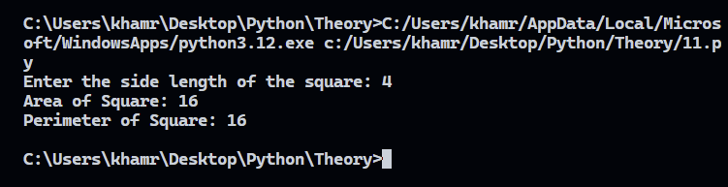

**12. To determine the miles on the basis of given kilometres.**

**Source code:-**

kilometers = eval(input("Enter distance in kilometers: "))

miles = kilometers * 0.621371

print("Distance in Miles:", miles)

**Output:-**

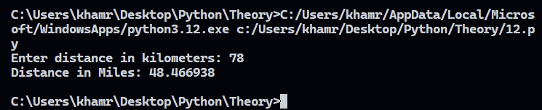

**13. To determine the acceleration due to gravity on the basis of the effective length of a simple pendulum.**

**Source code:-**

length = eval(input("Enter the effective length of the pendulum in meters: "))

import math

gravity = (4 * math.pi ** 2 * length) / (1 ** 2) # assuming time period of 1 second for simplicity

print("Acceleration due to Gravity:", gravity)

**Output:-**

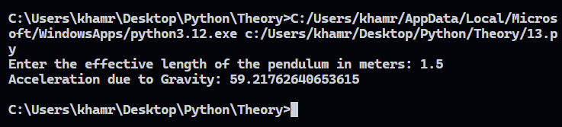

**14. To determine the volume a certain mass of gas at a given temperature and pressure when the volume is known at the normal pressure and at the absolute temperature.**

**Source code:-**

V1, T1, T2 = eval(input("Enter initial volume, initial temperature, and final temperature separated by commas: "))

V2 = V1 * (T2 / T1)

print("Final Volume (V2):", V2)

**Output:-**

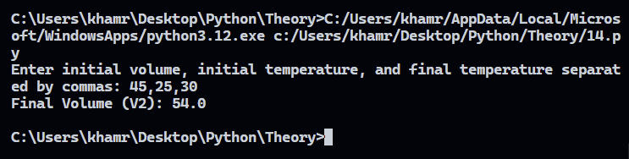

**15. To determine the net salary of an employee when it is known that the employee is eligible to dearness allowance (DA) of 97% of the basic pay, House Rent Allowance (HRA) of 57% of the basic pay and medical allowance of Rs.150. It is further known that 12% of the basic pay is deducted from the gross salary for the Employees' Provident fund (EPF) and Rs. 200 is deducted from the gross pay as the professional tax.**

**Source code:-**

basic_pay = eval(input("Enter basic pay: "))

DA = 0.97 * basic_pay # Dearness Allowance

HRA = 0.57 * basic_pay # House Rent Allowance

medical_allowance = 150 # Fixed medical allowance

gross_salary = basic_pay + DA + HRA + medical_allowance

EPF_deduction = 0.12 * basic_pay # Employees' Provident Fund deduction

professional_tax = 200 # Fixed professional tax

net_salary = gross_salary - (EPF_deduction + professional_tax)

print("Net Salary:", net_salary)

**Output:-**

