**File Plans**

**Technological Effect on Sleep and Learning Behaviour’s**

By Lachlan Harrison

**File Management Plan**

The File Management Plan refers to how the files collected throughout the duration of the SAT are sorted, and organised. This incorporates the following

File Naming Strategy:

* File names will consist of capital/lowercase letters, numbers and symbols

Allows easy sorting, with consistent names

* File names will include title of SAT Criterion they are a part of

Allows easy finding of files related to certain SAT Criterions

* File names will include (DA) to reference the subject

References that the work is for Data Analytics

Example: File naming Strategy:

File Hierarchy Strategy:

* All folders will be inside the Data Analytics Subject

Allows the Data Analytics to be found in one area

* All files will put separated into their respective SAT Criterion

Allows easy finding of work from specific SAT Criterions

* There will be 3 levels of nested folders to separate the files, while keeping it easy to search

Provides an easy way to search through a limited number of folders

Example: File Hierarchy Strategy:

**File Security Plan**

The file security plan incorporates ways that the files used for this SAT are protected from unauthorised people’s grasp. This incorporates the following:

Physical Security:

* Laptop will be held in safe and secure premises over night as well as being hidden

The laptop will be hidden overnight in a safe and secure area, which means somebody would be less likely to find it, as well as having more trouble to enter the area it held

(If I show where then it’s not so hidden anymore)

* Files will be backed-up to a hard drive which will be hidden

Copies of the files are backed up, in case laptop is broken/lost. The hard drive is hidden meaning someone is less likely to find it.

Example: Hard Drive the files are stored on:

* Files will be stored on a protected computer

Copies of the files will be backed up onto a secure computer, in case the laptop is broken/lost

Example: Files backed up on a protected computer:

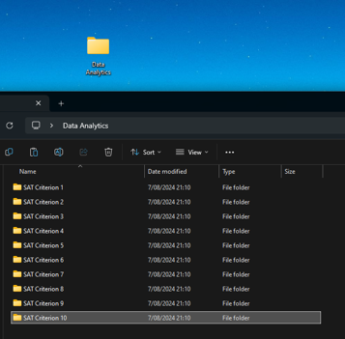

* The laptop, hard drive and computer will be held in a locked house with security doors

The devices will be locked in a secure area, this means anyone attempting to take the data will have a difficult time entering the property

Example: Locked Door:

* The locked house will feature an alarm system

The device will be held in an alarmed house, this means anyone attempting to steal the data must deal with an alarm, and potentially the police

Example: Alarm System:

Software Security:

* All files will be featured on OneDrive, which will feature a secure passcode

Allows the files to be backed up elsewhere, while being protected from unintended people

Example: Stored on OneDrive

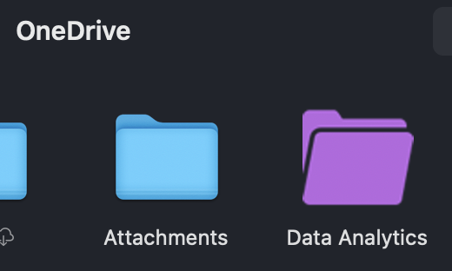

* Laptop, Hard Drive, and Computer will be protected with a secure passcode which will all be different from each other

Prevents data from being stolen if someone knows part of a password

Example: Secure Passcode for Entry:

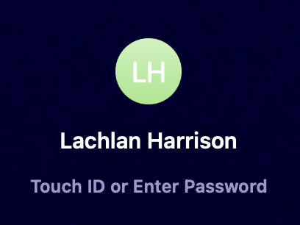

* Computer and Mac will feature an anti-virus system

Anti-virus system that prevents against any virus’s attacking the system of files

Example: Anti-Virus System:

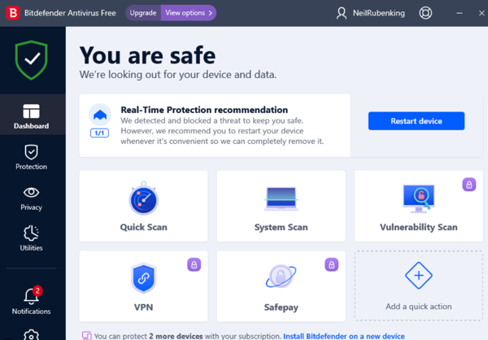

* Computer and Laptop will shut off after 1 minute of no usage

Prevents anyone from stealing the files while I’m away from the computer/laptop

Example: Lock Screen after 1 minute:

