Design Folio

Evaluation criteria

* Are the audience able to navigate their way around the different parts of the infographic with a minimal amount of effort?
* do the paragraphs and text included read well?
* is the data represented clearly within the info graph?
* Does the infographic allow the audience to learn a comprehensive amount about the topic in a minimal amount of time?
* is the message of the infographic displayed properly and completely?
* does the info graph show the complete set of data and the information able to be displayed from that?
* is the cost of the creation info graph free?
* can people with lower reading levels be able to read and understand the infographic?
* is the infographic using the most recent data?

IPO Chart

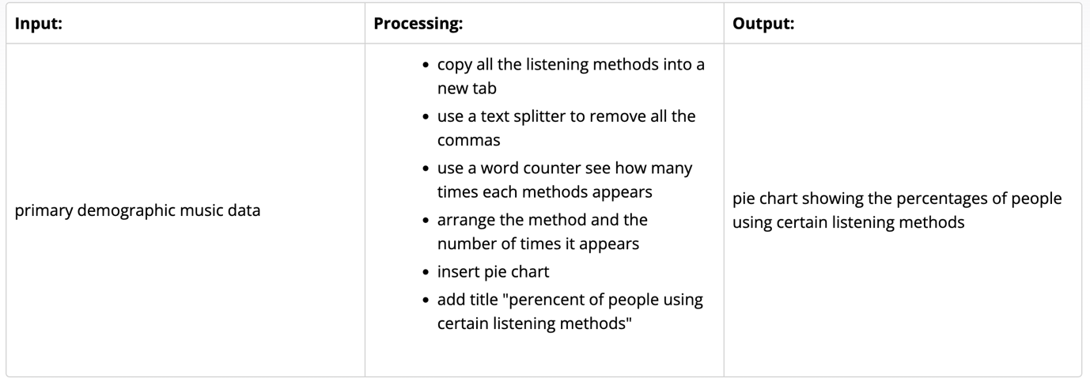

Annotated Mockup

