**SAT Criterion 6**

Took all answers from the google sheet into an excel file named “Survey Question analysis” in which I then split them all up into different questions and their respective answers, as well as respective numbers for the question number. [1]

During the process of moving the questions across I quickly read through and removed answers that either were not relevant to the survey response and did some manual validation in which I checked and changed values to correct things such as spelling errors. Due to me using google forms to create the google sheet I only had to worry about errors within the qualitative questions. (this went undocumented at the time because it was before sat criterion 6 was released)

For the questions that were radio buttons I simply used =if(cellnumber = “answer”, 1, 0)[3] to turn into a number and would nest more if statements depending on the number of answers available. Then I could simply sum/count the answers. (sum if it was a yes/no, and if it had more than 2 answers it would be =cointIF(range, number) for each number[2])

For questions that were qualitative or worded I made a key/legend of sorts [4]. I would then go through each question and mark down with a letter representative of each option in the legend that would be a describer of these questions[5]. Then using the same =countIF(range,”answer”) as before I would count through each row to see the total number of answers for each, which is shown in the legend by the number next to each item[4].

I continued through with this simultaneous data coding changing what the values for each question were.

I then made a new excel file that I had named “Charts” and renamed the sheet to “Interactive Pie #” in which I then moved the quantitative values within the key from questions; 2, 5, 8, and 11 [6]. I then calculated the values (as percentages) of each answer [6]. And copy pasted these values further into the sheet in which I created 4 pie charts, one for each question. I then formatted the charts to be the same size and with the pie the same size and horizontal position within the chart.[7] I also created a colour scheme composed of cold colours to represent a ‘robotic’ feel and used an contrasting colour scheme to represent ‘humanity’. Then made a sheet just to contain the hex values of these colours named “Colours (in case you need them)”. [8]

These charts were then saved under the names “Chart x” x being 1,2,3,4 respectively

Then did almost the same thing for the qualitative data, and calculated percentage of answers that had this response. [9]

Ref 1

Ref 2

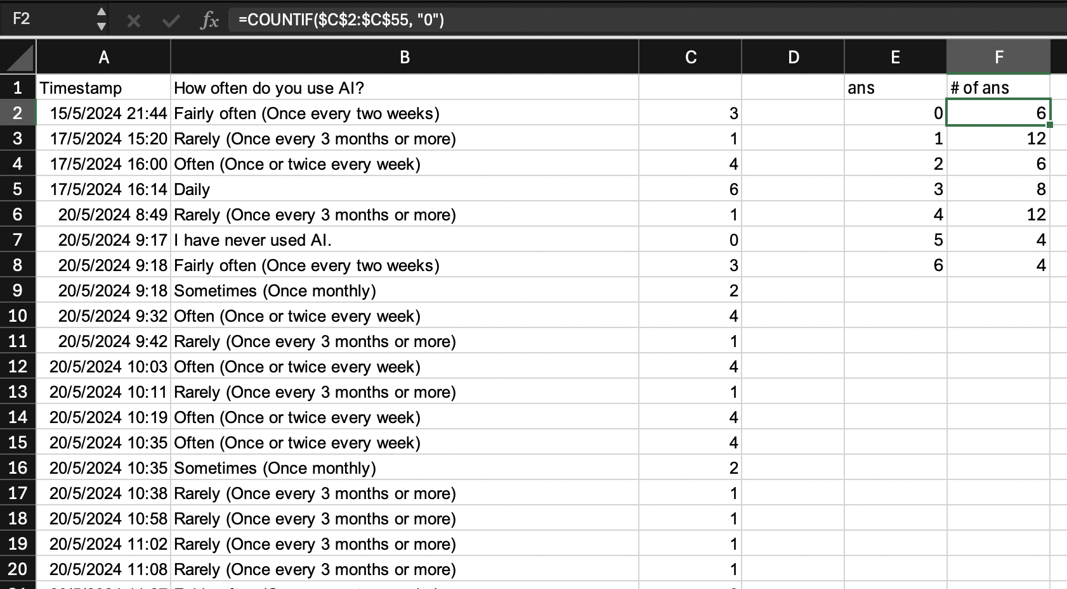

Ref [3]

Ref [4]

Ref [5]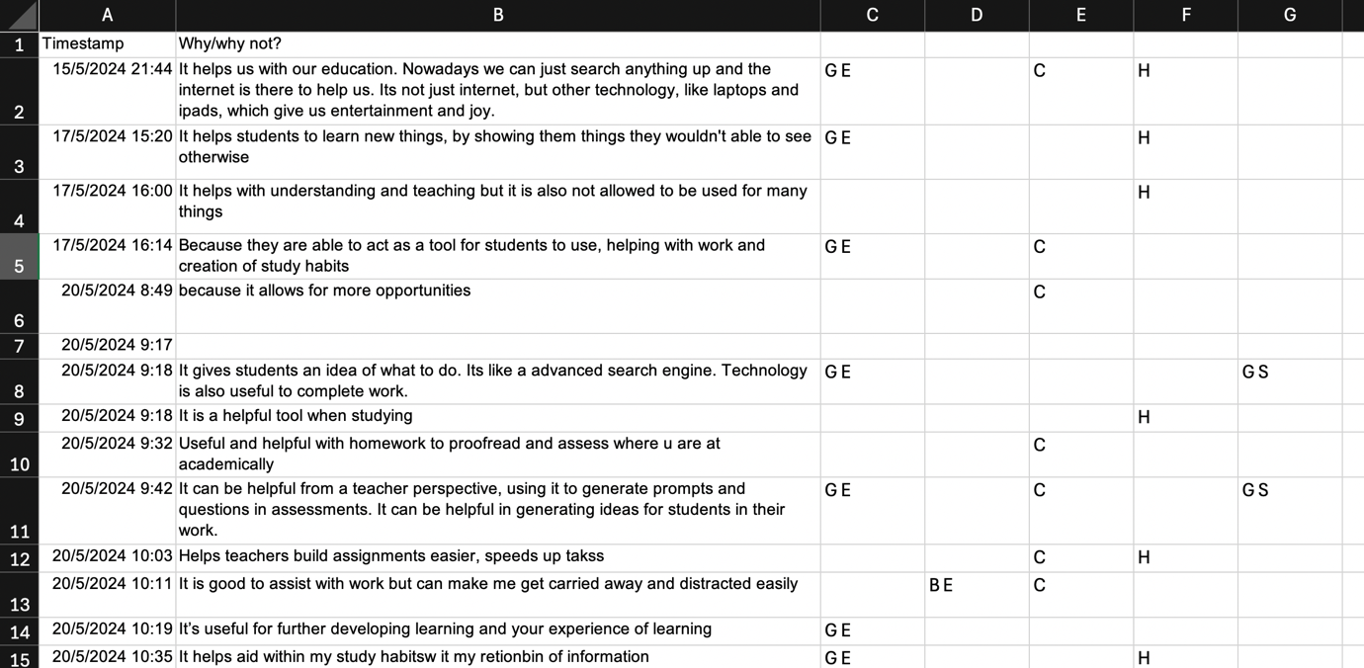

Ref [6]

Ref [6]

Ref [7]

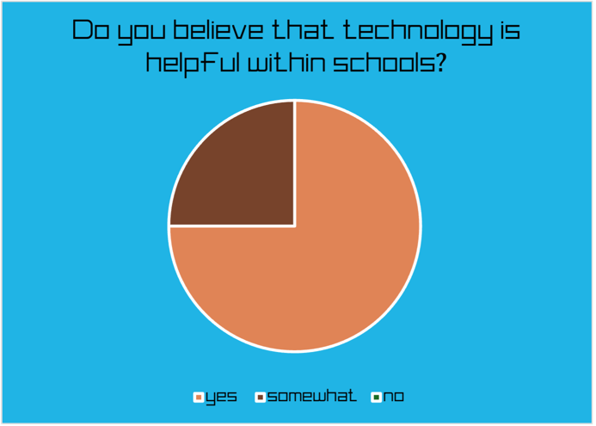

Ref [8]

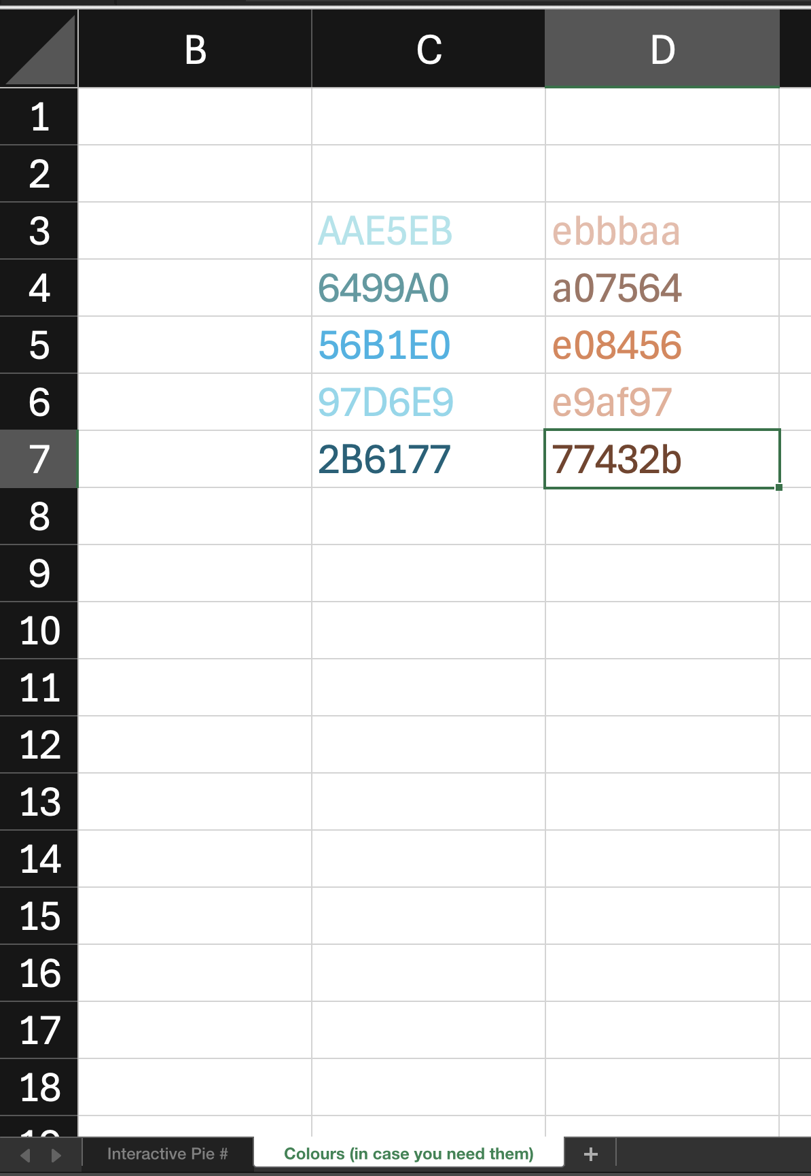

Ref [9]

