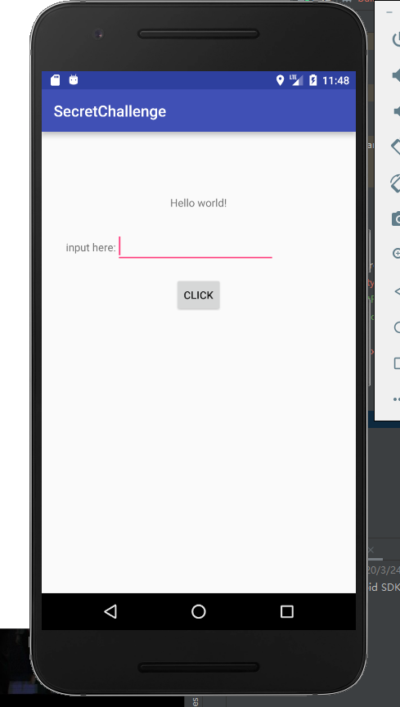

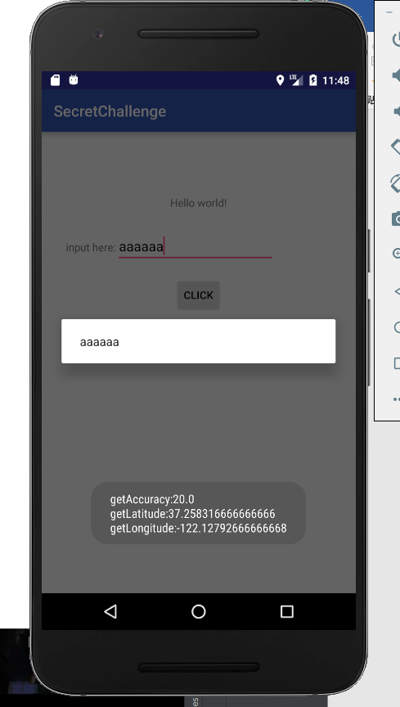

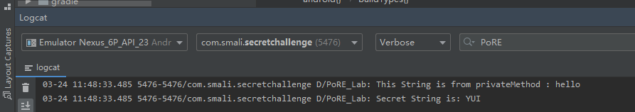

Task1/

1.Use a BroadcastReceiver to monitor the android.intent.action.BOOT_COMPLETED, in order to wake up MainActivity and SecretService.

2.Bind the SecretService with MainActivity to make sure the SecretService can be closed by MainActivity. Using LocationManager to get GPS location, and use Handler+Toast to push a message about the location in front of all the Apps.

3.Use checkSelfPermission and requestPermissions to get the location authority.

Task2/

Use a Handler and AlertDialog to make a Suspension window.

Task3/

Simple Java Reflection. But Always remember the try-catch.