CS-303 Assignment 1

Mohammadreza Akbari Lor

This code has a “input.txt” file that can be replaced with any file with the same name and containing less than 200 integers delineated by comma(,).

The file already in the submission contains 156 number all of them non zero.

At first the program brings the menu and acts based on user input.

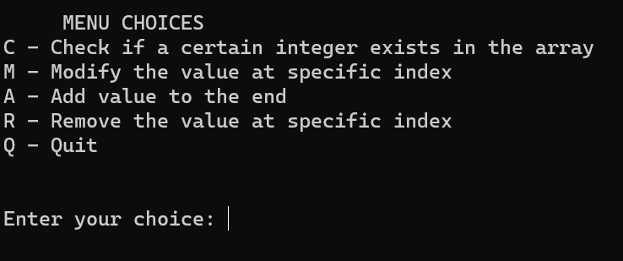

Selecting ‘C’ results in a prompt to enter the value the user is looking for.

After the user has entered what they are looking for the program returns the position of the value if found and a message if not.

Selecting ‘M’ results in prompting the user for the index of the position that is to be modified.

This path includes error checking for the inputs as demonstrated in the following image.

Selecting ‘A’ results in a prompt for the user to add an integer to the end of the array.

As demonstrated in the next image, this also includes an error check for user input.

Also using the check function introduced earlier, the add function is shown to work properly.

Finally, selecting ‘R’ results in the prompt for user to select an index to be removed( replaced by zero).

This does not include an error check since it was not required.

The function is checked again with the check function.

The end!