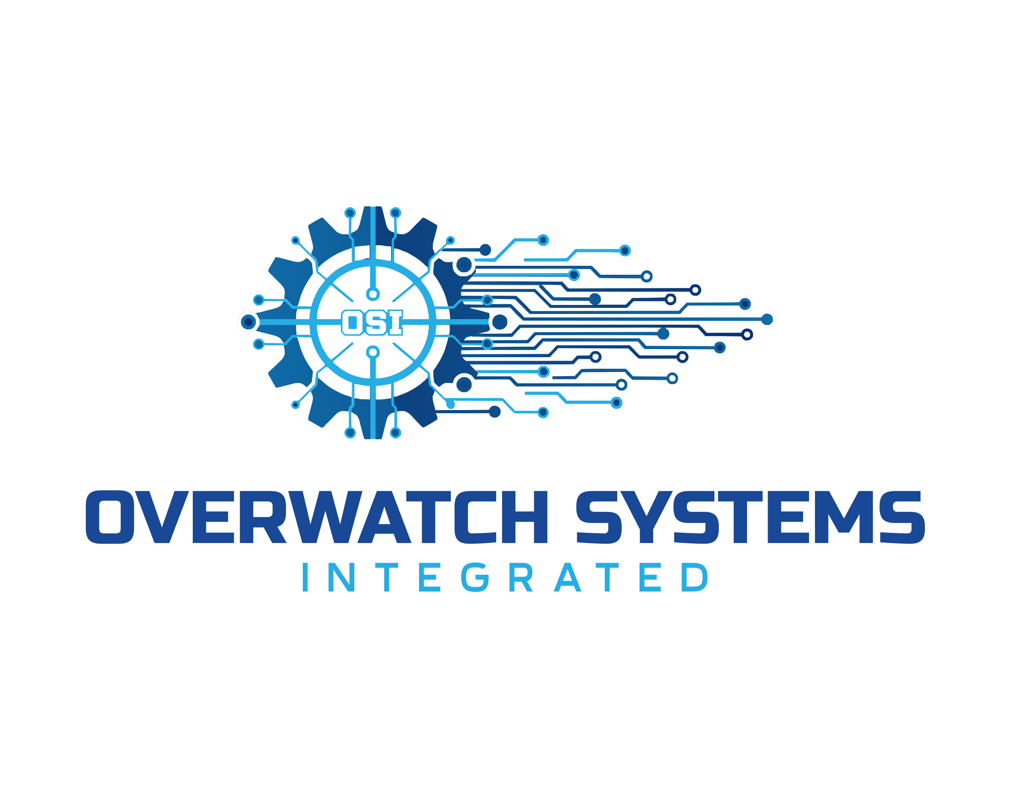

Securing and Connecting the Industrial Workforce
Oxford, Alabama | Advanced Security, Network & Automation Solutions
Phone: (256) 240-0681
Email: sales@overwatchsi.com
Website: www.overwatchsi.com

Overwatch Systems Integrated delivers purpose-built industrial security, networking, and automation solutions to manufacturers and industrial operators throughout Northeast Alabama. We combine technical expertise with local presence — ensuring your systems are installed right, maintained proactively, and supported when it matters most.

OUR CORE SERVICES
CCTV & SURVEILLANCE | NETWORK INFRASTRUCTURE | AUTOMATION
- HD & 4K industrial cameras  - Thermal imaging systems  - Remote & mobile monitoring  - Encrypted, secure access  - AI analytics and tools | - Structured cabling & fiber  - Industrial-grade switching  - Network security & firewalls  - System monitoring & support  - Server Upgrades and OS or VM migration | - PLC & control systems  - Production line automation  - Process control upgrades  - SCADA integration  - Custom workflow solutions
WHY OVERWATCH SYSTEMS INTEGRATED?
Local & Responsive  Based in Oxford — we're here when you need us, not a 1-800 number away. | Industrial-Grade Expertise  Our systems are built for foundries, chemical plants, and heavy manufacturing — not adapted from residential solutions.
End-to-End Service  From design and installation to ongoing maintenance and support — we own the full lifecycle. | Complimentary Assessment  We offer a no-obligation facility walkthrough and custom proposal for every prospective client.

CALL FOR A FREE CONSULTATION TODAY

Phone: (256) 240-0681 | Email: Sales@OverwatchSI.com | Website: www.overwatchsi.com

