MODULE 4
Graphical User Interface (GUI) Programming
Java Swing & JavaFX — Student Handout

Learning Objectives
By the end of this module, students should be able to:

- Understand the fundamentals of GUI programming.
- Identify and use common GUI components such as buttons, labels, text fields, panels, and windows.
- Integrate event-driven programming with GUI components.
- Implement GUIs using Java Swing and JavaFX libraries.
- Apply layout management techniques to organize and arrange components effectively.

1. What is GUI Programming?
Graphical User Interface (GUI) programming allows users to interact with software through visual elements such as windows, buttons, menus, and text fields — rather than typing text commands. In Java, two major libraries support GUI development:

Library | Key Characteristics
Java Swing | Part of Java SE, lightweight components (J-prefix), mature and stable, built on AWT.
JavaFX | Modern replacement, supports CSS styling, FXML layouts, animations, and rich media.

2. GUI Architecture
A Java GUI application is structured as a hierarchy of containers and components. The top-level window (JFrame/Stage) contains panels, which hold individual UI widgets.

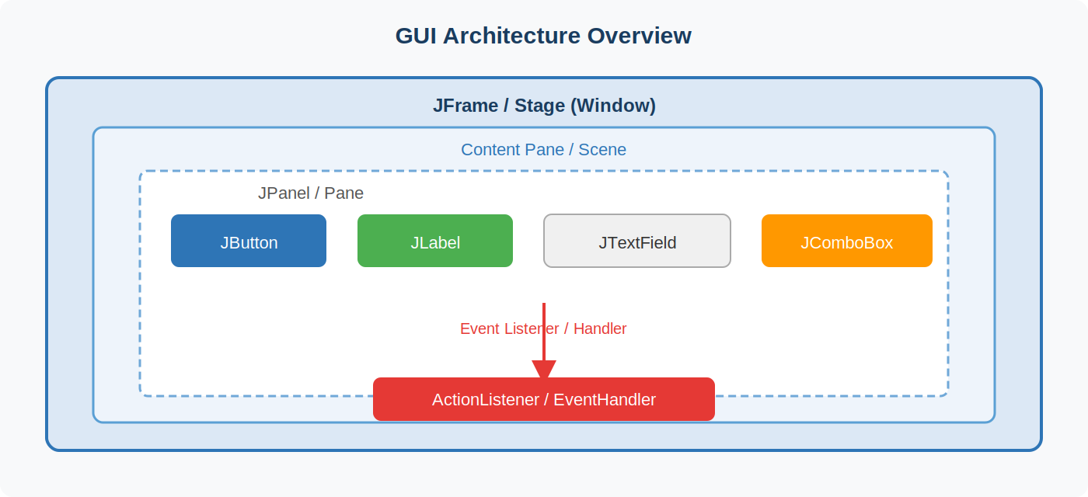
Figure 1 — GUI Component Hierarchy and Event Flow

3. Common GUI Components

3.1 Java Swing Components
import javax.swing.*;
import java.awt.*;

public class SwingComponents extends JFrame {
public SwingComponents() {
setTitle("Swing Demo");
setSize(400, 300);
setDefaultCloseOperation(JFrame.EXIT_ON_CLOSE);
setLayout(new FlowLayout());

JLabel label = new JLabel("Name:"); // Display text
JTextField tf = new JTextField(15); // Single-line input
JButton btn = new JButton("Submit"); // Clickable button
JCheckBox cb = new JCheckBox("Remember me"); // Toggle option
JComboBox<String> combo = new JComboBox<>( // Drop-down list
new String[]{"Java", "Python", "C++"});

add(label); add(tf); add(btn); add(cb); add(combo);
setVisible(true);
}
public static void main(String[] args) {
SwingUtilities.invokeLater(SwingComponents::new);
}
}

3.2 JavaFX Components
import javafx.application.Application;
import javafx.scene.Scene;
import javafx.scene.control.*;
import javafx.scene.layout.VBox;
import javafx.stage.Stage;

public class FXComponents extends Application {
@Override
public void start(Stage stage) {
Label lbl = new Label("Username:");
TextField tf = new TextField();
PasswordField pf = new PasswordField();
Button btn = new Button("Login");
ComboBox<String> cb = new ComboBox<>();
cb.getItems().addAll("Admin", "User", "Guest");

VBox root = new VBox(10, lbl, tf, pf, btn, cb);
root.setStyle("-fx-padding: 20; -fx-alignment: center;");
stage.setScene(new Scene(root, 300, 250));
stage.setTitle("JavaFX Demo");
stage.show();
}
public static void main(String[] args) { launch(args); }
}

4. Event-Driven Programming
In GUI programming, the program responds to events triggered by user actions (button clicks, key presses, mouse movements). Java uses the Listener/Observer pattern for this.

Key Concept
An Event Listener is an interface you implement. When the user triggers an action, Java calls the corresponding method (e.g., actionPerformed()) automatically.

4.1 ActionListener with Swing
import javax.swing.*;
import java.awt.event.*;

public class EventDemo extends JFrame {
private JLabel output = new JLabel("Result: ");
private JTextField input = new JTextField(10);

public EventDemo() {
JButton btn = new JButton("Say Hello");

// Method 1: Anonymous inner class
btn.addActionListener(new ActionListener() {
@Override
public void actionPerformed(ActionEvent e) {
output.setText("Hello, " + input.getText() + "!");
}
});

// Method 2: Lambda expression (Java 8+) — preferred
btn.addActionListener(e -> output.setText("Hello, " + input.getText() + "!"));

setLayout(new java.awt.FlowLayout());
add(input); add(btn); add(output);
setSize(350, 100); setVisible(true);
setDefaultCloseOperation(EXIT_ON_CLOSE);
}
public static void main(String[] args) {
SwingUtilities.invokeLater(EventDemo::new);
}
}

4.2 Event Handling in JavaFX
Button btn = new Button("Click Me");
Label lbl = new Label("Waiting...");

// Using a lambda (clean and concise)
btn.setOnAction(event -> lbl.setText("Button clicked!"));

// Mouse event example
btn.setOnMouseEntered(e -> btn.setStyle("-fx-background-color: #4CAF50;"));
btn.setOnMouseExited (e -> btn.setStyle("-fx-background-color: #2196F3;"));

5. Layout Management
Layout managers control the size and position of components inside a container. Choosing the right layout is essential for a clean, responsive UI.

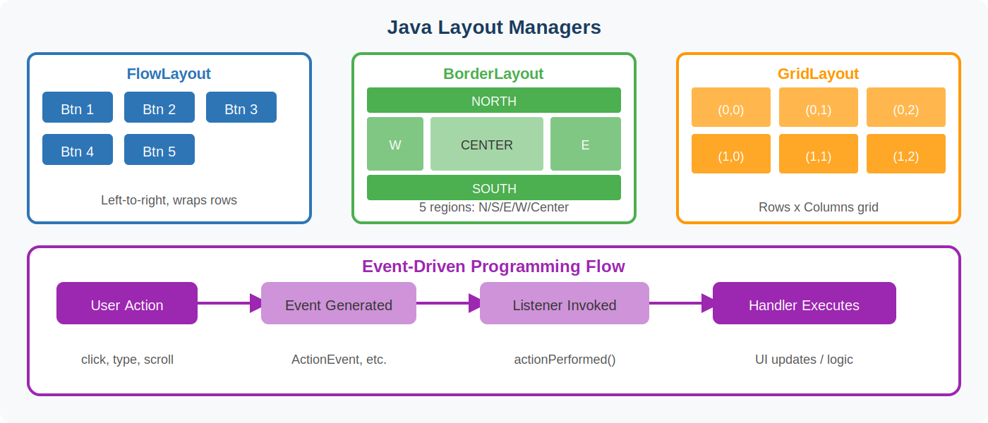
Figure 2 — Common Layout Managers and Event-Driven Flow

5.1 FlowLayout
// Default layout for JPanel
// Components are placed left-to-right, wrapping to next line
JPanel panel = new JPanel(new FlowLayout(FlowLayout.LEFT, 10, 5));
// gaps: hgap=10px, vgap=5px
panel.add(new JButton("One"));
panel.add(new JButton("Two"));
panel.add(new JButton("Three"));

5.2 BorderLayout
// Divides container into 5 regions
JFrame frame = new JFrame();
frame.setLayout(new BorderLayout());
frame.add(new JButton("NORTH"), BorderLayout.NORTH);
frame.add(new JButton("SOUTH"), BorderLayout.SOUTH);
frame.add(new JButton("EAST"), BorderLayout.EAST);
frame.add(new JButton("WEST"), BorderLayout.WEST);
frame.add(new JTextArea("Center Content"), BorderLayout.CENTER);

5.3 GridLayout
// Creates an evenly spaced grid of rows x columns
JPanel grid = new JPanel(new GridLayout(3, 3, 5, 5)); // 3 rows, 3 cols, gaps
for (int i = 1; i <= 9; i++) {
grid.add(new JButton(String.valueOf(i)));
}

5.4 JavaFX Layout Panes
// VBox — vertical stack
VBox vbox = new VBox(10); // spacing=10
vbox.getChildren().addAll(new Label("Name"), new TextField(), new Button("Submit"));

// HBox — horizontal row
HBox hbox = new HBox(5);
hbox.getChildren().addAll(new Button("OK"), new Button("Cancel"));

// GridPane — flexible grid with row/column control
GridPane gp = new GridPane();
gp.setHgap(10); gp.setVgap(10);
gp.add(new Label("Email:"), 0, 0); // col, row
gp.add(new TextField(), 1, 0);
gp.add(new Button("Send"), 1, 1);

6. Quick Reference Summary
Concept | Java Swing | JavaFX
Window | JFrame | Stage
Container | JPanel | Pane (VBox, HBox, GridPane)
Button | JButton | Button
Text Input | JTextField / JTextArea | TextField / TextArea
Label | JLabel | Label
List | JComboBox / JList | ComboBox / ListView
Event | ActionListener | EventHandler<ActionEvent>
Entry point | main() + SwingUtilities | Application.launch()

Tip
Always call SwingUtilities.invokeLater() when creating Swing UIs — GUI operations must run on the Event Dispatch Thread (EDT) to avoid threading issues.

Module 4 — GUI Programming Handout | Java Programming Course

