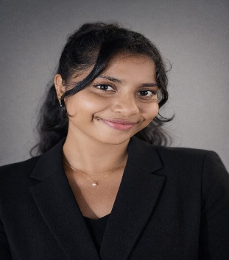
Contact  Phone : 071-4242824  Email: ovindijayawardena@gmail.com  LinkedIn : www.linkedin.com/in/ovindi-jayawardena-5516933a5  Personal Details  Full Name : Ovindi Jayawardena  Date of Birth : April 17, 2004  Gende r: Female  Address: 213 De Soysa Rd, Moratumulla , Moratuwa, Colombo, Sri Lanka  City: Moratuwa  Country : Sri Lanka  Education : IJSE - Institute of Software Engineering  Languages: Sinhala, English |  |  | Career Objective  A responsible and enthusiastic student seeking an opportunity to serve as a member of the Student Committee. I aim to actively contribute to organizing events, supporting fellow students, and representing student interests while developing leadership, communication, and teamwork skills.  Education  General Certificate of Education (Ordinary Level) - 2020(2021)  Convent of Our Lady of Victories, Moratuwa  General Certificate of Education (Advanced Level) - 2023(2024)  Convent of Our Lady of Victories, Moratuwa  English Diploma Moratuwa University - 2024  University of Moratuwa  Software Engineering Diploma – 2025 (Currently Following)  IJSE, Panadura  Full Stack Developer Online Courses – 2026 (Currently Following)  University of Moratuwa  Key Skills  • Good communication skills in Sinhala and English  • Ability to work well in a team environment  • Responsible and disciplined  • Good organizational and time management skills  • Ability to handle tasks under pressure  • Positive attitude and willingness to learn  Projects / Technical & Creative Skills  - Java Project (2025): Developed a Gold Management System to handle attendance, records, and events using Java and OOP concepts.  - UI/UX Design – Figma (2025): Created user-friendly mobile app prototypes with wireframes and interactive designs.  - Reports – Jaspersoft Studio (2025): Designed automated data visualization reports for Java applications.  - Video Editing – CapCut & TikTok (2025–2026): Edited creative short videos for social media, improving audience engagement.
STUDENT COMMITTEE MEMBER

