 



Database Programming with SQL 13-2: Using Data Types

Practice Activities

# Objectives

* Create a table using TIMESTAMP and TIMESTAMP WITH TIME ZONE column data types
* Create a table using INTERVAL YEAR TO MONTH and INTERVAL DAY TO SECOND column data types
* Give examples of organizations and personal situations where it is important to know to which time zone a date-time value refers
* List and provide an example of each of the number, date, and character data types

# Vocabulary

Identify the vocabulary word for each definition below.

|  |  |
| --- | --- |
| INTERVAL YEAR TO MONTH | Allows time to be stored as an interval of years and months |
| TIMESTAMP with LOCAL TIME ZONE | When a column is selected in a SQL statement the time is automatically converted to the user’s timezone |
| BLOB | Binary large object data up to 4 gigabytes |
| TIMESTAMP WITH TIME ZONE | Stores a time zone value as a displacement from Universal Coordinated Time or UCT |
| INTERVAL DAY TO SECOND | Allows time to be stored as an interval of days to hours, minutes, and seconds |
| VARCHAR2 | Character data up to 4 gigabytes |
| TIMESTAMP | Allows the time to be stored as a date with fractional seconds |

# Try It / Solve It

1. Using the examples provided in the slides, create eacCRE

h of the three time-zone tables.

ions

e-time

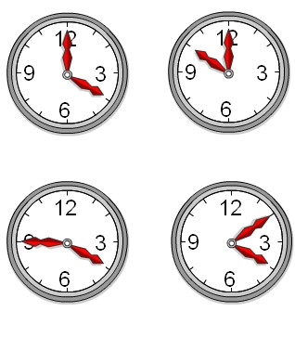

**LONDON**

**NEW YORK**

t

* 1. TIMESTAMP WITH LOCAL TIME ZONE
  2. INTERVAL YEAR TO MONTH
  3. INTERVAL DAY TO SECOND

a.

CREATE TABLE time_ex1

( Rommania TIMESTAMP WITH LOCAL TIME ZONE,

Greenwick TIMESTAMP WITH TIME ZONE,

New_York TIMESTAMP WITH TIME ZONE);

INSERT INTO time_ex1

VALUES

('15-Nov-2007 06:00:00', '31-OCT-2020 04:00:00 AM -02:00','31-OCT-2020 04:00:00 AM -10:00');

b. CREATE TABLE time_ex2

(duration1 INTERVAL YEAR(3) TO MONTH);

INSERT INTO time_ex2(duration1)

VALUES(INTERVAL '120' MONTH(3));

SELECT SYSDATE + duration1 AS "120 months from now"

FROM time_ex2;

c.

CREATE TABLE time_ex3

(day_duration1 INTERVAL DAY(3) TO SECOND);

INSERT INTO time_ex3

(day_duration1)

VALUES(INTERVAL '25' DAY(3));

1. Execute a SELECT * from each table

to verify your input.

SELECT *

FROM time_ex1;

SELECT *

FROM time_ex2;

SELECT *

FROM time_ex3;

1. Give 3 examples of organizations and personal situation where it is important to know to which time zone a da value refers.

-cand intr-o organizatie se realizeaza sedinte cu parteneri din mai multe state, trebuie sa le comunici ora conform fusului lor orar

-cand planifici o intalnire cu un client international, probabil ca acesta iti va spune orar conform fusului lui orar asa ca trebuie sa o convertesti in ora pentru tara ta

-cand vrei sa ii spui unei rude plecate in strainatate La multi ani si vrei sa o suni, atunci ar trebui sa verifici ce ora este in tara ei pentru a nu o deranja-o noaptea

Copyright © 2020, Oracle and/or its affiliates. All rights reserved. Oracle and Java are registered trademarks of Oracle and/or its affiliates. Other names may be trademarks of their respective owners.