

**Software Requirements**

**Specification**

**For**

**Web Aplication Design for Antique Shop Online**

**Version 1.0**

**Prepared by**

**Nicolae Ovidiu Petrisor**

**19.03.2017**

# Table of Contents

Table of Contents 1

Revision History 1

1. Introduction 2

1.1 Purpose 2

1.2 Product Scope 2

1.3 Intended Audience and Reading Suggestions 2

1.4 Definitions, Acronyms, and Abbreviations 2

1.5 References 2

2. Overall Description 3

2.1 Product Perspective 3

2.2 Product Functions 3

2.3 User Classes and Characteristics 3

2.4 Operating Environment 3

2.5 Design and Implementation Constraints 3

2.6 User Documentation 3

2.7 Assumptions and Dependencies 4

3. External Interface Requirements 4

3.1 User Interfaces 4

3.2 Hardware Interfaces 4

3.3 Software Interfaces 4

3.4 Communications Interfaces 4

4. System Features 5

4.1 Activity diagram 6

4.2 Activity diagram 7

5. Other Nonfunctional Requirements 8

5.1 Performance Requirements 8

5.2 Security Requirements 8

5.3 Software Quality Attributes 8

5.4 Business Rules 8

# Revision History

|  |  |  |  |
| --- | --- | --- | --- |
| **Name** | **Date** | **Comments** | **Version** |
|  |  |  |  |
|  |  |  |  |
| Nicolae Ovidiu Petrisor | 19.03.2017 | First Revision | 1.0 |
| Nicolae Ovidiu Petrisor | 23.03.2017 | Second Revision | 1.1 |

# 1. Introduction

## 1.1 Purpose

The purpose of this document is to present a description of a antiques online shop . It will explain the features of the system, the interfaces of the system and what the system will do.

## 1.2 Product Scope

The system will be built on a client/server architecture for assisting online customers on achieving the following tasks:

* Be able to see the products.
* Be able to register and login/register.
* Be able to add items in cart.
* Be able to buy items.

## 1.3 Intended Audience and Reading Suggestions

This document is intended for both the customers and the developers of the system.

## 1.4 Definitions, Acronyms, and Abbreviations

Not Aplicable

## 1.5 References

GitHub project link: https://github.com/Ovidiu-Petrisor-Nicolae/W.A.D.

# 2. Overall Description

## 2.1 Product Perspective

This product is an online shop. The purpoase is to be able to buy items by the customers, and be able to add, delete, modify products by administrator.

**Use case diagram**

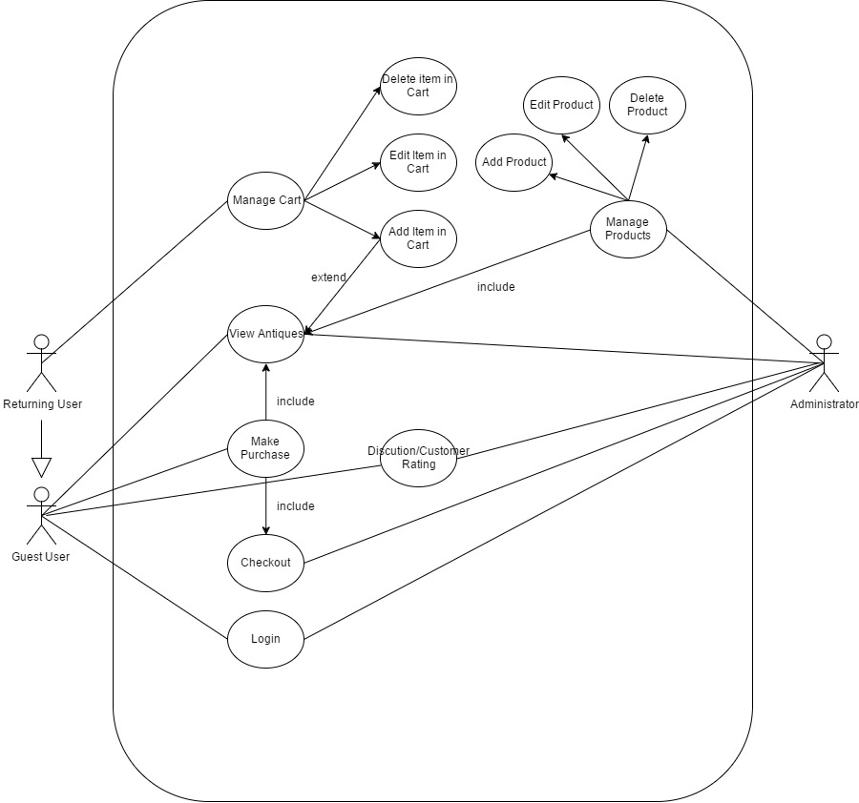

## 

## 2.2 Product Functions

The product will have the following main functions:

* Authentication.
* View products.
* Add,delete,modify products (Administrator only).
* Managing shopping cart.
* Managing account.
* Coments/Ratings of products.

**Activity diagram**

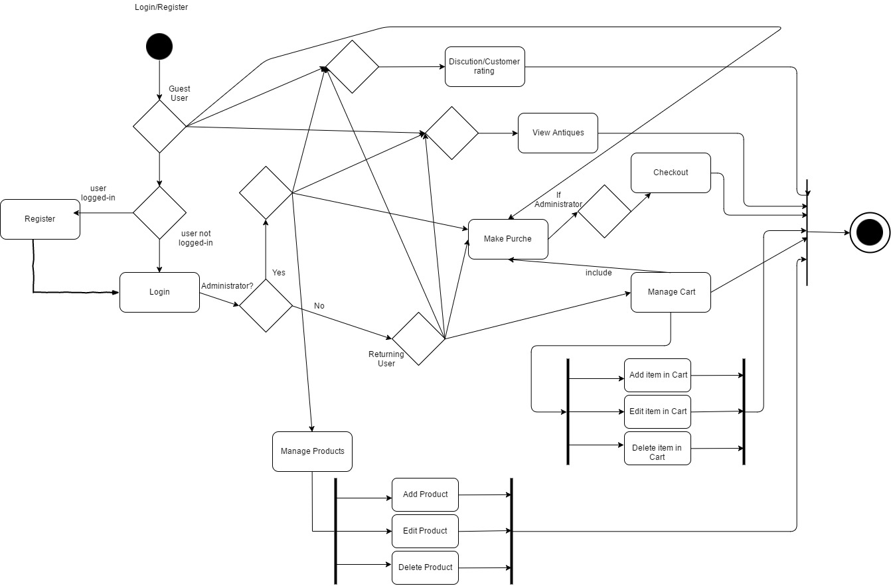

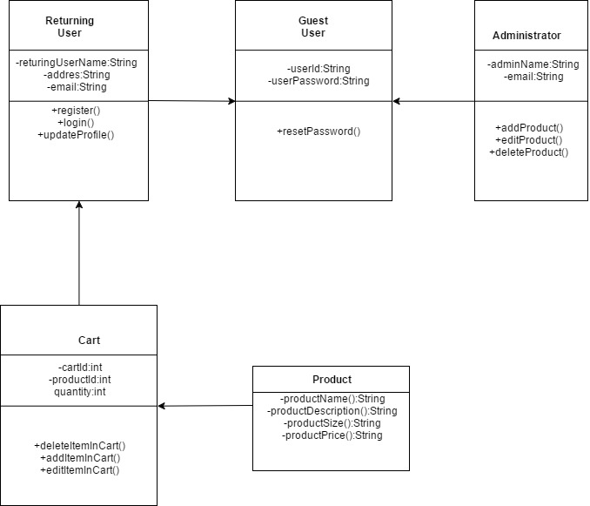

## 2.3 User Classes and Characteristics

The application users will be:

- Administrator (full privileges):

- login.

- see products.

- manage products.

- talk with customers.

- Returning User :

- Guest privileges.

- add products in cart.

- edit products in cart.

- delete products in cart.

- Guest User

- login

- make purchase.

- see products.

- discution & rating about products.

## 2.4 Operating Environment

This application was developed in:Microsoft Visual Studio IDE.

The application supports the following web browsers: Google Chrome and Mozilla Firefox.

## 2.5 Design and Implementation Constraints

This application is distributed with a proprietary software license.

The owner of proprietary software exercises certain [exclusive rights](https://en.wikipedia.org/wiki/Exclusive_right) over the software. The owner can restrict use, inspection of source code, modification of source code, and redistribution.

## 2.6 User Documentation

System Requirements Specifications document, System Design Specifications document and testing documents.

## 2.7 Assumptions and Dependencies

An internet connection is required in order to use the application.

Introduced data must respect the formatting options of the field in case.

# 3. External Interface Requirements

## 3.1 User Interfaces

The application should be accessible via web.  
The Layout should be the same for all users, with a main page for announcements and general information, and a navigation bar that allows access to the other functionalities and pages depending on the type of user.

Returning User / Guest User will be able to:

* Login
* View Products.
* Make purchase of the products.
* Leave comments/rating.
* Manage shopping cart ( only returning user)

Administrator privilege will be able to

* Login
* Add products
* Delete products.
* Modify products.
* View products.
* Respond to user message requests.

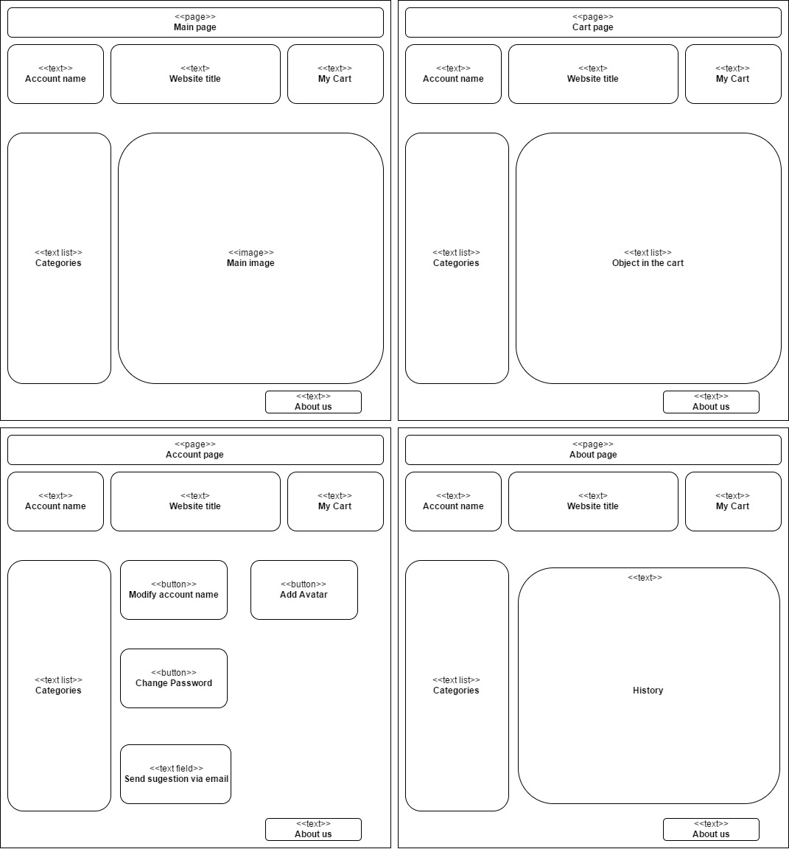

## 3.2 Hardware Interfaces

Not applicable.

## 3.3 Software Interfaces

The application is connected to the database (SQL) through a connection string located in the web.config file from the application project.

There will be a communication interface between the server and the database (functions to read from and write into the database) and another one between the server and the client application (get input text and display data).

## 3.4 Communications Interfaces

This application uses the HTTP protocol.

# 4. System Features

* **Authentication**
* *Register.*
* *Log in* using user id (email) and password.
* *Forgot password* option for resetting password.

* **View product list**
* *Search products*
* Order products by name and price
* *Add products to cart (*only logged in users can perform this action)
* **Managing products (administrators only)**
* *Add products.*
* *Delete products.*
* Edit product details (such as picture, price or description)
* **Managing account details**
* Modify account information.
* Add avatar
* Change Password
* Send Sugestion via email.
* **Shopping cart**

Authenticated users will be able to:

* *add* products to cart
* *see cart content*
* *delete* products from the cart
* *change quantity* (number of items of the same kind)
* *place order* (finalize).
* **Leave comments about products**
* *Add comment* and ratings about product.
* *Delete comments*: action performed only by administrators.
* Logged in users will be able to rate products.

# 5. Other Nonfunctional Requirements

## 5.1 Performance Requirements

1. The information system will run on Windows 7/8/10 OS.
2. Minimal system requirements:

* Processor: 3 GHz
* RAM Memory: 128 Mb
* Storage space: 10 Mb minimum

1. An internet connection should be set up before running the web application.

## 5.2 Security Requirements

The sensitive information in this application is considered:

* User and password – password will be encrypted using MD5 hash
* Database – Protection against SQL Injection will be set to every necessary input that works with the database

## 

## 5.3 Software Quality Attributes

Rule 1 (required): No reliance shall be placed on undefined or unspecified behavior.

Rule 2 (required): Insert one space between the comment delimiter (//) and the comment text

Rule 3 (advisory): No identifier in one name space should have the same spelling as an identifier in another name space, with the exception of structure member and union member names.

Rule 4 (advisory): Write only one declaration per line.

Rule 5 (advisory): Add at least one blank line between method definitions and property definitions.

Rule 6 (advisory): Place the comment on a separate line, not at the end of a line of code.

Rule 7 (advisory): Use the + operator to concatenate short strings.

Rule 8 (advisory): Use meaningful names for query variables.

## 5.4 Business Rules

There is no warranty or representation, expressed or implied, as to the accuracy, completeness or appropriateness of the information on this website. Therefore the user must assume full responsibility for using the information and agree that developers are not responsible or liable for any claim, loss, damage or inconvenience caused as a result of reliance on such information.  
All rights reserved.  
Images and copy on this website are for personal use only and cannot be reproduced commercially without permission.