SEP1 Process report

V-Class Group 3:

Andrei Chirtoaca, Dana Rusu, KOnstantina Blazhukova & Tamas Boda

SuperVisors:

Ole Ildsgaard Hougaard & Alexis Claire Walhovd

2015



Table of Contents

**Group Policy2**

**SWOT analysis3-7**

**Considerations before writing the reports 8**

**Reflections of the group members9-10**

**List of tasks11**

**Conclusions from group meetings12**

**Self and peer assessment**

Table 113

Table 214

Table 315

Table 416

**Group role definitions**17

**Belbin profile analysis**

Figure 118

Figure 219

Figure 320

Figure 421

**Assessment of the group project work22**

**Bloom profiles23-25**



**Group Policy**

1. Never be late! The one who is late brings tea to everyone.
2. Every member of the group should be respected and each opinion matters. You break the rule – you bring coffee.
3. Each member of the group has to take part when setting up a new decision.
4. Everybody should get their task done and present it to the others.
5. It is necessary to show up on every meeting
   1. If you can’t show up on a meeting, you must inform the others a day before.
6. Don’t hesitate to ask for help.
7. If you break a rule more than two times you should bring cupcakes every time.



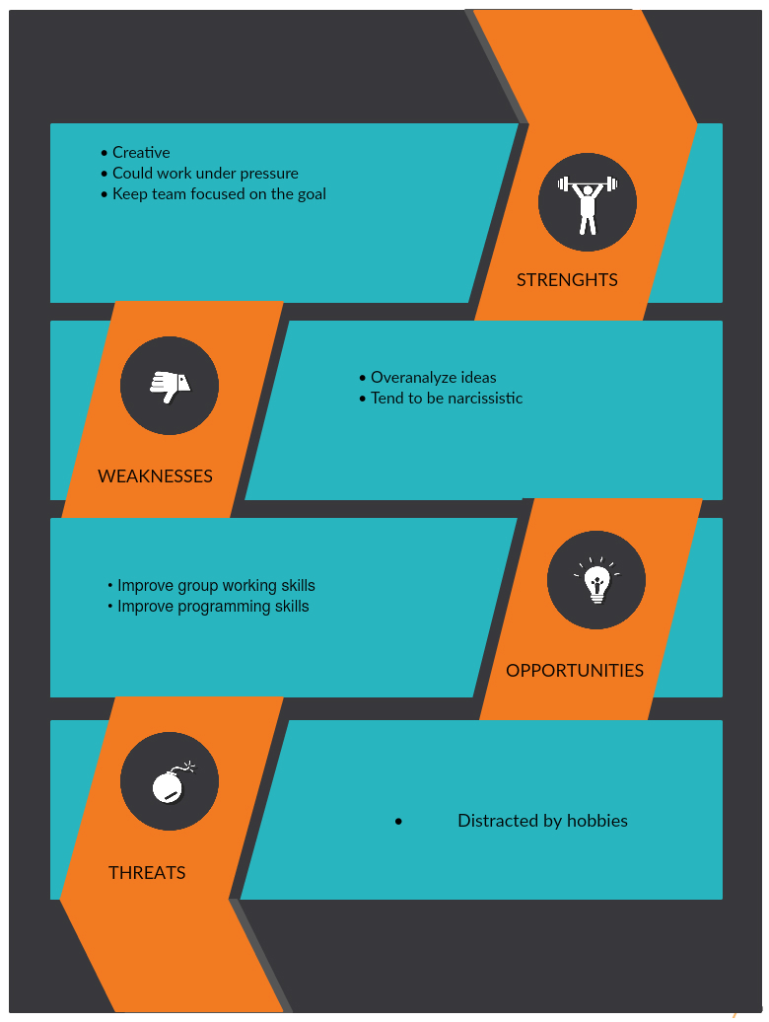

# Figure 1- swot – andrei chirtoaca

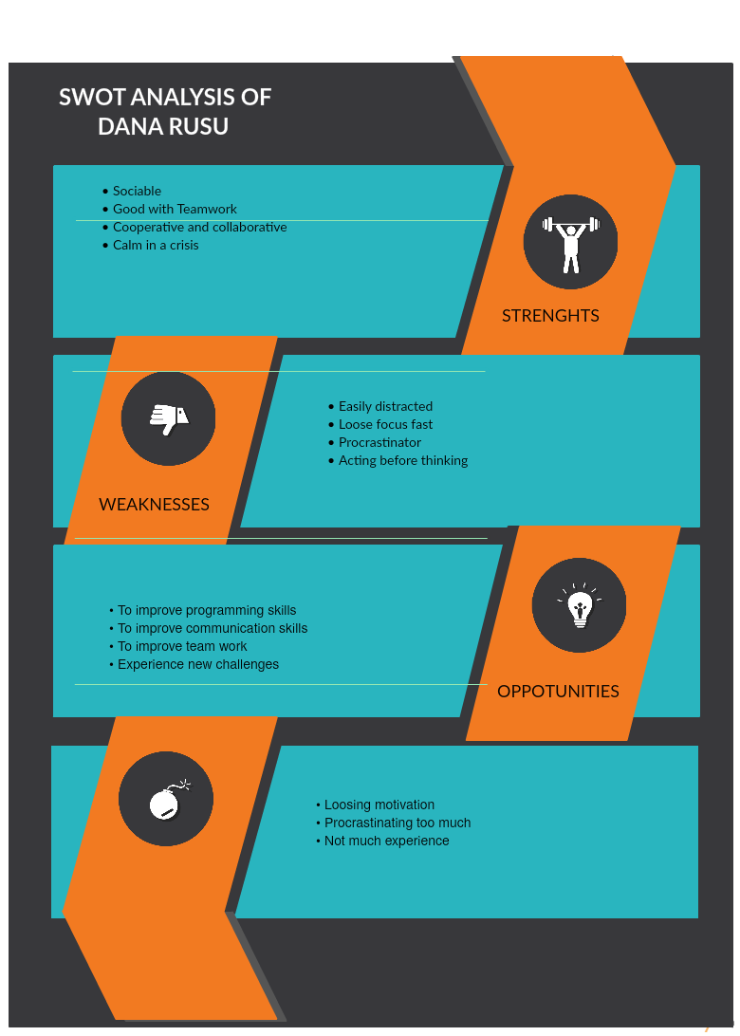

# figure 2 – swot – dana rusu

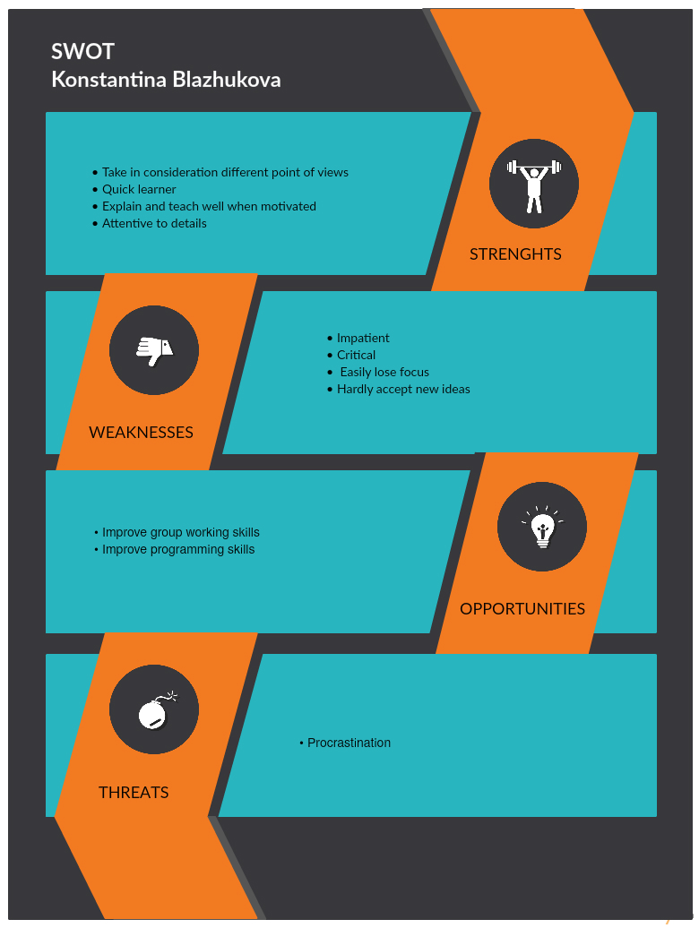

# Figure 3 – swot – konstantina blazhukova

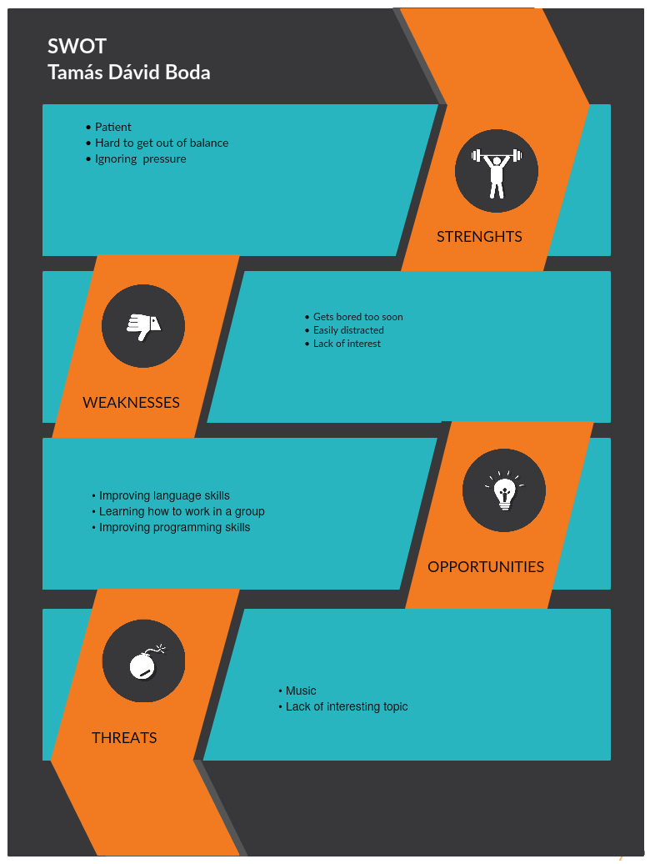

# figure 4 – swot – tamas boda

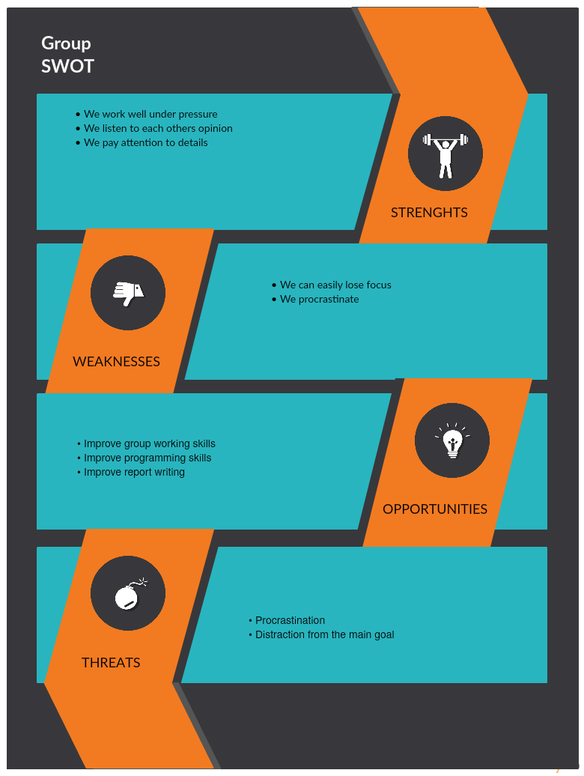

# Figure 5 - GROUP SWOT

Considerations before writing the report

Since we have a non-expert audience in mind the Process report should be written in semi-formal style, without any technical expressions and detailed expert information. The purpose of the report is to explain the process of doing the project step by step. Also it contains individual information about the group members as self-assessment and personal reflections.

On the other hand, the Project report should be written in formal style because it is aimed to an expert audience. This report contains technical information about how the project was accomplished, it is written by using specialized language, with no explanations as we assume that the audience is familiar with the used terms.

**Reflections of group members**

***Before starting the project.. (Konstantina Blazhukova)***

I am excited about working on this particular project because the topic seems really interesting to me. I suppose that it will not be an easy task, but I believe that our group has the qualities to finish everything on time. However, I am concerned if we will get along smoothly without confrontations, because I know well the other team members and we seem to be really individualistic. All in all, I am positive about the result and believe that it will be a valuable experience.

***After the project.. (Konstantina Blazhukova)***

Now as we have finished our project I feel happy and proud of the work we did. At the beginning, I felt calm and I was convinced everything will pass without big difficulties. Nevertheless it was definitely not an easy journey, because we met a lot of obstacles with the code and design of the system, during these three weeks. A few times we got stuck on some tasks and did not know how to overcome the issues. Frequently, we had different opinions on some matters, but in the end with compromises from everyone we always succeeded in reaching a consensus. From my point of view we gained a lot of practical knowledge not only in java programming but also in team working and how to be cooperative. Especially for me I could say that I learned how to be more patient and tolerant towards others’ opinion. In conclusion, I will say that I am glad I worked with this group and I am satisfied with the job we did.

***Before the project..(Tamas Boda)***

I am looking forward to work with my group this semester. I have never had an experience like this before, the tasks we had in high school weren’t that important, and were much easier. I think it is going to be really useful for me in the future, since a lot of jobs require cooperation. Besides improving our programming skills by figuring things out on our own, we will also be better at communicating and solving problems together.

***After the project..(Tamas Boda)***

During the project I learned that sometimes time passes faster than you would expect it to. I thought we planned our timetable well, but only after the project I realised how wrong I was. I know that a group needs to make plans ahead, and try to stick to it as much as possible. It’s good to know that your teammates got your back, no matter what. When a problem occurs it’s important for us that we put our differences aside and talk about the issues we have. All in all, I am satisfied with the outcome of the final project, I’m glad that I had a chance to experience something like this.

***Considerations before the project..(Andrei Chirtoaca)***

As usual, whenever I have something new, I have big expectations - this is my nature. I know some of the group members, I am sure they are responsible and I suppose there won’t be problems like: someone is doing all the work and the others are just waiting for something to happen.

Anyway, group work has never been a problem for me, I enjoy working in a group and I hope in this project period I will learn a lot of new things.

***Considerations after the project..(Andrei Chirtoaca)***

Now, project days are numbered and with every hour we are more and more close to the deadline...I’ve made new friends, new interesting and open-minded people that have the same interests as I do. I didn’t even notice how fast time passed. In this project period I’ve boosted my Java skills, gained experience in adapting to work with people I’ve never worked before and also had the opportunity to study these people’s behaviour in different situations.

I am looking forward for the second semester project as soon as possible.

***My thoughts before starting the project..(Dana Rusu)***

I am very enthusiastic about starting this project together with my team. Looking forward to improving and shaping myself into a better version. I am keen on gathering experience through this project not only on programming and report writing but also on team work. My level of confidence is enough to say that we will conquer every problem we meet.

***My thoughts after the project..(Dana Rusu)***

After the project I can say that we met some problems, that we didn’t expect we are going to have, but gladly we solved them all. This project taught me that working in a group is not that easy as I thought it would be and that there is always more you can do. I can say that working on this project made me discover new parts about me as a person. I found out what team role suit me the best and in what fields I work the best. In my opinion this project creates new boundaries and relationships, even though sometimes we were arguing because of different points of views and different personalities.However, we all shared the idea that to success in a project you need to pass through all four stages of group development: forming, storming, norming and performing.

**List of tasks**

**Andrei Chirtoaca:**

Main classes – CheckIn

GUI classes – BookingGUI, Cancel Booking, CheckIn, CheckIn Search, Edit Booking, Make a booking

Process Report - SWOT, Group role, Belbin profile, Self and Peer assessment

**Dana Rusu:**

Main Classes – Suite, Container, Room, Guest

GUI Classes – Add Guest, Functionality List

Process Report - SWOT, Group role, Belbin profile, Self and Peer assessment

**Konstantina Blazhukova**

Main Classes – Hotel, Booking, My Date

GUI Classes – CheckOut

Process Report – SWOT, Group role, Belbin profile, Self and Peer assessment, Design, Input information

Project Report – Design, Input information

**Conclusions of the Group meetings**

When the project started we had one main meeting in which we stated that we’ll meet everyday, besides Saturday. As the project was going on we noticed improvement in our communication, because we got to know each other better and how and when we work to our best expectations. Our meetings were all at the university and everybody was present, for us it was easier to discuss all the problems that appeared when we were all together talking face to face. In the meetings there were tasks that were done together and there were tasks that we divided through all the four of us so the project would progress with a higher pace.

Of course our group experienced some misunderstandings, but we got over them by communicating and listening to each other opinions and needs.

|  |  |  |  |  |  |  |
| --- | --- | --- | --- | --- | --- | --- |
|  | Excellent | Good | Fair | Adequate | Inadequate | Unacceptable |
| Programming skills |  | x |  |  |  |  |
| Preparation for  Meetings | x |  |  |  |  |  |
| Communication  skills |  | x |  |  |  |  |
| Structure of  workload |  | x |  |  |  |  |
| Presence at  meetings | x |  |  |  |  |  |
| Activity at meetings | x |  |  |  |  |  |
| Respecting  deadlines | x |  |  |  |  |  |
| Responding to criticism, advice or instructions |  | x |  |  |  |  |
| Group tasks skills |  | x |  |  |  |  |
| Individual tasks  skill | x |  |  |  |  |  |
| Group participation | x |  |  |  |  |  |

## table 1 - Self and peer ASSESSMENT - Konstantina bLazhukova

|  |  |  |  |  |  |  |
| --- | --- | --- | --- | --- | --- | --- |
|  | Excellent | Good | Fair | Adequate | Inadequate | Unacceptable |
| Programming skills |  | x |  |  |  |  |
| Preparation for  Meetings | x |  |  |  |  |  |
| Communication  skills | x |  |  |  |  |  |
| Structure of  workload | x |  |  |  |  |  |
| Presence at  meetings | x |  |  |  |  |  |
| Activity at meetings | x |  |  |  |  |  |
| Respecting  deadlines | x |  |  |  |  |  |
| Responding to criticism, advice or instructions |  | x |  |  |  |  |
| Group tasks skills |  | x |  |  |  |  |
| Individual tasks  skill | x |  |  |  |  |  |
| Group participation | x |  |  |  |  |  |

## table 2 – self and peer assessment – andrei chirtoaca

|  |  |  |  |  |  |  |
| --- | --- | --- | --- | --- | --- | --- |
|  | Excellent | Good | Fair | Adequate | Inadequate | Unacceptable |
| Programming skills |  | x |  |  |  |  |
| Preparation for  Meetings |  | x |  |  |  |  |
| Communication  skills | x |  |  |  |  |  |
| Structure of  workload |  | x |  |  |  |  |
| Presence at  meetings | x |  |  |  |  |  |
| Activity at meetings | x |  |  |  |  |  |
| Respecting  deadlines |  | x |  |  |  |  |
| Responding to criticism, advice or instructions | x |  |  |  |  |  |
| Group tasks skills |  | x |  |  |  |  |
| Individual tasks  skill | x |  |  |  |  |  |
| Group participation | x |  |  |  |  |  |

## table 3 – self and peer assessment – Dana rusu

|  |  |  |  |  |  |  |
| --- | --- | --- | --- | --- | --- | --- |
|  | Excellent | Good | Fair | Adequate | Inadequate | Unacceptable |
| Programming skills |  | x |  |  |  |  |
| Preparation for  Meetings |  | x |  |  |  |  |
| Communication  skills | x |  |  |  |  |  |
| Structure of  workload |  | x |  |  |  |  |
| Presence at  meetings | x |  |  |  |  |  |
| Activity at meetings |  |  | x |  |  |  |
| Respecting  deadlines | x |  |  |  |  |  |
| Responding to criticism, advice or instructions |  | x |  |  |  |  |
| Group tasks skills |  | x |  |  |  |  |
| Individual tasks  skill | x |  |  |  |  |  |
| Group participation |  | x |  |  |  |  |

## table 4 – self and peer assessment- tamas boda

**Recorder (Konstantina Blazhukova)**

As a Recorder my task is to take notes on every meeting and write down all the suggestions, ideas and decisions the group makes. I am in charge of presenting the notes to the group and highlighting the important sections that matter for the project. If I do not fulfill my task properly there is a chance of losing track of our ideas and becoming disorganized and chaotic.

**Monitor (Konstantina Blazhukova)**

As a Monitor my work is to make sure that everyone in the group understand every idea we have and every decision we make. I am the one who is responsible for providing help from outside if the group has difficulties with completing some tasks. This project requires cooperation and team work so I must always be sure that everyone is aware of what their task is and how they will fulfil it.

**Presenter (Dana Rusu)**

As a presenter my tasks are to regularly contribute to the team’s efforts by explaining all the assignments and pointing out the problems that we have and suggesting solutions. I am providing an overview of the project and how all the tasks are linked to each other and how the program works all together. Taking in mind all the all the group’s responses and conclusions I am preparing a summary of the group’s work not forgetting about the clarity of understanding of all that is done.

**Coordinator (Andrei Chirtoaca)**

During the project period I had the chance to challenge myself in new ways. First of all, I was put in the situation to observe myself from different perspectives than usual. When we began working, I was ready to put all my dedication and knowledge into completing the task at hand. In return I was sure that all my investments would in turn increase my experience as much as possible. In my opinion this is the most important thing, because the semester project is actually a simulation of a real-life project, just at a smaller scale. During this time, I grew to understand better how the industry works and how it is actually possible to develop a product that works and could potentially be used. Also, I had the chance to work with different kind of people, of different nationality and culture. It had a huge impact on me, because first of all, I learnt teamwork and respect for my other teammates.

As a coordinator, I had to assure both a good working atmosphere in the group and a good communication channel between the group members. It was pretty hard to accomplish, because this was a new experience for me. I am a very social person, but applying this skill in a professional environment is a little bit different than any day to day interaction. During high school, I participated in all kinds of extra-curricular activities just to prove myself that I can do more than I think. Now that the semester period is finished, I can finally affirm that I improved dramatically in a lot of ways and actually managed to surprise myself. At times, it was hard to keep the team in one piece, because the members had too different views on how things should be done. Tamas was pretty uninterested in the work in comparison to Dana and Konstatntina who tried their best. I think that this was the most difficult part to accomplish as a coordinator.

I hope that all the experience I gained during these 3 weeks will impact positively my performance in the upcoming semesters and projects.

**Konstantina Blazhukova**

As a **Shaper** I am highly motivated to work and ensure that the group does not lose focus. I am also determined to overcome obstacles which could appear during the project. My efficiency does not change under pressure and I easily adapt to any situations.

As an **Implementor** I am efficient and reliable. I suggest practical solutions to problems and organize the work that has to be done.

**Strengths: Weaknesses:**

Dynamic Too direct

Thrives on pressure Could be easily provoked

Determined Inflexible

Practical Slow response to new possibilities

Efficient

**Andrei Chirtoaca**

*Coordinator*: I am very confident, stable and mature, interested in planning and clarifying decisions. Because I can recognise abilities in others, I am very good at delegating tasks to the right person for the job. That’s why I usually tend to be the chairperson of a team.

*Team worker*: I am a good listener and diplomat, talented at smoothing over conflicts and helping parties understand one another without becoming confrontational.

All in all, I enjoy working with my teammates. I am the one who wants improvements all the time, “Guys, everything looks great, but anyway we need to polish and to beautify something”

Weaknesses: My group colleagues say that sometimes I tend to be too manipulative. The weaknesses for the Teamworker(“avoids confrontation”) and for the Specialist(“contributes only on a narrow front”) DO NOT APPLY.

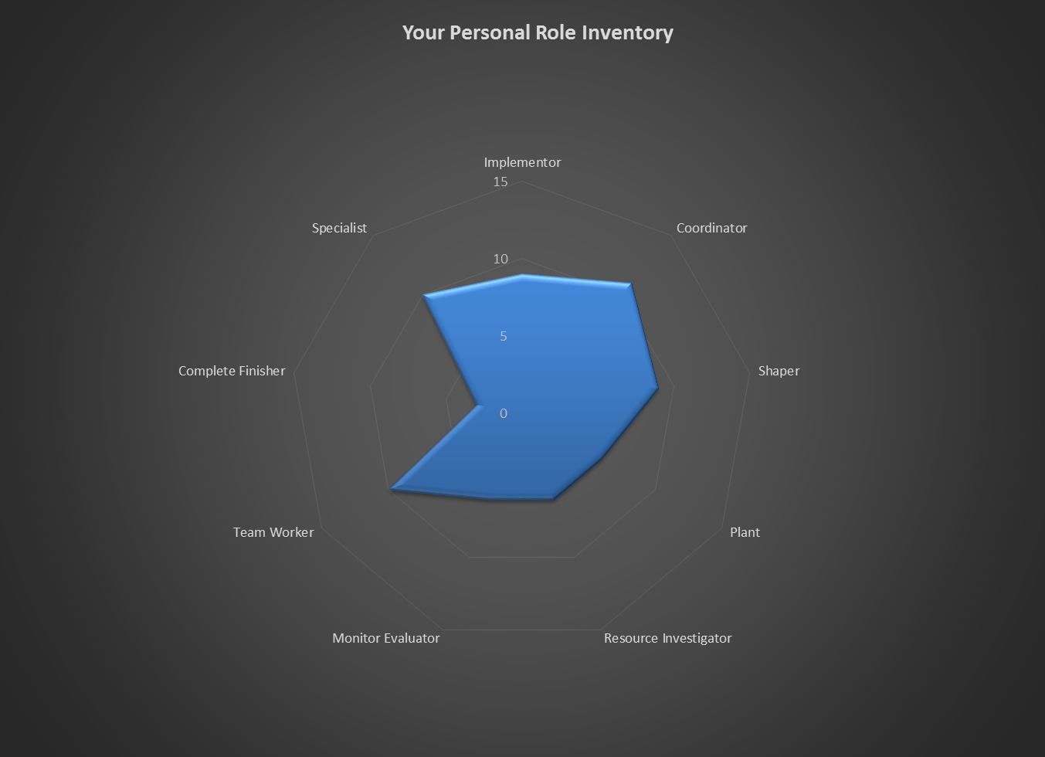

**Dana Rusu**

By looking at my charts it is evident that I implement a little from all of the team roles. However the ones that describe me the best are Resource Investigator and Team Worker. By all means that says I am enthusiastic and communicative and always explore the opportunities that come in my way, but at the same time I can easily lose interest and motivation. I listen and advert friction and I am co-operative and collaborative with the team.

**Strengths: Weaknesses:**

Enthusiastic Over- optimistic

Communicative Indecisive

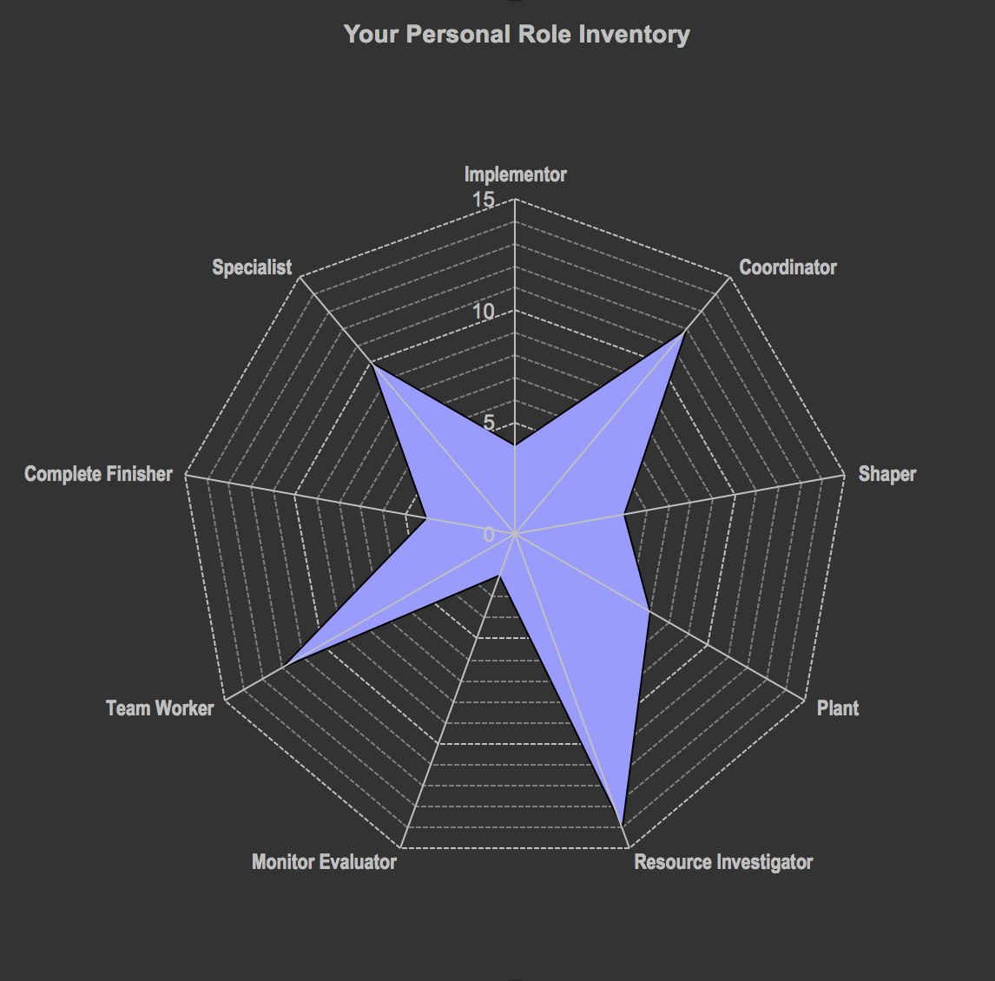Perceptive Lose interest

**Tamas Boda**

As a Resource Investigator I am an outgoing person who is very enthusiastic towards his job. I always try to investigate the new solutions, but as soon as I don’t seem to find them I lose interest and get distracted easily.

As a Coordinator I can easily tell what others are good at and I always make sure that we are on the right way to the solution of the problem.

**Strengths**  **Weaknesses:**

Outgoing Over optimistic

Communicative Easily loses interest

Confident Manipulative

Enthusiastic Offloads his part of the job

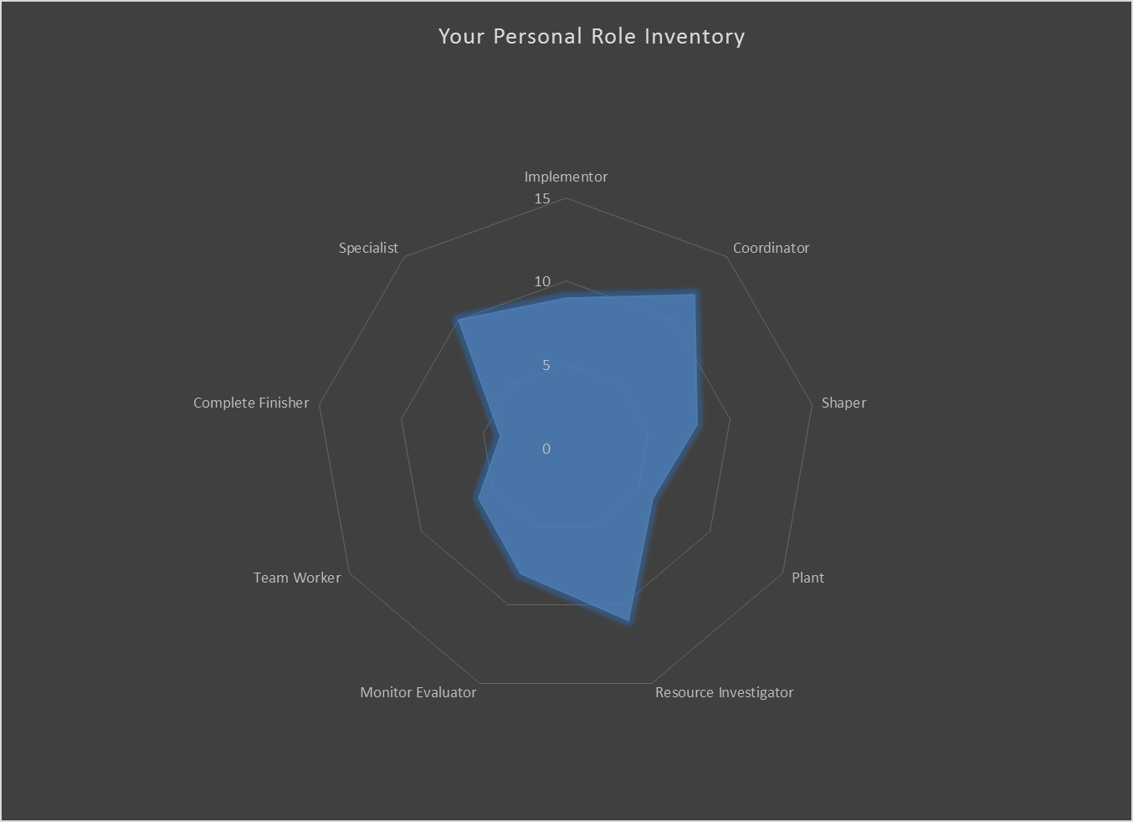

**Assessment of the group project work**

At first all of the group members were highly motivated and determined to work together. In the first week we were very productive but still we tended to get distracted and lose focus from the tasks we had for our meetings. Despite this fact everyone came to the meetings and stayed until we finish everything we had for the day. Although, in the second week we met some issues with designing the system, we quickly found the solution as a group and continued working without loosing temp. There were times when not everyone were actively participating and this is a main problem in team working which should have been changed earlier in time. In addition we had different opinions on some matters but with making compromises and acting as mature people we always got to a consensus. We always tried to keep the good atmosphere and the sense of humour in the group by spending time together outside school and sharing our common interests.

All of us will face the results of their behavior and the job they have done during the project period.

|  |  |  |  |  |  |  |  |  |  |  |  |  |  |  |  |  |  |  |  |  |  |  |  |  |  |  |  |  |  |
| --- | --- | --- | --- | --- | --- | --- | --- | --- | --- | --- | --- | --- | --- | --- | --- | --- | --- | --- | --- | --- | --- | --- | --- | --- | --- | --- | --- | --- | --- |
|  | Date 10/10/2015 | Keeping portfolio | Reflecting on learning | System  Development | SCRUM | Java programming | Object-orientated design and programming | | | UML |  | Web programming | | | Database design | | | Written English | | Spoken English | | Team working | | Sharing knowledge | | Project planning | | Presentation/exam skills | |
| Excell ent | 6 |  |  |  |  |  |  |  |  |  |  | | |  | |  |  | |  | |  | |  | |  | |  | |
| 5 |  |  |  |  |  |  | | |  | | |  |  | | | x | | x | |  | |  | |  | |  | |
| Good | 4 |  |  |  |  |  |  | | |  | | |  |  | | |  | |  | | x | |  | |  | | x | |
| 3 |  | x | x |  |  |  | | |  | | | x |  | | |  | |  | |  | | x | | x | |  | |
| Basic | 2 | x |  |  |  |  |  | | |  | | |  |  | | |  | |  | |  | |  | |  | |  | |
| 1 |  |  |  |  | x |  | | |  | | |  |  | | |  | |  | |  | |  | |  | |  | |
| No know ledge | 0 |  |  |  | x |  | x | | | x | | |  | x | | |  | |  | |  | |  | |  | |  | |

# AndREI Chirtoaca – Bloom profile - before

|  |  |  |  |  |  |  |  |  |  |  |  |  |  |  |  |  |  |  |  |  |  |  |  |  |  |  |  |
| --- | --- | --- | --- | --- | --- | --- | --- | --- | --- | --- | --- | --- | --- | --- | --- | --- | --- | --- | --- | --- | --- | --- | --- | --- | --- | --- | --- |
|  | Date 10/10/2015 | Keeping portfolio | Reflecting on learning | System  Development | SCRUM | Java programming | Object-orientated design and programming | | | UML |  | Web programming | | | Database design | | | Written English | | Spoken English | | Team working | | Sharing knowledge | Project planning | Presentation/exam skills | |
| Excell ent | 6 |  |  |  |  |  |  |  |  |  |  | | |  | |  |  | |  | |  | |  | |  |  |
| 5 | X |  |  |  |  |  | | |  | | | x |  | | | x | | x | | x | | X | | X |  |
| Good | 4 |  | x | x |  | x | x | | | x | | |  |  | | |  | |  | |  | |  | |  | x |
| 3 |  |  |  |  |  |  | | |  | | |  |  | | |  | |  | |  | |  | |  |  |
| Basic | 2 |  |  |  |  |  |  | | |  | | |  |  | | |  | |  | |  | |  | |  |  |
| 1 |  |  |  |  |  |  | | |  | | |  |  | | |  | |  | |  | |  | |  |  |
| No know ledge | 0 |  |  |  | x |  |  | | |  | | |  | x | | |  | |  | |  | |  | |  |  |

# Andrei chitoaca – bloow profile - After

|  |  |  |  |  |  |  |  |  |  |  |  |  |  |  |  |  |  |  |  |  |  |  |  |  |  |  |  |  |  |
| --- | --- | --- | --- | --- | --- | --- | --- | --- | --- | --- | --- | --- | --- | --- | --- | --- | --- | --- | --- | --- | --- | --- | --- | --- | --- | --- | --- | --- | --- |
|  | Date 10/10/2015 | Keeping portfolio | Reflecting on learning | System  Development | SCRUM | Java programming | Object-orientated design and programming | | | UML |  | Web programming | | | Database design | | | Written English | | Spoken English | | Team working | | Sharing knowledge | | Project planning | | Presentation/exam skills | |
| Excell ent | 6 |  |  |  |  |  |  |  |  |  |  | | |  | |  |  | |  | |  | |  | |  | |  | |
| 5 |  |  |  |  |  |  | | |  | | |  |  | | |  | |  | | x | |  | |  | |  | |
| Good | 4 |  | x |  |  |  |  | | |  | | |  |  | | | x | | x | |  | | x | |  | |  | |
| 3 | x |  |  |  |  |  | | |  | | |  |  | | |  | |  | |  | |  | | x | | x | |
| Basic | 2 |  |  | x |  |  |  | | |  | | |  |  | | |  | |  | |  | |  | |  | |  | |
| 1 |  |  |  |  |  |  | | |  | | | x |  | | |  | |  | |  | |  | |  | |  | |
| No know ledge | 0 |  |  |  | x | x | x | | | X | | |  | x | | |  | |  | |  | |  | |  | |  | |

# Dana rusu – bloom profile - before

|  |  |  |  |  |  |  |  |  |  |  |  |  |  |  |  |  |  |  |  |  |  |  |  |  |  |  |  |  |  |
| --- | --- | --- | --- | --- | --- | --- | --- | --- | --- | --- | --- | --- | --- | --- | --- | --- | --- | --- | --- | --- | --- | --- | --- | --- | --- | --- | --- | --- | --- |
|  | Date 09/12/2015 | Keeping portfolio | Reflecting on learning | System  Development | SCRUM | Java programming | Object-orientated design and programming | | | UML |  | Web programming | | | Database design | | | Written English | | Spoken English | | Team working | | Sharing knowledge | | Project planning | | Presentation/exam skills | |
| Excell ent | 6 |  |  |  |  |  |  |  |  |  |  | | |  | |  |  | |  | |  | |  | |  | |  | |
| 5 |  |  |  |  |  |  | | |  | | |  |  | | | x | | x | | x | |  | |  | |  | |
| Good | 4 | x | x |  |  | x | x | | | x | | | x |  | | |  | |  | |  | |  | | x | | x | |
| 3 |  |  | x | x |  |  | | |  | | |  |  | | |  | |  | |  | | x | |  | |  | |
| Basic | 2 |  |  |  |  |  |  | | |  | | |  |  | | |  | |  | |  | |  | |  | |  | |
| 1 |  |  |  |  |  |  | | |  | | |  |  | | |  | |  | |  | |  | |  | |  | |
| No know ledge | 0 |  |  |  |  |  |  | | |  | | |  | x | | |  | |  | |  | |  | |  | |  | |

# dana rusu – bloom profile - after

|  |  |  |  |  |  |  |  |  |  |  |  |  |  |  |  |  |  |  |  |  |  |  |  |  |  |  |  |  |  |
| --- | --- | --- | --- | --- | --- | --- | --- | --- | --- | --- | --- | --- | --- | --- | --- | --- | --- | --- | --- | --- | --- | --- | --- | --- | --- | --- | --- | --- | --- |
|  | Date 10/10/2015 | Keeping portfolio | Reflecting on learning | System  Development | SCRUM | Java programming | Object-orientated design and programming | | | UML |  | Web programming | | | Database design | | | Written English | | Spoken English | | Team working | | Sharing knowledge | | Project planning | | Presentation/exam skills | |
| Excell ent | 6 |  |  |  |  |  |  |  |  |  |  | | |  | |  |  | |  | |  | |  | |  | |  | |
| 5 |  |  |  |  |  |  | | |  | | |  |  | | | x | |  | |  | |  | |  | |  | |
| Good | 4 |  | x |  |  |  |  | | |  | | |  |  | | |  | | x | | x | | X | | x | |  | |
| 3 |  |  |  |  |  |  | | |  | | |  |  | | |  | |  | |  | |  | |  | | x | |
| Basic | 2 |  |  |  |  |  |  | | |  | | |  |  | | |  | |  | |  | |  | |  | |  | |
| 1 | x |  |  |  | x |  | | |  | | | X |  | | |  | |  | |  | |  | |  | |  | |
| No know ledge | 0 |  |  | x | x |  | x | | | x | | |  | x | | |  | |  | |  | |  | |  | |  | |

# Konstantina Blazhukova – bloom profile - before

|  |  |  |  |  |  |  |  |  |  |  |  |  |  |  |  |  |  |  |  |  |  |  |  |  |  |  |  |  |  |
| --- | --- | --- | --- | --- | --- | --- | --- | --- | --- | --- | --- | --- | --- | --- | --- | --- | --- | --- | --- | --- | --- | --- | --- | --- | --- | --- | --- | --- | --- |
|  | Date 09/12/2015 | Keeping portfolio | Reflecting on learning | System  Development | SCRUM | Java programming | Object-orientated design and programming | | | UML |  | Web programming | | | Database design | | | Written English | | Spoken English | | Team working | | Sharing knowledge | | Project planning | | Presentation/exam skills | |
| Excell ent | 6 |  |  |  |  |  |  |  |  |  |  | | |  | |  |  | |  | |  | |  | |  | |  | |
| 5 |  | X |  |  |  |  | | | x | | |  |  | | | x | | x | | x | | x | | X | | x | |
| Good | 4 | x |  | X |  | x | x | | |  | | | x |  | | |  | |  | |  | |  | |  | |  | |
| 3 |  |  |  |  |  |  | | |  | | |  |  | | |  | |  | |  | |  | |  | |  | |
| Basic | 2 |  |  |  |  |  |  | | |  | | |  |  | | |  | |  | |  | |  | |  | |  | |
| 1 |  |  |  |  |  |  | | |  | | |  |  | | |  | |  | |  | |  | |  | |  | |
| No know ledge | 0 |  |  |  | X |  |  | | |  | | |  | x | | |  | |  | |  | |  | |  | |  | |

# konstantina blazhukova – bloom profile - after