DI Cooling Skid Validation Procedures & Results

Prepared By  NOAH OVIKIAN | Prepared Date  10/26/2026

Contents
1 Introduction 6
1.1 Purpose 6
1.2 Acronyms & Units 6
1.3 Instrument & Signal Tags 7
1.4 Terminology & Assumptions 8
1.5 DI Water Cooling Skid P&ID 11
1.6 Control Philosophy 12
1.7 Control System Framework 12
2 System Operation 13
2.1 System Modes 13
2.1.1 Simplex Mode 13
2.1.2 Manual Fan Control (MFC) Mode 13
2.1.3 Manual Control Valve Actuation (MCVA) Mode 13
2.1.4 Automatic Pump Cycling (APC) Mode 13
2.1.5 Default Mode of Operation 14
2.2 System States 15
2.2.1 System Offline 15
2.2.2 System Stasis 16
2.2.3 System Standby 17
2.2.4 System Active 18
2.2.5 System Fault 19
2.3 System Sequences 20
2.3.1 System Cold Start Sequence 20
2.3.2 System Standby Startup Sequence 22
2.3.3 System Fault Startup Sequence 27
2.3.4 System Pulse Sequence 32
2.3.5 System Shutdown Sequence 36
2.4 Fault Management 38
3 Temperature Control System 39
3.1 Signal Processing 39
3.2 Temperature Regulation 40
3.3 Manual Operation 42
4 Hydraulic Control System 43
4.1 Signal Processing 43
4.2 Low Thresholds & Failure Classification 44
4.3 Hydraulic Failure Pump Turnover 45
4.4 Lifecycle Pump Monitoring & Turnover 46
4.5 Manual Operation 46
5 Vessel Level Control System 47
5.1 Signal Processing 47
5.2 Level Monitoring 47
5.3 Redundancy Control 47
6 Conductivity Control System 48
6.1 Signal Processing 48
6.2 Conductivity Monitoring 48
6.3 Redundancy Control 48

List of Tables
Table 1: System Status During Offline State 13
Table 2: System Status During Stasis State 14
Table 3: System Status Standby State 15
Table 4: System Status Active State 15
Table 5: System Status During Fault State 16
Table 6: System Status During Alignment Phase; Cold Start Sequence 18
Table 7: System Status During Check Phase; Standby-Startup Sequence 20
Table 8: System Status During Initialization Phase; Standby-Startup Sequence 21
Table 9: System Status During Calibration Phase; Standby-Startup Sequence 21
Table 10: System Status During Check Phase; Fault-Startup Sequence 24
Table 11: System Status During Initialization Phase; Fault-Startup Sequence 25
Table 12: System Status During Calibration Phase; Fault-Startup Sequence 25
Table 13: System Status During Initialization Phase; Pulse Sequence 28
Table 14: System Status During Calibration Phase; Pulse Sequence 29
Table 15: System Status During Shutdown Phase 31
Table 16: Actuation Schedule of the control valve, along with differential temperature setpoints, and ground setpoint. 33

List of Figures
Figure 1: P&ID of DI Water Cooling Skid 10
Figure 2: Flow-Diagram of System Cold Start Sequence 17
Figure 3: Flow Diagram of System Standby-Startup Sequence 19
Figure 4: Flow Diagram of System Fault-Startup Sequence 23
Figure 5: Flow Diagram of System Pulse Sequence 27
Figure 6: Flow Diagram of System Shutdown Sequence 30

Introduction

Purpose
The purpose of this document is to describe process, methods and philosophy for controlling the Deionized (DI) Water Variable Frequency Drive (VFD) Cooling Skid for the Toshiba Mitsubishi-Electric Industrial Systems Corporation (TMEIC). This document shall act as the primary method of communication when describing the process, methods, and philosophy of skid control, serving to align all parties and entities involved in the engineering, procurement, construction, and operation of the cooling skid. All changes to the process, methods and philosophy of control of the cooling skid, shall be formalized through this document.

Acronyms & Units
The following is a list of acronyms and units that are used throughout this document:
- DI: Deionized
- VFD: Variable Frequency Drive
- TMEIC: Toshiba Mitsubishi-Electric Industrial Systems Corporation
- PLC: Programable Logic Controller
- P&ID: Piping and Instrumentation Diagram
- HMI: Human Machine Interface
- SP: Setpoint
- GPM: Gallons Per Minute
- V: Volts
- mA: Milliamps
- cm: Centimeters
- μS: Micro Siemens
- W: Watts
- s: Seconds
- ms: Milliseconds
- BOOL: Single bit Boolean data type
- INT: Signed 16-bit Integer data type
- WORD: Unsigned 32-bit integer data type
- REAL: Signed 32-bit float data type
- DINT: Signed 32-bit integer data type
- UDINT: Unsigned 32-bit integer data type

Instrument & Signal Tags
This control narrative briefly refers to instruments by their tags. Instrument tags shall be defined in the sponsor specification document, and the signals shall be defined in the PLC point list (TMEIC-TAMU-ECEN-DOC-02).
All instrument tags shall have a prefix “P” followed by an integer (1-17). Additionally, the integer may be followed by a letter to specific multiple instruments of the save time. (For example, P1A and P1B are two pumps). For more details, please reference the sponsor specification document
This control narrative refers to signals produced outside and within the PLC by their tags. These signals include switch signals, physical signals, internal signals, alarm signals, and fault signals. All signals shall carry information to, from, and within various entities, including, but not limited to, the HMI, the PLC, and various field instruments. Physical signals shall carry data over a physical medium, either through a 4-20 mA signal, or a 0-24V signal. All other signals shall carry data digitally by various sized buses of bits.
All signals mentioned in this document shall be referenced by their tags, as defined in the PLC point list. Below is a brief description of the naming conventions used for all signals.
All physical signal tags shall have a prefix “PHY-” followed by an integer, inclusively ranging 1-21. “PHY-1” is an example of a tag for a physical signal. For more details, please see PLC Point List
All switch signals tags shall have a “SW-” prefix, followed by an integer, inclusively ranging from 1 to 21. “SW-1” is an example of a tag for a switch signal. For more details, please see PLC Point List
All internal signal tags shall have a “SIG-” prefix, followed by an integer. The integer following the prefix shall range, inclusively, from 1 to 25. “SIG-1” is an example of a tag for a internal signal. For more details, please see PLC Point List.
All alarm signal tags shall have a “ALM-” prefix, followed by an integer. The integer following the prefix shall range, inclusively, from 1 to 17. “ALM-1” is an example of a tag for an alarm signal. For more details, please see the PLC Point List.
All fault signals tags shall have a “FLT-“ prefix, followed by an integer. The integer following the prefix shall range, inclusively, from 1 to 17. “FLT-1” is an example of a tag for an alarm signal. For more details, please see the PLC Point List.

Terminology & Assumptions
The DI Water Cooling Skid may be referred to as “cooling skid” throughout this document.
This control narrative shall make use of terminology related to the operation and control of the cooling skid. The meaning of these shall be explicitly defined in this section.
References to the control scheme as a program within the PLC, and the scheme’s connection to field instrumentation, and the HMI shall be referred to as the “system.” Power distribution, and protection, including power supplied to the PLC, the HMI, and instruments represent a separate entity and are not apart from the system entity. Active power distribution and protection for the PLC and HMI shall be assumed present, except when stated otherwise.
References to the maximum, combined flow rate of the cooling skid at any arbitrarily selected pump inlet restriction shall be referred to as the “total flow”. The total flow is assumed to be constant during the operation of the skid, and inconsequential to which pump (that is either the primary or secondary pump) is engaged during operation. The flow of coolant through the physical heat exchanger as a percentage of total flow shall henceforth be referred to as “throughput”. Additionally, references to the flow of coolant which bypass the physical heat exchanger shall henceforth be referred to as “bypass.” The degree to which total flow is converted into throughput flow or bypass flow shall be represented as a percentage. Hence, the degree to which total flow is converted into throughput flow shall always equal to degree to which total flow is not converted into bypass flow. Therefore, complete conversion of total flow into throughput flow shall equal no bypass flow and may referred to as “100% throughput flow” or “0% bypass flow”. It may also be referred to as “complete throughput flow” or “no bypass flow”. Likewise complete conversion of total flow into bypass flow shall equal zero bypass flow and may be referred to as “0% throughput flow” or “100% bypass flow”. It also may be referred to as “no throughput flow” or “complete bypass flow”.
References 3-way electrically actuated valve shall henceforth be referred to as the “control valve.” The orifice within the valve that directs total flow into bypass flow shall be referenced to as the “opening.” The extent to which the opening is not obstructed by the spool of the control valve, shall be referred to as “closed.” Inversely the extent to which the opening is not obstructed by the spool of the control valve shall be referred to as “open” or “openness.”
The degree to which the opening is or is not obstructed shall be represented as a percentage. Hence, the degree to which the opening is unobstructed shall always equal the degree of which the lack thereof any obstruction exists. Therefore, complete obstruction shall equal no un-obstruction and thus may be referred to as “0% open” or “100% closed.” It also may be referred as “not open” or “completely closed”. Likewise, complete un-obstruction of the opening or no obstruction of the opening may be referred to as “100% open”, or “0% closed.” It also may be referred to as “completely open” or “not closed.” The degree of obstruction or un-obstruction shall range inclusively between 0% and 100%.
The meaning of some component of the cooling skid to be “engaged” or “disengaged” shall be dependent on the component that is being engaged. An engaged primary or secondary pump shall mean the primary or secondary pump is receiving power. A disengaged primary or secondary pump shall mean the primary or secondary is not receiving power. Engaged fans shall mean that the fans attached to the heat exchanger are receiving power. Disengaged fans shall mean that the fans attached to the heat exchanger are not receiving power. For a binary signal, an engaged signal means that the Boolean value of the signal equals TRUE or that the signal has been set to high. A disengaged signal means that the Boolean value of the signal has been set to false or is set low. An engaged switch shall mean that the switch has completed the physical or digital circuit, allowing for power or data to flow. A disengaged switch shall mean that switch has made the physical or digital circuit incomplete, blocking power or data from flowing. An engaged control valve shall mean that the openness of the valve is changing. A disengaged control valve shall mean that the openness of the valve remains unchanged. An engaged (non-binary) continuous signal shall mean that the signal is changing in its bit-defined value or is dynamically changing. A disengaged continuous signal shall mean that the signal is not changing its bit-based value or is not dynamically changing (i.e. static).
The cooling skid contains a primary and secondary electrically actuated pump. Either pump may be engaged. An engaged pump, whether the primary or secondary pump, shall be referred to as the “active” pumps, and the disengaged pump, whether the primary or secondary pump, shall be referred to as the “inactive” pump or the “backup” pump.
Power to engage field instruments, such as fans, pumps, and control valve, shall be provided by an auxiliary power system. The control system shall only interfere with the relays which permit power flow to these field instruments. That is, when engaging fans, or pumps, a relay shall complete the power circuit between the auxiliary power system, and the instrument for actuation.
“Nominal actuation status” shall refer to actuation of the fan, control valve, and pump during the default mode of operation. (See Section 2.1 for more information). Fans & pumps whose nominal actuation status is “engaged” indicates that the fan and/or pumps are receiving power from the auxiliary power system. A nominal actuation status that is referred to as “variable” means that the actuation is dependent on the response of the control system (see Section 3-6), the state/active sequence of the system (see section 2.2), and/or operator input.
The “Failsafe” condition of the control shall be when the valve is 100% closed. This is to ensure that the control system maximizes throughput flow, when observation and control of the valve is not feasible.

DI Water Cooling Skid P&ID
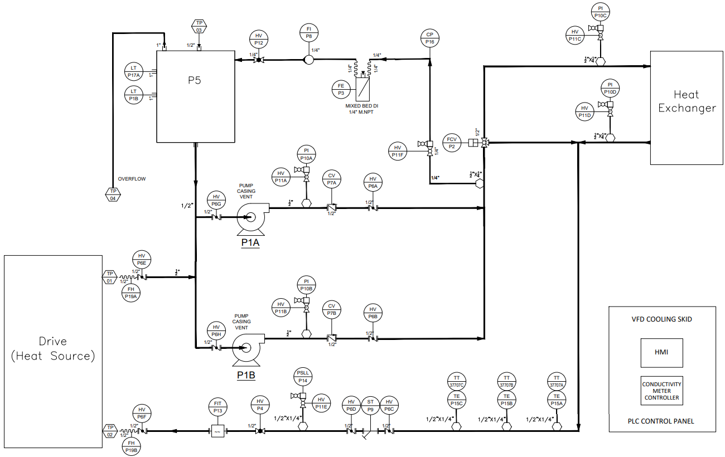
Figure 1: P&ID of DI Water Cooling Skid

Figure 1 is the P&ID for the DI Water Cooling Skid. Used DI water shall be expelled from the VFD/heat source. Additionally, excess DI water shall be stored in a Vessel (P5). P5 shall be monitored with the Vessel Level control system within the PLC. The used DI Water shall be mixed with the excess DI Water and pushed upstream. There, one of two pumps (P1A & P1B) shall act as a pressure source, and in tandem with one of the respective preceding manual butterfly valves (P6G or P6H) shall regulate flow of the DI Water flow throughout the entire system. Only one pump shall be active during operation, while the other pump shall serve as a backup. P1A shall be referred to as the “Primary Pump” and P1B shall be referred as the “Secondary Pump.” The actuation of these pumps shall be controlled by the hydraulic control system, programed within the PLC. From these pumps, the used DI Water shall travel upstream towards a junction point. There, approximately 15% of the flow shall be diverted midstream, in which a resin bed (P3) shall serve to maintain quality of the DI Water. A conductivity sensor (P8) shall monitor the quality of the DI Water, through the conductivity control system within the PLC. The filtered DI Water shall then be stored in P5 as excess DI Water. The remaining 85% DI Water at the junction point shall be fed into a 3-way electrically actuated valve(P2), actuated by the temperature control system. P2 shall divert some portions of the remaining DI Water through a heat exchanger, while allowing the rest of the DI water to bypass. Once the portion of DI Water has been passed through the heat exchanger, it shall remix with the portion of DI water that was bypassed and be pushed downstream towards the VFD/Heat Source Inlet. There three RTD temperature probes (P15A, P15B, P15C), shall monitor the temperature of the DI water, through the temperature control system, prior to entering the VFD/Heat Source. Additionally, a pressure switch (P14) and a flow indicator (P13), shall feed data into the hydraulic control system, and along with the calculated pump power of either the primary or secondary pump, shall determine the status of the system hydraulics. Downstream DI water shall be fed into the VFD/Heat Source for cooling purposes.

Control Philosophy
This DI cooling skid shall act as a model for the DI cooling skid responsible for cooling TMEIC’s Variable Frequency Drive (VFD). The four (4) primary control objectives of this skid is 1) to ensure that the VFD is supplied with coolant which does not surpass a temperature of 45°C, 2) that the coolant supplied to the VFD is uninterrupted, 3) that the coolant conductivity never surpasses 1 μS/cm at 25°C, and 4) that pumps installed within the system are not damaged. Additionally, it shall be assumed that ambient air temperature does not exceed 35°C.

Control System Framework
The control system shall be comprised of four main systems: the temperature control system, the hydraulic control system, the vessel level control, and the conductivity control. Temperature control shall observe the inlet coolant temperature and utilize the control valve to ensure that the coolant temperature remains below a given maximum threshold, using a multistage control scheme (see Section 3 for more details). The hydraulic control system shall observe cooling skid power, pressure, and flow, executing manual and automatic pump turnovers when applicable (see Section 4 for more details). The vessel level control system shall monitor excess coolant level to ensure adequate coolant level for pump safety, whilst monitoring level switch health (see Section 5 for more details). Finally, the conductivity control system shall monitor coolant conductivity, ensuring coolant conductivity remains below the maximum set level, while monitoring the health of the conductivity probe (see Section 6 for more details)

Nominal Operation

N-TST-1: Starup from Standby

Scenario Description & Expectation
Operator shall attempt to bring the skid from the standby state to the running state. No faults shall be present. This description represents a normal system startup.

Expected Behavior
Power shall be supplied to the PLC, and the PLC program shall be running. Upon engaging SW-1, the skid shall enter the diagnostics phase, followed by the initialization phase, and finally enter the running state. States shall be shown on the state indicator screen accordingly.

Test Execution

Test Results
Test to be completed

N-TST-2: Starup from Fault

Scenario Description & Expectation
Operator shall attempt to bring the skid from the fault state to the running state. The master fault signal shall be true; however, no actual faults shall exist. This description represents a startup after a system fault. Should the skid experience a system fault that is subsequently corrected, the operator will need to acknowledge the master fault alert and then attempt to start up the scenario. Assuming no additional faults are present, the skid should be able to start up from normal.

System Prerequisites
- Sufficient Power Shall be supplied to PLC
- SW-0 shall be set to run, both physically and digitally
- SW-1 Engaged and system set in Run Mode
- No changes from default mode of operation

Test Execution
- Force a fault on the system
- Allow system to fully shut down and enter fault state
- Clear Forced Fault
- Engage the Override Fault
- Engage System Start Button
- Observe System Status; Verify Diagnostics, Initialization, and Running

Test Results
Test to be completed.

N-TST-3: Universal System Digital Shutdown

Scenario Description & Expectation
The operator shall attempt to digitally shut down the system throughout the system operation. Upon the operator engaging SW-2, the system must immediately shut down, regardless of the current mode, phase, or state of operation.

System Prerequisites
- Sufficient Power Shall be supplied to PLC
- SW-0 shall be set to run, both physically and digitally

Test Execution
- Start system. once system enters diagnostics, engage shutdown button.
- Restart system. Once system enters initializtion phase, engage shutdown button.
- Restart system. Once system enters running state, engage shutdown button.
- Restart system. Engage manual valve control mode, and engage manual fan control mode, simplex mode. Once modes are engaged, shutdown system.
- Restart system. Engage automatic. pump cycling mode. Once engaged, shutdown system.

Test Results
Test to be completed.

N-TST-4: Manual Pump Switching

Scenario Description
The operator shall attempt to digitally shut down the system throughout the system operation. Upon the operator engaging SW-2, the system must immediately shut down, regardless of the current mode, phase, or state of operation.

System Prerequisites
- Sufficient Power Shall be supplied to PLC
- SW-0 shall be set to run, both physically and digitally

Test Execution
- Start system. once system enters diagnostics, engage shutdown button.
- Restart system. Once system enters initializtion phase, engage shutdown button.
- Restart system. Once system enters running state, engage shutdown button.
- Restart system. Engage manual valve control mode, and engage manual fan control mode, simplex mode. Once modes are engaged, shutdown system.
- Restart system. Engage automatic. pump cycling mode. Once engaged, shutdown system.

Test Results
Test to be completed.

Automatic Pump Cycling (APC) Mode
To extend the life of pumps, the cooling skid shall have a feature that automatically switches between pumps. This feature may be enabled by engaging SW-12. When engaged, the system shall automatically switch between pumps. (see Hydraulic Control System for More Information). The feature may be disabled anytime as by disengaging SW-12.

Default Mode of Operation
By default, the cooling skid shall have SW-3 disengaged, and the cooling skid shall be operated in duplex mode – in which the active pumps shall have a backup pump available for turnover. Additionally, by default, SW-5 and SW-6 shall be disengaged, thus allowing actuation of the control valve and heat exchanger fans to be handled automatically by the control system. Finally, by default, SW-12 shall be disengaged, disabling automatic pump cycling.
The mode of operation shall always be default upon resetting, rerunning, or power cycling the PLC.

System States
System states shall only describe what the PLC is doing in terms of control, actuation, and program execution. The necessary conditions, sequencing, and behind these states shall be described in section 2.2 – Sequences of Operation

System Offline
During the “System Offline” state the PLC shall not receive sufficient power. In this state, the control valve shall be in its fail-safe condition which is completely closed. If the cooling skid creates a non-inconsequential amount of flow while the PLC is off, the fail-safe condition will allow maximum conversion of total flow into bypass flow. Power to both primary and secondary pumps, along with the heat exchanger fans, shall be disengaged, as the PLC shall have no observation nor control over the skid. Additionally, all elements of system control shall remain disengaged.
Table 1 summarizes the system status during the offline state.
Table 1: System Status During Offline State
Item |  | Status
PLC Power |  | Disconnected
PLC Program |  | Stopped
User Inputs |  | Ignored
Control System |  | Rules of Engagement
Temperature |  | Disengaged
Hydraulics |  | Disengaged
Conductivity |  | Disengaged
Vessel Level |  | Disengaged
Instrument | Nominal Actuation Status |  | User Overridable Mode
Control Valve | 100% Open |  | N/A
Fan 1 | Disengaged |  | N/A
Fan 2 | Disengaged |  | N/A
Pump | Disengaged |  | None

System Stasis
During the “System Stasis” state, the PLC shall receive power, but the latest logic program shall not be executed. In other words, the PLC program shall be “stopped”, either by SW-0, or by the CODESYS program itself. Additionally, all user inputs shall be ignored, all pumps and fans shall remain disengaged, the control valve shall be in its failsafe condition. And all elements of control shall remain disengaged.
Table 2: System Status During Stasis State
Item |  | Status
PLC Power |  | Connected
PLC Program |  | Stopped
User Inputs |  | Ignored
Control System |  | Rules of Engagement
Temperature |  | Disengaged
Hydraulics |  | Disengaged
Conductivity |  | Disengaged
Vessel Level |  | Disengaged
Instrument | Nominal Actuation Status |  | User Overridable Mode
Control Valve | 100% Open |  | N/A
Fan 1 | Disengaged |  | N/A
Fan 2 | Disengaged |  | N/A
Pump | Disengaged |  | None

System Standby
During the “system standby” state, the PLC shall receive power and execute its latest code. User inputs shall be processed by the program. Pumps shall remain disengaged. The control valve shall remain in its failsafe condition, unless MCVA is engaged, and the heat exchanger fans shall remain disengaged unless MFC is engaged. Conductivity and vessel control shall be engaged; however, all other elements of control shall remain disengaged.
Table 3: System Status Standby State
Item |  | Status
PLC Power |  | Connected
PLC Program |  | Running
User Inputs |  | Processing
Control System |  | Rules of Engagement
Temperature |  | Disengaged
Hydraulics |  | Disengaged
Conductivity |  | Engaged
Vessel Level |  | Engaged
Instrument | Nominal Actuation Status |  | User Overridable Mode
Control Valve | 100% Open |  | MCVA Mode
Fan 1 | Disengaged |  | MFC Mode
Fan 2 | Disengaged |  | MFC Mode
Pump | Disengaged |  | None

System Running
During the “system runnning” state, the PLC shall receive power and execute the installed program. User inputs shall be processed by the PLC, and all control systems shall be engaged. The primary and secondary pumps and fans shall be dynamically actuated according to the mode of system operation, the response of the control systems, and/or operator input. Likewise, the control valve shall be dynamically actuated according to the mode of system operation (see section 2.3), the response of the control systems, and/or operator input.
Table 4: System Status Active State
Item |  | Status
PLC Power |  | Connected
PLC Program |  | Running
User Inputs |  | Processing
Control System |  | Rules of Engagement
Temperature |  | Disengaged
Hydraulics |  | Disengaged
Conductivity |  | Engaged
Vessel Level |  | Engaged
Instrument | Nominal Actuation Status |  | User Overridable Mode
Control Valve | Variable |  | MCVA Mode
Fan 1 | Variable |  | MFC Mode
Fan 2 | Variable |  | MFC Mode
Pump | Engaged |  | None

System Fault
During the “System Fault” state, the PLC shall receive power and execute the installed program. User input shall be processed by the PLC. All pumps and fans shall remain disengaged, the control valve shall remain in its fail-safe condition, and all elements of control shall be disengaged. Additionally, the master fault signal (FLT-9) shall be engaged.
Table 5: System Status During Fault State
Item |  | Status
PLC Power |  | Connected
PLC Program |  | Running
User Inputs |  | Processing
Control System |  | Rules of Engagement
Temperature |  | Disengaged
Hydraulics |  | Disengaged
Conductivity |  | Engaged
Vessel Level |  | Engaged
Instrument | Nominal Actuation Status |  | User Overridable Mode
Control Valve | 100% Open |  | MCVA Mode
Fan 1 | Disengaged |  | MFC Mode
Fan 2 | Disengaged |  | MFC Mode
Pump | Disengaged |  | None

System Sequences

System Cold Start Sequence
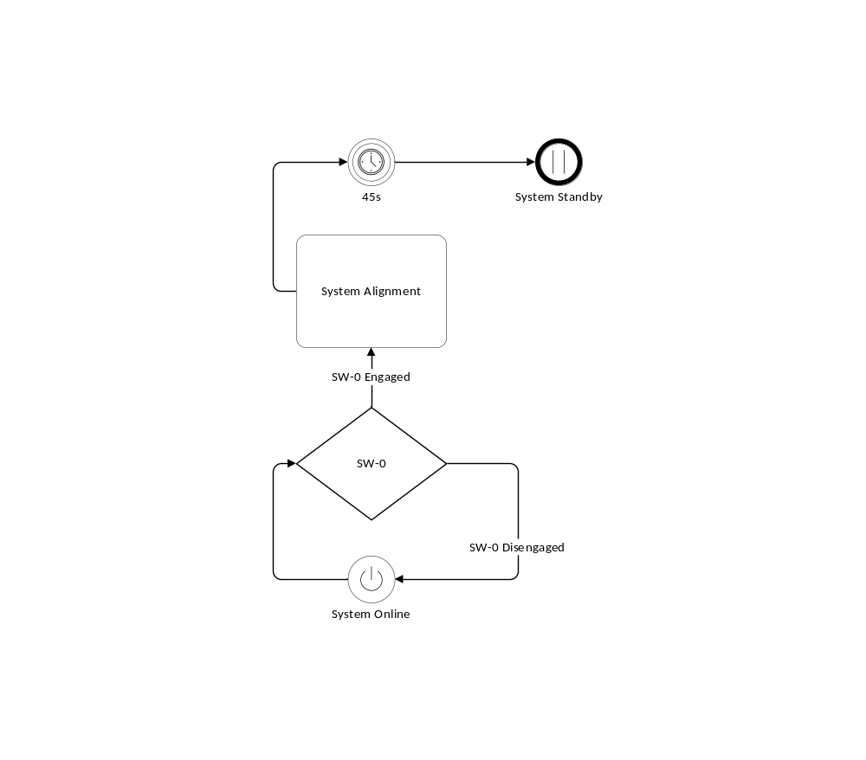
Figure 2: Flow-Diagram of System Cold Start Sequence
The “Cold Start Sequence” requires for the system to be within the Online state (that is power must be supplied to the PLC). At any point power is disconnected from the PLC, the PLC shall immediately fall into the Offline state. If the physical PLC run switch (SW-0) is not engaged, the PLC shall simply remain in the System Online state. Otherwise, if it is engaged, the PLC will enter the “system alignment” phase for ten (10) seconds, allowing the system to clear any residual active bits and noise from the memory. After ten (10) seconds, the system will arrive at the standby state.
Table 6: System Status During Alignment Phase; Cold Start Sequence
Item |  | Status
PLC Power |  | Connected
PLC Program |  | Running
User Inputs |  | Processing
Control System |  | Rules of Engagement
Temperature |  | Disengaged
Hydraulics |  | Disengaged
Conductivity |  | Disengaged
Vessel Level |  | Disengaged
Instrument | Nominal Actuation Status |  | User Overridable Mode
Control Valve | 100% Open |  | MCVA Mode
Fan 1 | Disengaged |  | MFC Mode
Fan 2 | Disengaged |  | MFC Mode
Pump | Disengaged |  | None

System Standby Startup Sequence
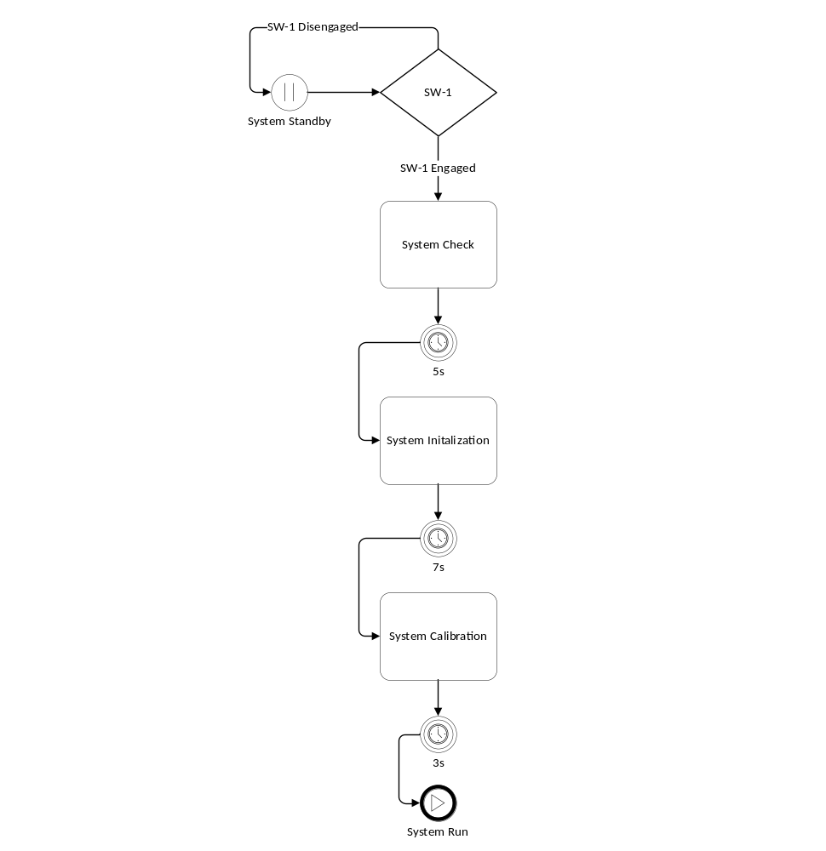
Figure 3: Flow Diagram of System Standby-Startup Sequence
To transition from a System Standby State to a System Run State, the system must go through the “System Standby-Startup.” The System Standby-Startup sequence is made of three phases: System Checking, System Initialization, and System Calibration. To initialize this sequence from the operator must engage system start switch (SW-1). If the operator fails to engage the system start switch (SW-1) while the system is in the standby state, the system will simply remain in the standby state. Otherwise, should the operator engage, SW-1 the sequence will begin.

System Check
The first phase of the sequence is referred to as: “System Check.” This phase will last for five (5) seconds before proceeding forward to the next phase. Five (5) seconds provides excess time for the system to perform one final check for any existing faults from the conductivity control system or the vessel level control system. This prevents the system from engaging with the pumps and fans (assuming disengaged MFC) and immediately having to shut down due to a fault. During this phase, pumps shall remain disengaged. The control valve shall remain in its failsafe position if MCVA is disengaged, and the fans shall remain disengaged if MFC is disengaged. Additionally, only the conductivity and vessel level control elements will remain active. After five (5) seconds has elapsed, the sequence will proceed into the second phase.
Table 7: System Status During Check Phase; Standby-Startup Sequence
Item |  | Status
PLC Power |  | Connected
PLC Program |  | Running
User Inputs |  | Processing
Control System |  | Rules of Engagement
Temperature |  | Disengaged
Hydraulics |  | Disengaged
Conductivity |  | Engaged
Vessel Level |  | Engaged
Instrument | Nominal Actuation Status |  | User Overridable Mode
Control Valve | 100% Open |  | MCVA Mode
Fan 1 | Disengaged |  | MFC Mode
Fan 2 | Disengaged |  | MFC Mode
Pump | Disengaged |  | None

System Initialization
The second phase of the sequence shall be referred to as “System Initialization” This phase shall last for seven (7) seconds before proceeding forward to the next phase. Seven (7) seconds provides enough time for the primary pump to be engaged and builds up enough head to provide adequate flow to the system. Additionally, the heat exchanger fans may be engaged if MFC is disengaged. The control valve shall continue to remain in its failsafe condition, unless MCVA is engaged. The temperature and hydraulic control elements remain disengaged. After seven (7) seconds has elapsed, the sequence will proceed into the third and final phase.
Table 8: System Status During Initialization Phase; Standby-Startup Sequence
Item |  | Status
PLC Power |  | Connected
PLC Program |  | Running
User Inputs |  | Processing
Control System |  | Rules Engagement
Temperature |  | Disengaged
Hydraulics |  | Disengaged
Conductivity |  | Engaged
Vessel Level |  | Engaged
Instrument | Nominal Actuation Status |  | User Overridable Mode
Control Valve | 100% Open |  | MCVA Mode
Fan 1 | Disengaged |  | MFC Mode
Fan 2 | Disengaged |  | MFC Mode
Pump | Engaged |  | None

System Calibration
The final phase of the sequence shall be referred to as “System Calibration.” This phase shall last for three (3) seconds before concluding the sequence. Three seconds provides enough time for the temperature controller to accumulate the control valve to the appropriate level During this phase; the hydraulic control system will be engaged. However, the temperature control system shall only be partially engaged. Fault signals controlled by the temperature control system shall be ignored, as to allow enough time for temperature to correct course. After three (3) seconds has elapsed, the sequence will conclude, and the system shall enter the active state.
Table 9: System Status During Calibration Phase; Standby-Startup Sequence
Item |  | Status
PLC Power |  | Connected
PLC Program |  | Running
User Inputs |  | Processing
Control System |  | Rules of Engagement
Temperature |  | Partially Engaged
Hydraulics |  | Engaged
Conductivity |  | Engaged
Vessel Level |  | Engaged
Instrument | Nominal Actuation Status |  | User Overridable Mode
Control Valve | Variable |  | MCVA Mode
Fan 1 | Engaged |  | MFC Mode
Fan 2 | Engaged |  | MFC Mode
Pump | Engaged |  | None

System Fault Startup Sequence
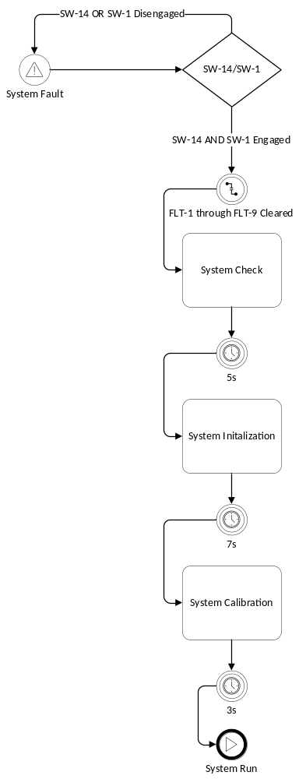
Figure 4: Flow Diagram of System Fault-Startup Sequence
The System Fault-Startup sequence is made of three phases: System Checking, System Initialization, and System Calibration. To initialize this sequence from the operator must engage system start switch (SW-1) and engage the fault acknowledge switch (SW-14). If the operator fails to engage both switches while the system is in the fault state, the system will simply remain in the fault state. Otherwise, should the operator engage both SW-1 and SW-14, the system should clear all faults signals (FLT-1 through FLT-9) and begin the sequence.

System Check
The first phase of the sequence is referred to as: “System Check.” This phase will last for five (5) seconds before proceeding forward to the next phase. Five (5) seconds provides excess time for the system to perform one final check for any existing faults from the conductivity control system or the vessel level control system. This prevents the system from engaging with the pumps and fans (assuming disengaged MFC) and immediately having to shut down due to a fault. During this phase, pumps shall remain disengaged. The control valve shall remain in its failsafe position if MCVA is disengaged, and the fans shall remain disengaged if MFC is disengaged. Additionally, only the conductivity and vessel level control elements will remain active. After five (5) seconds has elapsed, the sequence will proceed into the second phase
Table 10: System Status During Check Phase; Fault-Startup Sequence
Item |  | Status
PLC Power |  | Connected
PLC Program |  | Running
User Inputs |  | Total Processing
Control System |  | Rules of Engagement
Temperature |  | Disengaged
Hydraulics |  | Disengaged
Conductivity |  | Engaged
Vessel Level |  | Engaged
Instrument | Nominal Actuation Status |  | User Overridable Mode
Control Valve | 100% Open |  | MCVA Mode
Fan 1 | Disengaged |  | MFC Mode
Fan 2 | Disengaged |  | MFC Mode
Pump | Disengaged |  | None

System Initialization
The second phase of the sequence shall be referred to as “System Initialization” This phase shall last for seven (7) seconds before proceeding forward to the next phase. Seven (7) seconds provides enough time for the primary pump to be engaged and builds up enough head to provide adequate flow to the system. Additionally, the heat exchanger fans may be engaged if MFC is disengaged. The control valve shall continue to remain in its failsafe condition, unless MCVA is engaged. The temperature and hydraulic control elements remain disengaged. After seven (7) seconds has elapsed, the sequence will proceed into the third and final phase
Table 11: System Status During Initialization Phase; Fault-Startup Sequence
Item |  | Status
PLC Power |  | Active
PLC Program |  | Running
User Inputs |  | Total Processing
Control System |  | Rules Engagement
Temperature |  | Disengaged
Hydraulics |  | Disengaged
Conductivity |  | Engaged
Vessel Level |  | Engaged
Instrument | Nominal Actuation Status |  | User Overridable Mode
Control Valve | 100% Open |  | MCVA Mode
Fan 1 | Engaged |  | MFC Mode
Fan 2 | Engaged |  | MFC Mode
Pump | Engaged |  | None

System Calibration
The final phase of the sequence shall be referred to as “System Calibration.” This phase shall last for three (3) seconds before concluding the sequence. Three seconds provides enough time for the temperature controller to accumulate the control valve to the appropriate level During this phase; the hydraulic control system will be engaged. However, the temperature control system shall only be partially engaged. Fault signals controlled by the temperature control system shall be ignored, as to allow enough time for temperature to correct course. After three (3) seconds has elapsed, the sequence will conclude, and the system shall enter the active state.
Table 12: System Status During Calibration Phase; Fault-Startup Sequence
Item |  | Status
PLC Power |  | Connected
PLC Program |  | Running
User Inputs |  | Processing
Control System |  | Rules of Engagement
Temperature |  | Partially Engaged
Hydraulics |  | Engaged
Conductivity |  | Engaged
Vessel Level |  | Engaged
Instrument | Nominal Actuation Status |  | User Overridable Mode
Control Valve | Variable |  | MCVA Mode
Fan 1 | Engaged |  | MFC Mode
Fan 2 | Engaged |  | MFC Mode
Pump | Engaged |  | None

System Pulse Sequence
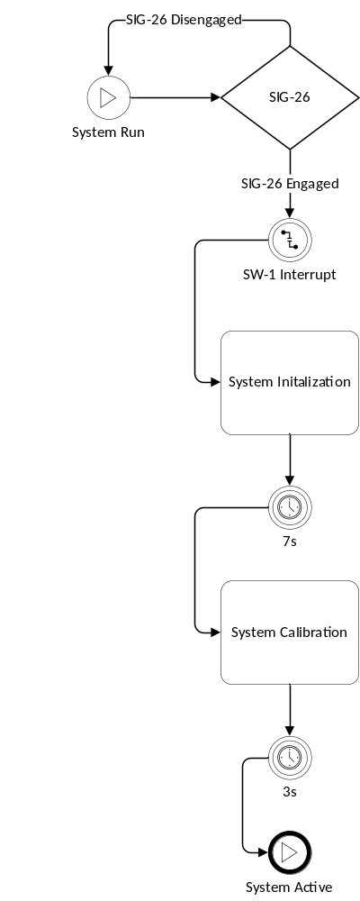
Figure 5: Flow Diagram of System Pulse Sequence
The “System Pulse” sequence when switching from the primary to secondary pump or switching from the secondary to primary pump. The system pulse allows the system to reinitialize and recalibrate to handle transients caused by switching between pumps. This sequence is made of two (2) phases: System Initialization and System Calibration. To initiate this sequence, the pulse switch (SW-26) must be engaged. This switch is engaged when a request to switch pumps, either manually, or automatically, is allowed. Upon SW-26 engaging, the system shall interrupt SW-1, forcing the system to reinitialize.

System Initialization
The first phase of the sequence shall be referred to as “System Initialization” This phase shall last for seven (7) seconds before proceeding forward to the next phase. The active pump Seven (7) seconds provides enough time for the transients caused by switching pumps to stabilize. The active pump at the time SW-26 is engaged, shall be disengaged, and the pump inactive at the time of SW-26 shall be engaged. Additionally, the heat exchanger fans may be engaged if MFC is disengaged. The control valve shall continue to remain in its failsafe condition, unless MCVA is engaged. The temperature and hydraulic control elements shall be disengaged. After seven (7) seconds have elapsed, the sequence will proceed into the second and final phase.
Table 13: System Status During Initialization Phase; Pulse Sequence
Item |  | Status
PLC Power |  | Connected
PLC Program |  | Running
User Inputs |  | Processing
Control System |  | Rules Engagement
Temperature |  | Disengaged
Hydraulics |  | Disengaged
Conductivity |  | Engaged
Vessel Level |  | Engaged
Instrument | Nominal Actuation Status |  | User Overridable Mode
Control Valve | 100% Open |  | MCVA Mode
Fan 1 | Engaged |  | MFC Mode
Fan 2 | Engaged |  | MFC Mode
Pump | Engaged |  | None

System Calibration
The final phase of the sequence shall be referred to as “System Calibration.” This phase shall last for three (3) seconds before concluding the sequence. Three seconds provides enough time for the temperature controller to accumulate the control valve to the appropriate level During this phase; the hydraulic control system will be engaged. However, the temperature control system shall only be partially engaged. Fault signals controlled by the temperature control system shall be ignored, as to allow enough time for temperature to correct course. After three (3) seconds has elapsed, the sequence will conclude, and the system shall enter the active state.
Table 14: System Status During Calibration Phase; Pulse Sequence
Item |  | Status
PLC Power |  | Connected
PLC Program |  | Running
User Inputs |  | Processing
Control System |  | Rules Engagement
Temperature |  | Partially Engaged
Hydraulics |  | Engaged
Conductivity |  | Engaged
Vessel Level |  | Engaged
Instrument | Nominal Actuation Status |  | User Overridable Mode
Control Valve | Variable |  | MCVA Mode
Fan 1 | Engaged |  | MFC Mode
Fan 2 | Engaged |  | MFC Mode
Pump | Engaged |  | None

System Shutdown Sequence
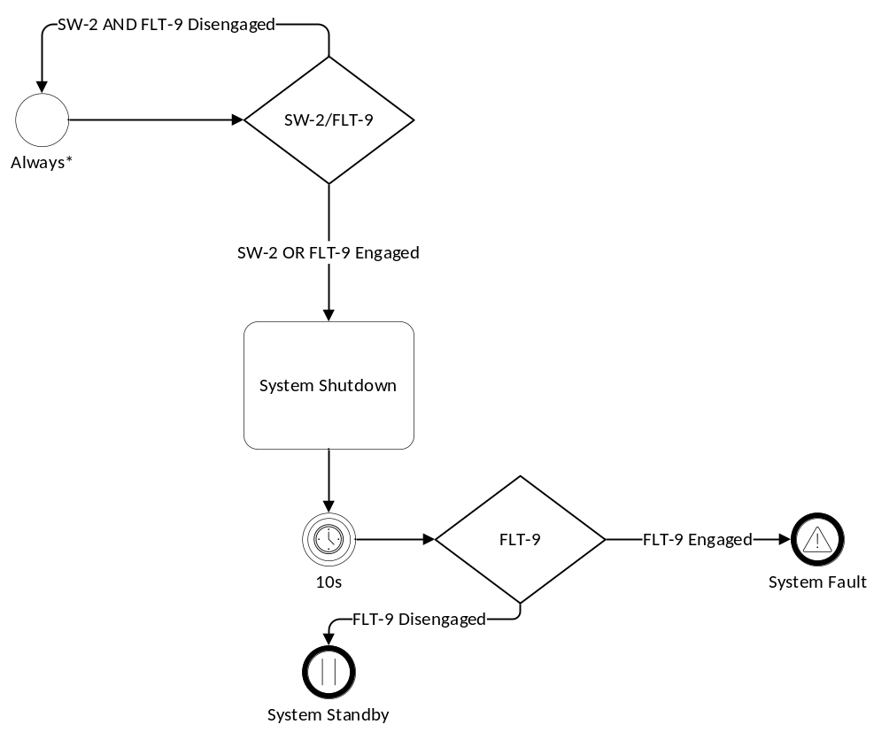
Figure 6: Flow Diagram of System Shutdown Sequence
The “System Shutdown Sequence” is a sequence that, apart from the system being in the offline or stasis states, will bring the system to a standby or fault state, regardless of the current state, sequence, or control procedure the program is. The sequence may be initiated at any point if SW-2 (system shutdown switch) or FLT-9 (master fault signal) is engaged. (Note: should the system be in the standby state, and SW-2 is engaged, the system will simply ignore the command. However, if FLT-9 is engaged while the system is in the standby state, the system will transition into the fault state). When SW-2 or FLT-9 is engaged, the sequence shall initiate its single System Shutdown Phase.
This shall last ten (10) seconds, allowing sufficient time for the pump to wind down during disengagement. During this phase, the system shall place the control valve in the fail-safe condition (unless MCVA is engaged) and shall engage the heat exchanger fans (unless MFC is engaged). During shutdown, the temperature and hydraulic control system shall be disengaged, although any existing fault trips shall remain active. The conductivity and vessel level control systems shall remain engaged. All pumps shall be disengaged. Once ten (10) seconds have elapsed, the system shall check the master fault signal (FLT-9). Should FLT-9 be engaged, the system will transition into a fault state. Otherwise, it shall transition into a standby state.
Table 15: System Status During Shutdown Phase
Item |  | Status
PLC Power |  | Connected
PLC Program |  | Running
User Inputs |  | Processing
Control System |  | Rules Engagement
Temperature |  | Disengaged
Hydraulics |  | Disengaged
Conductivity |  | Engaged
Vessel Level |  | Engaged
Instrument | Nominal Actuation Status |  | User Overridable Mode
Control Valve | 100% Open |  | MCVA Mode
Fan 1 | Engaged |  | MFC Mode
Fan 2 | Engaged |  | MFC Mode
Pump | Disengaged |  | None

Fault Management
FLT-9 is the master fault signal. Any fault signal (that is FLT-1 through FLT-8) shall activate the master fault signal. Only when all fault signals are set to false will the master fault signal be set to false as well. The initializing the system shutdown sequence shall Soley be determined by the status of the master fault signal.
Clearing all the faults, including the master fault signal, require the operator to engage the acknowledge fault switch (SW-14), while initializing the system by engaging the start switch (SW-1). Failure to engage both switches leave the fault signals engaged, and therefore leaving the system in the fault state.

Temperature Control System

Signal Processing
Inlet coolant temperature (SIG-6) shall be sampled prior to entering the heat source, and just after exiting the heat-exchanger loop. Three (3) RTD sensors (P15A, P15B, P15C) shall be used in determining the measured coolant temperature. RTD sensors shall communicate to the PLC using a 4-20 mA INT-valued signal (PHY-2, PHY-3, and PHY-4 respectively). Any RTD physical signal that exceeds 20.5 mA or falls below 3.5mA shall be considered a bad signal, and the affected RTD shall be considered as “non-functioning” and shall engage its respective alarm (that is ALM-14, ALM-15 or ALM-16). All INT-valued signals from the RTDs shall be converted into REAL-valued signals (that is SIG-10, SIG-11, and SIG-12 respectively). If three (3) of three (3) sensors are functioning, the median value of the REAL-valued RTD signals shall be considered as the measured coolant temperature (SIG-6). If two (2) or more of the REAL-valued RTD signals are the same, then that value shall be considered as SIG-6. If two (2) of three (3) sensors are functioning, the average value of the two (2) functioning REAL-valued RTD signals shall be considered as SIG-6. If less than two (2) of three (3) sensors are function, FLT-7 shall be engaged, and the last read measured coolant temperature shall be considered as SIG-6 for measurement continuity during system shutdown.
The measured coolant temperature shall be regulated by controlling flow entering the heat exchanger through the control valve. The valve open percentage shall be stored as a REAL-valued signal (SIG-9) within the PLC. SIG-9 will then be converted into a WORD-valued 4-20mA output signal (PHY-16), shall be fed to the physical control valve for control actuation.

Temperature Regulation
A multi-stage control scheme shall be implemented, in which the control shall be opened to convert 0%, 33.4%, 66.7%, or 100% of the total flow as throughput flow. It shall be assumed henceforth that throughput flow is directly proportional to the open percentage of the valve. (For example, a 33.4% open control valve shall correlate to 33.4% throughput flow) Additionally, the heat exchanger itself shall be fitted with two (2) pairs of fans to assist with convection cooling. These fans shall be controlled binarily through a digital 0-24V signal (PHY-12, PHY-13). When throughput flow is greater than 0%, both pairs of fans shall be activated, and when throughput flow is at 0%, both pairs of fans shall be deactivated.
Valve actuation shall be controlled by comparing the measured temperature with maximum threshold. The resulting comparison shall be referred to as the differential temperature (ΔT) and is the difference between the measured temperature and the maximum threshold.
The openness of the control valve shall be actuated in four (4) stages, including the ground stage. Each stage shall have a unique SP which increments the stage, and all stages shall share a SP, that resets the ground stage.
At ground stage, the control valve shall be 0% open, and the heat exchanger fans shall be disengaged. To advance from the ground stage to the first stage, the ΔT SP must be less than equal to 6°C.
At the first stage, the control valve shall be 33.4% open, and the heat exchanger fans shall be engaged. To advance from the first stage to the second stage the ΔT SP must be less than or equal to 4°C.
At the second stage, the control valve shall be 66.7% open, and the heat exchanger fans shall be engaged. To advance from the second stage to the third stage the ΔT SP must be less than or equal to 1°C.
At the third stage, the control valve shall be 100% open, and the heat exchanger fans shall be engaged.
The reset from any stage (that is going from the first, second, or third stage to the ground stage, the ΔT SP must be greater than or equal to 8°C.

Stages must increase incrementally (e.g. the controller cannot jump from stage 0 to stage 3 immediately, without going through stage 1 and stage 2), and stages can only be reset back to the ground stage (e.g. stage 3 cannot be decremented to stage 2)
Table 16: Actuation Schedule of the control valve, along with differential temperature setpoints, and ground setpoint.
Current Stage | Open % | Next Stage | ΔT SP | Reset ΔT SP
0 (Ground) | 0% | 1 | ≤ 6°C | ≥ 8°C
1 | 33.4% | 2 | ≤ 4°C | ≥ 8°C
2 | 66.7% | 3 | ≤ 1°C | ≥ 8°C
3 | 100% | - | - | ≥ 8°C

This staging method allows for multistage operation of the temperature controller without causing hysteresis.
Should the differential temperature reach or become less than 1°C and remain at that level for a duration of at least 10 seconds, a high coolant temperature alarm (ALM-1) be engaged. At any point where ALM-1 is engaged, should the measured coolant temperature fall below 1°C, ALM-1 shall be disengaged.
Should the differential temperature become equal to or less than 0°C but then rise above 1°C before 5 seconds has elapsed, ALM-1 shall remain disengaged.
Should the differential temperature reach or become less than 0°C, ALM-1 shall be engaged, and shall only be disengaged once the differential temperature rises above 1°C.
Should the differential temperature reach or become less than 0°C and remain at or less than 0°C for at least 5 seconds, the system shall engage the temperature fault (FLT-1), and the system shall shut down.
Should the differential temperature reach or become less than 0°C but then rise above 0°C before 5 seconds elapse, FLT-1 remain disengaged.
The time durations for both the engagement of the alarm and fault signals allow prevents accidentally alarm and fault triggers from noise, while also allowing for transients to be worked out within the cooling skid.

Manual Operation
The control valve may be manually actuated if MCVA mode is engaged. When MCVA mode is engaged, all automatic control shall be overridden by the operator, so long as the PLC is in run mode. When engaged, the operator may choose to change the openness percentage of the valve by inputting in a real value inclusively between 0 and 100 into the manual open valve signal (SIG-27). Any value below 0 shall be considered 0, and any value above 100 shall be 100. This signal shall then be converted into a WORD-valued 4-20mA output signal (PHY-16) and shall be fed to the physical control valve for control actuation.
Each fan pair may be manually controlled by the operator if MFC mode is engaged. When MFC mode is engaged, all automatic control of the fans shall be overridden by the operator, so long as the PLC is in run mode. When MFC mode is engaged, operator may engage or disengage the fans using switches SW-8 and SW-9 for fan 1 and 2 respectively. When MFC mode is engaged switches shall control the 0-24V BOOL-values physical signals (PHY-12 and PHY-13) to actuate the fans according to the operator’s commands.
Note, engaging in MFC or MCVA may cause damage to the VFD/heat source and should only be done in a controlled environment, for a limited time.

Hydraulic Control System

Signal Processing
System hydraulics shall be observed by three parameters: pump power, flow, and pressure. Pump voltage shall be communicated from the active pump (P1A/P1B) to the PLC through a 4-20mA WORD-valued signal. Specifically, the primary pump voltage shall be communicated through WORD-valued signal PHY-18 and the secondary pump current shall be communicated through WORD-valued signal PHY-20.
Additionally, the pump current shall be communicated from the active pump to the PLC through a 4-20mA WORD-valued signal. Specifically, the primary pump current shall be communicated through WORD-valued signal PHY-19 and the secondary pump current shall be communicated through WORD-valued signal PHY-21. Any pump signal that exceeds 20.5 mA or falls below 3.5 mA shall be considered a bad signal, engaging ALM-7 or ALM-8 (respective of the pump). The voltage and current WORD-valued signals of the primary pump shall be converted into a REAL-valued signal (SIG-32, and SIG-33 respectively). Additionally, the voltage and current WORD-valued signals of the secondary pump shall be converted into a REAL-valued signal (SIG-34, and SIG-35 respectively).
The voltage and current shall be multiplied together to calculate the power produced by the primary and secondary pump, and shall be stored as a REAL-value signal (SIG-13 and SIG-14, respectively)
Only the power of the active pump shall be considered as the measured pump power (SIG-5). Flow shall be sampled by an ultrasonic flowmeter (P13) and communicated to the PLC through a 4-20mA WORD-valued signal (PHY-1). A flow signal that exceeds 20.5 mA or falls below 3.5 mA shall be considered a bad signal, engaging alarm ALM-13. The WORD-valued flow signal shall be converted into a REAL-valued signal (SIG-8) System pressure shall be observed binarily as to be low or nominal. System pressure status shall be communicated to the PLC through a 0-24V signal (PHY-17). System pressure shall be passed through a hysteresis filter before being considered as the final pressure measurement (SIG-16 and SIG-22)
Primary and secondary pumps shall be engaged using a 0-24V signal from the PLC (PHY-14, PHY-15). One and only one pump may be active during the operation. A pump is considered active if it receives a 24V signal from the PLC.

Low Thresholds & Failure Classification
Values that fall approximately below 20% their nominal value shall be considered low. Pump power shall be classified binarily as either low or nominal. Nominal pump power should be approximately 100W. Pump power that reaches or drops below 80 Watts shall be classified as low. Pump power that exceeds 80 Watts shall be considered nominal. Flow shall be classified binarily as either low or nominal. Nominal flow should be approximately 6 GPM Flow that reaches or drops below 4.7 GPM shall be considered low. Flow that exceeds 4.7 GPM shall be considered nominal.
Additionally, should the active pump signal or the flow signal be considered bad, the pump power and/or the flow signal shall be automatically classified as low.
The state of the system’s hydraulics shall be binarily determined as either nominal or failed. Additionally, the system’s hydraulics shall be dependent on the pump driving it. That is, for a primary and secondary pump, the system shall have primary and secondary hydraulics. The system’s primary hydraulics are considered to have failed if and only if any two (2) of the three (3) hydraulic parameters are considered low, whilst the primary pump is active. A primary hydraulic failure shall enable ALM-9 The system’s secondary hydraulics are considered to have failed if and only if any two (2) of the three (3) hydraulic parameters are considered low, whilst the secondary pump is active. A secondary hydraulic failure shall enable alarm ALM-10 In the event of a primary or secondary hydraulic failure, the system will attempt an automatic pump turnover. During system initialization, a system’s hydraulics status shall be overridden as nominal.
The primary and secondary hydraulic failures may be only disabled by the operator by enabling the acknowledge hydraulic fault switches (SW-10 and SW-11 respectively)
Power, pressure and flow classifications shall be fitted with hysteresis control, such that a change in classification (that is, a change from nominal to low or from low to nominal), must meet the threshold requirements listed above for at least 500ms, allowing for noise or hysteresis to be filtered out.

Hydraulic Failure Pump Turnover
Should a hydraulic failure occur in connection with the active pump, the system shall attempt an automatic pump turnover. Should simplex mode be engaged in the event of an automatic pump turnover, the system will engage the duplex failure fault (FLT-6) and engage the shutdown sequence. Should simplex mode be disengaged, during the event of an automatic pump turnover, SW-26 shall engage, and the system shall engage a pulse sequence.

Lifecycle Pump Monitoring & Turnover
To maximize the lifespan of the primary and secondary pump, the cooling skid shall have an automatic lifecycle pump turnover feature (i.e. pump cycling). The primary and secondary pump differential usage shall be counted using hours (i.e. ticks in the program), by a DINT-valued differential pump signal (SIG-25) Primary pump usage shall increase SIG-25 by 1 for every hour in operation. Secondary pump usage shall decrease SIG-25 by 1 for every hour in operation. Should the pump differential signal reach 2147483646 or -2147483647 the EOTW fault (FLT-8) shall be engaged, and the system engage the shutdown sequence.
Assuming APC is disengaged: if SIG-25 reaches or surpasses 30 and the primary pump is active or SIG-25 reaches or becomes less than -30 and the secondary pump is active, the pump cycle alarm (ALM-17) shall be engaged. In all other cases, ALM-17 shall remain disengaged.
Assuming APC is engaged: if SIG-25 reaches or surpasses 30 and the primary pump is active or SIG-25 reaches or becomes less than -30 and the secondary pump is active, SIG-26 shall be engaged, and the system shall engage the pulse sequence.

Manual Operation
The operator may choose to engage a manual pump turnover at any point during skid operation, by engaging the manual turnover switch (SW-4) Should simplex mode be engaged when attempting to engage SW4, SW4 shall disengage with no additional action. If simplex mode is disengaged when attempting to engage SW-3, SW-4 shall disengage, SW-26 shall engage and the system shall engage the pulse sequence.

Vessel Level Control System

Signal Processing
The vessel storing excess coolant shall be fitted with two hall sensor switches to indicate low coolant level in the vessel (P17A) and critical low coolant level in the vessel (P17B). These hall sensors shall be engaged if the coolant level within the vessel falls below the level at which the respective sensors have been installed on the vessel. The hall sensors shall be disengaged when the coolant level within the vessel is at, or surpasses, the level at which the hall sensors have been installed at.
Both hall sensors shall be integrated with hysteresis control, such that the physical signals (PHY-10 and PHY-11 respectively), shall not engage the final output signals (SIG-20, SIG-21) until at least 500 milliseconds have elapsed, in order to filter out hysteresis and noise.

Level Monitoring
If SIG-20 is engaged, the Low Coolant Level in Vessel Alarm (ALM-2) shall be engaged. If both SIG-20 and SIG-21 are engaged, the critical vessel level fault (FLT-2) shall be engaged, and the system shall engage the shutdown sequence.

Redundancy Control
Should SIG-21 be engaged, but SIG-20 remain disengaged, the Level Sensor Malfunction fault (FLT-4) shall engage, and the system shall engage the shutdown sequence.

Conductivity Control System

Signal Processing
The conductivity sensor shall communicate to the PLC using a 4-20mA WORD-valued signal (PHY-7). The WORD-valued signal shall be converted into a REAL-valued signal (SIG-7). Additionally, the conductivity sensor shall communicate integrated alarm and fault trips by communicating to the PLC through 0-24V BOOL-valued signal (PHY-8, PHY-9). The alarm and fault trip signals shall require 500ms of stability before engaging the filtered alarm and fault signals (SIG-23, SIG-24), in order to filter out hysteresis and noise.
In addition to the alarm and fault trips in the conductivity sensor, the REAL-valued signal shall also be observed for the same alarm and fault conditions. The REAL-valued signal shall be passed through a hysteresis filter, requiring 500 ms of stability before its value is classified as an alarm or fault condition.

Conductivity Monitoring
Should the conductivity sensor alarm trip, and the REAL-valued signals observe a conductivity at or greater than 0.9 μS/cm at 25°C, the conductivity alarm (ALM-3) shall be engaged. Should the conductivity sensor alarm trip, and the conductivity sensor fault trip, and the REAL-valued signal observe a conductivity greater than 1 μS/cm at 25°C, the critical conductivity fault (FLT-3) be engaged, and the system shall engage the shutdown sequence.

Redundancy Control
Should the conductivity sensor fault trip engage while the conductivity sensor alarm trip remains disengaged, the conductivity sensor malfunction fault (FLT-5) shall be engaged.
Should the conductivity sensor alarm trip engage, but SIG-7 fails to observe a conductivity at or greater than 0.9 μS/cm at 25°C after an elapsed time of 2 seconds, FLT-5 shall be engaged. Should SIG-7 observe a conductivity at or greater than 0.9 μS/cm at 25°C, but the conductivity alarm trip fails to engage after an elapsed time of 2 seconds, FLT-5 shall be engaged. Should both the conductivity sensor alarm trip engage, and the conductivity sensor fault trip engage, but the SIG-7 fails to register a conductivity greater than 1 μS/cm at 25°C after an elapsed time of 2 seconds, FLT-5 shall be engaged. Should the conductivity fault trip fail to engage, regardless of whether the conductivity sensor trip alarm is, or is not engaged, while SIG-7 registers a conductivity greater than 1 μS/cm at 25°C after an elapsed time of 2 seconds, FLT-5 shall be engaged.
2 seconds provides excess time such that both the analog and digital sensors of the conductivity probe may align without creating a false trip.

