Infosys Springboard Virtual Internship 6.0 Completion Report

Team Details
Batch C
Start date 12-OCT2025
Names:
S.no | Name
1 | Muhammad Rashad Hashim
2 | Girija Geddavalasa
3 | Oviya K P
4 | Meesala Dhanush

Internship Duration: 8 Weeks

- Project Title

Air Volume-Controlling Volume with Hand Gestures Using a MediaPipe

- Project Objective

  - To develop a touch-free volume control system that utilizes computer vision to translate human hand gestures into system-level audio commands.
  - To implement real-time hand landmark detection using the MediaPipe framework to accurately track finger positions and geometric relationships from a standard webcam feed.
  - To engineer a mathematical mapping algorithm that converts gesture measurements, such as the angular distance between finger joints, into precise and dynamic volume levels.
  - To design an interactive Control Center dashboard that provides users with live visual feedback, including gesture angles, current volume percentages, and system status logs.
  - To enhance user experience through signal smoothing and noise reduction techniques, ensuring fluid volume transitions and preventing accidental adjustments.
  - To support multi-application audio management by allowing users to toggle control between master system volume and specific targeted applications like Chrome or Discord.

- Project description in detail

The AIR Gesture Control Center is a computer vision-based platform designed for touch-free audio management. Built with OpenCV, MediaPipe, and PyCaw, the system translates hand landmarks into precise system-level volume commands. By calculating geometric relationships, such as finger angles, it eliminates the need for physical contact, providing a futuristic and accessible human-computer interface.
The platform features a high-fidelity Kivy dashboard that supports real-time monitoring and multi-application control. Key features include:

- Real-time Gesture Tracking: Uses MediaPipe to detect 21 hand landmarks and map joint angles to a 0–100% volume scale.
- Dual-Zone Control: Implements a partitioned logic system where the left hand toggles system locks and the right hand adjusts audio.
- Windows Audio Integration: Interfaces directly with the Windows Core Audio API for master volume and mute state modulation.
- Application-Specific Targeting: Allows users to select and control individual volume levels for apps like Chrome, Discord, or Spotify.
- Interactive UI/UX: Provides a "Neon" themed HUD with live FPS tracking, gesture angle visualization, and automated system logs.

4. Timeline Overview

Week | Activities Planned | Activities Completed
Week 1 | Project understanding, requirement analysis and tool research. | Finalized project scope and studied MediaPipe and OpenCV.
Week 2 | Webcam integration and hand detection | Implemented real-time hand landmark detection.
Week 3 | Gesture logic development. | Calculated vector angles between finger joints to determine hand states.
Week 4 | Volume mapping and audio control | Integrated PyCaw and COM objects for system-level audio modulation.
Week 5 | GUI design | Developed Kivy-based Neon HUD with real-time data binding.
Week 6 | System integration | Connected gesture pipeline with application-specific audio control.
Week 7 | Testing and optimization | Improved stability using linear interpolation for gesture smoothing.
Week 8 | Documentation and presentation | Prepared final report and technical demonstration.

5. Project execution details

The Project is an advanced human-computer interaction platform that leverages computer vision to provide touch-free control over a computer's audio environment. The project's execution is built upon a modular, pipeline-based architecture that cleanly separates high-speed image processing from system-level audio modulation. At the start of the pipeline, OpenCV manages the hardware interface with the webcam, capturing video frames and performing necessary colour space conversions from BGR to RGB to ensure compatibility with the AI detection engine. These frames are processed in real-time to maintain a high frame rate, ensuring the user experience remains responsive and fluid.

Central to the vision processing layer is the MediaPipe Hands framework, which identifies and tracks 21 distinct 3D hand landmarks, including fingertips and joint coordinates. The application interprets these coordinates through geometric analysis, specifically calculating the vector-based angles between landmarks—such as the relationship between the thumb and index finger—to translate physical movement into digital commands. This data is then passed through a mapping algorithm that utilizes Linear Interpolation to convert raw angular measurements into a proportional 0–100% volume scale. To eliminate the jitter inherent in sensor data, the code implements a smoothing function that ensures volume transitions are gradual and natural.

The audio execution layer utilizes PyCaw to interface with the Windows Core Audio API (WASAPI), allowing the software to bypass physical hardware controls and modify system endpoints directly. Because these operations rely on Windows COM interfaces which have strict threading requirements, the system is designed to handle COM initialization and uninitialization carefully within the application lifecycle to prevent instability. This deep integration allows the user to not only control the master system volume but also to target specific application sessions, such as Discord or Chrome, enabling granular control over different audio streams.

Finally, the entire system is wrapped in a high-fidelity Kivy-based Graphical User Interface, styled as a "Neon" control center. This UI acts as a real-time heads-up display (HUD), providing visual confirmation of hand landmarks, current gesture angles, and gain levels. A unique safety feature of the execution is the Dual-Zone logic, which partitions the camera view; the left hand is dedicated to a "Lock/Unlock" state machine—triggered by thumb orientation—while the right hand is reserved for active volume modulation. This comprehensive architecture ensures that the Project remains a stable, secure, and highly intuitive tool for modern touch-free interaction.

- Snapshots / Screenshots

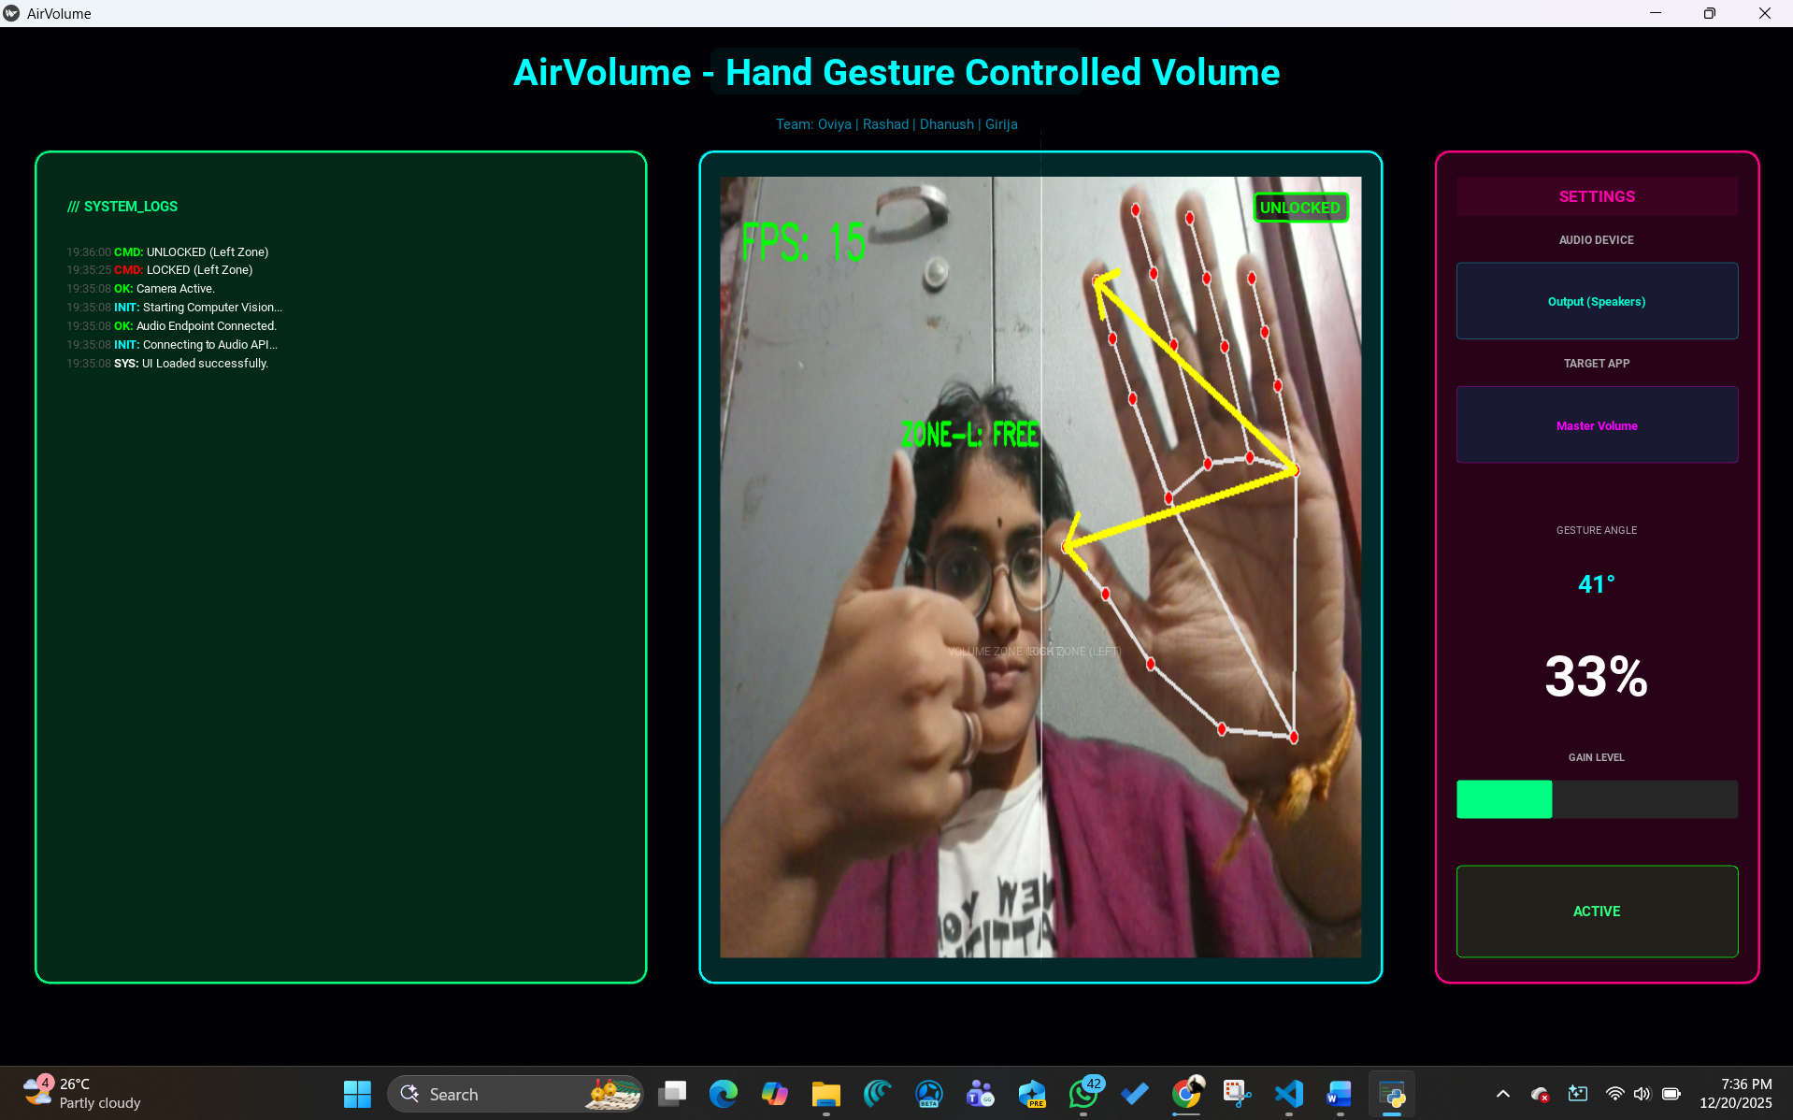

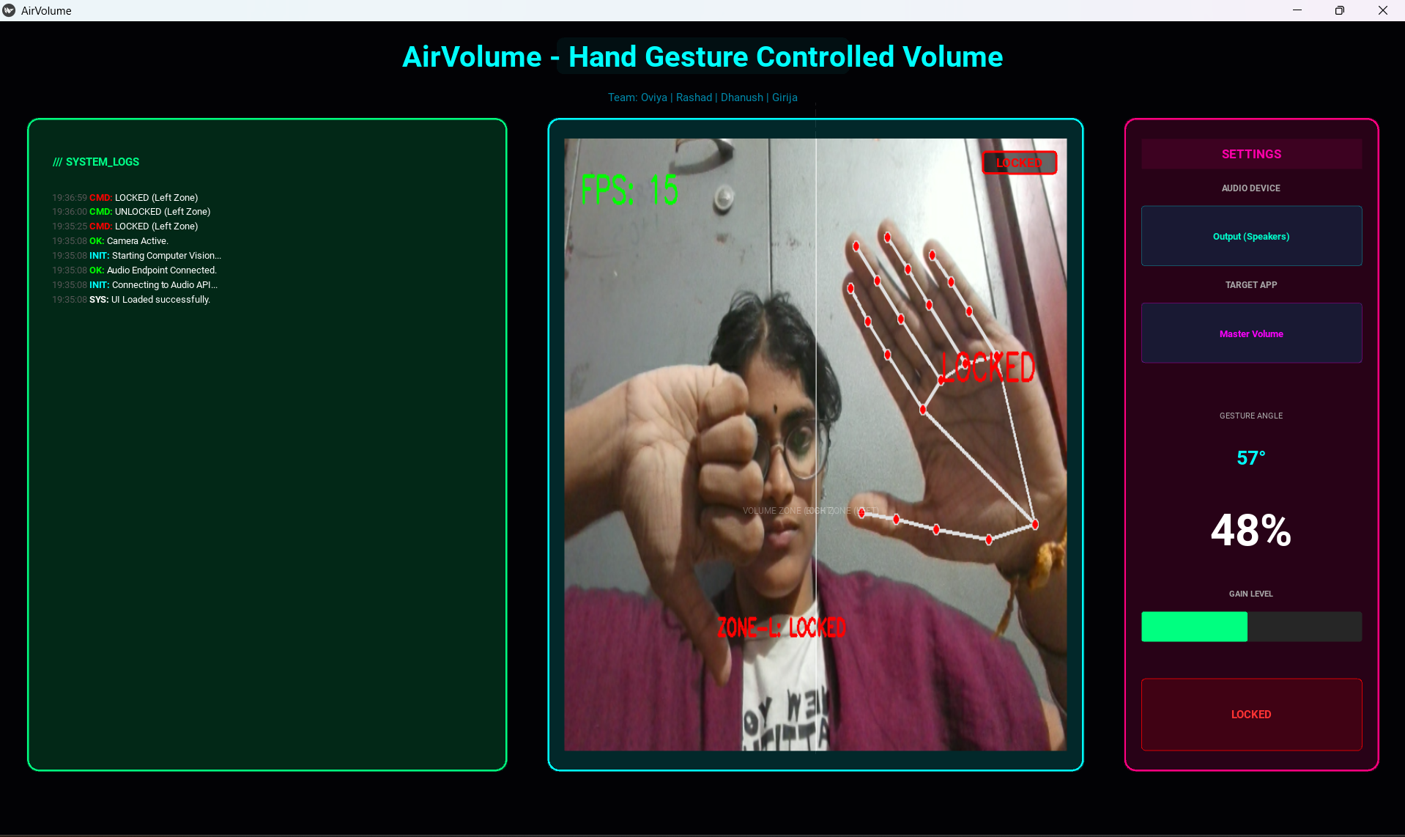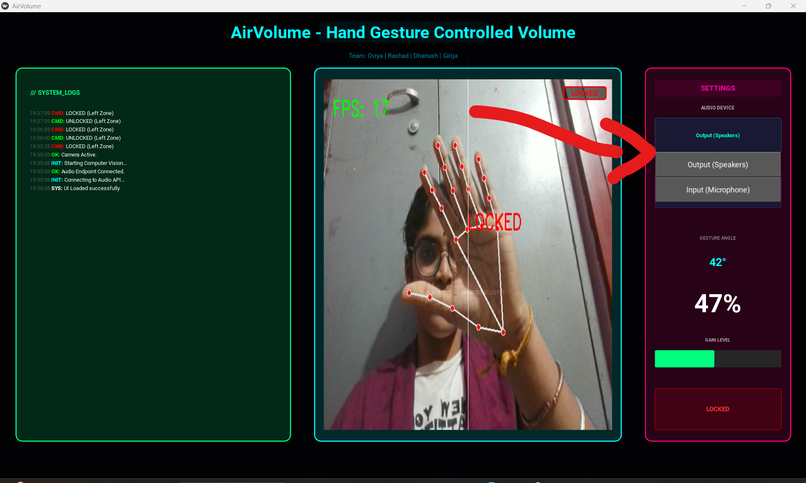

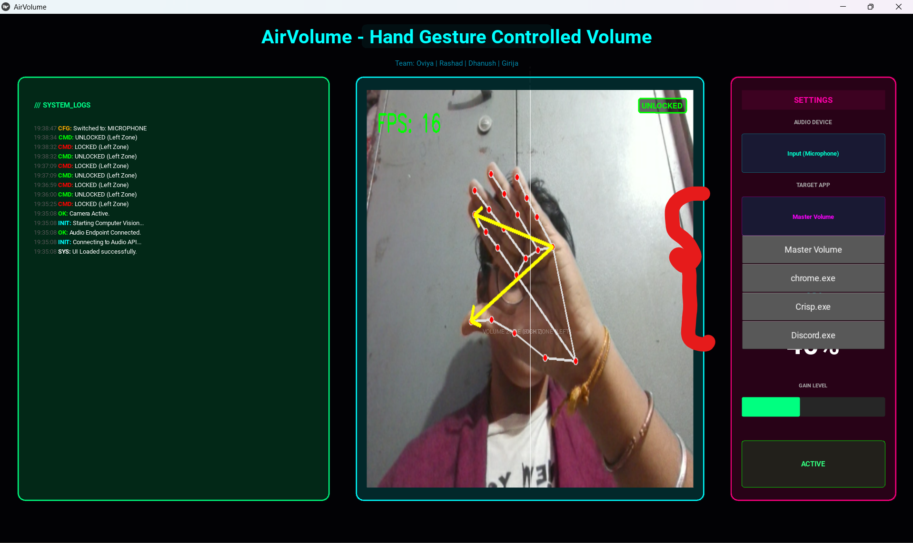

- Challenges Face
During the development of the Project, multiple challenges were encountered while integrating real-time computer vision, Windows audio APIs, and graphical user interfaces. Key challenges and their resolutions are summarized below:
- Unstable Hand Landmark Detection:
MediaPipe Hands occasionally lost hand tracking in low-light conditions or when the hand moved too close to the camera edges, resulting in inconsistent gesture recognition. This issue was resolved by fine-tuning the min_detection_confidence and min_tracking_confidence parameters, improving ambient lighting during testing, and applying a linear interpolation smoothing logic to the landmark measurements to significantly improve detection stability.
- Inconsistent Gesture-to-Volume Mapping:
Directly using raw angular distances between joints caused sudden volume jumps due to perspective variation and frame-to-frame sensor noise. This was addressed by normalizing the raw data using a dedicated mapping function. By establishing a fixed range for "closed" and "open" gestures and mapping them to a controlled 0–100% volume scale, the system achieved smooth and predictable audio transitions.

- PyCaw and COM Threading Instability:
The PyCaw library interfaces with the Windows Core Audio API through COM, which enforces strict threading and initialization rules. When audio adjustment commands were executed directly within the main GUI thread, it resulted in COM initialization errors, application crashes, and laggy volume response. To resolve this, a modular architecture was introduced where the audio interface operations were carefully managed, ensuring that COM was initialized correctly once per session and that audio commands did not block the real-time vision loop.
- GUI Framework Performance (Kivy vs. Streamlit):
Initial consideration of browser-based frameworks like Streamlit revealed limitations for real-time gesture applications, such as high latency and restricted control over low-level system loops. To ensure a high-performance experience, Kivy was chosen as the primary framework. Kivy provided a native desktop event loop, low-latency rendering of the camera feed, and precise thread coordination, allowing for a seamless integration of the OpenCV vision pipeline and the user interface.

- Learnings & Skills Acquired

The Air Volume Control project offered strong exposure to real-time computer vision, human-computer interaction (HCI), audio engineering, and GUI development. Key learnings include:
- Computer Vision & Hand Tracking: Gained proficiency in using MediaPipe and OpenCV to detect multi-hand landmarks and track coordinates in a real-time video stream.
- Mathematical Modeling (Geometry): Learned to apply Vector Calculus (Dot Products and Norms) to calculate the angular relationship between finger joints for precise gesture mapping.
- Windows Audio API Integration: Developed skills in interfacing with the PyCaw library and COM objects to control system-level master volume and specific application audio sessions.
- Kivy GUI Development: Designed an interactive, Neon-themed dashboard using Kivy and KV Language, incorporating dynamic data binding for real-time FPS and volume metrics.
- Signal Processing & Smoothing: Implemented Linear Interpolation (interp) and smoothing algorithms to convert raw sensor data into fluid, non-jittery volume adjustments.
- State Machine Logic: Engineered a Zone-based locking system, allowing the software to toggle between "Active" and "Locked" states based on specific hand orientations (Thumbs Up/Down)

- Testimonials from team

The Air Volume Control project served as a comprehensive learning platform for the interns. The team demonstrated high technical agility by mastering complex libraries like Mediapipe and PyCaw within a short timeframe. Their commitment was evident in their regular attendance at virtual development syncs and their ability to balance rigorous academic schedules with project milestones. Their consistency in debugging low-level Windows API integrations and refining the UI's user experience showed exceptional professional dedication.

- Conclusion

Overall, the AI Gesture Control Center internship project provided an advanced learning pathway, strengthening capabilities in computer vision, human-computer interaction (HCI), and system-level software engineering. The team gained hands-on experience in real-time landmark processing, mathematical gesture modeling, dashboard architecture, and cross-platform testing. This project has significantly contributed to building technical confidence and shaping a strong foundation for future career growth in AI-driven applications and Computer Vision.

- Acknowledgements

I am truly grateful for your continuous support and mentorship throughout this project. Your guidance, patience, and expertise have played a major role in shaping my technical and professional growth. Thank you for always encouraging us and helping us succeed.

