 

# Placement Empowerment Program

***Cloud Computing and DevOps Centre***

### Use Cloud Storage

*Create a storage bucket on your cloud platform and upload/download files. Configure access permissions for the bucket.*

Name: Oviya G Department : IT



# Introduction and Overview

To create a storage bucket on a cloud platform, navigate to your cloud console, select the storage service, and follow prompts to create a new bucket with a unique name, region, and storage class. To upload files, access the bucket and use the 'upload' button; to download files, select them and click 'download.' For access permissions, go to the permissions tab, add users or groups, assign roles, and fine-tune with IAM policies if needed.

# Objective

To create a storage bucket on a cloud platform, go to your cloud console, select the storage service, and create a new bucket with a unique name, region, and storage class. Upload files by navigating to the bucket and using the 'upload' button. Download files by selecting them and clicking 'download.' Configure access permissions in the permissions tab by adding users or groups, assigning roles, and adjusting IAM policies as needed.

# Importance of Storage Bucket(S3)

Storage buckets, like Amazon S3 (Simple Storage Service), are vital for several reasons:

1. **Scalability**: They can handle any amount of data, scaling up or down as needed.
2. **Durability**: They offer high durability, ensuring your data is safe and available even in case of hardware failures.
3. **Cost-Effectiveness**: You only pay for what you use, making it a budget- friendly option for data storage.
4. **Accessibility**: Data stored in S3 can be accessed from anywhere in the world, making it highly convenient for remote access and collaboration.
5. **Security**: You can configure advanced security settings, including encryption and fine-grained access controls, to protect your data.
6. **Integration**: It integrates seamlessly with other cloud services, enhancing functionality and workflow efficiency.

Storage buckets like S3 are a cornerstone for modern data storage solutions, offering a combination of flexibility, reliability, and security.

# Step-by-Step Overview

## Step1:

Go to the AWS Management Console, Search for S3.

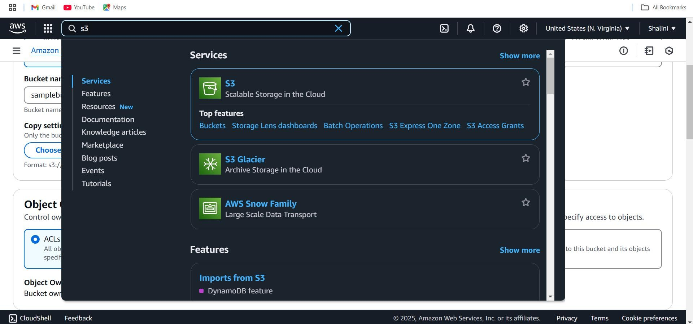

## Step 2 :

Click the "Create bucket" and enter a unique bucket name.

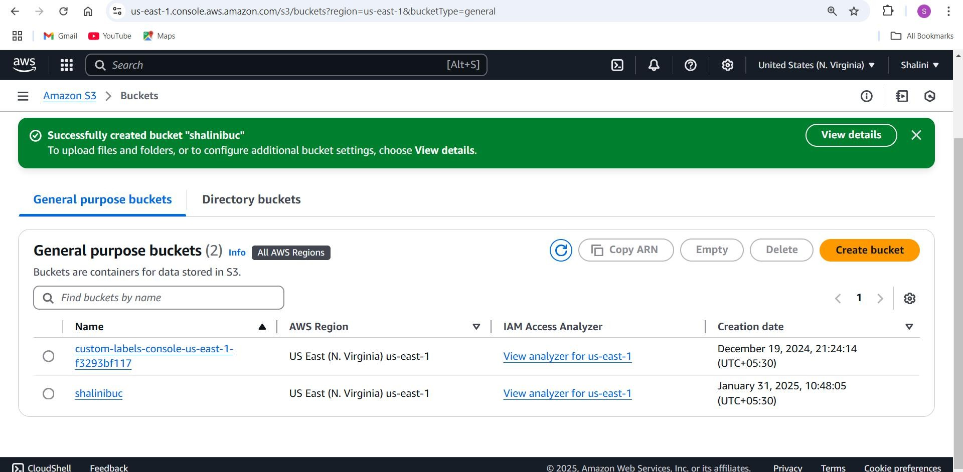

## Step 3 :

Open the created bucket and upload any file into it.

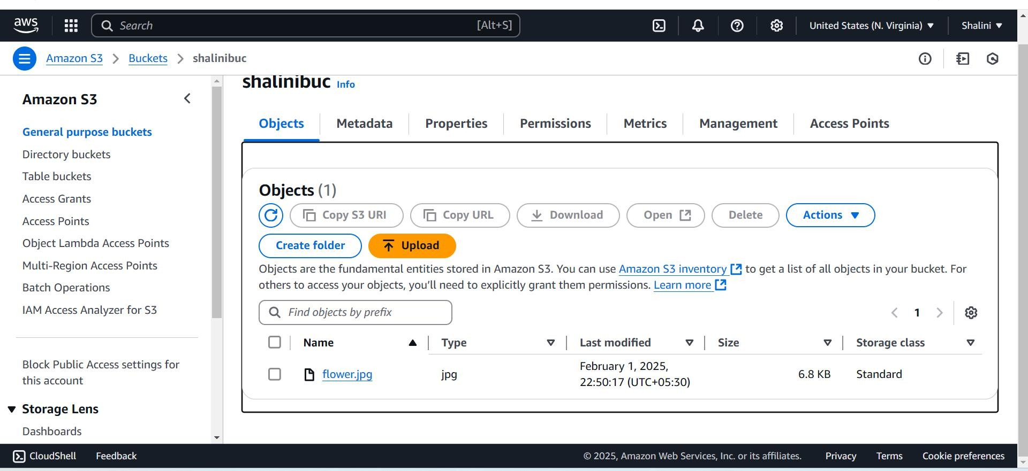

## Step 4 :

After adding file click upload to complete.

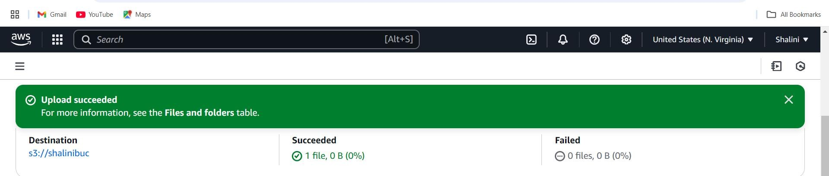

## Step 5 :

Go to the uploaded file in your bucket. Click the file name to open its details. Select Download to save the file locally.

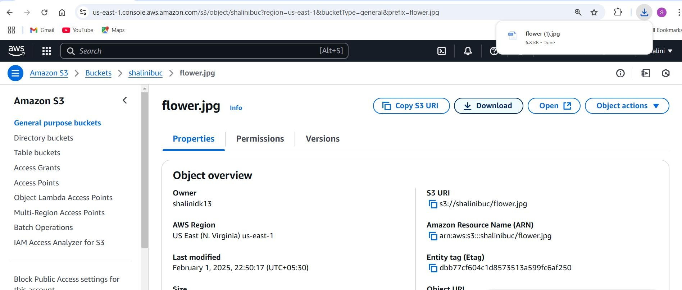

## Step 6:

Open your bucket and navigate to the "Permissions" tab.

Under Block public access, click Edit and uncheck "Block all public access". Confirm by typing "confirm" and save.

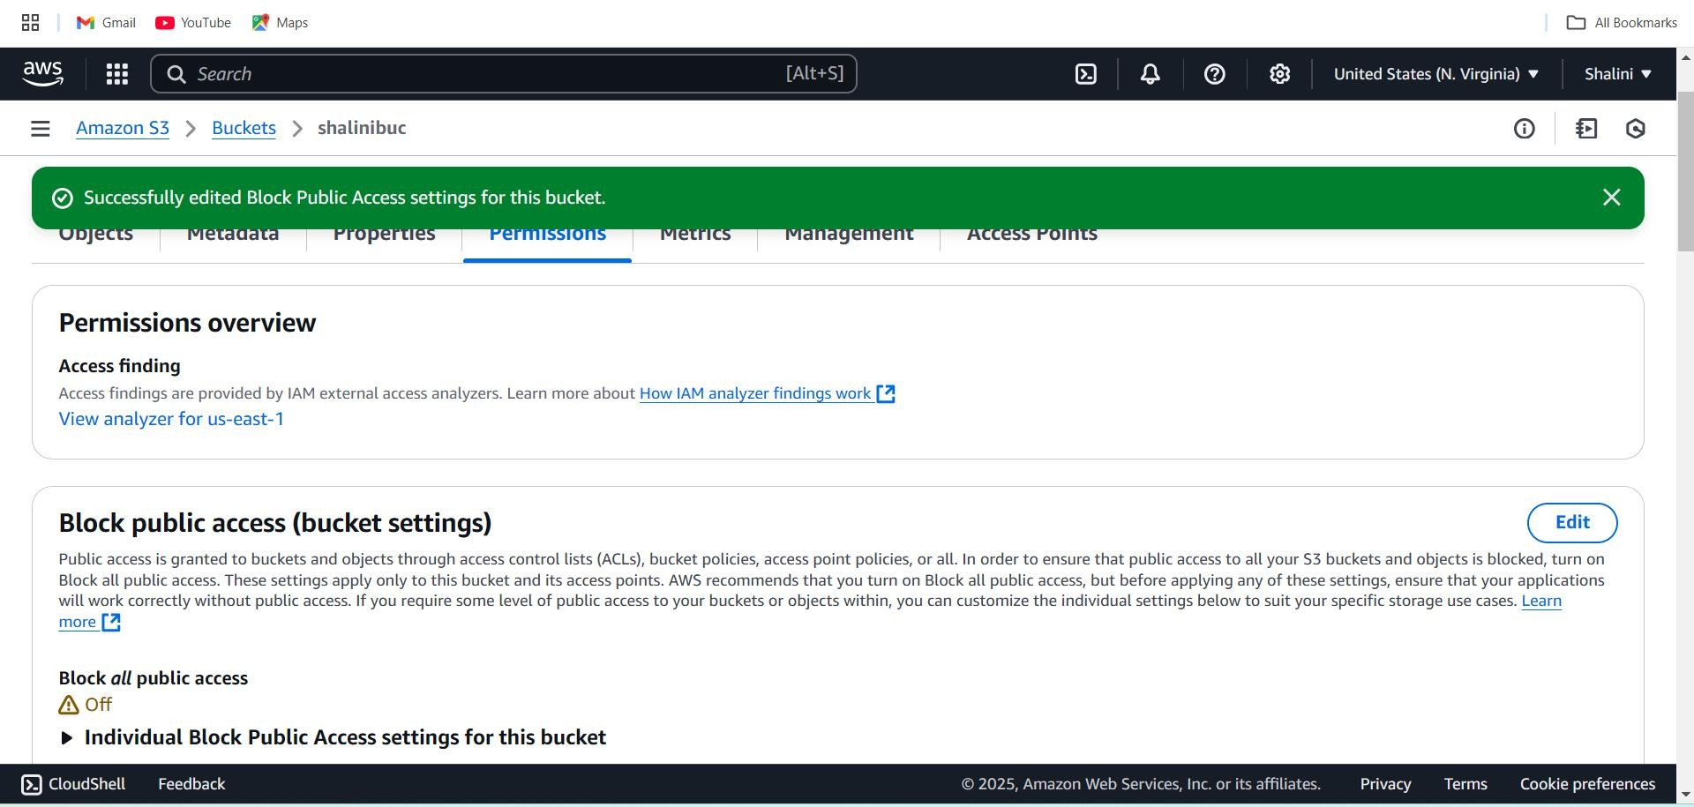

## Step 7 :

In the "Permissions" tab, scroll to Bucket Policy and click Edit.Replace your- bucket-name with your actual bucket name.Save changes.

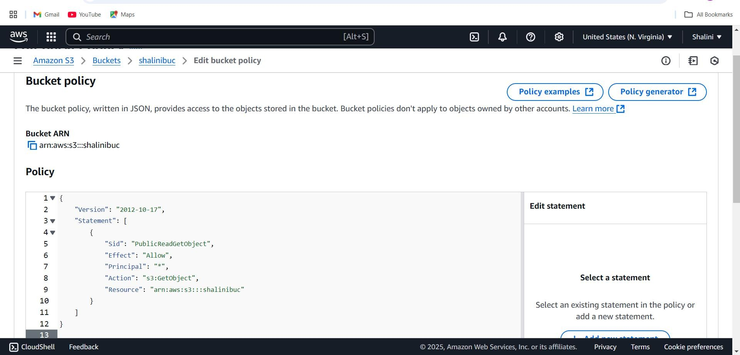

## Step8:

Use the S3 bucket URL or public file URL to test access permissions.

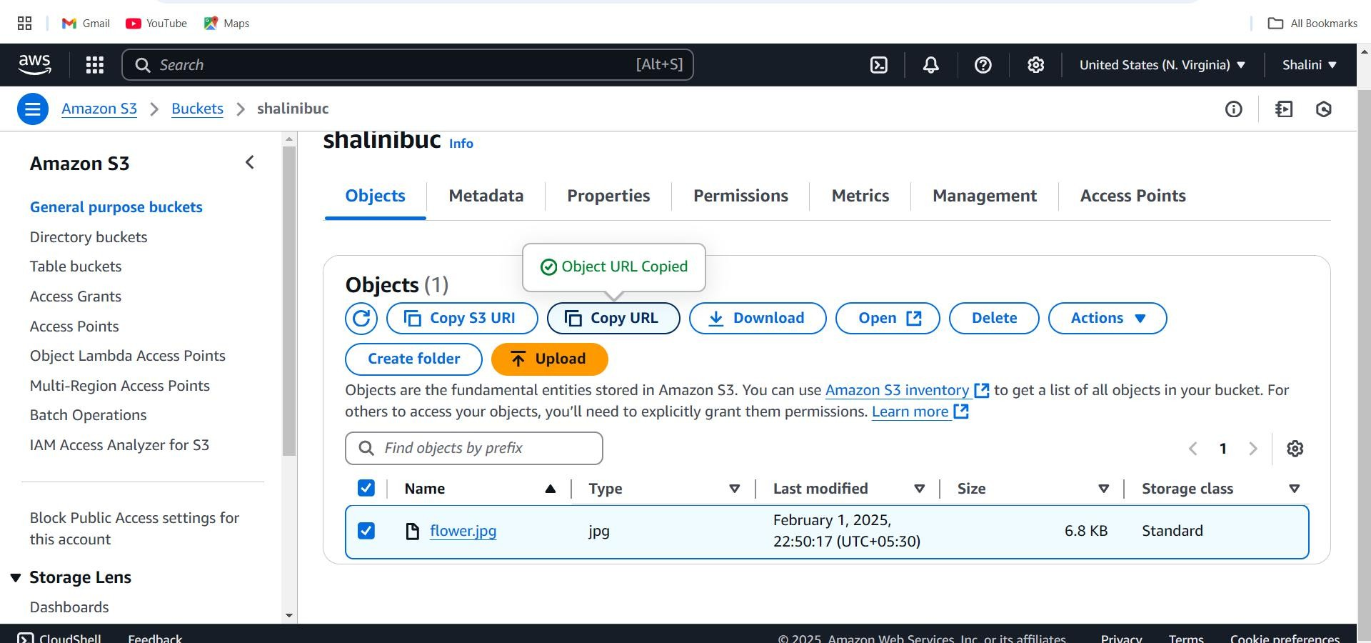

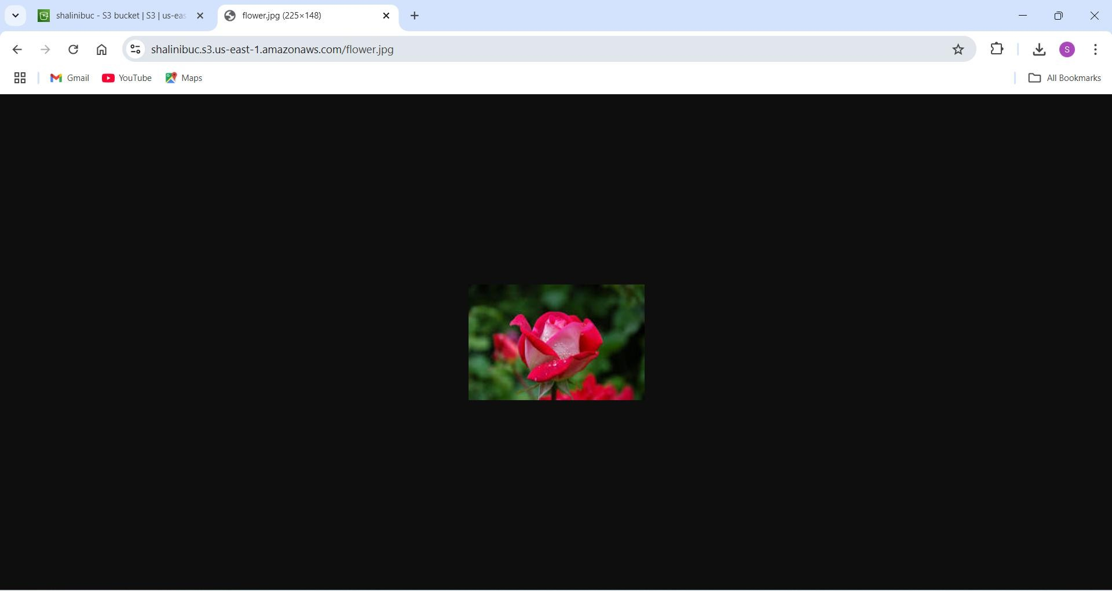

### Expected Outcome:

When utilizing storage buckets like Amazon S3, you can expect the following outcomes: **Efficient Data Storage**: Seamless storage of large amounts of data with easy scalability. **Enhanced Data Durability**: High reliability, ensuring your data is safe and backed up. **Cost Savings**: Reduced storage costs due to pay-as-you-go pricing models.

**Improved Accessibility**: Data can be accessed globally, fostering better collaboration and remote work.

**Tightened Security**: Advanced security features to protect your data from unauthorized access.

**Seamless Integration**: Smooth integration with other cloud services to enhance your workflows and applications.

These outcomes make S3 a powerful tool for modern data storage and management.