 

# Placement Empowerment Program

***Cloud Computing and DevOps Centre***

Use Cloud CLI ToolsInstall the CLI for your cloud provider (e.g., AWS CLI).

Use it to list resources, upload files to storage, and manage VMs.

Name: Oviya.G Department : IT



# Introduction and Overview

Using CLI tools for cloud providers like AWS, Azure, or Google Cloud can greatly simplify managing your cloud resources. These tools allow you to interact with your cloud infrastructure directly from your terminal or command prompt, enabling you to automate and streamline many tasks.

# Objective

Cloud CLI tools are designed to help you interact with and manage your cloud resources efficiently from your command line. They offer a wide range of functionalities, such as listing resources, uploading files to storage, and managing virtual machines.

# Importance

**Efficiency:** Automate repetitive tasks and save time.

**Flexibility:** Manage resources from any machine with CLI access.

**Scalability:** Easily script and scale operations to handle large cloud infrastructures.

**Control:** Fine-grained control over your cloud resources without needing navigate through graphical interfaces.

# Step-by-Step Overview

## Step1:

Search for "AWS CLI Installer for Windows"

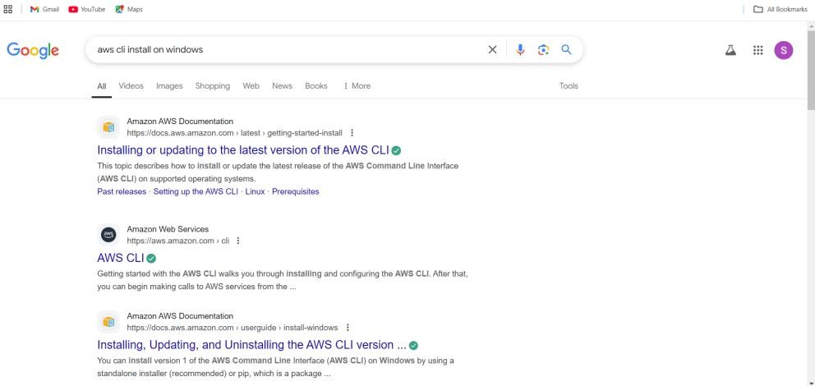

## Step 2 :

Click on the "Install/Update" option located on the left-hand side of the Apache Lounge website.

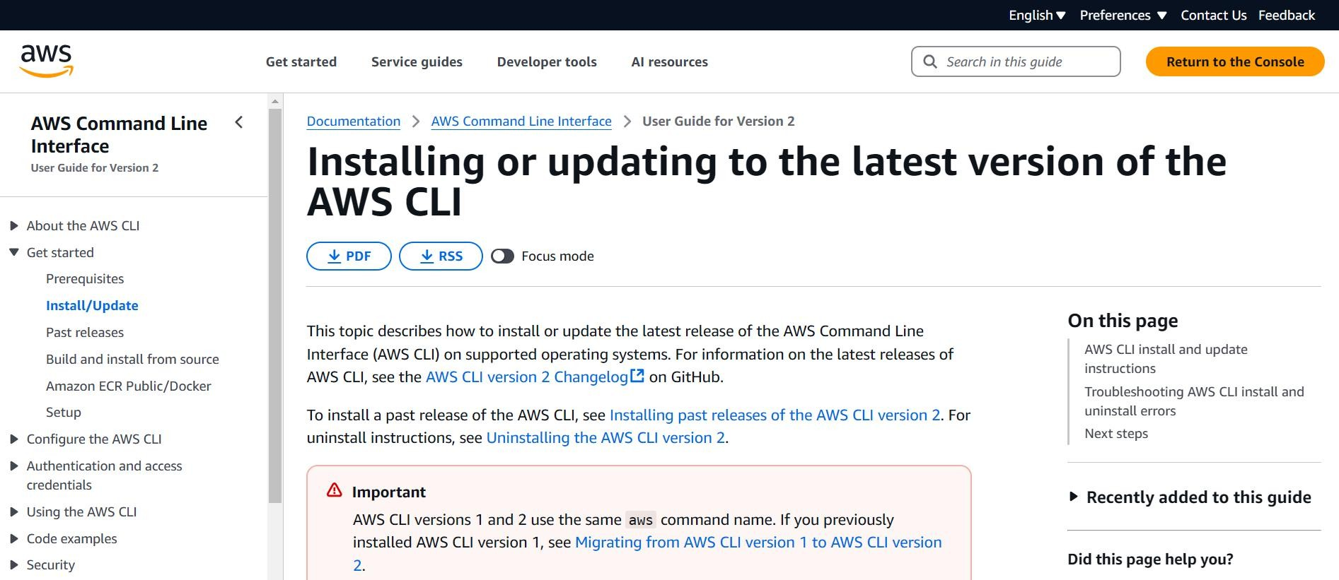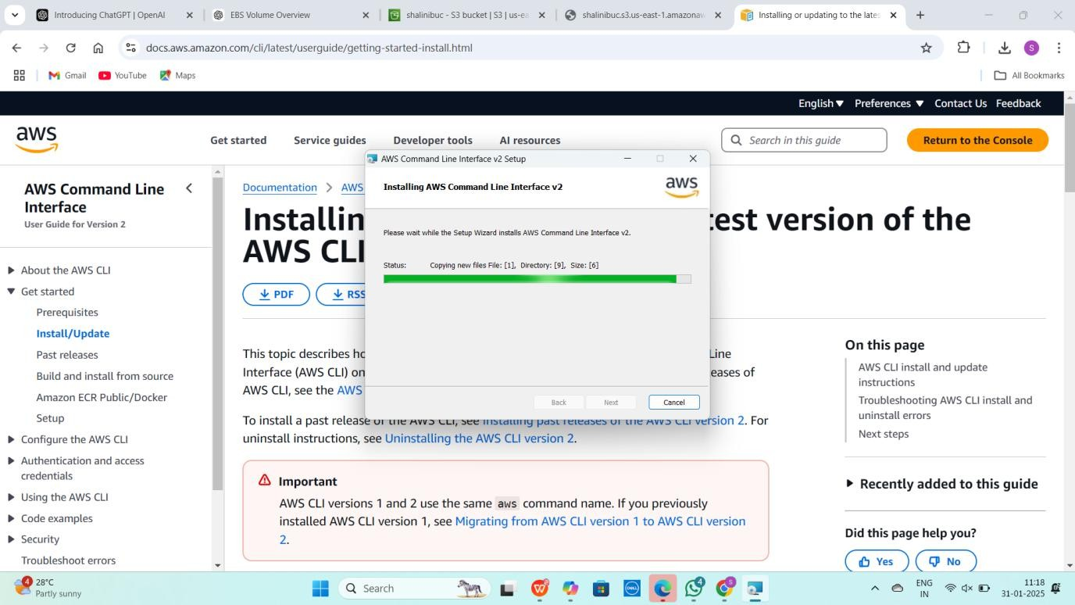

## Step 3 :

Verify the installation by opening Command Prompt (cmd) or PowerShell and running **aws --version**



## Step 4 :

Open Command Prompt and type **aws configure**

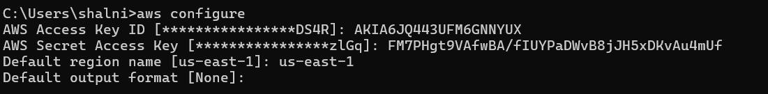

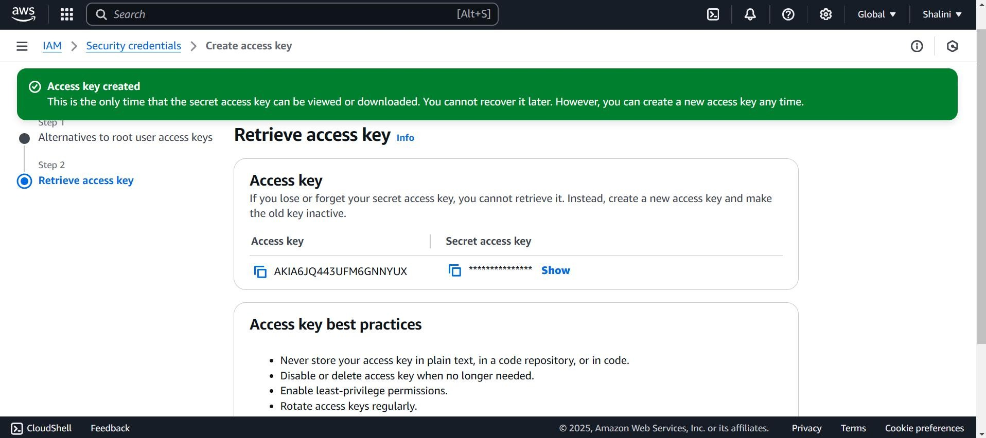

## Step 5 :

To see all storage buckets, Type **aws s3 ls** in cmd

To check running EC2 instances **aws ec2 describe-instances** in cmd



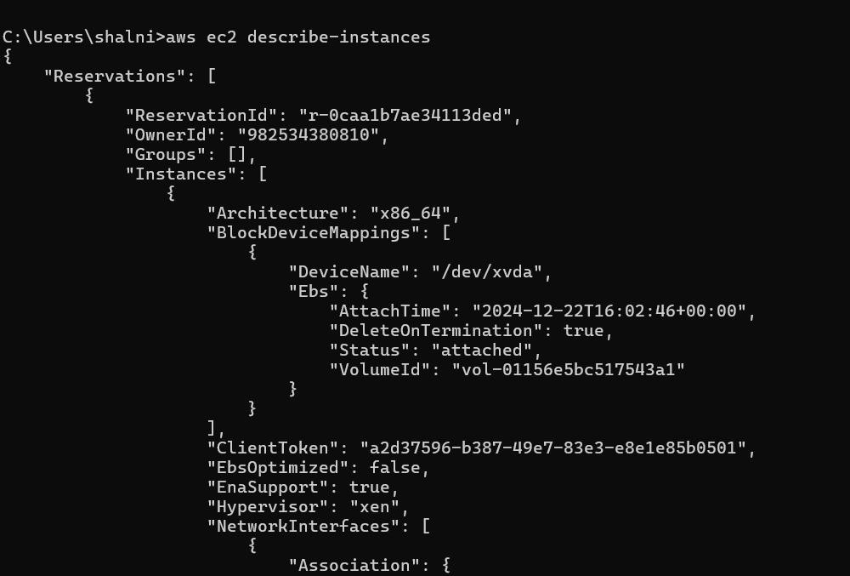

## Step 6 :

Create an S3 Bucket

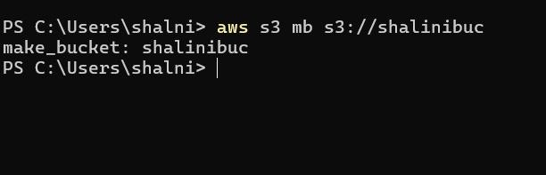

Upload a file to S3 Bucket by typing **aws s3 cp yourfile.txt s3://your- unique-bucket-name/** in cmd



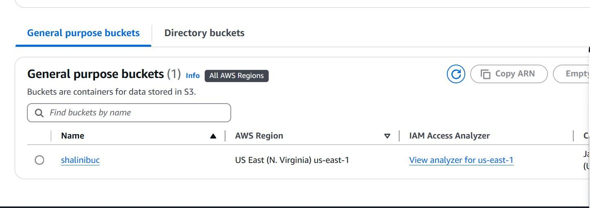

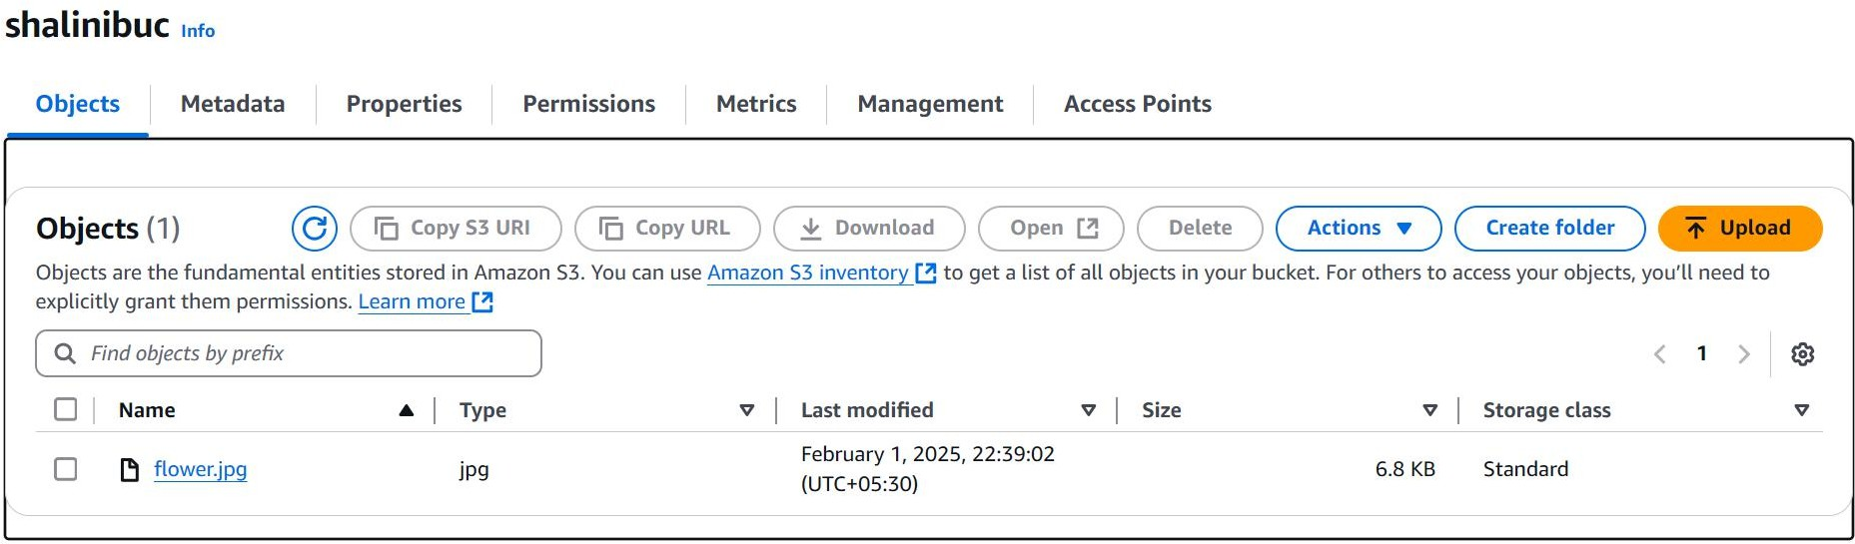

## Step 7 :

To Start an EC2 Instance, Type **aws ec2 start-instances --instance-ids**

**<INSTANCE_ID>** in cmd

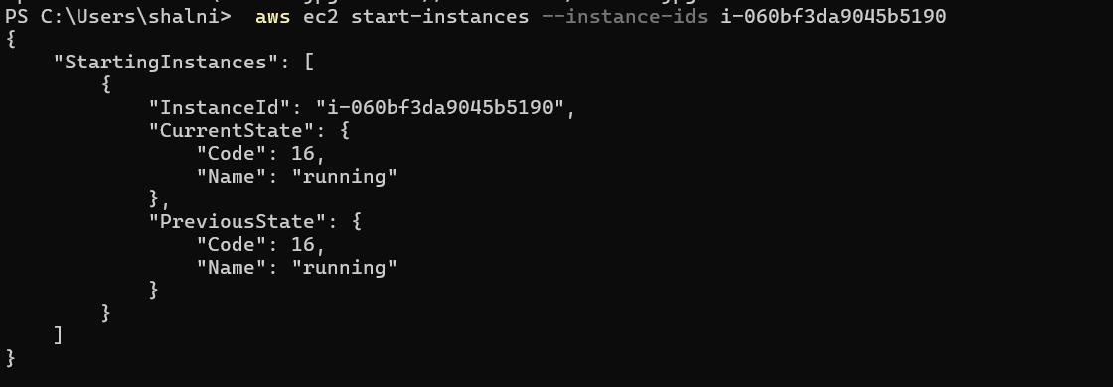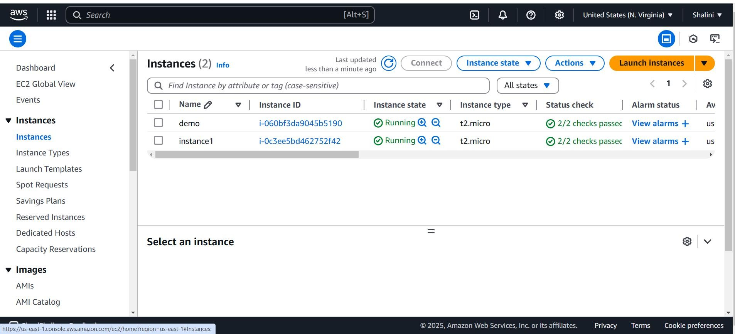

**Expected Outcome**

1. **Effortless Installation & Configuration:**

Achieve seamless interaction with AWS services by installing and configuring AWS CLI with the correct credentials.

1. **Efficient Cloud Resource Listing:**

Easily list AWS resources like S3 buckets, EC2 instances, and IAM users with simple CLI commands.

1. **Mastery of S3 File Management:**

Gain practical experience uploading, downloading, and managing files in Amazon S3 using the CLI.

1. **Command Over EC2 Instances:**

Master control over EC2 instances, learning to start, stop, and reboot them right from the command line, enhancing your cloud management expertise.

1. **Enhanced Automation Skills:**

Develop essential automation capabilities for DevOps and cloud computing by using CLI over the AWS Console, streamlining processes and increasing efficiency.