 

# Placement Empowerment Program

***Cloud Computing and DevOps Centre***

Set Up Git Branching

Name: Oviya G Department: IT



# Introduction

Git is a powerful version control system used to track changes in code. It allows multiple developers to work on a project simultaneously without interfering with each other's work.

Key concepts include

* repositories (which store project files and their history)
* branches (independent lines of development)
* commits (snapshots of the repo with unique IDs and messages)
* merges (integrating changes from one branch to another)
* pulling (fetching changes from a remote repo)
* pushing (sending changes to a remote repo)
* cloning (copying an existing remote repo to your local machine). Git is essential for collaboration, tracking changes, and managing project versions efficiently.

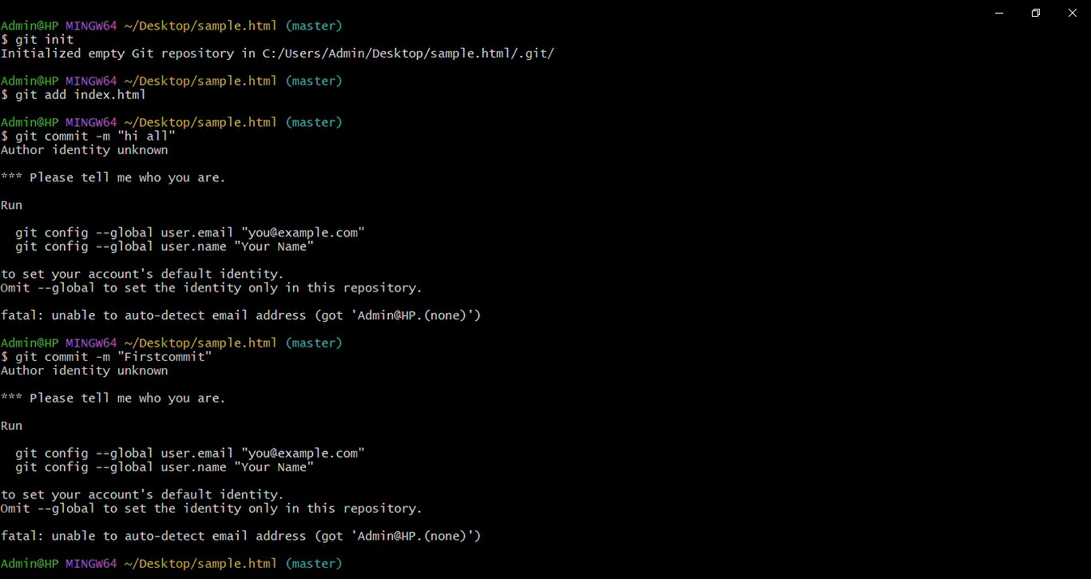

# Step-by-Step Overview

Step 1:Initialize the repository.



Step 2

Add the files to the repository



Step 3

Commit the changes.



Step 5

Create the branch

Git branch -M main



Step 6

**Push Your Branch to Remote**:



Step 7

**Merge the Branch**: Switch back to your main branch:



# Expected Outcome

To set up Git branching in Windows PowerShell, navigate to your repo with cd /path/to/your/repo, create a new branch using git checkout -b new-feature-branch, add a new feature by creating or modifying a file, stage your changes with git add new_feature.py, commit them using git commit -m "Add new feature: Print 'Hello, new feature!'", push your branch to remote with git push origin new- feature-branch, switch back to the main branch using git checkout main, merge the feature branch into the main branch with git merge new-feature-branch, and finally push the merged changes to remote using git push origin main. This will create a new branch, add a feature, merge it into the main branch, and push the changes to the remote repository.