**Sales Analysis**

1. select sum(total_price) as Total_Revenue from Pizzasales;

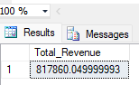

1. SELECT SUM(TOTAL_PRICE)/COUNT(DISTINCT ORDER_ID) AS AVERAGE_ORDER FROM PIZZASALES;

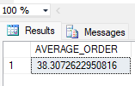

1. SELECT SUM(QUANTITY) AS TOTAL_NO_OF_PIZZAS_SOLD FROM PIZZASALES;

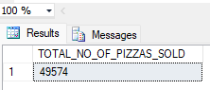

1. SELECT COUNT(DISTINCT ORDER_ID) AS TOTAL_ORDER_PLACED FROM PIZZASALES;

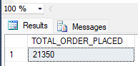

5) SELECT CAST(CAST(SUM(QUANTITY) AS DECIMAL(10,2))/ CAST(COUNT(DISTINCT ORDER_ID) AS DECIMAL(10,2)) AS DECIMAL(10,2)) AS AVERAGE_PIZZAS_PER_ORDER FROM PIZZASALES;

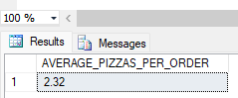

DAILY TREND

6) SELECT DATENAME(DW,ORDER_DATE) AS ORDER_DAY,COUNT(DISTINCT ORDER_ID) AS TOTAL_ORDERS FROM PIZZASALES

GROUP BY DATENAME(DW,ORDER_DATE);

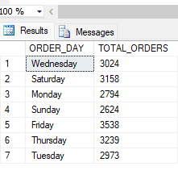

7) SELECT DATEPART(HOUR,ORDER_TIME) AS ORDER_HOURS,COUNT(DISTINCT ORDER_ID) AS TOTAL_ORDERS FROM PIZZASALES

GROUP BY DATEPART(HOUR,ORDER_TIME)

ORDER BY DATEPART(HOUR,ORDER_TIME);

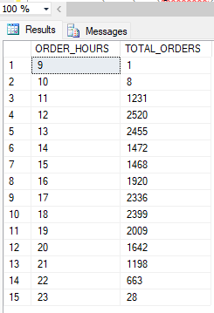

8) SELECT PIZZA_CATEGORY,SUM(TOTAL_PRICE)*100/(SELECT SUM(TOTAL_PRICE) FROM PIZZASALES) AS PERCENTAGE_OF_SALES_BY_CATEGORY FROM PIZZASALES

GROUP BY PIZZA_CATEGORY

ORDER BY PIZZA_CATEGORY;

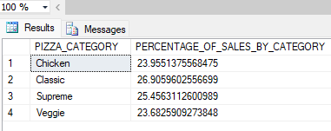

9) SELECT PIZZA_SIZE,SUM(TOTAL_PRICE) AS TOTAL_SALES,SUM(TOTAL_PRICE)*100/(SELECT SUM(TOTAL_PRICE) FROM PIZZASALES) AS PERCENTAGE_OF_SALES_BY_PIZZA_SIZE FROM PIZZASALES

GROUP BY PIZZA_SIZE;

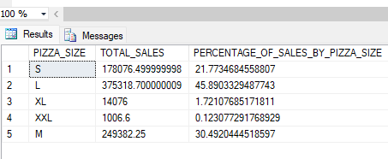

10) SELECT PIZZA_CATEGORY,SUM(QUANTITY) AS PIZZAS_SOLD FROM PIZZASALES

GROUP BY PIZZA_CATEGORY

ORDER BY PIZZA_CATEGORY;

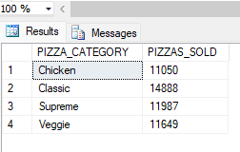

11) SELECT TOP 5 PIZZA_NAME,SUM(QUANTITY) AS TOTAL_PIZZAS_SOLD FROM PIZZASALES

GROUP BY PIZZA_NAME

ORDER BY SUM(QUANTITY) DESC;

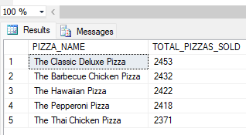

12) SELECT TOP 5 PIZZA_NAME,SUM(QUANTITY) AS TOTAL_PIZZAS_SOLD FROM PIZZASALES

GROUP BY PIZZA_NAME

ORDER BY SUM(QUANTITY) ASC;

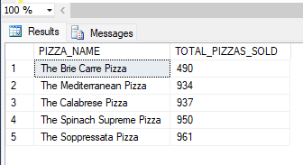

1. Total revenue
2. average order value
3. total pieces are sold
4. Total Orders
5. Average pizza for order
6. Daily trend for total orders
7. Hourly trend for total orders
8. Percentage of sales by pizza category
9. Percentage of sales by pizza size
10. Total pizzas sold by pizza category
11. Top 5 best sellers by total pizzas sold
12. Bottom 5 worst sellers by total pizzas sold