JAVA ASSIGNMENT-1
1.
import java.util.Scanner;
public class UsernameCheck {
public static void main(String[] args)
Scanner scanner = new Scanner(System.in);
System.out.print("Enter the user name: ");
String username1 = scanner.nextLine(); System.out.print("Reenter the user
name: ");
String username2 = scanner.nextLine(); if (username1.equals(username2)) { System.out.println("User name is
Valid");
} else { System.out.println("User name is Invalid");
}
scanner.close();
}
}

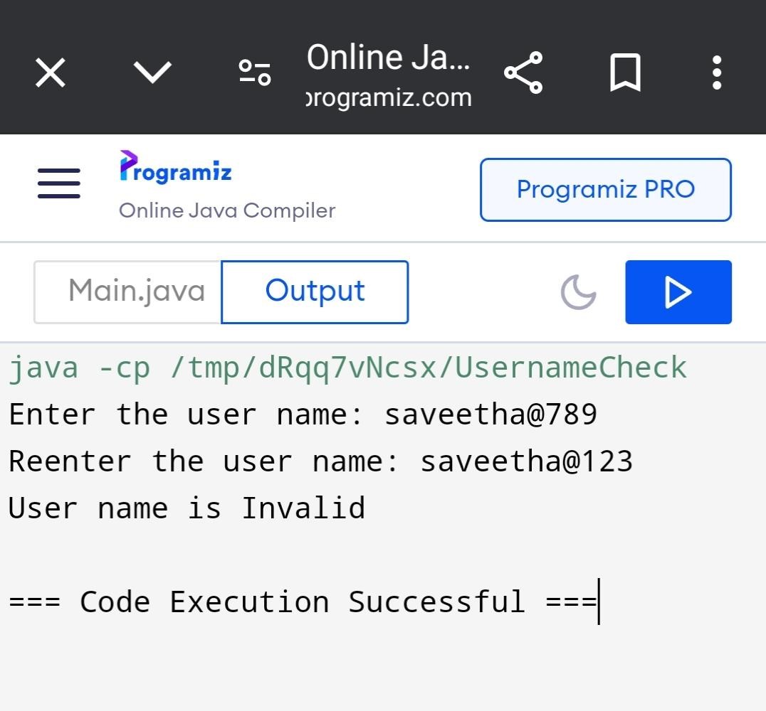

2.
import java.util.Scanner;
public class Voting{
public static void main(String[] args)
{
Scanner s = new Scanner(System.in);
System.out.print("Enter age: ");
int age = s.nextInt();
if (age >= 18)
{
System.out.println("You are eligible to vote.");
}
else
{
int yearsLeft = 18 - age;
System.out.println("You are allowed to vote after " + yearsLeft + " years.");
}
}
}
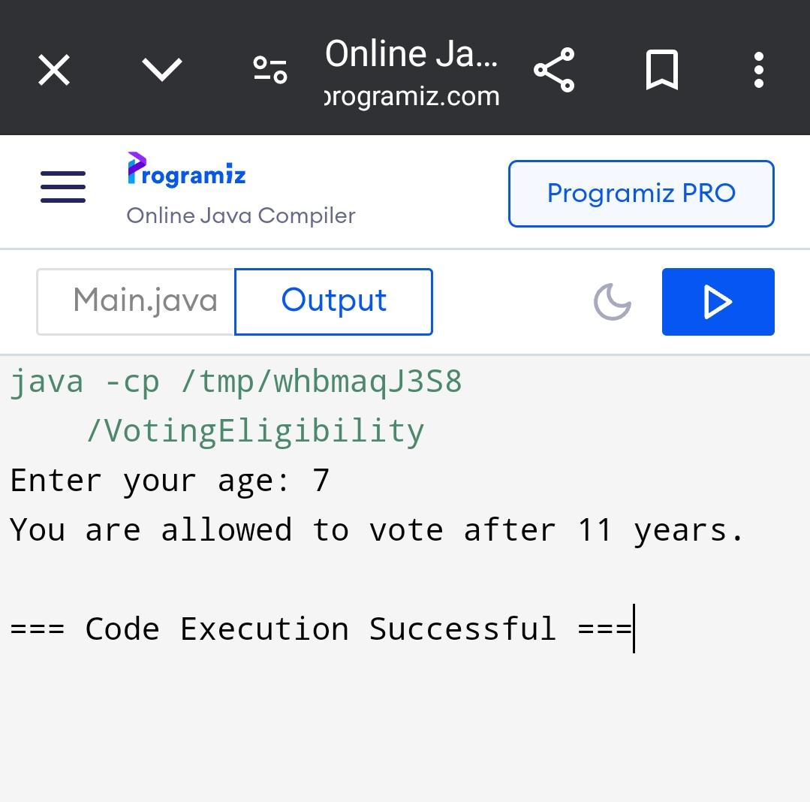

3.
import java.util.Scanner;
public class Simple_intrest
{
public static void main(String[] args)
{
int Interest;
Scanner s = new Scanner(System.in);
System.out.print("Enter the principal amount: ");
double principal = s.nextDouble();
System.out.print("Enter the number of years: ");
int years = s.nextInt();
System.out.print("Enter age of citizen:");
int age = s.nextInt();
if (age>60){
Interest=12;
}
else
{
Interest=10;
}
double I = (principal * years * Interest) / 100;
System.out.println("Interest: " + I);
}
}
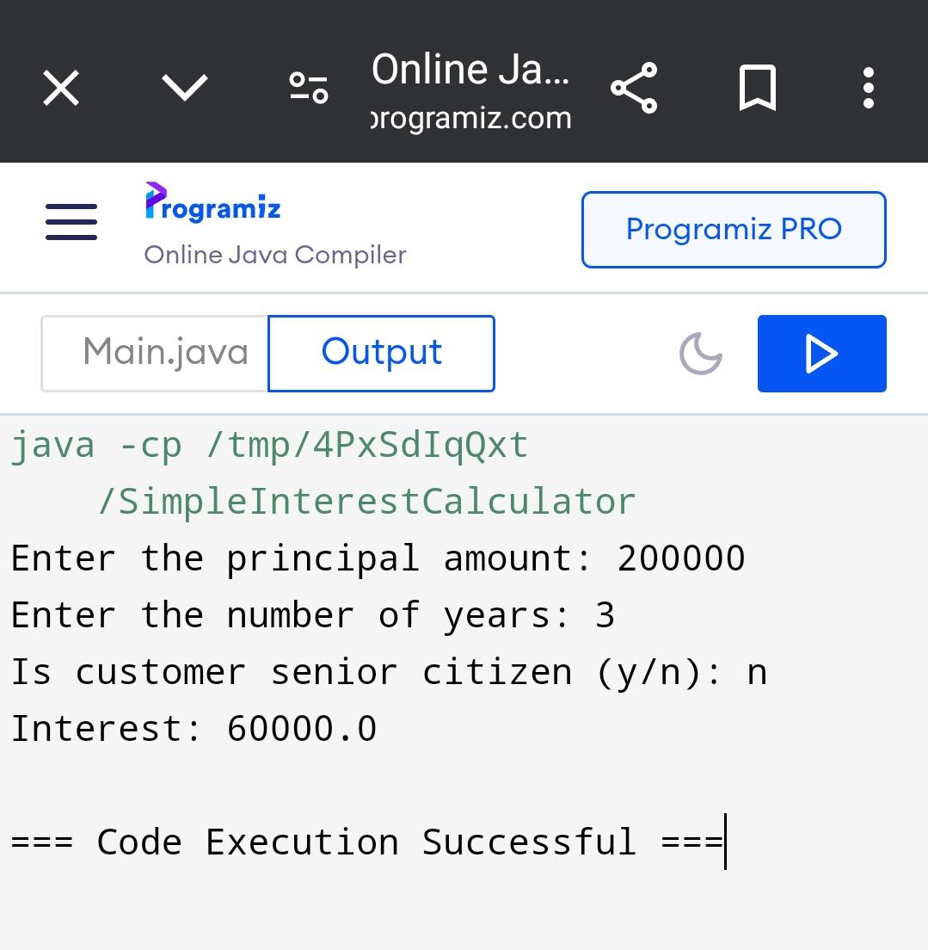

4.
import java.io.*;
import java.util.*;
class leap
{
public static void main(String[] args)
{
int year;
Scanner s=new Scanner(System.in);
System.out.println("enter the year");
years.nextInt();
if((year%4==0) && (year%400==0) || (year%100==0))
{
System.out.println("leap year");
}
else
{
System.out.println("not a leap year");
System.out.println("years left "+(4-year%4));
}
}
}

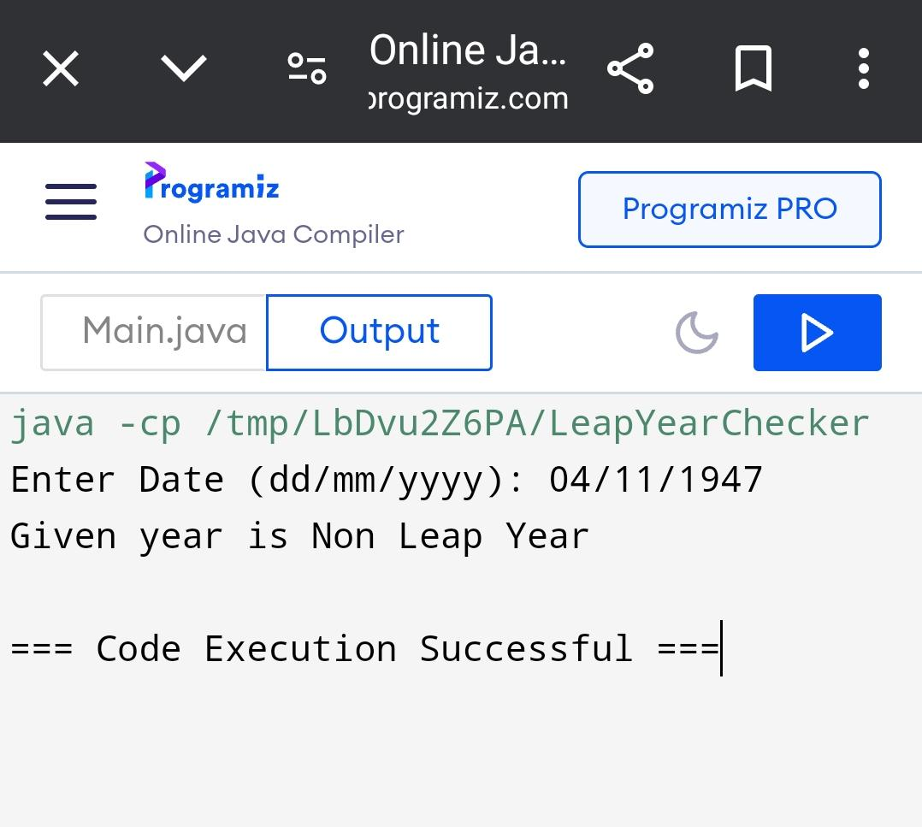

5.
import java.io.*;
import java.util.Scanner;
class decimal
{
public static void main(String[] args) }
float x, square, cube;
Scanner s=new Scanner(System.in);
X=s.nextFloat();
square=x*x;
cube=a*x*x;
System.out.println("square" +(square));
System.out.println("cube " +(cube));
}
}
