Network Intrusion Detection System
Deployment and Testing of Suricata IDS
Lab Report — Suricata NIDS against a Metasploitable 2 target

1. Objective
The objective of this exercise was to set up a network-based Intrusion Detection System (IDS) using Suricata, configure custom detection rules, generate representative malicious/suspicious traffic against a vulnerable target, and confirm that Suricata correctly logged and alerted on each type of activity. The following process areas were covered:
- Installing and configuring suricata as a network-based IDS.
- Defining the protected network (HOME_NET) and writing custom detection rules.
- Loading the custom rule file into suricata's yaml configuration.
- Generating test traffic (ICMP, HTTP, SSH, Telnet, FTP) against a target host.
- Monitoring Suricata's fast.log output to verify alerts were raised for each activity.

2. Lab Environment
- IDS sensor / attacker workstation - ubuntu linux running suricata.
- Target host - metasploitable 2, intentionally vulnerable linux VM.
- Protected network - 192.168.154.0/24, defined as HOME_NET in Suricata's yaml configuration.
- Services exercised on the target - ICMP echo request, HTTP (port 80), SSH (port 22), Telnet (port 23), FTP (port 21).
- Test web application - Altoro Mutual demo banking site (testfire.net) used to generate HTTP GET traffic.

3. Configuring Suricata
The core Suricata configuration file, suricata.yaml, was edited to define the network Suricata should protect and to point Suricata at the custom rule file.

3.1 Defining HOME_NET
Within the vars: address-groups section of suricata.yaml, HOME_NET was set to the lab subnet 192.168.154.0/24, and EXTERNAL_NET was left as the default "!$HOME_NET" (everything not in the home network). This ensures alerts correctly distinguish traffic to/from the protected network from external traffic.
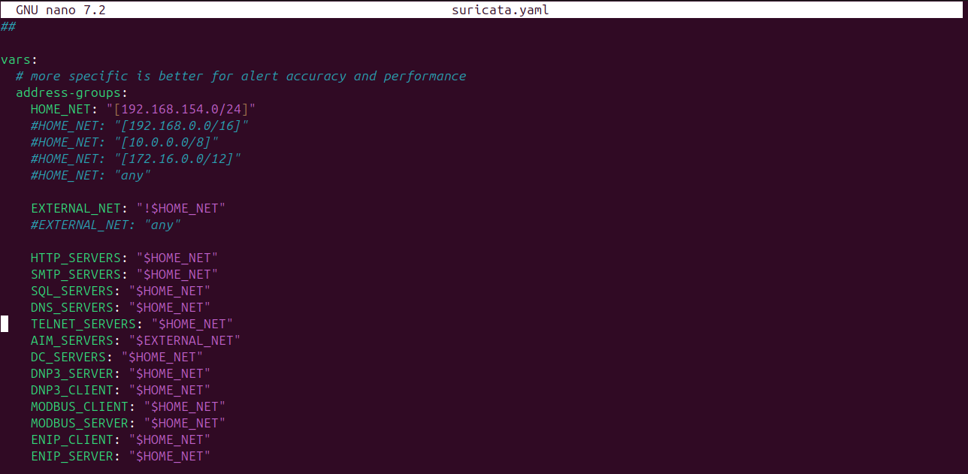
Figure 1 — HOME_NET and related address-group variables defined in suricata.yaml.

3.2 Loading the custom rule file
Suricata was configured to load a custom rules file in addition to the default rule set. In /etc/suricata/suricata.yaml, the default-rule-path was set to /var/lib/suricata/rules, and both suricata.rules and custom.rules were listed under rule-files so suricata would parse the custom rules on startup.
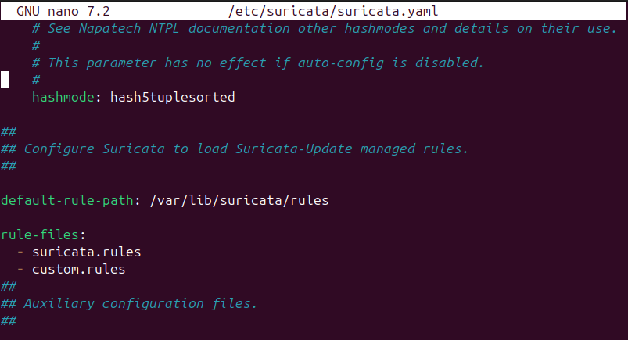
Figure 2 — suricata.yaml configured with default-rule-path and rule-files including custom.rules.
A directory listing of /var/lib/suricata/rules confirms that custom.rules sits alongside the standard suricata.rules and classification.config files.
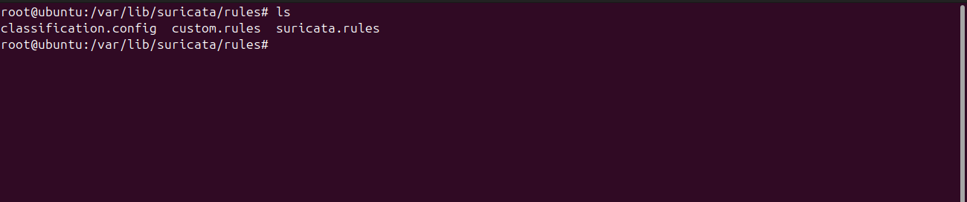
Figure 3 — Directory listing of /var/lib/suricata/rules showing custom.rules.

3.3 Custom detection rules
A custom rule file (custom.rules) was created to detect the specific activities tested in this exercise, ICMP echo requests, HTTP GET requests, SSH connection attempts (including a brute-force threshold rule), Telnet connection attempts, FTP login attempts, and a generic port-scan detector. Each rule is assigned a unique Suricata ID (sid) so the alerts appearing in the log can be traced back to the exact rule that fired.
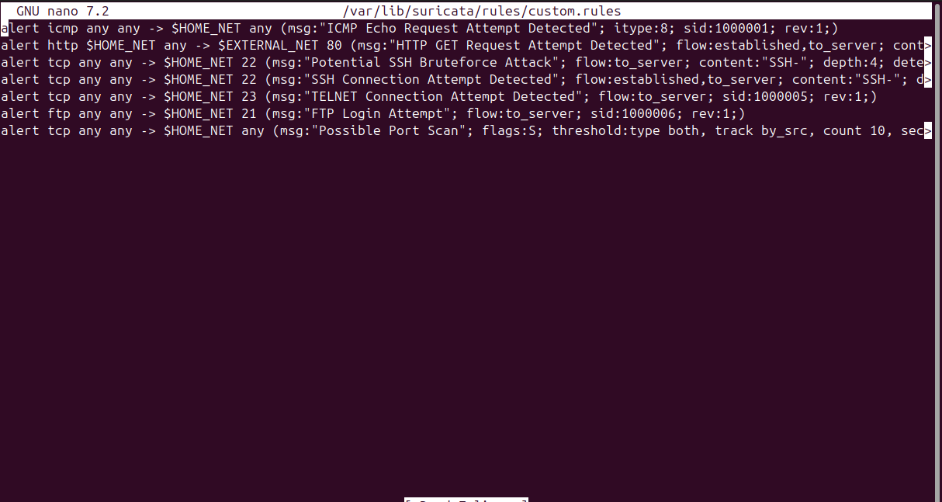
Figure 4 — Custom Suricata rules defined in /var/lib/suricata/rules/custom.rules.

Summary of the custom rules configured:

ACTION PROTOCOL SRC_IP SRC_PORT DIRECTION DEST_IP DEST_PORT (OPTIONS)
- sid:1000001 — ICMP Echo Request Attempt Detected (Alert icmp any any → $HOME_NET any, Options).
- sid:1000002 — HTTP GET Request Attempt Detected (http, HOME_NET any → EXTERNAL_NET port 80).
- Potential SSH Bruteforce Attack — (Alert tcp any any → HOME_NET port 22 options) matches the "SSH-" banner.
- sid:1000004 — SSH Connection Attempt Detected (Alert tcp any any → $HOME_NET 22 options).
- sid:1000005 — TELNET Connection Attempt Detected (Alert tcp any any → $HOME_NET port 23, Options).
- sid:1000006 — FTP Login Attempt (Alert ftp any any → $HOME_NET port 21, Options).
- Possible Port Scan — tcp, SYN-flag flood threshold (10 within a configured time window).

4. Generating and Detecting Test Traffic
With Suricata running and monitoring the network interface, several types of traffic were generated against the Metasploitable 2 target (192.168.154.138). Suricata's alert log, /var/log/suricata/fast.log, was tailed in real time to confirm each activity produced the expected alert.

4.1 ICMP Echo Request (Ping Sweep)
An ICMP ping was sent from the attacker host to the target using "ping -c 4 192.168.154.138". All four echo requests received replies, confirming host reachability.
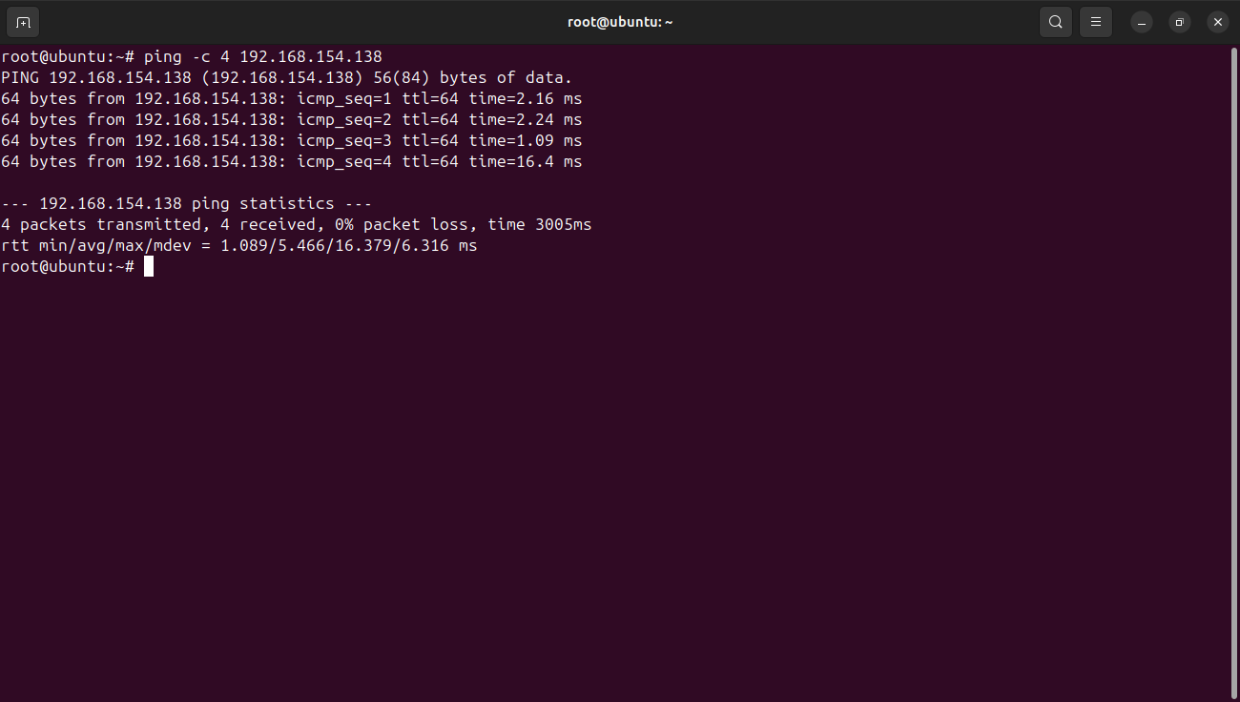
Figure 5 — Four ICMP echo requests sent to 192.168.154.138 with successful replies.
Suricata's fast.log shows matching "ICMP Echo Request Attempt Detected" alerts (sid:1000001) for the echo requests directed at the target, interleaved here with earlier HTTP GET alerts (sid:1000002) from prior test traffic.
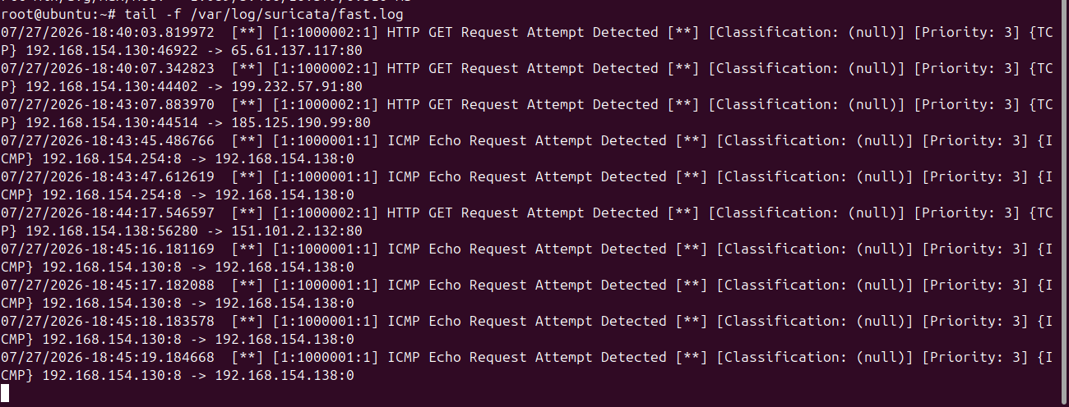
Figure 6 — fast.log entries confirming detection of ICMP echo requests and HTTP GET requests.

4.2 HTTP GET Request
HTTP traffic was generated by browsing to the Altoro Mutual demo banking application at http://testfire.net, a purpose-built vulnerable test site.
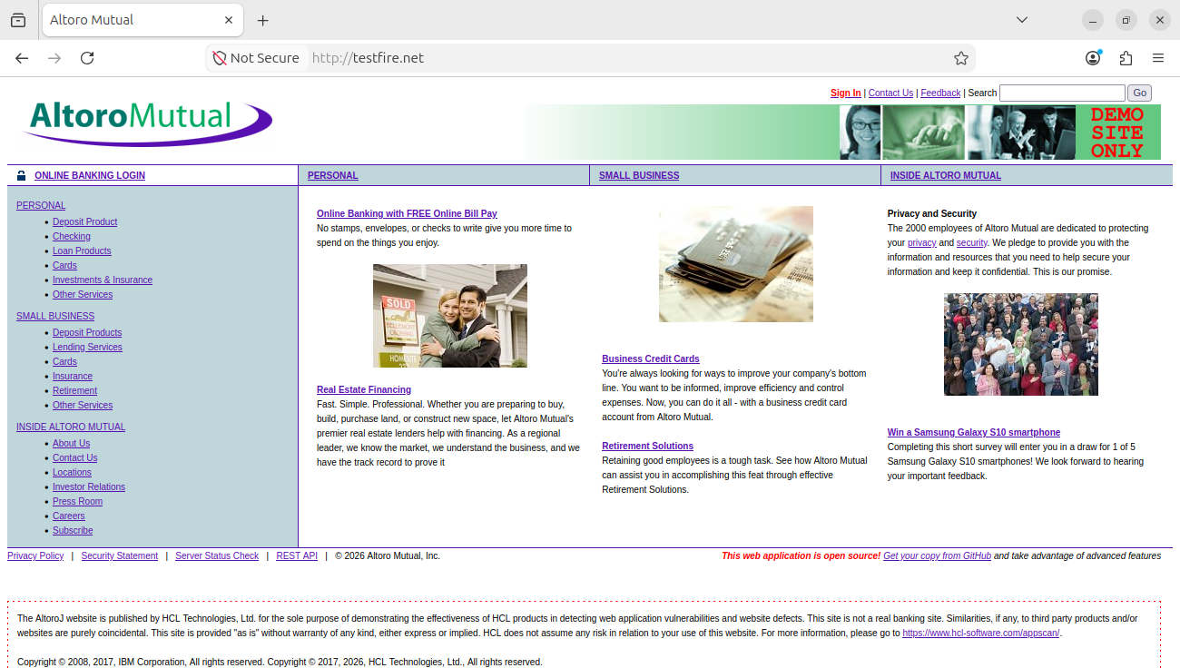
Figure 7 — Altoro Mutual demo site (testfire.net) loaded in the browser to generate HTTP GET traffic.
Each page request produced a corresponding "HTTP GET Request Attempt Detected" alert (sid:1000002) in fast.log, with the source workstation IP and destination IP:port (80) of the remote web server logged for every request.
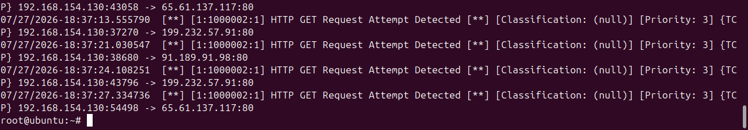
Figure 8 — fast.log entries showing repeated HTTP GET Request alerts for outbound web traffic on port 80.

4.3 SSH Connection Attempt
An SSH session was opened to the target with "ssh -oHostKeyAlgorithms=+ssh-rsa msfadmin@192.168.154.138", authenticating with the default Metasploitable credentials (msfadmin/msfadmin) and confirming shell access via an ls -la listing.
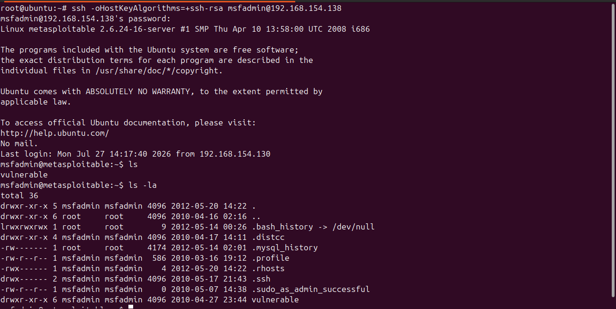
Figure 9 — Successful SSH login to the Metasploitable target on port 22.
The connection attempt was logged by Suricata as an "SSH Connection Attempt Detected" alert (sid:1000004) on TCP port 22 between the workstation and the target.
Figure 10 — fast.log entry confirming detection of the SSH connection attempt on port 22.

4.4 Telnet Connection Attempt
A Telnet session was opened with "telnet 192.168.154.138 23" and logged in using the msfadmin/msfadmin credentials, reaching an interactive shell on the target.
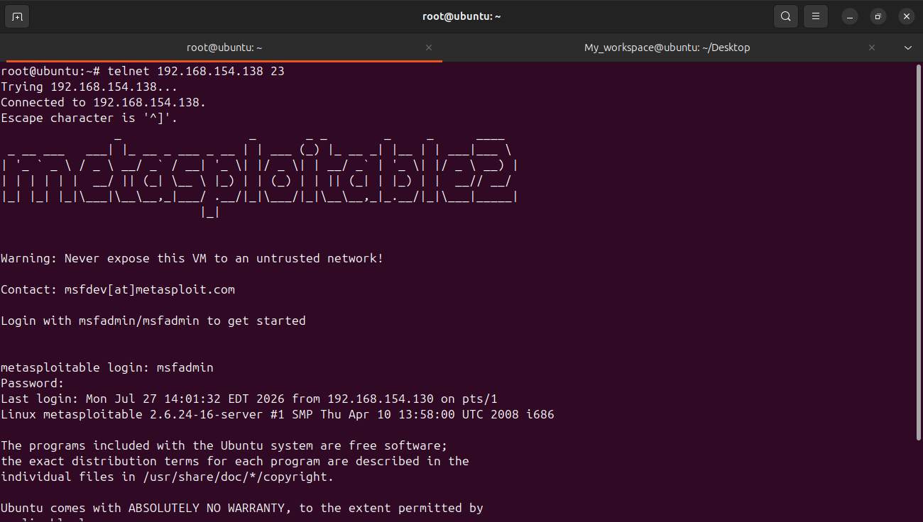
Figure 11 — Telnet session established to the Metasploitable target on port 23.
Suricata generated repeated "TELNET Connection Attempt Detected" alerts (sid:1000005) for the session traffic on TCP port 23, reflecting the multiple packets exchanged during the interactive session.
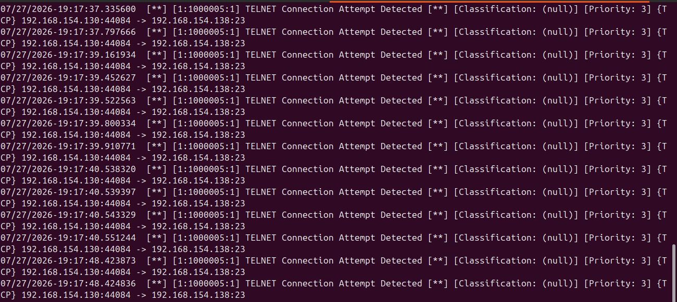
Figure 12 — fast.log entries showing repeated TELNET Connection Attempt alerts on port 23.

4.5 FTP Login Attempt
An FTP session was initiated with "ftp 192.168.154.138", logging in with the msfadmin credentials against the target's vsFTPd 2.3.4 service and listing the remote directory contents.
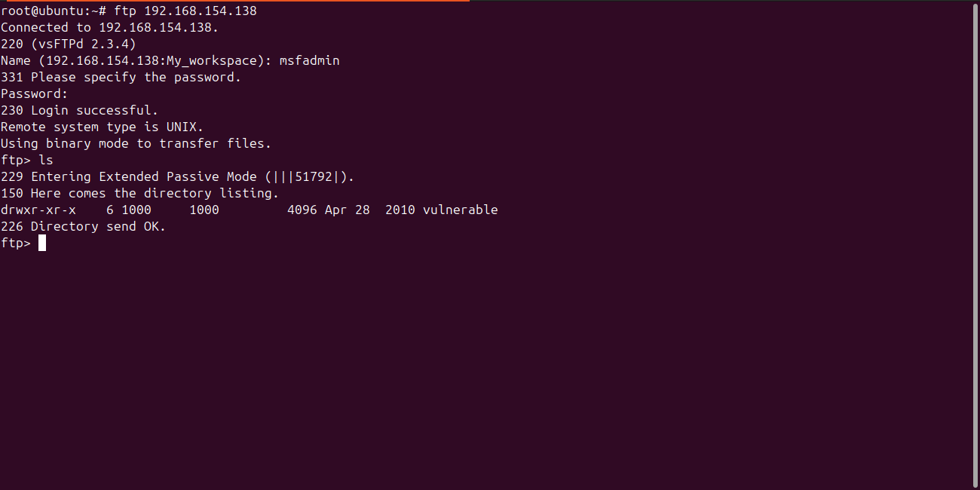
Figure 13 — FTP login to the Metasploitable target (vsFTPd 2.3.4) on port 21.
Suricata logged the corresponding "FTP Login Attempt" alerts (sid:1000006) on TCP port 21. The repeated timestamps reflect the FTP control-channel handshake and login negotiation observed on the wire.
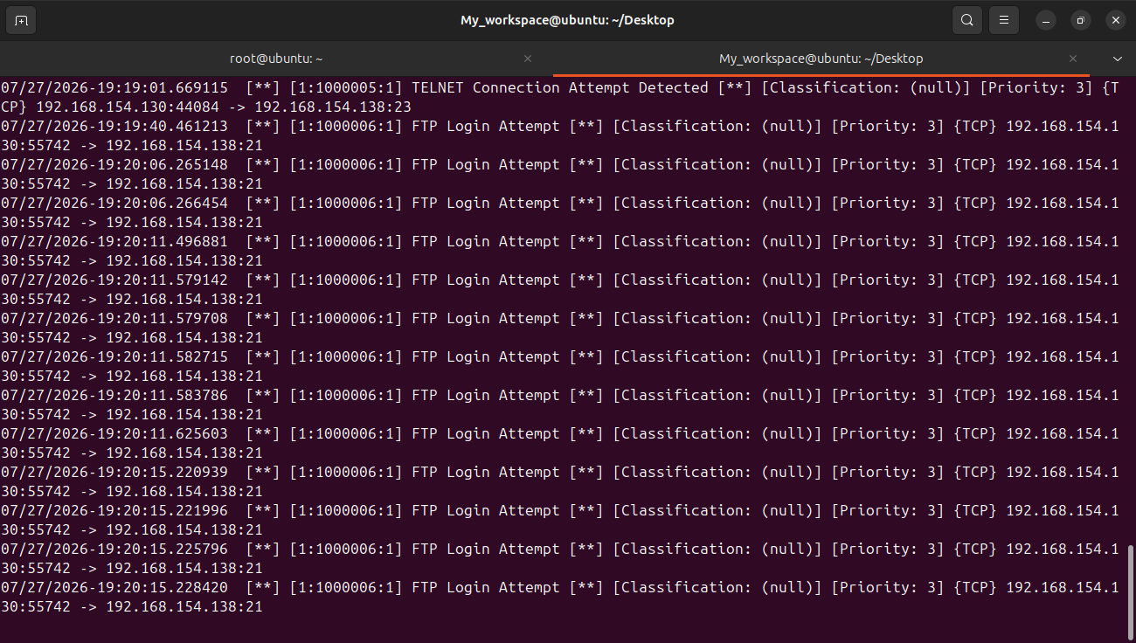
Figure 14 — fast.log entries confirming detection of FTP login attempts on port 21, together with preceding TELNET alerts

5. Continuous Monitoring
Suricata was run with "tail -f /var/log/suricata/fast.log" kept open throughout testing, allowing alerts to be observed in real time as each type of traffic was generated. This confirmed that the IDS was actively monitoring the interface rather than only performing a one-time scan, satisfying the requirement for continuous traffic monitoring.

6. Conclusion
Suricata was successfully deployed as a network-based IDS protecting the 192.168.154.0/24 lab network. Custom rules were written and loaded to detect ICMP, HTTP, SSH, Telnet, and FTP activity, and each rule was validated by generating live traffic against a Metasploitable 2 target and confirming matching alerts in /var/log/suricata/fast.log. The exercise demonstrated the full workflow required for an operational NIDS: configuration, custom rule authoring, continuous traffic monitoring, and identification of response mechanisms for each class of detected activity.

