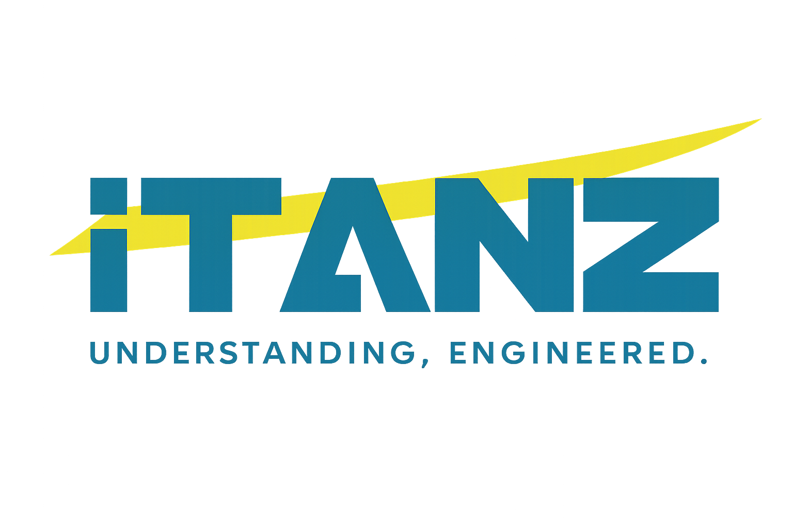

CORPORATE NEWS
iTANZ Strengthens Middle East Expansion Through Strategic Regional Partnerships
Building strategic relationships across the region to support the next generation of enterprise transformation.
iTANZ is strengthening its business expansion across the Middle East, developing strategic relationships with regional partners and business leaders as part of its continued international growth strategy.
The expansion reflects iTANZ’s commitment to building stronger regional capabilities and supporting organisations navigating increasingly complex technology and transformation priorities.
Supporting a New Era of Enterprise Transformation
Across the Middle East, organisations are accelerating investment in digital modernisation and increasingly looking to technologies such as cloud, data and AI, enterprise platforms, system integration and managed services to create more connected, scalable and resilient operations.
For iTANZ, strengthening relationships across the region creates an opportunity to combine enterprise technology expertise with greater local market understanding and regional collaboration.
The objective is not simply geographical expansion. It is to establish the relationships, capability and delivery ecosystem required to create sustained transformation value for organisations operating across high-growth Middle Eastern markets.
Building Stronger Regional Relationships
Strategic relationships play an important role in how iTANZ approaches international expansion.
By engaging with regional partners and business leaders, iTANZ aims to strengthen the foundation for long-term collaboration while creating new opportunities to address complex enterprise technology requirements across the region.
This approach supports iTANZ’s broader ambition to enable technology environments that are more connected, scalable and ready for continued transformation.
Enterprise Capability for High-Growth Markets
As organisations modernise critical systems, the challenge increasingly extends beyond deploying individual technologies.
Enterprises need technology environments where platforms, data, infrastructure, applications and operations work together effectively.
- Cloud & Infrastructure
- Data, Analytics & AI
- Enterprise Platforms
- System Integration
- Automation
- Managed Services
- Technology Advisory & Transformation
The focus is on helping organisations move from fragmented technology initiatives toward enterprise environments designed for greater operational confidence, scalability and long-term performance.
Expanding With Purpose
The Middle East represents an important part of iTANZ’s international growth journey.
Strengthening regional relationships is another step toward creating a broader enterprise technology ecosystem capable of combining global capability with local market collaboration.
As the region continues its rapid technology transformation, iTANZ intends to build on these relationships and support organisations seeking to modernise critical operations, connect technology environments and prepare their enterprises for what comes next.

Regional relationships. Enterprise capability. Transformation at scale.
NEWSROOM CARD EXCERPT
Strategic regional relationships strengthen iTANZ’s growing Middle East presence and its ability to support enterprise transformation across high-growth markets.

