My Awesome Paper

Author Name

2021-03-01

# Table of content

## List of figures

## List of tables

Sample manuscript showing style and formatting specifications for *Journal of Biomedical Optics and Neurophotonics* journal papers

First Author,a Second Author,a Third Author,b Fourth Authora,b,*

a University Name, Faculty Group, Department, City, Country

b Company Name, City, Country

# Introduction

Your introduction is going to include citations. You can include one citation[1] or several citations.[1,2]

## Use of This Template

Authors may use this Microsoft (MS) Word template by employing the relevant styles from the Styles and Formatting list (which is accessed from the Styles group in the Home ribbon). To view which style is being used in any part of this document, place the cursor on the line and look in the style list Figure )

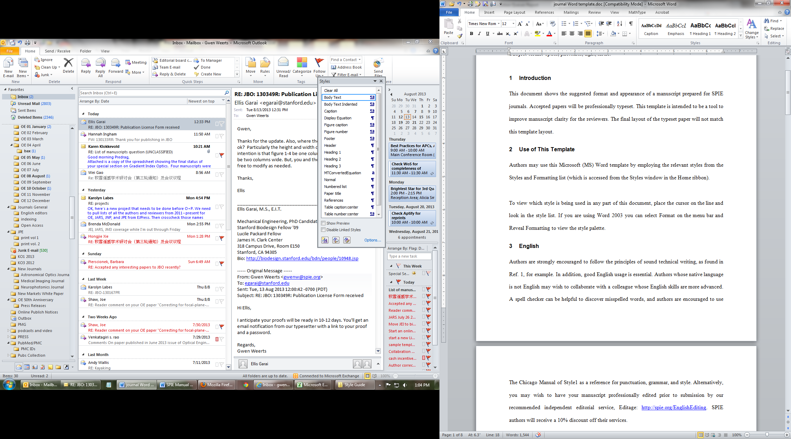

Figure : MS Word 2010 Home ribbon. Red arrow indicates where to access Styles window.

# Results

There was a significant effect of “Group” on the average test score *F*(2, 176) = 56.57, *p* < .001. Descriptive statistics were run and are shown in Table below

Table : Descriptives

| Group | Sex | n | Mean Age | SD |
| --- | --- | --- | --- | --- |
| Control | Female | 5 | 25.8 | 3.033 |
| Control | Male | 5 | 28.2 | 1.924 |
| OI | Female | 5 | 28.2 | 1.643 |
| OI | Male | 5 | 24.2 | 4.266 |
| TBI | Female | 5 | 24.8 | 3.701 |
| TBI | Male | 5 | 24.8 | 3.768 |

A plot is shown in Figure

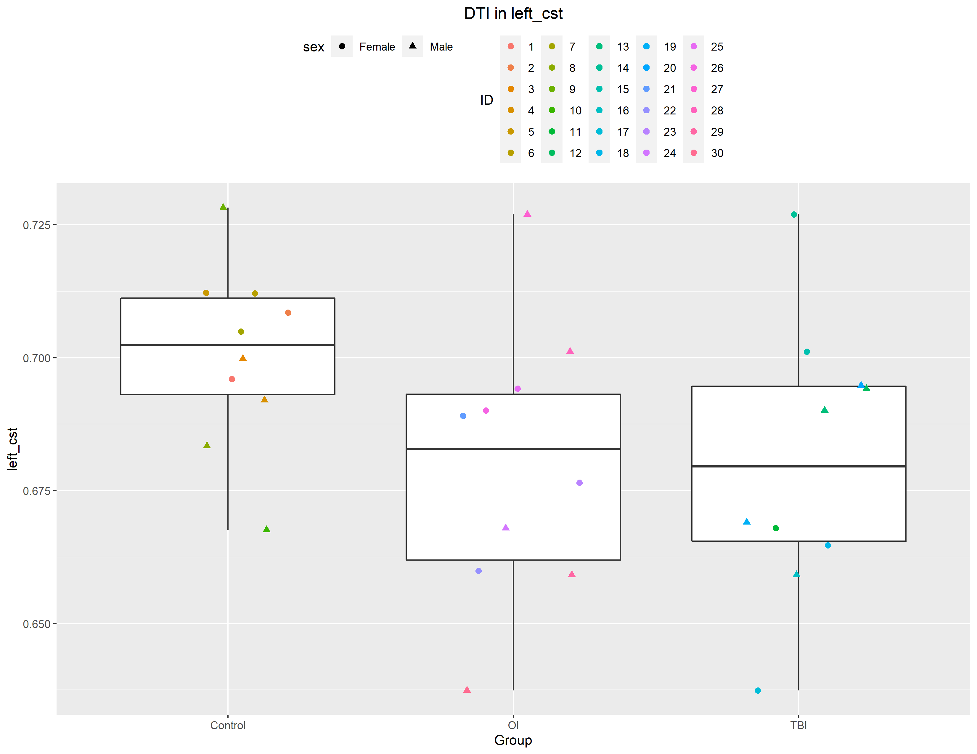

Figure : Caption for my Figure

Its common to want to use “landscape” pages in order to fit a larger image. Below I show an example

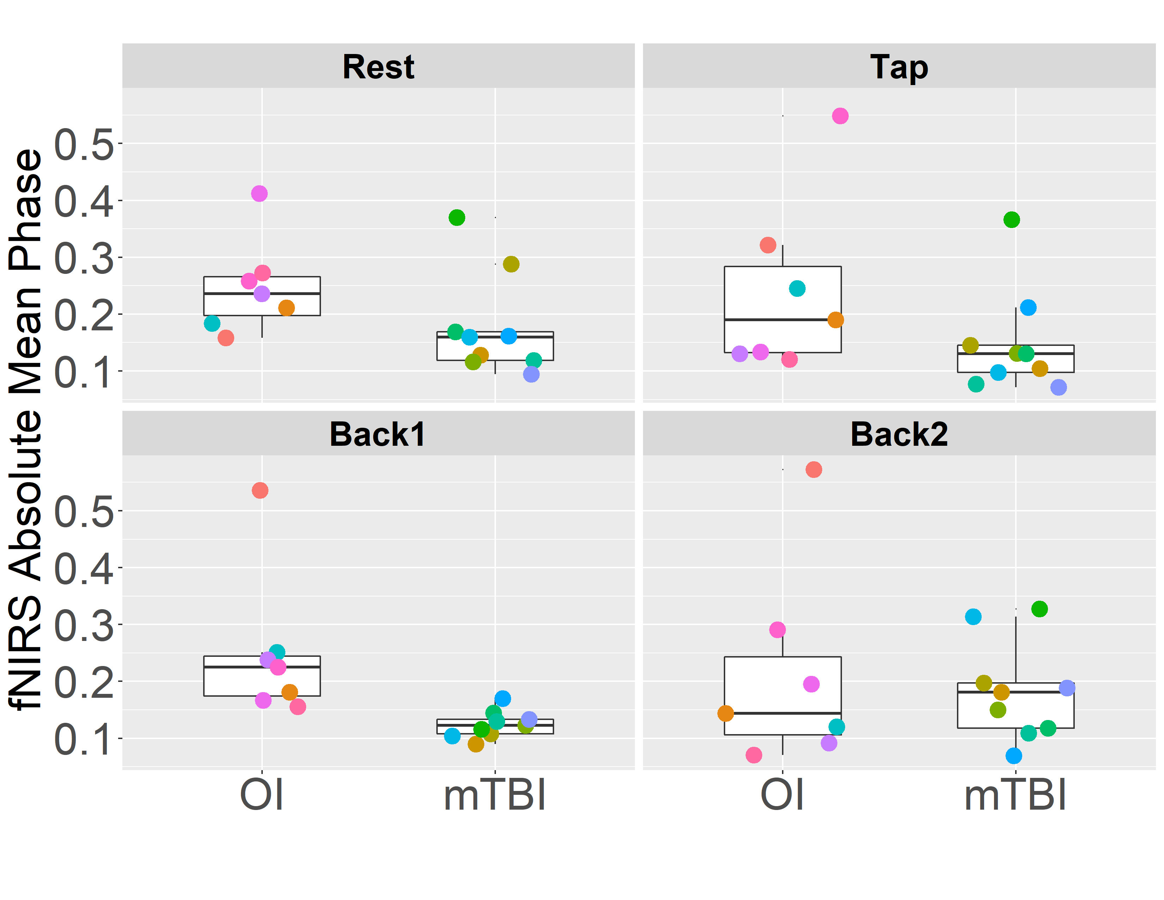

Figure : Changes in Coherence over all Tasks in L-DLPFC/R-DLPFC. Significant group differences were noted in the Rest and 2-Back tasks

# Discussion

Insert your discussion here

# Appendix

Below I show some other common tricks you can accomplish in RMarkdown. You can view the [RMarkdown cheatsheet](https://rstudio.com/wp-content/uploads/2015/02/rmarkdown-cheatsheet.pdf) for more information

## Text formatting

*italic* or *italic* **bold** **bold** code superscript2 and subscript2

## Headings

# 1st Level Header

## 2nd Level Header

### 3rd Level Header

## Lists

* Bulleted list item 1
* Item 2
  + Item 2a
  + Item 2b

1. Numbered Item 1. The numbers are incremented automatically in the output.
   * Sub-item 1A
2. Numbered Item 2
   * Sub-item 2A
   * Sub-item 2B
3. Numbered list item 1

[linked phrase](http://example.com)

## Random Symbols I can use

You can render emojis in RMarkdown. Here are some examples.

✅ Correct/Checkmark   
 ❌ Incorrect sign   
 🧠 Brain   
 📚 Books   
 ∵ == because

# References

1. Lapointe, A.P.; Nolasco, L.A.; Sosnowski, A.; Andrews, E.; Martini, D.N.; Palmieri-Smith, R.M.; et al. Kinematic differences during a jump cut maneuver between individuals with and without a concussion history. International Journal of Psychophysiology: Official Journal of the International Organization of Psychophysiology 2018, 132(Pt A), 93–98 [10.1016/j.ijpsycho.2017.08.003](https://doi.org/10.1016/j.ijpsycho.2017.08.003).

2. Vlisides, P.E.; Li, D.; Zierau, M.; Lapointe, A.P.; Ip, K.I.; McKinney, A.M.; et al. Dynamic Cortical Connectivity during General Anesthesia in Surgical Patients. Anesthesiology 2019, 130(6), 885–897 [10.1097/ALN.0000000000002677](https://doi.org/10.1097/ALN.0000000000002677).