JSS *Journal of Statistical Software*



*MMMMMM YYYY, Volume VV, Issue II.* [*doi:10.18637/jss.v000.i00*](https://doi.org/10.18637/jss.v000.i00)

**Imputation of Incomplete Multilevel Data with** mice

|  |  |
| --- | --- |
| **Hanne Oberman**  Utrecht University | **Johanna Munoz Avila** University Medical Center Utrecht |
| **Valentijn de Jong** University Medical Center Utrecht | **Gerko Vink**  Utrecht University |

**Thomas Debray**

University Medical Center Utrecht

# Abstract

This is a tutorial paper on imputing incomplete multilevel data with mice. Footnotes in the current version show work in progress/under construction. The last section is not part of the manuscript, but purely for reminders. We aim to submit at JSS, so there is no word count limit (“There is no page limit, nor a limit on the number of figures or tables”). [Just adding some text to get a better guess of what the actura abstract will look like: Lorem ipsum dolor sit amet, consectetur adipiscing elit, sed do eiusmod tempor incididunt ut labore et dolore magna aliqua. Ut enim ad minim veniam, quis nostrud exercitation ullamco laboris nisi ut aliquip ex ea commodo consequat. Duis aute irure dolor in reprehenderit in voluptate velit esse cillum dolore eu fugiat nulla pariatur. Excepteur sint occaecat cupidatat non proident, sunt in culpa qui officia deserunt mollit anim id est laborum.]

*Keywords*: missing data, multilevel, clustering, mice, R.

# Introduction

In many contemporary data analysis efforts, some form of hierarchical or clustered data structures are recorded. In the simplest case, such a structure entails the nesting of units within clusters (e.g., students within school classes). More complex clustered structures may occur when there are multiple hierarchical levels (e.g., patients within hospitals within regions or countries), or when the clustering is non-nested (e.g., electronic health record data from Table 1: Concepts in multilevel methods

|  |  |
| --- | --- |
| **Concept** | **Details** |
| ICC | The variability due to clustering is often measured by means of the intraclass coefficient (ICC). The ICC can be seen as the percentage of variance that can be attributed to the cluster-level, where a high ICC would indicate that a lot of variability is due to the cluster structure. |
| Random effect | Multilevel models typically accommodate for variability by including a separate group mean for each cluster. In addition to random intercepts, multilevel models can also include random coefficients and heterogeneous residual error variances across clusters [see e.g.  @gelm06, @hox17 and @jong21]. TODO: add stratification. |

cluster X1 X2 X3 ... Xp

|  |  |  |  |  |  |
| --- | --- | --- | --- | --- | --- |
| 1 |  |  | **NA** |  |  |
| 1 |  |  |  |  |  |
| 2 |  | **NA** |  |  |  |
| 2 |  | **NA** | **NA** |  |  |
|  |  |  |  |  |  |
| N |  |  |  |  |  |

Figure 1: Missingness in multilevel data

diverse settings and populations within large databases). The clustered structure of multilevel data should be taken into account when developing analysis models: 1) for the simple reason that groups of observations share some common variance, and 2) because ignoring multilevel structures can be harmful to the statistical inferences and introduce bias in estimators (Hox, Moerbeek, and van de Schoot 2017). There are many names for models that take clustering into account. Some popular examples are ‘multilevel models’, ‘hierarchical models’, ‘mixed effect models’ and ‘random effect models’. Table 1 provides an overview of some key concepts in multilevel modeling.

## Missingness in multilevel data

The process of analyzing multilevel data is further complicated when not all data entries are observed. Just as with single level data, missingness may occur at the unit level. But with multiple levels of data comes the potential for clustered missingness. Therefore, incomplete multilevel data can be categorized into two general patterns: systematic missingness and sporadic missingness (Resche-Rigon, White, Bartlett, Peters, and Thompson 2013). Systematic missingness implies that one or more variables are never observed in a certain cluster. With sporadic missingness there may be observed data for some but not all units in a cluster (Van Buuren 2018; Jolani 2018). We have visualized this difference in Figure 1, which shows an *n × p* set **X** = *X*1*,...,Xp*, with *n* units distributed over *N* clusters and *p* variables.

Table 2: Concepts in missing data methods

|  |  |
| --- | --- |
| **Concept** | **Details** |
| MCAR | Missing Completely At Random, where the probability to be missing is equal across all data entries |
| MAR | Missing At Random, where the probability to be missing depends on observed information |
| MNAR | Missing Not At Random (MNAR), where the probability to be missing depends on unrecorded information, making the missingness non-ignorable [@rubi76; @meng94].  [TODO: add congeniality, but maybe in-text?] |

Column *X*1 in Figure 1 is completely observed, column *X*2 is systematically missing in cluster 2, and column *X*3 is sporadically missing. To analyze these incomplete data, we have to take the nature of the missingness and the cluster structure into account. For example, the sporadic missingness in *X*3 could be easily amended if this would be a cluster-level variable (and thus constant within clusters). We could then just extrapolate the true (but missing) value of *X*3 for unit 1 from unit 2, and the value for unit 4 from unit 3. If *X*3 would instead be a unit-level variable (which may vary within clusters), we could not just recover the unobserved ‘truth’, but would need to use some kind of missing data method, or discard the incomplete units altogether (i.e., complete case analysis). Complete case analysis can however introduce bias in statistical inferences and lowers statistical power. Further, with the systematic missingness in *X*2, it would be impossible to fit a multilevel model without accommodating the missingness in some way. Complete case analysis in that case would mean excluding the entire cluster from the analyses. The wrong choice of missing data handling method can thus be extremely harmful to the inferences.

A key characteristic of the missing data to take into account in analyses is the mechanism behind the missingness. We distinguish between MCAR, MAR and MNAR in theory (see Table 2), but in practice this distinction is less clear. Since the essence of the true nonresponse mechanism may not be known, it is generally inferred or assumed to be ignorable (i.e., MCAR or MAR). [TODO: add that this assumption may not always be valid, especially with modern types of big dasta sources.] Depending on the actual missingness-generating mechanism, missing data handling strategies may be more or less suitable, see e.g., Yucel (2008) and Hox, van Buuren, and Jolani (2015).

Since excluding observations is not a desirable workflow, the missingness in multilevel data should be accommodated before or within the analysis of scientific interest. In this paper, we focus on the former approach: imputing (i.e., filling in) the missing data with plausible values, whereafter the completed data may be analyzed as if it were completely observed. Imputation separates the missing data problem from the scientific problem, which makes the missing data strategy very generic and popular. If each missing value is replaced multiple times, the resulting inferences may validly convey the uncertainty due to missingness (c.f. Rubin 1976). The R package mice has become the de-facto standard for imputation by chained equations, which iteratively solves the missingness on a variable-by-variable basis. mice is known to yield valid inferences under many different missing data circumstances (Van Buuren 2018). In this paper, we will discuss how to use mice in the context of multilevel data.

[TODO: clarify why clustering is relevant during imputation, and why this exposes the need Table 3: Notation

|  |  |
| --- | --- |
| **Concept** | **Details** |
|  | [TODO: explain lme4 notation here] |

for specialized imputation methods and more attention during their implementation (“thou shall not simply run mice() on any incomplete dataset”). Add that the more the random effects are of interest, the more you need ml models. And add overview of possible predictor matrix values.]

## Aim of this paper

This papers serves as a tutorial for imputing incomplete multilevel data with mice in R. We provide practical guidelines and code snippets for different missing data situations, including non-ignorable mechanisms. For reasons of brevity, we focus on multilevel imputation by chained equations with mice exclusively; other imputation methods and packages (e.g., jomo and mdmb) are outside the scope of this tutorial. Assumed knowledge includes basic familiarity with multilevel imputation (see e.g. Audigier, White, Jolani, Debray, Quartagno, Carpenter, van Buuren, and Resche-Rigon 2018, and Grund, Lüdtke, and Robitzsch (2018)) and the lme4 notation for multilevel models (see Table 3).

We illustrate how to impute incomplete multilevel data by means of three case studies:

* popmis from the mice package (simulated data on perceived popularity, *n* = 2*,*000 pupils across *N* = 100 schools, van Buuren and Groothuis-Oudshoorn 2021);
* hiv from the GJRM package (simulated data on HIV diagnoses, *n* = 6*,*416 patients across *N* = 9 regions, Radice 2021);
* impact from the metamisc package (empirical data on traumatic brain injuries, *n* = 11*,*022 patients across *N* = 15 studies, Debray and de Jong 2021).

**TODO: add where novice and more experienced readers should start reading.** For each of these datasets, we will discuss the nature of the missingness, choose one or more imputation models and evaluate the imputed data, but we will also highlight one specific aspect of the imputation workflow. With the popmis data, we show how (and how not) to develop an imputation model. With the hiv data we focus on extending the imputation model to include Heckman-type selection-inclusion methods. With the impact data we provide an example of multivariate missingness in real-world data. Together, this should give enough scaffolding for applied researchers who are faced with incomplete multilevel data.

## Setup

[TODO: Add environment info, seed and version number(s) somewhere.] Set up the R environment and load the necessary packages:

|  |  |
| --- | --- |
| *R> set.seed(2022)* |  |
| *R> library(mice)* | *# for imputation* |
| *R> library(ggmice)* | *# for visualization* |
| *R> library(ggplot2)* | *# for visualization* |

*R> library(dplyr) # for data wrangling*

*R> library(lme4) # for multilevel modeling*

*R> library(broom.mixed) # for multilevel estimates*

*R> library(mitml) # for multilevel pooling*

# Case study I: popularity data

In this section we’ll go over the different steps involved with imputing incomplete multilevel data. The data we’re using is the popmis dataset from the mice package. This is a simulated dataset with pupils (*n* = 2000) clustered within schools (*N* = 100). In this tutorial we’ll use the following variables:

* school, school identification number (clustering variable);
* popular, pupil popularity (self-rating between 0 and 10; unit-level);
* sex, pupil sex (0=boy, 1=girl; unit-level); • texp, teacher experience (in years; cluster-level).

The analysis model corresponding to this dataset is multilevel regression with random intercepts, random slopes and a cross-level interaction. The outcome variable is popular, which is predicted from the unit-level variable sex and the cluster-level variable texp:

*R> mod <- popular ~ 1 + sex + texp + sex:texp + (1 + sex | school)*

Load the data into the environment and select the relevant variables:

*R> popmis <- popmis[, c("school", "popular", "sex", "texp")]* Plot the missing data pattern:

*R> plot_pattern(popmis)*

The missingness is univariate and sporadic, which is illustrated in the missing data pattern in Figure 2.

To develop the best imputation model for the incomplete variable popular, we need to know whether the observed values of popular are related to observed values of other variables. Plot the pair-wise complete correlations in the incomplete data:

*R> plot_corr(popmis)*

Variable

school

sex

texp

popular

1152

848

0

1

0

0

0

848

(

name

)

Variable

Pattern

(

)

frequency

Pattern

(

number of missing entries

)

(number of missing entries)

missing observed

Figure 2: Missing data pattern in the popularity data

school

popular

sex

texp

texp

sex

popular

school

Imputation model predictor

Variable to impute



−1.0

−0.5

0.0

0.5

1.0

Correlation*

*pairwise complete observations

This shows us that both sex and texp may be useful imputation model predictors. Moreover, the missingness in popular may depend on the observed values of other variables. We’ll highlight one other variable to illustrate, but ideally one would inspect all relations. The questions we’ll ask are: ‘Does the missing data of pupil popularity (popular) depend on observed teacher popularity (texp)?’. This can be evaluated statistically, but visual inspection usually suffices. We’ll make a histogram of texp separately for the pupils with known popularity and missing popularity.

Plot the histogram for teacher experience conditional on the missingness indicator of popular:

*R> ggmice(popmis, aes(texp)) +*

*+ geom_histogram(fill = "white") +*

*+ facet_grid(. ~ is.na(popular), scales = "free", labeller = label_both)*

is.na(popular): FALSE

is.na(popular): TRUE

5

10

15

20

25

5

10

15

20

25

0

30

60

90

texp

count

observed

This shows us that there are no apparent differences in the distribution of texp depending on the missingness indicator of popular (t = -0.873, p = 0.383). **TODO: think about what is a meaningful rule of thumb to signal that the user should be worried?**

## *Imputation ignoring the cluster variable (not recommended)*

The first imputation model that we’ll use is likely to be invalid. We do not use the cluster identifier school as imputation model predictor. With this model, we ignore the multilevel structure of the data, despite the high ICC. This assumes exchangeability between units. We include it purely to illustrate the effects of ignoring the clustering in our imputation effort.

Create a methods vector and predictor matrix for popular, and make sure school is not included as predictor:

*R> meth <- make.method(popmis) # methods vector*

*R> pred <- quickpred(popmis) # predictor matrix*

*R> plot_pred(pred)*

0

0

0

0

0

0

0

0

0

1

0

0

0

1

0

0

school

popular

sex

texp

texp

sex

popular

school

Imputation model predictor

Variable to impute

Predictor used

no

yes

Impute the data, ignoring the cluster structure:

*R> imp_ignored <- mice(popmis, maxit = 1, pred = pred, print = FALSE)*

**TODO: remove the broom.mixed output, use mitml only**

Analyze the imputations:

*R> fit_ignored <- imp_ignored %>%*

*+ with(lme4::lmer(popular ~ 1 + sex + texp + sex:texp + (1 + sex | school))) R> testEstimates(as.mitml.result(fit_ignored), var.comp = TRUE)*

Call:

testEstimates(model = as.mitml.result(fit_ignored), var.comp = TRUE)

Final parameter estimates and inferences obtained from 5 imputed data sets.

|  |  |  |  |  |  |  |
| --- | --- | --- | --- | --- | --- | --- |
|  | Estimate Std.Error t.value | | df | P(>|t|) | RIV | FMI |
| (Intercept) | 3.489 | 0.179 19.542 | 9.227 | 0.000 | 1.927 | 0.714 |
| sex | 1.138 | 0.197 5.776 | 11.588 | 0.000 | 1.424 | 0.644 |
| texp | 0.100 | 0.014 7.339 | 6.914 | 0.000 | 3.177 | 0.809 |
| sex:texp | -0.019 | 0.015 -1.217  Estimate | 7.708 | 0.260 | 2.576 | 0.773 |

Intercept~~Intercept|school 0.123

|  |  |
| --- | --- |
| sex~~sex|school | 0.143 |
| Intercept~~sex|school | 0.014 |
| Residual~~Residual | 0.656 |
| ICC|school | 0.158 |

Unadjusted hypothesis test as appropriate in larger samples.

## *Imputation with the cluster variable as predictor (not recommended)*

We’ll now use school as a predictor to impute all other variables. This is still not recommended practice, since it only works under certain circumstances and results may be biased (Drechsler 2015; Enders, Mistler, and Keller 2016). But at least, it includes some multilevel aspect. This method is also called ‘fixed cluster imputation’, and uses N-1 indicator variables representing allocation of N clusters as a fixed factor in the model (Reiter, Raghunathan, and Kinney 2006; Enders et al. 2016). Colloquially, this is ‘multilevel imputation for dummies’.

**TODO: Add that it doesn’t work with syst missing (only sporadically). There’s some pro’s and con’s. May not differ much if the number of clusters is low.**

*R> # adjust the predictor matrix*

*R> pred["popular", "school"] <- 1*

*R> plot_pred(pred)*

0

1

0

0

0

0

0

0

0

1

0

0

0

1

0

0

school

popular

sex

texp

texp

sex

popular

school

Imputation model predictor

Variable to impute

Predictor used

no

yes

*R> # impute the data, cluster as predictor*

*R> imp_predictor <- mice(popmis, maxit = 1, pred = pred, print = FALSE)*

# Case study II: HIV data

Data are simulated and included in the GJRM package. We will use the following variables:

* region Cluster variable,
* hiv HIV diagnosis (0=no, 1=yes),
* age Age of the patient,
* marital Marital status,
* condom Condom use during last intercourse,
* smoke Smoker (levels; inclusion restriction variable).

The imputation of these date is based on the toy example from [IPDMA Heckman Github repo.](https://github.com/johamunoz/Heckman-IPDMA/blob/main/Toy_example.R)

region

age

marital

condom

smoke

hiv

5098

1318

0

1

0

0

0

0

0

1318

Variable

(

name

)

Variable

(

number of missing entries

)

Pattern

)

(

frequency

Pattern

(

number of missing entries

)

missing observed

# Case study III: IMPACT data

We illustrate how to impute incomplete multilevel data by means of a case study: impact from the metamisc package (empirical data on traumatic brain injuries, *n* = 11*,*022 units across *N* = 15 clusters, Debray and de Jong 2021). [TODO: add more info about the complete data.]

The impact data set contains traumatic brain injury data on *n* = 11022 patients clustered in *N* = 15 studies with the following 11 variables:

* name Name of the study,
* type Type of study (RCT: randomized controlled trial, OBS: observational cohort), • age Age of the patient,
* motor_score Glasgow Coma Scale motor score,
* pupil Pupillary reactivity,
* ct Marshall Computerized Tomography classification,
* hypox Hypoxia (0=no, 1=yes),
* hypots Hypotension (0=no, 1=yes),
* tsah Traumatic subarachnoid hemorrhage (0=no, 1=yes),
* edh Epidural hematoma (0=no, 1=yes), • mort 6-month mortality (0=alive, 1=dead).

The analysis model for this dataset is a prediction model with mort as the outcome. In this tutorial we’ll estimate the adjusted prognostic effect of ct on unfortunate outcomes. The estimand is the adjusted odds ratio for ct, after including type, agemotor_score and pupil into the analysis model:

*R> mod <- mort ~ 1 + type + age + motor_score + pupil + ct + (1 | name)*

Note that variables hypots, hypox, tsah and edh are not part of the analysis model, and may thus serve as auxiliary variables for imputation.

The impact data included in the metamisc package is a complete data set. The original data has already been imputed once (Steyerberg et al, 2008). For the purpose of this tutorial we have induced missingness (mimicking the missing data in the original data set before imputation). The resulting incomplete data can be accessed from [zenodo link to be created.](https://zenodo.com/) TODO: email script to thomas.

Load the complete and incomplete data into the R workspace:

*R> data("impact", package = "metamisc") # complete data*

*R> dat <- read.table("link/to/the/data.txt") # incomplete data*

We will use the following estimates as comparative truth in this tutorial [TODO: make this a table or forest plot instead, to see if there is heterogeneity in the association of ct with mort]:

*R> fit <- glmer(mod, family = "binomial", data = impact) # fit the model*

*R> tidy(fit, conf.int = TRUE, exponentiate = TRUE) # print estimates*

# A tibble: 11 x 9 effect group term estimate std.error statistic p.value conf.low conf.high

|  |  |  |  |  |  |  |  |  |  |  |
| --- | --- | --- | --- | --- | --- | --- | --- | --- | --- | --- |
| <chr> <chr> <chr> | <dbl> | <dbl> | | <dbl> <dbl> | | | <dbl> | | <dbl> | |
| 1 fixed <NA> (Int~ | 0.101 | 0.0173 | | -13.4 4.94e- 41 | | | 0.0723 | | 0.141 | |
| 2 fixed <NA> type~ | 0.713 | 0.123 | | -1.96 5.01e- 2 | | | 0.509 | | 1.00 | |
| 3 fixed <NA> age | 1.03 | 0.00165 | | 20.2 2.13e- 90 | | | 1.03 | | 1.04 | |
| 4 fixed <NA> moto~ | 0.553 | 0.0386 | | -8.50 1.95e- 17 | | | 0.482 | | 0.634 | |
| 5 fixed <NA> moto~ | 0.405 | 0.0289 | | -12.7 8.43e- 37 | | | 0.352 | | 0.466 | |
| 6 fixed <NA> moto~ | 0.275 | 0.0202 | | -17.6 1.67e- 69 | | | 0.239 | | 0.318 | |
| 7 fixed <NA> pupi~ | 3.73 | 0.230 | | 21.4 2.09e-101 | | | 3.31 | | 4.21 | |
| 8 fixed <NA> pupi~ | 1.87 | 0.133 | | 8.80 1.36e- 18 | | | 1.63 | | 2.15 | |
| 9 fixed <NA> ctIII | | 2.25 0.157 | | 11.6 | | 5.12e- 31 | 1.96 | | 2.58 | |
| 10 fixed <NA> ctIV~ | | 2.30 0.136 | | 14.0 | | 9.47e- 45 | 2.05 | | 2.58 | |
| 11 ran_p~ name sd__~ | | 0.277 NA | | NA | | NA | NA | | NA | |

APOE

CSTAT

EBIC

HIT I

HIT II

NABIS

PEG

PHARMOS

SAP

SKB

SLIN

TCDB

TINT

TIUS

UK4

0

3

6

9

12

Adjusted odds ratio for ct

Study

[TODO: add ICC before/after imputation and interpret: This tells us that the multilevel structure of the data should probably be taken into account. If we don’t, we’ll may end up with incorrect imputations, biasing the effect of the clusters towards zero.] [TODO: add descriptive statistics of the complete and incomplete data.]

## Missingness

To explore the missingness, it is wise to look at the missing data pattern:

*R> plot_pattern(dat, rotate = TRUE) # plot missingness pattern*

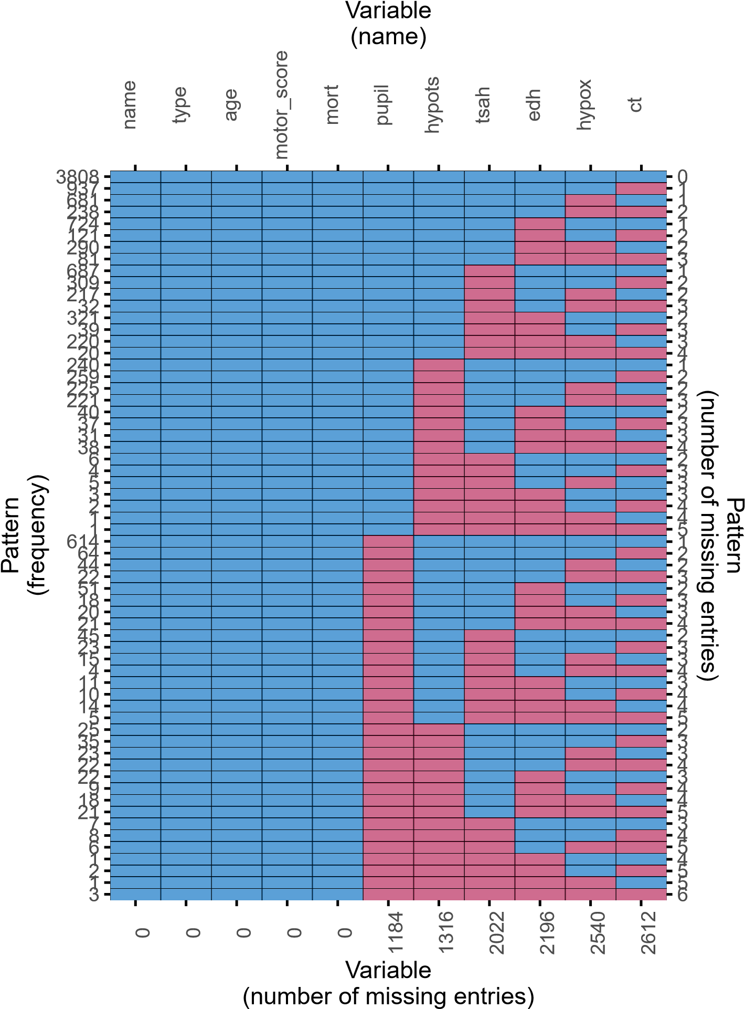

missing observed

This shows... [TODO: fill in that we need to impute ct and pupil.] TODO: remove axis labels

To develop the best imputation model, we need to investigate the relations between the observed values of the incomplete variables and the observed values of other variables, and the relation between the missingness indicators of the incomplete variables and the observed values of the other variables. To see whether the missingness depends on the observed values of other variables, we... [TODO: fill in that we can test this statistically or use visual inspection (e.g. a histogram faceted by the missingness indicator).]

We should impute the variables ct and pupil and any auxiliary variables we might want to use to impute these incomplete analysis model variables. We can evaluate which variables may be useful auxiliaries by plotting the pairwise complete correlations:

*R> plot_corr(dat, rotate = TRUE) # plot correlations*

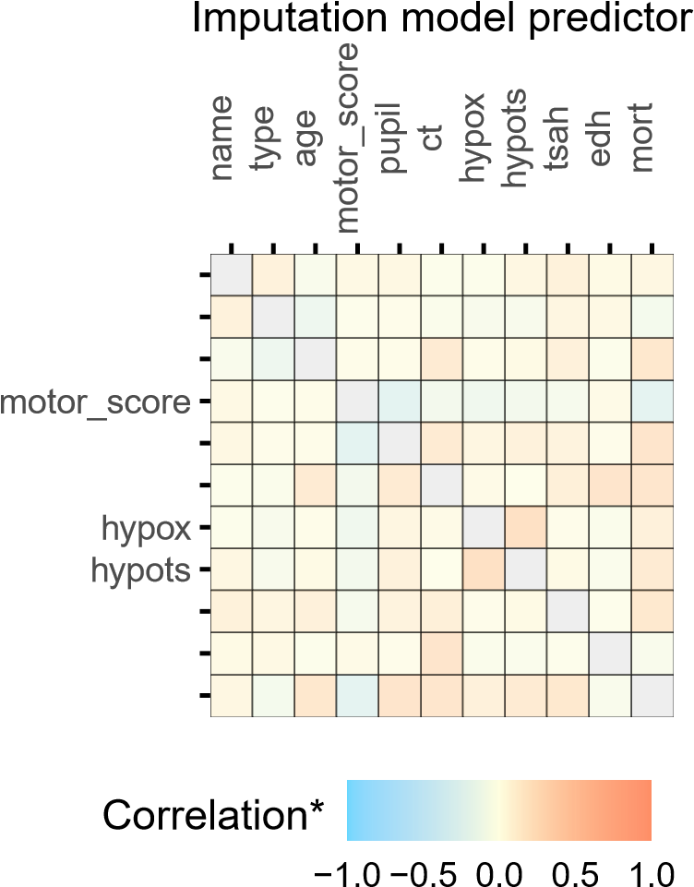name type age

Variable to impute

pupil ct

tsah edh mort

*pairwise complete observations

This shows us that hypox and hypot would not be useful auxiliary variables for imputing ct. Depending on the minimum required correlation, tsah could be useful, while edh has the strongest correlation with ct out of all the variables in the data and should definitely be included in the imputation model. For the imputation of pupil, none of the potential auxiliary variables has a very strong relation, but hypots could be used. We conclude that we can exclude hypox from the data, since this is neither an analysis model variable nor an auxiliary variable for imputation:

*R> dat <- select(dat, !hypox) # remove variable*

## Complete case analysis

As previously stated, complete case analysis lowers statistical power and may bias results. The complete case analysis estimates are:

*R> fit <- glmer(mod, family = "binomial", data = na.omit(dat)) # fit the model*

*R> tidy(fit, conf.int = TRUE, exponentiate = TRUE) # print estimates*

# A tibble: 11 x 9 effect group term estimate std.error statistic p.value conf.low conf.high

|  |  |  |  |  |  |
| --- | --- | --- | --- | --- | --- |
| <chr> <chr> <chr> | <dbl> | <dbl> | <dbl> <dbl> | <dbl> | <dbl> |
| 1 fixed <NA> (Int~ | 0.0863 | 0.0182 | -11.6 2.99e-31 | 0.0571 | 0.130 |
| 2 fixed <NA> type~ | 0.757 | 0.137 | -1.54 1.22e- 1 | 0.531 | 1.08 |
| 3 fixed <NA> age | 1.03 | 0.00265 | 12.9 7.40e-38 | 1.03 | 1.04 |
| 4 fixed <NA> moto~ | 0.651 | 0.0732 | -3.82 1.34e- 4 | 0.522 | 0.811 |
| 5 fixed <NA> moto~ | 0.489 | 0.0555 | -6.30 2.97e-10 | 0.391 | 0.611 |
| 6 fixed <NA> moto~ | 0.274 | 0.0321 | -11.0 2.28e-28 | 0.218 | 0.345 |
| 7 fixed <NA> pupi~ | 3.20 | 0.317 | 11.7 8.18e-32 | 2.63 | 3.88 |
| 8 fixed <NA> pupi~ | 1.75 | 0.195 | 5.06 4.27e- 7 | 1.41 | 2.18 |
| 9 fixed <NA> ctIII | 2.41 | 0.268 | 7.89 3.05e-15 | 1.94 | 2.99 |
| 10 fixed <NA> ctIV~ | 2.30 | 0.214 | 8.95 3.55e-19 | 1.92 | 2.76 |
| 11 ran_pa~ name sd__~ | 0.230 | NA | NA NA | NA | NA |
| As we can see... [TODO: fill in.]  **4.3. Imputation model** | |

The first imputation model that we’ll use is likely to be invalid. We do not use the cluster identifier name as imputation model predictor. With this model, we ignore the multilevel structure of the data, despite the high ICC. This assumes exchangeability between units. We include it purely to illustrate the effects of ignoring the clustering in our imputation effort. We’ll use the default imputation methods in mice() (predictive mean matching to impute the continuous variables and logistic regression to impute binary variables).

Updated until here!

Create a methods vector and predictor matrix, and make sure name is not included as predictor:

*R> meth <- make.method(dat) # methods vector*

*R> pred <- quickpred(dat) # predictor matrix*

*R> plot_pred(pred)*

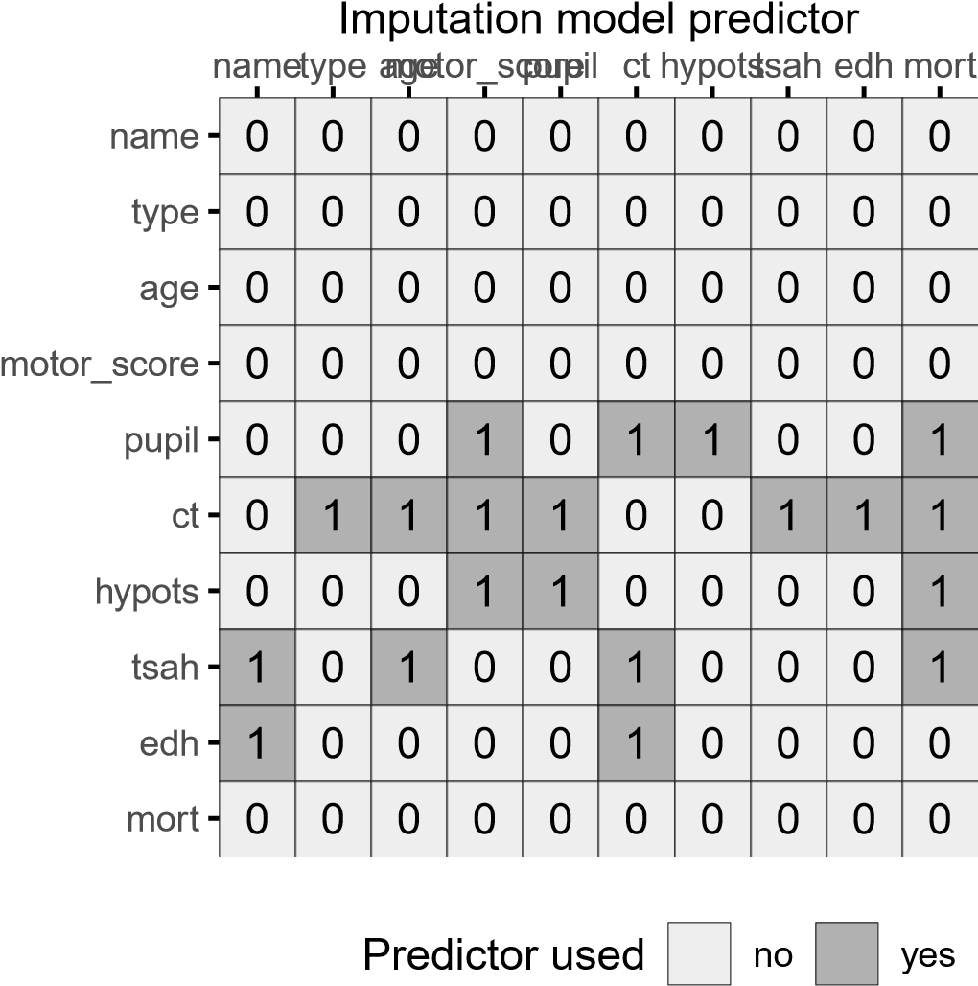

Variable to impute

[TODO: mutate data to get the right data types for imputation (e.g. integer for clustering

variable).]

# Discussion

* JOMO in mice -> on the side for now
* Additional levels of clustering
* More complex data types: timeseries and polynomial relationship in the clustering.

# Think about

* Adding some kind of help function to mice that suggests a suitable predictor matrix to the user, given a certain analysis model.
* Adding a multilevel_ampute() wrapper function in mice.
* Exporting mids objects to other packages like lme4 or coxme?
* Adding a ICC=0 dataset to show that even if there is no clustering it doesn’t hurt.
* Show use case for deductive imputation for cluster level variables?
* env dump in repo

# References

Audigier V, White IR, Jolani S, Debray TPA, Quartagno M, Carpenter J, van Buuren S, Resche-Rigon M (2018). “Multiple Imputation for Multilevel Data with Continuous and Binary Variables.” Statistical Science, **33**(2), 160–183. ISSN 0883-4237, 2168-8745. [doi:](https://doi.org/10.1214/18-STS646)

[10.1214/18-STS646.](https://doi.org/10.1214/18-STS646) 1702.00971.

Debray T, de Jong V (2021). “Metamisc: Meta-Analysis of Diagnosis and Prognosis Research

Studies.”

Drechsler J (2015). “Multiple Imputation of Multilevel Missing Data—Rigor Versus Simplicity.” Journal of Educational and Behavioral Statistics, **40**(1), 69–95. ISSN 1076-9986. [doi:10.3102/1076998614563393.](https://doi.org/10.3102/1076998614563393)

Enders CK, Mistler SA, Keller BT (2016). “Multilevel Multiple Imputation: A Review and Evaluation of Joint Modeling and Chained Equations Imputation.” Psychological Methods, **21**(2), 222–240. ISSN 1939-1463. [doi:10.1037/met0000063.](https://doi.org/10.1037/met0000063)

Grund S, Lüdtke O, Robitzsch A (2018). “Multiple Imputation of Missing Data for Multilevel Models: Simulations and Recommendations.” Organizational Research Methods, **21**(1), 111–149. ISSN 1094-4281. [doi:10.1177/1094428117703686.](https://doi.org/10.1177/1094428117703686)

Hox J, van Buuren S, Jolani S (2015). “Incomplete Multilevel Data: Problems and Solutions.” In J Harring, L Staplecton, S Beretvas (eds.), Advances in Multilevel Modeling for Educational Research: Addressing Practical Issues Found in Real-World Applications, CILVR Series on Latent Variable Methodology, pp. 39–62. Information Age Publishing Inc., Charlotte, NC. ISBN 978-1-68123-328-4.

Hox JJ, Moerbeek M, van de Schoot R (2017). Multilevel Analysis: Techniques and Applications, Third Edition. Routledge. ISBN 978-1-317-30868-3.

Jolani S (2018). “Hierarchical Imputation of Systematically and Sporadically Missing Data: An Approximate Bayesian Approach Using Chained Equations.” Biometrical Journal. Biometrische Zeitschrift, **60**(2), 333–351. ISSN 1521-4036. [doi:10.1002/bimj.201600220.](https://doi.org/10.1002/bimj.201600220) Radice GMaR (2021). “GJRM: Generalised Joint Regression Modelling.”

Reiter JP, Raghunathan T, Kinney SK (2006). “The Importance of Modeling the Sampling Design in Multiple Imputation for Missing Data.” undefined.

Resche-Rigon M, White IR, Bartlett JW, Peters SAE, Thompson SG (2013). “Multiple Imputation for Handling Systematically Missing Confounders in Meta-Analysis of Individual Participant Data.” Statistics in medicine, **32**(28), 4890–4905. ISSN 1097-0258 0277-6715. [doi:10.1002/sim.5894.](https://doi.org/10.1002/sim.5894)

Rubin DB (1976). “Inference and Missing Data.” Biometrika, **63**(3), 581–592. [doi:10.2307/](https://doi.org/10.2307/2335739)

[2335739.](https://doi.org/10.2307/2335739)

Van Buuren S (2018). Flexible Imputation of Missing Data. Chapman and Hall/CRC.

van Buuren S, Groothuis-Oudshoorn K (2021). “Mice: Multivariate Imputation by Chained Equations.”

Yucel RM (2008). “Multiple Imputation Inference for Multivariate Multilevel Continuous Data with Ignorable Non-Response.” Philosophical Transactions of the Royal Society A: Mathematical, Physical and Engineering Sciences, **366**(1874), 2389–2403. [doi:10.1098/ rsta.2008.0038.](https://doi.org/10.1098/rsta.2008.0038)

**Affiliation:**

Hanne Oberman

Utrecht University

Padualaan 14

3584 CH Utrecht

E-mail: h.i.oberman@uu.nl

URL: <https://hanneoberman.github.io/>

*Journal of Statistical Software* <http://www.jstatsoft.org/>published by the Foundation for Open Access Statistics <http://www.foastat.org/>

MMMMMM YYYY, Volume VV, Issue II *Submitted:* yyyy-mm-dd [doi:10.18637/jss.v000.i00](https://doi.org/10.18637/jss.v000.i00) *Accepted:* yyyy-mm-dd