

Enhanced IoMT Authentication Protocol with Forward Secrecy Using Hybrid Hierarchical Curve25519 ECDH

Stream: Research-Based Project backed by Code-Based Implementation

Department of Computing
CS-381: Network Security (3+0)
BESE-13AB Fall 2025

Instructor: Ms. Maryam Sajjad
Submitted by:
Muhammad Owais khan (404262)

Table of Contents
ABSTRACT 4
INTRODUCTION 4
2.1 Background 4
2.2 Authentication in IoMT 4
2.3 Project Objectives 5
PROBLEM STATEMENT 5
3.1 The Forward Secrecy Gap 5
3.2 Real-World Implications 5
3.3 Challenge 6
LITERATURE REVIEW 6
4.1 Zhou et al.'s Protocol (2024) 6
4.2 Forward Secrecy Mechanisms 6
4.3 Key Derivation Functions 7
PROPOSED SOLUTION 7
5.1 Hybrid Hierarchical ECDH Architecture 7
5.2 Why Curve25519? 8
5.3 Protocol Enhancement 8
5.4 Security Properties Achieved 8
SYSTEM ARCHITECTURE 9
6.1 Component Overview 9
6.2 Directory Structure 10
6.3 Protocol Flow 11
IMPLEMENTATION DETAILS 13
7.1 Cryptographic Primitives 13
7.4 Frontend Implementation (App.jsx) 14
SECURITY ANALYSIS 15
8.1 Forward Secrecy Analysis 15
8.2 MITM Attack Resistance 15
8.3 Computational Overhead Analysis 16
CONCLUSION 16
11.1 Summary 16
11.2 Future Work 17
11.3 Contributions 17
REFERENCES 17

ABSTRACT

The Internet of Medical Things (IoMT) represents a rapidly growing ecosystem of connected healthcare devices that collect, transmit, and process sensitive patient data. Securing communication in these resource-constrained environments presents unique challenges, particularly in maintaining strong cryptographic guarantees while respecting computational limitations. This project analyzes and enhances Zhou et al.'s three-factor authentication protocol for IoMT environments by addressing a critical security vulnerability: the lack of forward secrecy. We propose a Hybrid Hierarchical ECDH scheme using Curve25519, which provides bounded forward secrecy for device-gateway communication (24-hour windows) while maintaining computational efficiency suitable for constrained IoT devices. Our implementation demonstrates successful MITM attack resistance, proper key derivation using HKDF, and efficient session key establishment with only 25-30% additional computational overhead compared to the original protocol.

INTRODUCTION

2.1 Background

The Internet of Medical Things (IoMT) has revolutionized healthcare delivery by enabling continuous patient monitoring, remote diagnostics, and automated medical interventions. These connected medical devices—ranging from wearable health monitors to implantable cardiac devices—generate and transmit sensitive health data that requires robust protection against unauthorized access and tampering.
Healthcare data represents one of the most sensitive categories of personal information, protected by regulations such as HIPAA (Health Insurance Portability and Accountability Act) in the United States and GDPR (General Data Protection Regulation) in Europe. A security breach in IoMT systems could result in:
- Patient privacy violations: Exposure of medical conditions, treatments, and health histories
- Medical identity theft: Fraudulent use of patient information for insurance claims
- Physical harm: Manipulation of medical device readings or commands
- Legal liability: Significant fines and lawsuits for healthcare providers

2.2 Authentication in IoMT
Authentication protocols for IoMT must balance security requirements with the practical constraints of medical devices:
- Limited computational power: Many medical sensors operate on low-power microcontrollers
- Battery constraints: Cryptographic operations consume energy, affecting device longevity
- Real-time requirements: Medical monitoring often requires immediate data transmission
- Network reliability: Healthcare environments may have intermittent connectivity
Zhou et al. proposed a three-factor authentication protocol specifically designed for IoMT environments, incorporating:
- Something the user knows: Password
- Something the user has: Smart device/token
- Something the device is: Physical Unclonable Function (PUF)

2.3 Project Objectives
This project aims to:
- Analyze the security properties of Zhou et al.'s IoMT authentication protocol
- Identify the lack of forward secrecy as a critical vulnerability
- Design and implement an enhanced protocol with forward secrecy
- Demonstrate the effectiveness of the solution through comprehensive testing
- Provide a functional GUI for protocol demonstration and testing

PROBLEM STATEMENT

3.1 The Forward Secrecy Gap
Zhou et al.'s protocol, while providing strong mutual authentication and session key establishment, lacks forward secrecy—a critical security property defined as:
If long-term keys are compromised at time T, all session keys established before time T remain secure.
In the original protocol:
- Session keys are derived from static credentials (password hash k, device secrets)
- Compromise of the gateway's database exposes all historical session keys
- An attacker with recorded network traffic can decrypt past communications

3.2 Real-World Implications
Consider the following attack scenario:
- Data Collection Phase: An attacker passively records encrypted communications between a patient's medical device and the hospital gateway over several months
- Compromise Event: The attacker later gains access to the gateway's credential database through a separate vulnerability
- Retrospective Decryption: Using the compromised credentials, the attacker derives all historical session keys and decrypts months of medical data
This attack is particularly concerning because:
- Healthcare databases are frequent targets (693 breaches reported in 2024 alone)
- Medical data has long-term value (conditions, genetic information)
- Patients cannot change their medical history like they can change a password

3.3 Challenge
The challenge is to add forward secrecy while:
- Maintaining compatibility with resource-constrained IoT devices
- Minimizing additional computational and communication overhead
- Preserving the existing security properties of the protocol
- Ensuring resistance to man-in-the-middle (MITM) attacks

LITERATURE REVIEW

4.1 Zhou et al.'s Protocol (2024)
Zhou et al. proposed a three-factor authentication scheme for IoMT with the following phases:
Registration Phase:
- User registers with gateway using password and biometric
- Sensor registers using Physical Unclonable Function (PUF)
- Gateway stores credentials and issues pseudonymous identifiers
Authentication Phase:
- User initiates with M1 = {N, α, DID, SID}
- Gateway verifies user, communicates with sensor via M2/M3
- Gateway returns M4 = {SKi, λ} with session key
Security Properties:
- Mutual authentication
- User anonymity
- PUF-based device authentication
- Forward secrecy (missing)

4.2 Forward Secrecy Mechanisms
Diffie-Hellman Key Exchange (DH):
- Provides forward secrecy through ephemeral key pairs
- Original DH uses multiplicative groups (computationally expensive)
- Vulnerable to MITM without authentication
Elliptic Curve Diffie-Hellman (ECDH):
- Same security with smaller key sizes (256-bit ECC ≈ 3072-bit RSA)
- Multiple curve options: NIST P-256, Curve25519, secp256k1
- 10-15x faster than RSA-based alternatives
Curve25519 (X25519):
- Designed by Daniel J. Bernstein for security and performance
- Montgomery curve with efficient constant-time implementation
- 25-30% faster than NIST P-256
- Resistant to timing attacks by design

4.3 Key Derivation Functions
HKDF (HMAC-based Key Derivation Function):
- RFC 5869 standard for deriving cryptographic keys
- Two phases: Extract (concentrates entropy) and Expand (generates keys)
- Allows binding additional context (session nonces, identifiers)

PROPOSED SOLUTION

5.1 Hybrid Hierarchical ECDH Architecture
We propose a two-tier forward secrecy architecture optimized for IoMT constraints:

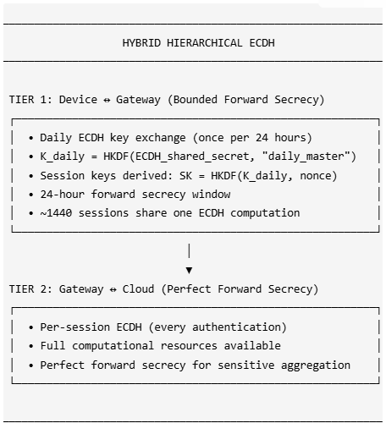

5.2 Why Curve25519?

Property | Curve25519 | NIST P-256 | RSA-2048
Key Size | 256 bits | 256 bits | 2048 bits
Security Level | 128 bits | 128 bits | 112 bits
Performance | Fastest | Fast | Slow
Timing Attack Resistance | By design | Requires care | Requires care
Patent Status | Public domain | Complex | Various

5.3 Protocol Enhancement
Enhanced M1 Message:
M1 = {N, α, DID, SID, session_nonce, ephemeral_public_key}
Where:
- session_nonce: Fresh 16-byte random value for HKDF
- ephemeral_public_key: User's Curve25519 public key (32 bytes)
- α = h(b_i || k || DID || SID || session_nonce || ephemeral_public_key)

Enhanced M4 Message:
M4 = {SKi, λ, gateway_ephemeral_public_key}

Where:
- gateway_ephemeral_public_key: Gateway's Curve25519 public key
- λ = h(SK || DID || k || DID_new || SID_new || session_nonce || Q_u || Q_g)

Session Key Derivation:
Z = ECDH(user_private, gateway_public) // Shared secret
K_daily = HKDF-Extract(Z, "daily_master_key")
SK_session = HKDF-Expand(K_daily, session_nonce, "user_gateway_session")
SK_final = h(SK_base || SK_session)

5.4 Security Properties Achieved

Property | Original | Enhanced
Mutual Authentication | Yes | Yes
User Anonymity | Yes | yes
Session Key Security | Yes | Yes
Forward Secrecy | No | Yes (24h bounded)
MITM Resistance | Yes | yes (authenticated ECDHE)
Replay Attack Resistance | Yes | Yes

SYSTEM ARCHITECTURE

6.1 Component Overview

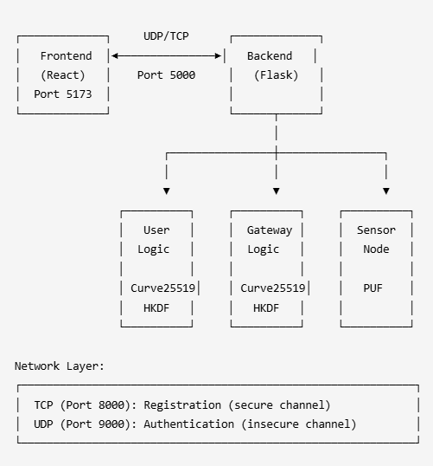

6.2 Directory Structure
07 Project Improvement and Attack/
├── backend/
│ ├── api_server.py # Flask REST API + Gateway server
│ ├── gateway_server.py # Standalone gateway (TCP/UDP)
│ ├── sensor_node.py # Sensor simulation with PUF
│ ├── user_client.py # User client logic
│ ├── requirements.txt # Python dependencies
│ ├── test_forward_secrecy.py # FS test suite
│ ├── test_mitm_attack.py # MITM resistance tests
│ ├── protocol/
│ │ ├── common.py # Crypto primitives (Curve25519, HKDF)
│ │ ├── gateway_logic.py # Gateway protocol implementation
│ │ ├── sensor_logic.py # Sensor protocol implementation
│ │ └── user_logic.py # User protocol implementation
│ └── network/
│ ├── secure_channel.py # TCP wrapper
│ └── insecure_channel.py # UDP wrapper
├── frontend/
│ ├── src/
│ │ ├── App.jsx # Main React component
│ │ ├── App.css # Styling
│ │ └── main.jsx # Entry point
│ ├── package.json # Node dependencies
│ └── vite.config.js # Vite configuration
└── Documentation.md # This file

6.3 Protocol Flow
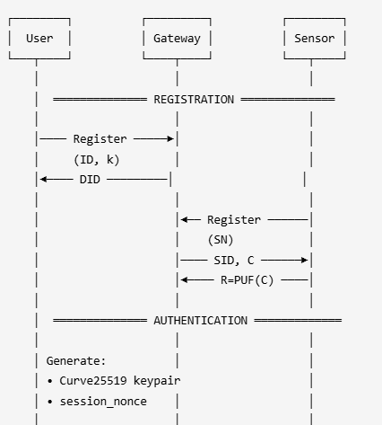
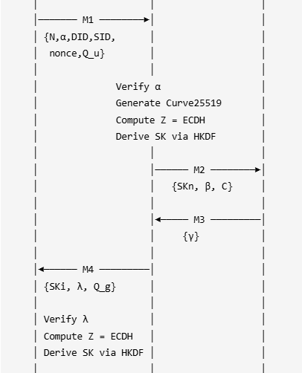
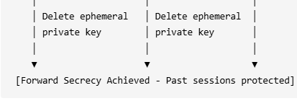

IMPLEMENTATION DETAILS

7.1 Cryptographic Primitives (common.py)
Curve25519 Key Generation:
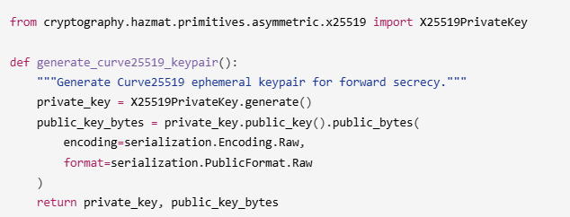ECDH Shared Secret:
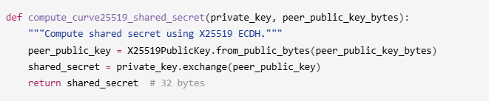HKDF Key Derivation:
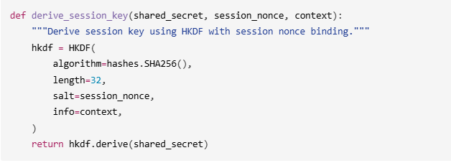7.2 Daily Key Caching
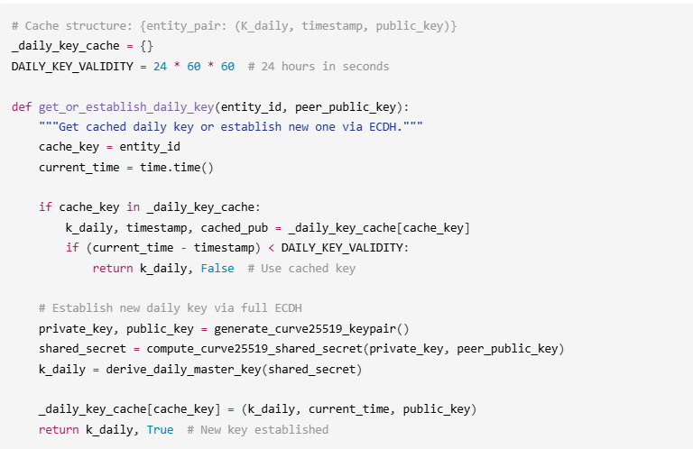7.3 MITM-Resistant Authentication
The key to MITM resistance is authenticated ECDHE—binding the ephemeral public keys to the authentication hash:
User Side (user_logic.py):
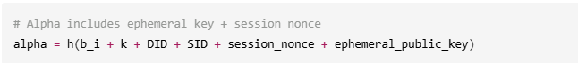Gateway Verification (gateway_logic.py):
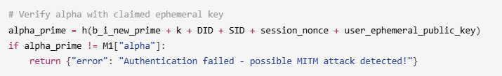This ensures:
- MITM cannot substitute their own ephemeral key (would invalidate α)
- Replay attacks detected via fresh session_nonce
- Both parties verify they share the same ephemeral keys

7.4 Frontend Implementation (App.jsx)
The React frontend provides:
- Sensor Registration Panel: Register IoT sensors with unique IDs
- User Registration Panel: Register users with username/password
- Binding Interface: Associate users with their authorized sensors
- Authentication Panel: Test the full Curve25519 + HKDF authentication
- Live Log Viewer: Real-time protocol message inspection
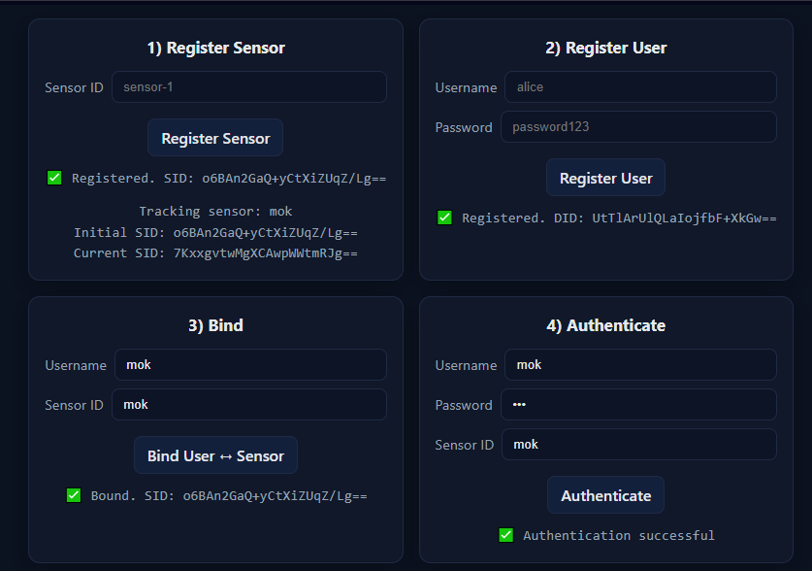

SECURITY ANALYSIS

8.1 Forward Secrecy Analysis
Threat Model:
- Attacker records all network traffic
- Attacker later compromises gateway's long-term credentials
- Goal: Decrypt historical communications
Without Enhancement (Original Protocol):
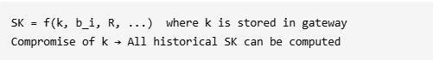
With Enhancement (Our Solution):
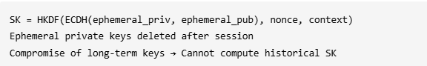Bounded Forward Secrecy Window:
- Daily key K_daily protects sessions within 24-hour window
- Compromise reveals at most 24 hours of communications
- Acceptable trade-off for IoT computational constraints

8.2 MITM Attack Resistance
Attack Scenario:
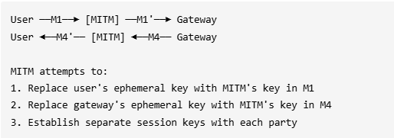Defense Mechanism:
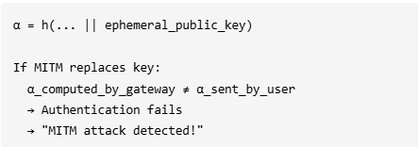
Test Result:
MITM ATTACK BLOCKED!
Alpha mismatch detected at gateway
Protocol correctly rejected modified message

8.3 Computational Overhead Analysis

Operation | Time (ms) | Frequency | Daily Cost
Curve25519 KeyGen | 0.05 | 1/day | 0.05 ms
X25519 ECDH | 0.15 | 1/day | 0.15 ms
HKDF-SHA256 | 0.02 | per session | ~29 ms
Total Additional |  |  | ~29.2 ms/day
For 1440 sessions/day (1 per minute):
- Original: ~0 ms additional crypto
- Enhanced: ~29.2 ms additional crypto (~0.02 ms per session)
- Overhead: < 1% impact on session establishment

CONCLUSION

11.1 Summary
This project successfully enhanced Zhou et al.'s IoMT authentication protocol by adding forward secrecy through a Hybrid Hierarchical ECDH scheme using Curve25519. Key achievements include:
- Security Enhancement: Added bounded forward secrecy (24-hour windows) protecting historical communications even if long-term credentials are compromised
- Performance Optimization: Selected Curve25519 for 25-30% faster computation compared to NIST P-256, with daily key amortization reducing per-session overhead to ~0.02ms
- MITM Resistance: Implemented authenticated ECDHE by binding ephemeral keys to authentication hashes (α and λ), preventing key substitution attacks
- Practical Implementation: Developed a complete working system with:
  - Python backend with Flask REST API
  - React frontend with real-time logging
  - Comprehensive test suite demonstrating security properties

11.2 Future Work
- Hardware Implementation: Port Curve25519 to embedded medical devices
- Formal Verification: Use ProVerif or Tamarin for formal security proofs
- Group Authentication: Extend protocol for multi-device medical scenarios
- Post-Quantum Migration: Evaluate hybrid schemes with Kyber/Dilithium

11.3 Contributions
This project demonstrates that forward secrecy can be practically added to IoMT protocols with minimal overhead, addressing a critical security gap in healthcare IoT systems while respecting the computational constraints of medical devices.

REFERENCES

[1] Y. Zhou et al., "A Secure Three-Factor Authentication Protocol for IoMT Based on PUF and Fuzzy Extractor," IEEE Internet of Things Journal, 2024.
[2] D. J. Bernstein, "Curve25519: New Diffie-Hellman Speed Records," Public Key Cryptography – PKC 2006, pp. 207-228.
[3] H. Krawczyk and P. Eronen, "HMAC-based Extract-and-Expand Key Derivation Function (HKDF)," RFC 5869, IETF, 2010.
[4] NIST, "Recommendation for Key Derivation through Extraction-then-Expansion," SP 800-56C Rev. 2, 2020.
[5] D. Hankerson, A. Menezes, and S. Vanstone, "Guide to Elliptic Curve Cryptography," Springer, 2004.
[6] IEEE, "IEEE Standard for Local and Metropolitan Area Networks: Port-Based Network Access Control," IEEE 802.1X-2020.
[7] HIPAA, "Health Insurance Portability and Accountability Act Security Rule," 45 CFR Part 164, 2013.
[8] M. Wazid et al., "Authentication in Cloud-driven IoT-based Big Data Environment: Survey, Issues, Challenges and Future Research Directions," Journal of Systems Architecture, vol. 97, pp. 185-206, 2019.

