Using google sheets / python - We want to get these pdf documents as they are released – system reads the documents and scans for key words. See XL for the user interface.

<https://www2.asx.com.au/markets/trade-our-cash-market/todays-announcements>

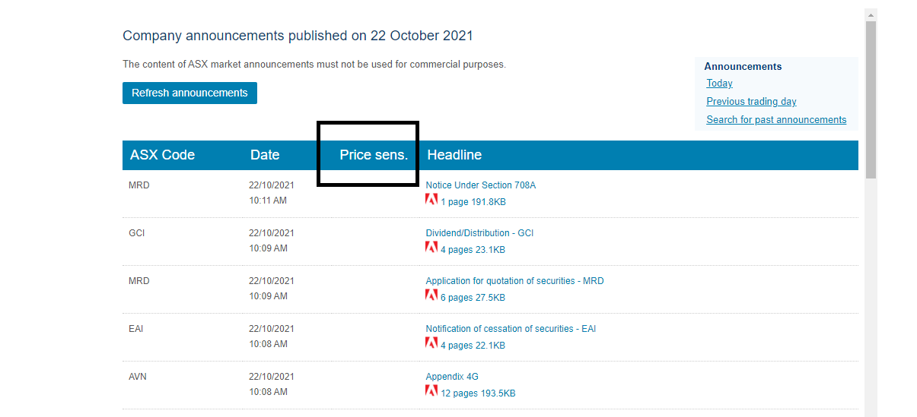

|  |  |  |  |  |  |  |  |  |  |  |
| --- | --- | --- | --- | --- | --- | --- | --- | --- | --- | --- |
| We will have 2500 companies listed here. The user interface needs to follow a grid format and display on one page. For now we will be looking at the data received for the day and not store historical records. If the system finds key words in the articles highlight the cell as green or red if its positive or negative. This will bring that particular article to the users attention. Social media Column J and K and news data to be fed into the system in phase 2. | | | | | | | | | | |
| **Company name** | **ASX code** | **Headline** | **Date published** | **PDF** | **Total Positive Key words** | **Positive Key words found** | **Total negative Key words** | **Negative Key words found** | **Social Media** | **News** |
| Avz Minerals Ltd | AVZ | Corporate Update  2 pages 304.8KB | 20/10/2021 1:46 PM | Link to PDF | 8 | Deal New client Customer | 12 | Cancel etc |  |  |
| Avz Minerals Ltd | AVZ | Corporate Update  2 pages 304.8KB | 20/10/2021 1:46 PM | Link to PDF | 8 | Deal New client Customer | 12 | Cancel etc |  |  |
| Avz Minerals Ltd | AVZ | Corporate Update  2 pages 304.8KB | 20/10/2021 1:46 PM | Link to PDF | 8 | Deal New client Customer | 12 | Cancel etc |  |  |