Unit 1: Numbers
Lesson 3: Comparing and Ordering Numbers

Introduction
Have you ever counted your birthday money and wondered whose piggy bank has more? Or looked at two big numbers and wondered which one wins? In this lesson, you will learn how to find 4-digit numbers on a number line, and how to compare and order them using the words before, after and between, and the signs <, > and =.

Students Learning Outcomes:
By the end of this lesson, I can:
- Use number lines to locate, compare and order 4-digit numbers.
- Compare numbers using symbols and arrange numbers up to 9,999 in ascending and descending order using appropriate language (before, after and between) and <, > and = signs.

Warm-Up Activity:
- Look at 2,000 and 5,000. Which number is bigger?
- Think of your house number or phone number. Can you find a number bigger than it?
- If you had 1,500 rupees and your friend had 1,050 rupees, who has more money?

Concept Building
What is a Number Line?
A number line is like a long road with numbers written on it in order. The numbers get bigger as we move to the right, and smaller as we move to the left. We can use a number line to find where a 4-digit number lives, and to see which numbers are bigger or smaller.
Reading a 4-Digit Number Line
A 4-digit number line can show numbers like 1000, 2000, 3000, all the way up to 9000. Each jump on the line is called a step. On a number line from 1000 to 9000, each step is usually worth 1000.
Look at the picture below. A small house needs about 1,000 bricks, a shelf of books might be around 3,000 pages, a piggy bank could hold 5,000 rupees, a school stadium can seat about 7,000 people, and a tall mountain might be 9,000 metres high! The number line helps us picture how big these numbers really are.
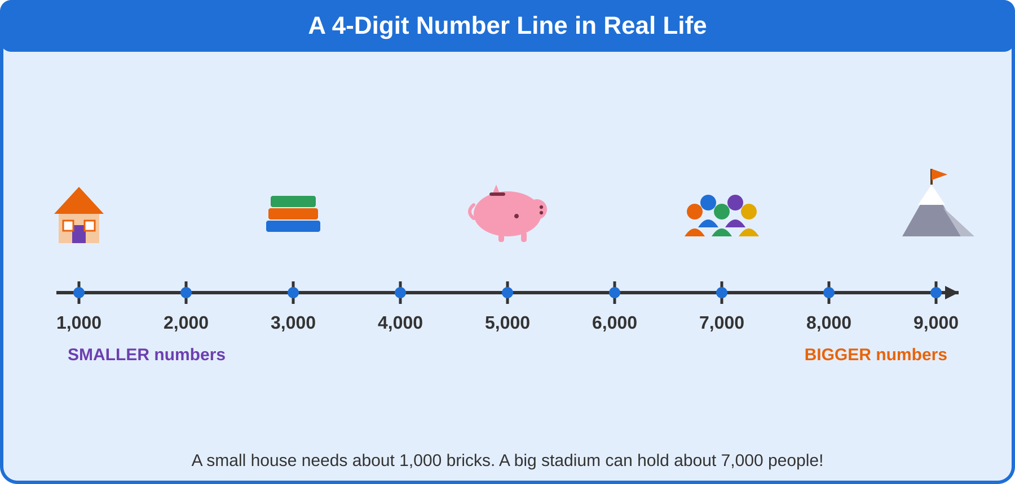
A 4-digit number line showing how numbers grow from 1,000 to 9,000.
We can also use a number line to find the number that comes before, after or between other numbers.
Example: On the number line, 4000 comes after 3000 and before 5000. It is between 3000 and 5000.
Remember!
Numbers to the RIGHT on a number line are always BIGGER.
Numbers to the LEFT on a number line are always SMALLER.
"Before" means one step back. "After" means one step forward.
"Between" means in the middle of two numbers.

The Alligator Signs: <, > and =
We use special signs to compare numbers: < (less than), > (greater than) and = (equal to).
Think of these signs as a hungry alligator's mouth! The alligator is greedy and always wants to eat the BIGGER number, so its mouth opens wide towards the bigger number.
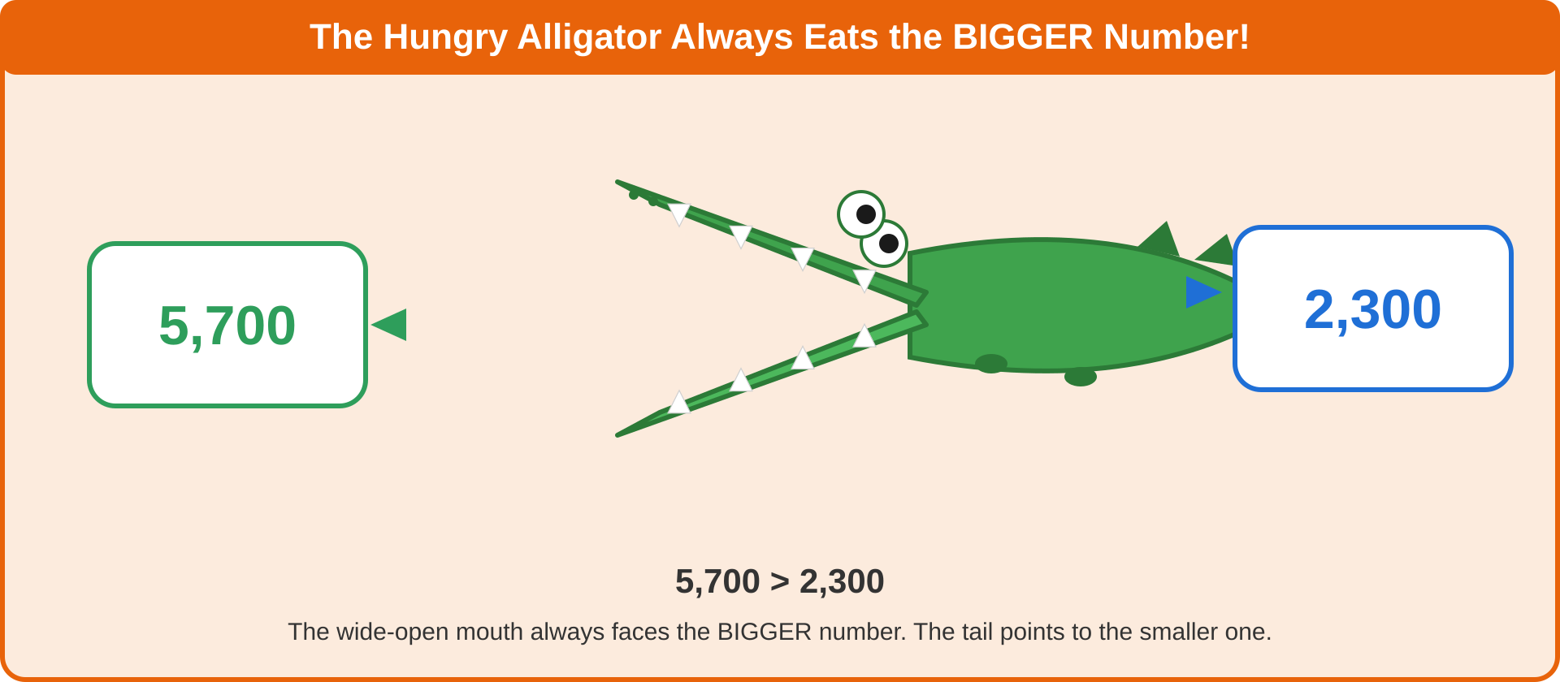
The alligator's wide-open mouth always faces the bigger number, and its tail points to the smaller one.
Remember!
5,700 > 2,300 (mouth opens towards the bigger number)
4,000 = 4,000 (the = sign means both numbers are exactly the same)

Ascending and Descending Order
Ascending means going UP! Just like walking up the stairs, we start with the smallest number and climb up to the biggest number.
Descending means going DOWN! Just like sliding down a slide, we start with the biggest number and slide down to the smallest number.
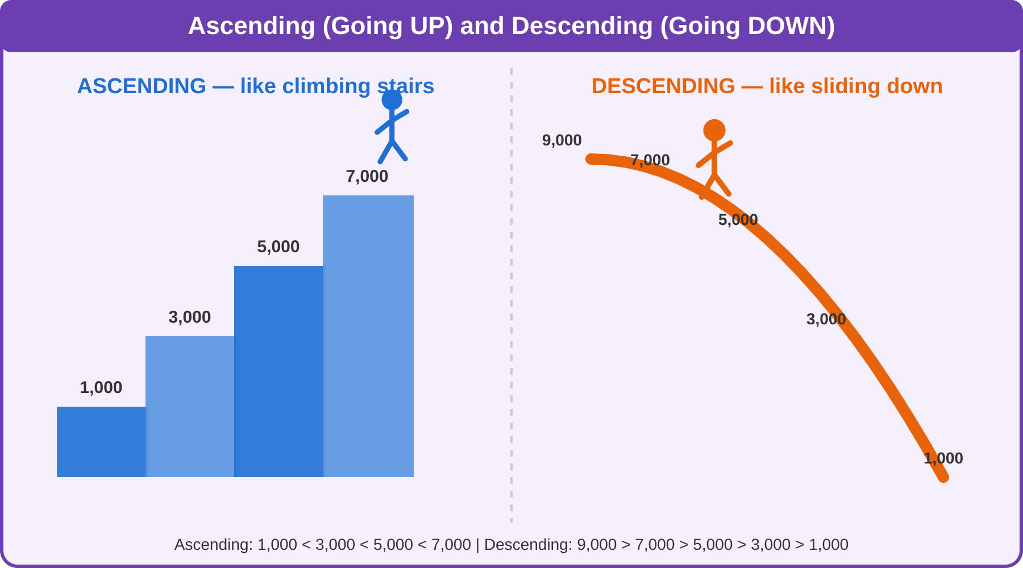
Climbing stairs = ascending order. Sliding down = descending order.
Remember!
Ascending order = smallest to biggest (going UP the stairs).
Descending order = biggest to smallest (going DOWN the slide).

Real-Life Number Comparisons
4-digit numbers are all around us! Let's look at some real-life examples where children compare numbers, just like you do every day.
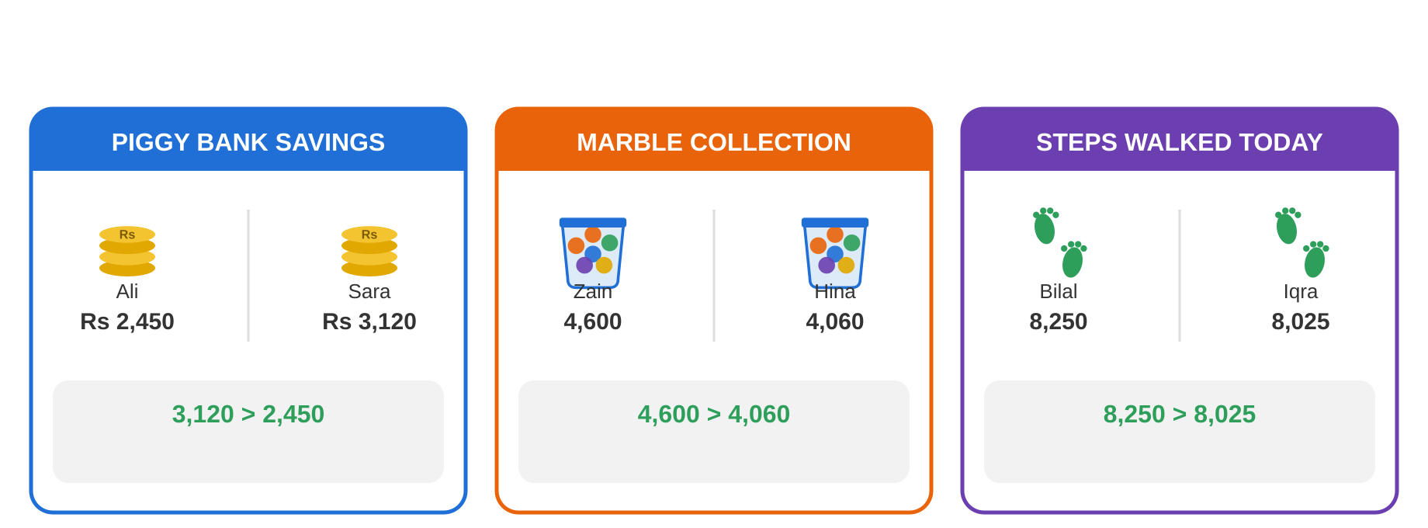
Comparing 4-digit numbers in everyday situations: savings, marbles, and steps walked.
Notice how in each example, we compare the numbers the same way: look at the thousands digit first, then keep comparing digit by digit until one number is bigger.
Examples
Example 1
Which number is bigger: 3,482 or 3,428?
We compare digit by digit, starting from the left.
Thousands: 3 = 3 (same)
Hundreds: 4 = 4 (same)
Tens: 8 is bigger than 2
Answer: 3,482 > 3,428, so 3,482 is bigger.
Example 2
Look at this number line:
2000 — 3000 — 4000 — 5000 — 6000

What number comes before 5000, and what number comes after 5000?
Answer: 4000 comes before 5000. 6000 comes after 5000.
Example 3
Put these numbers in ascending order (smallest to biggest): 6,250 1,900 4,700
We look at the thousand digit first: 1, 4, 6
1 is the smallest, then 4, then 6.
Answer: 1,900 < 4,700 < 6,250

Example 4
Put these numbers in descending order (biggest to smallest): 8,105 8,150 8,015
The thousands and hundreds digits are the same (8,1__), so we look at the tens digit.
8,150 has 5 tens, 8,105 has 0 tens, and 8,015 has only 0 hundreds so it is the smallest.
Answer: 8,150 > 8,105 > 8,015
Checkpoint
Compare the thousands digit first. If they are the same, compare the hundreds, then tens, then ones.
Ascending = going UP, smallest to biggest.
Descending = going DOWN, biggest to smallest.
5,600 > 4,800 means 5,600 is bigger than 4,800.

Your Turn:
- Fill in <, > or =:
- 2,300 ___ 3,200
- 6,050 ___ 6,050
- 9,999 ___ 8,999
- Order these numbers from smallest to biggest: 4,600 1,200 7,800
- Look at this number line: 3000 — 4000 — 5000 — 6000 — 7000. What number is between 4000 and 6000?
Answer Key Your Turn:
1. a) 2,300 < 3,200 b) 6,050 = 6,050 c) 9,999 > 8,999
2. 1,200 < 4,600 < 7,800
3. 5000 is between 4000 and 6000.

Mental Math
Can you answer these in your head?
- Which is bigger: 5,000 or 5,500?
- Fill in < or >: 2,100 ___ 1,200
- What number comes after 3,999?
- What number comes before 7,000?
- Is 9,000 closer to the start or the end of a 1,000–9,000 number line?
- Which word fits: to go from smallest to biggest is called ___ (ascending / descending)?
Answer Key Mental Math:
1. 5,500 is bigger.
2. 2,100 > 1,200
3. 4,000
4. 6,999
5. The end (it is close to 9,000).
6. Ascending

Practice Questions
- What is a number line used for?
- Fill in <, > or =: 4,050 ___ 4,500
- Order from smallest to biggest: 8,100 2,900 5,600
- Order from biggest to smallest: 3,300 3,030 3,003
- What number comes between 5,999 and 6,001?
- Which is smaller: 7,650 or 7,605?
- Hamza has 4,200 marbles. Areeba has 4,020 marbles. Who has more marbles?
- Fill in <, > or =: 9,000 ___ 9,000
- Write these numbers in ascending order: 1,010 1,100 1,001
- A number line shows 2000, 3000, 4000, 5000. What number comes right after 4000?
Answer Key Practice:
1. To find, compare and order numbers, and to see what comes before, after or between them.
2. 4,050 < 4,500
3. 2,900 < 5,600 < 8,100
4. 3,300 > 3,030 > 3,003
5. 6,000
6. 7,605 is smaller.
7. Hamza has more marbles (4,200 > 4,020).
8. 9,000 = 9,000
9. 1,001 < 1,010 < 1,100
10. 5000

Think Time
Four friends counted the stickers in their sticker books:
Ahmed: 3,450 Sana: 3,540 Bilal: 3,045 Iqra: 3,504
Who has the most stickers? Who has the fewest stickers? Write the numbers in order from fewest to most.
Think Time Answer:
Most stickers: Sana (3,540). Fewest stickers: Bilal (3,045).
Order: 3,045 < 3,450 < 3,504 < 3,540

Key Takeaways:
- A number line helps us find and compare 4-digit numbers, from smallest on the left to biggest on the right.
- The words before, after and between describe a number's position on the number line.
- The alligator always opens its mouth towards the bigger number: < means less than, > means greater than, = means equal to.
- Ascending order means going UP, from smallest to biggest. Descending order means going DOWN, from biggest to smallest.
- To compare numbers, look at the thousands digit first, then hundreds, then tens, then ones.

