Hadoop & Data Engineering Assessment

Section 1: Data Ingestion & Setup
Terminal Commands
wget https://raw.githubusercontent.com/allisonhorst/palmerpenguins/main/inst/extdata/penguins.csv
ls -la
hadoop fs -copyFromLocal penguins.csv /user/maria_dev/datasets/penguins.csv
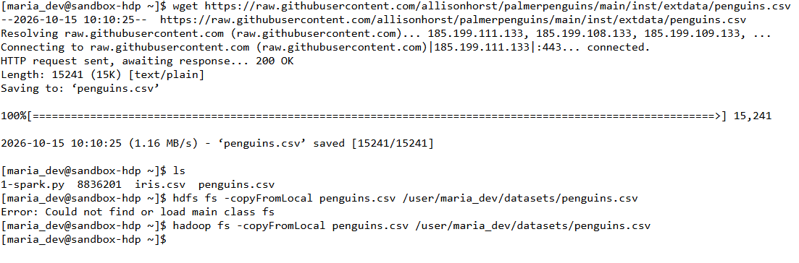
Output
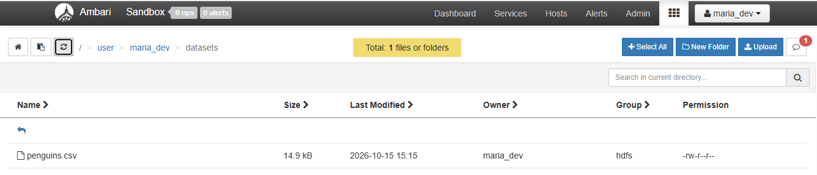

Section 2: Hive Table Creation & Data Analysis
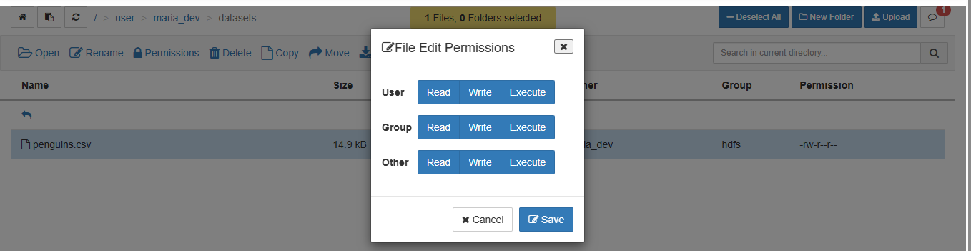
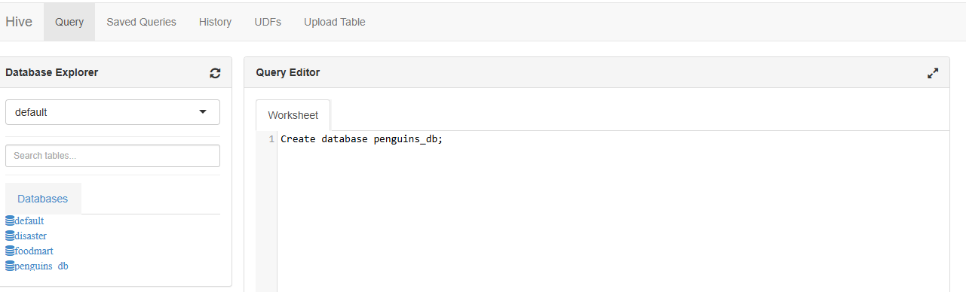
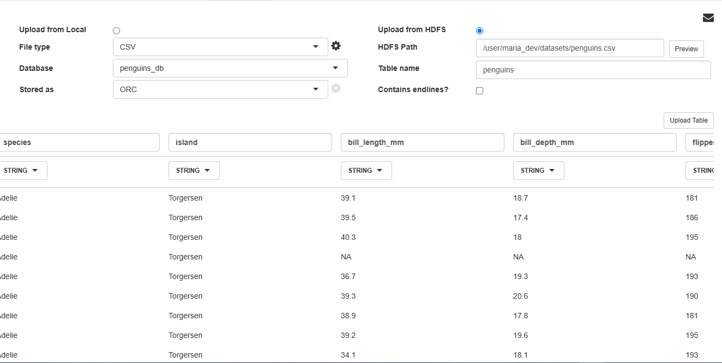

2.1 Data Ingestion & Initial Inspection
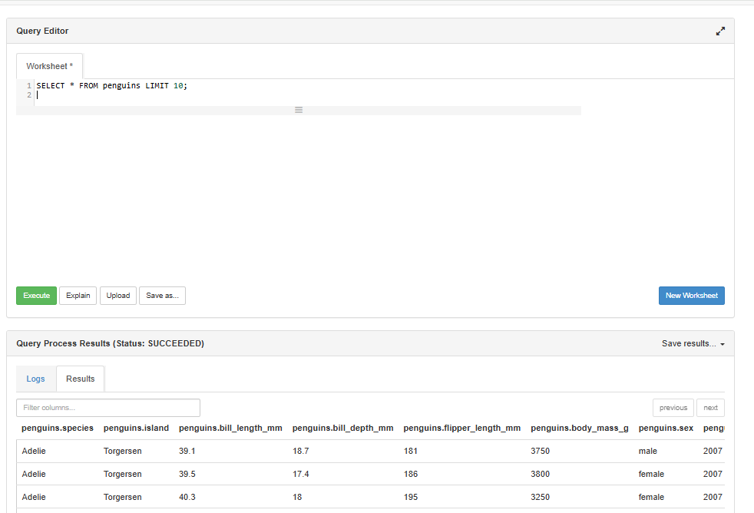
SELECT * FROM penguins LIMIT 10;

2.2 Record Counts by Species and Island
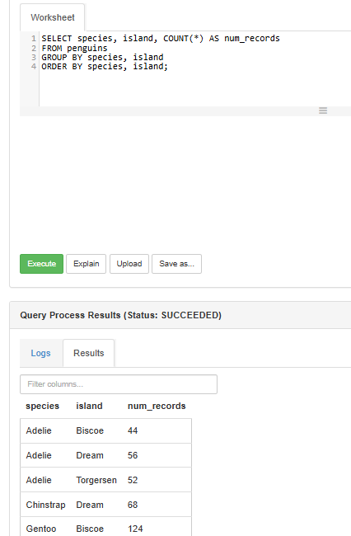
SELECT species, island, COUNT(*) AS num_records
FROM penguins
GROUP BY species, island
ORDER BY species, island;

2.3 Calculating Physical Metrics
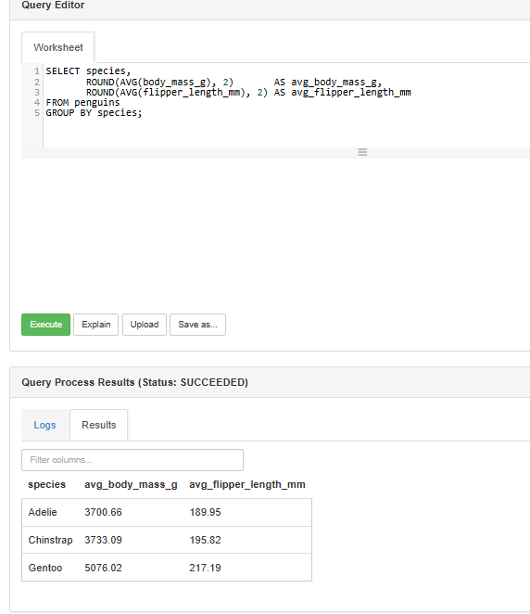
SELECT species,
ROUND(AVG(body_mass_g), 2) AS avg_body_mass_g,
ROUND(AVG(flipper_length_mm), 2) AS avg_flipper_length_mm
FROM penguins
GROUP BY species;

2.4 Checking for Missing Values
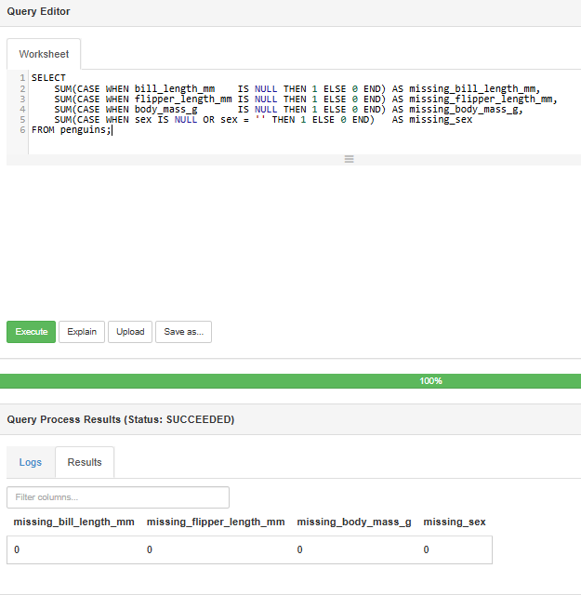
SELECT
SUM(CASE WHEN bill_length_mm IS NULL THEN 1 ELSE 0 END) AS missing_bill_length_mm,
SUM(CASE WHEN flipper_length_mm IS NULL THEN 1 ELSE 0 END) AS missing_flipper_length_mm,
SUM(CASE WHEN body_mass_g IS NULL THEN 1 ELSE 0 END) AS missing_body_mass_g,
SUM(CASE WHEN sex IS NULL OR sex = '' THEN 1 ELSE 0 END) AS missing_sex
FROM penguins;

Section 3: Python ETL with WebHDFS

3.1 Loading and Data Cleaning Pipeline
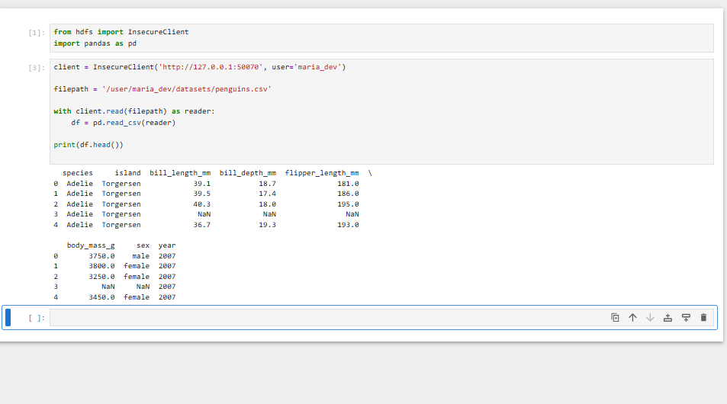
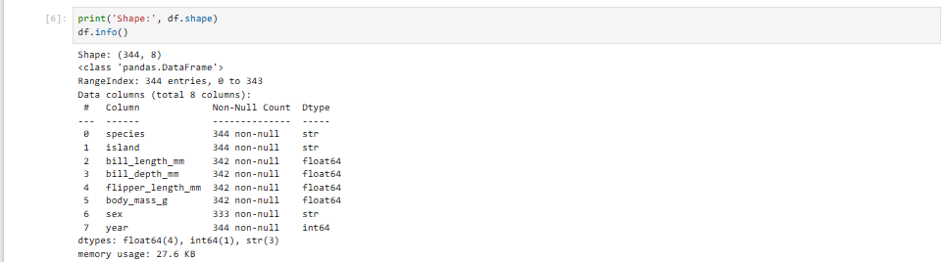
from hdfs import InsecureClient
import pandas as pd

# Connect to WebHDFS
client = InsecureClient('http://127.0.0.1:50070', user='maria_dev')

# Load original file
filepath = '/user/maria_dev/datasets/penguins.csv'
with client.read(filepath) as reader:
df = pd.read_csv(reader)

# Clean and transform dataset
clean = df.copy()
measure_cols = ['bill_length_mm', 'bill_depth_mm', 'flipper_length_mm', 'body_mass_g']
clean = clean.dropna(subset=measure_cols, how='all')

# Impute numeric missing values with species median
for c in measure_cols:
clean[c] = clean.groupby('species')[c].transform(lambda s: s.fillna(s.median()))

clean['sex'] = clean['sex'].fillna('unknown')
clean['body_mass_kg'] = (clean['body_mass_g'] / 1000).round(3)
clean = clean.drop(columns=['body_mass_g'])

# Upload clean file back to HDFS
client.makedirs('/user/maria_dev/datasets/clean')
with client.write('/user/maria_dev/datasets/clean/penguins_clean.csv', encoding='utf-8', overwrite=True) as writer:
clean.to_csv(writer, index=False)

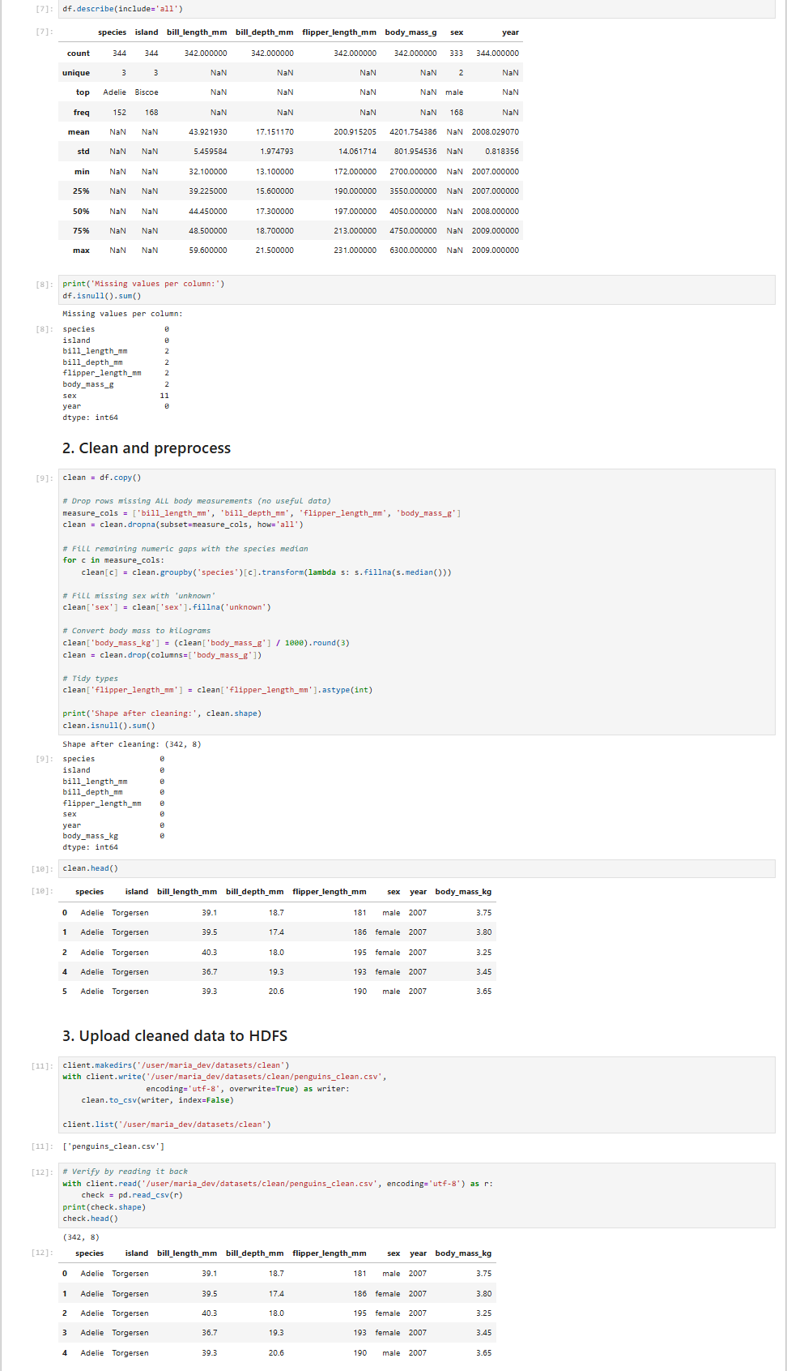
Output
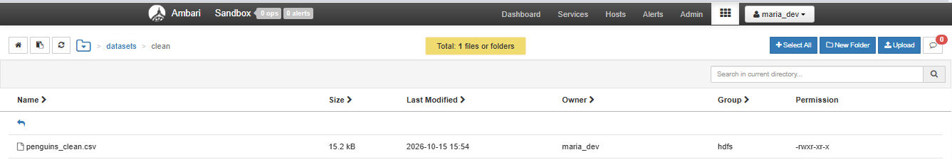

Section 4: PySpark Execution on YARN

4.1 Submitting PySpark Job
Commands
mkdir -p ~/spark
hdfs dfs -get /user/maria_dev/spark/penguins_spark.py ~/spark/
ls -l ~/spark/
spark-submit --master yarn ~/spark/penguins_spark.py
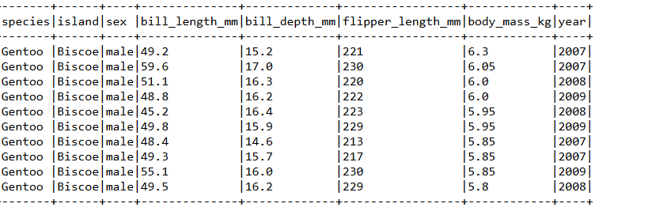
Output
