**Government digital services**

## Introduction:

This Is a government digital service project made in HTML that aims to tackle the problems that existing digital services have encountered, such as limited accessibility and difficult-to-navigate menus, by packaging all the information into a clean, structured project,

## Features

The website includes the following features:  
- A clean and modern sidebar navigation menu for easy access to different sections.  
- Dynamic content rendering to display relevant information based on user interaction.  
- Sections for all forms of information on government services.  
- Responsive and minimalistic design for improved usability on various devices.

## Development Details

- This project has a wireframe that was generated by ChatGPT to act as a baseline, which helped to aid the first steps of development.

-The design was then focused on, spending a large amount of time to allow for the website to look polished and clean, by making small changes to the formatting and layout of the digital government service.

## Usage Instructions

1. Clone or download the project files.  
2. Open the `project.html` file in a web browser.  
3. Use the sidebar menu to navigate between different sections of the website.

## Future Improvements

* Potential future enhancements include:
* Integration with back-end services for a real time information updating system
* Multilingual support to converse with a wider audience
* Enhances accessibility for users with disabilities
* A unified ID system which allows for a more personalised experience
* A larger amount of information, as this will mean that the website will cater to a much larger user base

**Project development:**

To start off this project, I spent some time to work out the main problems that are present within current government websites. There were many, ranging from ones that were present for a very niche group of people, and ones that would improve the state of the site if they were fixed. I started to notice a trend, that many of the problems that users reported turned out to be related to not being able to find information that is relevant to their situation, often finding that the website seems to be too cluttered and thus not easy to navigate. I tried to work out some of the root causes of these problems, making use of the Tom Read chatbot, which I asked a series of 5 why’s.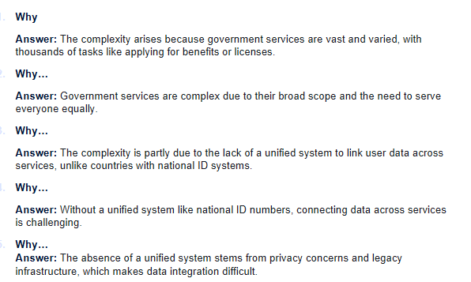

As you can see, the chatbot seemed to conclude that the main reason for this is the lack of a digital ID system, and that with it, the website could be much more personalised to its users, by gaining access to personal details and information. This would help to mitigate the problem of site usability, meaning that users could access relevant information much more quickly. However, after analysing this problem, I came to the conclusion that this is a very large undertaking, and it may not be worth my time over other core features. To help me work out other core features, I used an Impact vs feasibility chart and put my current problems into the chart.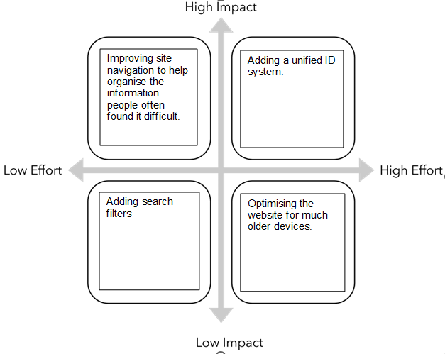

As you can see, I found that improving site navigation by something as simple as a better menu system was a move that, although low effort, would have a very high impact, and would be more worth focusing on as a core feature.

**Coding/Development:**

To start the coding, I first got ChatGPT to generate the code for a website in HTML. This code was then pasted into Visual studio code and ran as a HTML file. This website was basic, lacking many features and many different core functionalities, and was a bit of a mess, so I regenerated my website to have a sidebar and to generate some different menu buttons.

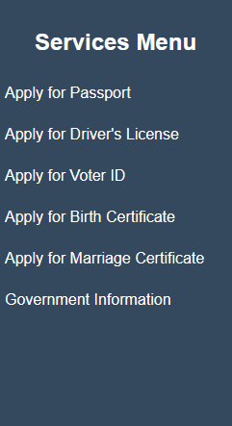 As you can see, this was an improvement, and allowed for me to fdss implement distinct functions into the buttons and the pages of the s website. However, these contained no functionality at the moment, f so I planned to add a system to enter personal details for each one. Aga

One of the problems I faced was that the website was not yet programmed to change pages when the different menu options were selected, meaning that when I wrote code for input boxes, the input boxes showed up on the same page. I realised that the easiest way to sort this was to take my code and set ChatGPT to add in the functionality. After doing this, my program is almost complete.

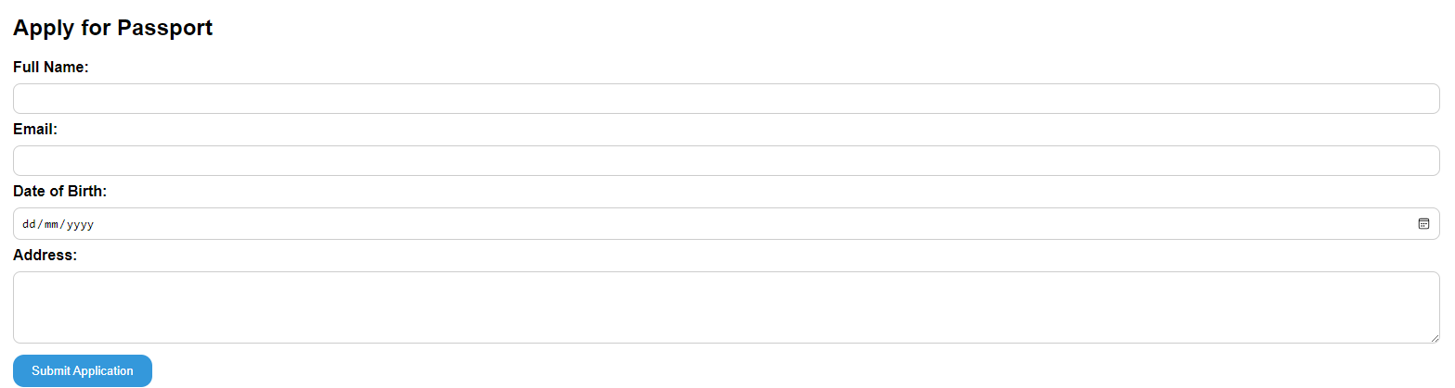

**Improvements for future development**

Considering that this is just a wireframe for an easy to navigate user interface, there are many other things that could be added to this project sometime in the future. One is to send confirmation emails, as currently there is a box to enter your email and information but it is never actually used. There could also be more functionality, currently the back button just takes you to the home page instead of taking you to the last page that you were on. Another one is to just add a larger amount of information onto the page, this means that the website caters to a much larger number of users, however the menu and UI will have to be upgraded to keep gaining this information quickly. This is how my project could be improved.