Homework

1. Add more lines to your Hello World program utilizing different escape characters. Research and list the other escape characters that weren’t mention during lecture in the doc.

|  |  |
| --- | --- |
| \t | Insert a tab in the text at this point. |
| \b | Insert a backspace in the text at this point. |
| \n | Insert a newline in the text at this point. |
| \r | Insert a carriage return in the text at this point. |
| \f | Insert a formfeed in the text at this point. |
| \' | Insert a single quote character in the text at this point. |
| \" | Insert a double quote character in the text at this point. |
| \\ | Insert a backslash character in the text at this point. |

1. Create some ASCII art using multiple printlns. Is there an issues with the output not matching what you type? Fix it and in the doc explain what steps you took to fix the problem.
2. Create some more ASCII art but only using prints and \n.

Debugging Problems

1. 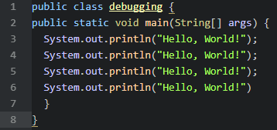
   1. Where is the error (line number) and what do you do to fix it? 6, add a semicolon?
2. 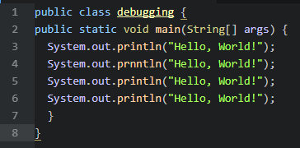
   1. Where is the error (line number) and what do you do to fix it?
3. 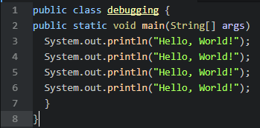
   1. Where is the error (line number) and what do you do to fix it? 2, add a curly bracet.