|  |  |  |  |  |  |  |  |  |  |  |  |
| --- | --- | --- | --- | --- | --- | --- | --- | --- | --- | --- | --- |
|  | BMTCB | CLTXB | FFTCB | HYTCB | JFTXB | MMTCB | NGTXB | P1TXB | PMTCB | RETCB | WWTXB |
| BMTCB | 1 | 4 | 3 | 1/3 | 7 | 5 | 3 | 5 | 1/3 | 1/5 | 5 |
| CLTXB | 1/4 | 1 | 1/2 | 1/5 | 5 | 3 | 1/3 | 3 | 1/5 | 1/7 | 5 |
| FFTCB | 1/3 | 2 | 1 | 1/3 | 5 | 5 | 1 | 3 | 1/3 | 1/7 | 5 |
| HYTCB | 3 | 5 | 3 | 1 | 7 | 5 | 3 | 5 | 1 | 1/3 | 7 |
| JFTXB | 1/7 | 1/5 | 1/5 | 1/7 | 1 | 1/3 | 1/5 | 1/2 | 1/6 | 1/7 | 3 |
| MMTCB | 1/5 | 1/3 | 1/5 | 1/5 | 3 | 1 | 1/4 | 1 | 1/7 | 1/8 | 3 |
| NGTXB | 1/3 | 3 | 1 | 1/3 | 5 | 4 | 1 | 5 | 1/3 | 1/7 | 7 |
| P1TXB | 1/5 | 1/3 | 1/3 | 1/5 | 2 | 1 | 1/5 | 1 | 1/5 | 1/7 | 5 |
| PMTCB | 3 | 5 | 3 | 1 | 6 | 7 | 3 | 5 | 1 | 1/5 | 7 |
| RETCB | 5 | 7 | 7 | 3 | 7 | 8 | 7 | 7 | 5 | 1 | 9 |
| WWTXB | 1/7 | 1/5 | 1/5 | 1/7 | 1/3 | 1/3 | 1/7 | 1/5 | 1/7 | 1/9 | 1 |

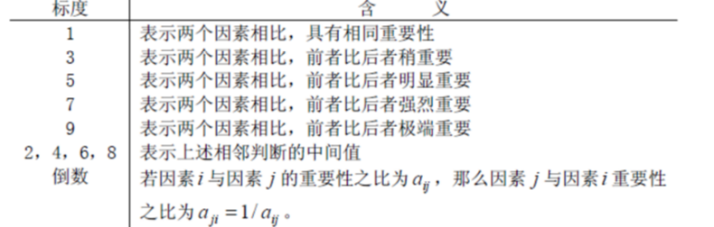

RETCB可再生能源总消费。>

HYTCB水力发电总生产。=PMTCB所有石油产品总消费不包括燃>

BMTCB生物质总消费 >

FFTCB化石燃料总消费。=NGTXB天然气最终用途消费总量(包括>

CLTXB 煤总最终用途消费。>

MMTCB车 用汽油总消费不包括燃料乙=P1TXB道路沥青和石油、航空汽油 >:

JFTXB喷气燃料总最终用途消费。WWTXB木头和浪费最终用途消费总量，=>