Owen Gaustad

9/23/2024

Phys 330 – Electronics

Rectifiers and Diode Clamps

**Abstract:**

In this lab, I examined the relationship between diodes and how they affect currents in various circuits. I found that a full wave rectifier turns a sine wave into a bouncing wave, giving it the property of a direct current(DC). I also discovered that diodes do not follow their ideal model. They have a voltage threshold that drops the positive and negative total amplitude of the provided wave by a static amount. The introduction of a capacitor also leads to a DC wave that has a slight ripple. The ripple in each wave after being tested was lower than my expected value. The last thing I went over in the lab was designing a Voltage Divider Clamp to discover a second voltage source can be used with a diode to “flatten a wave” While this isn’t necessarily true, I found the equation given a specific circuit in Figure [3] has the near flattened wave equation given in equation [3].

**Background & Theory:**

Rectifiers are crucial components in electronic circuits, converting alternating current (AC) to direct current (DC). This conversion is essential in many applications, such as powering DC-based electronic devices, battery charging, and providing a stable DC voltage to components in a circuit. Rectifiers are categorized into two main types: half-wave and full-wave rectifiers. In a half-wave rectifier, only one-half of the AC wave is allowed to pass through, while the other half is blocked. This results in a pulsating DC output, which is inefficient for many applications due to the large gap between pulses. It typically requires only a single diode for operation. A full-wave rectifier, on the other hand, allows both halves of the AC wave to pass but inverts the negative half so that the output consists of positive pulses. Bridge Full-Wave Rectifiers utilize four diodes arranged in a bridge configuration to rectify the entire AC wave. This is the most used configuration due to its efficiency and simplicity in many applications. In either rectifier configuration, the pulsating DC output can be smoothed using capacitors, inductors, or other filtering techniques to produce a more stable DC voltage.

Diode clamps are circuits that limit the voltage in a system to a predefined range, preventing signal levels from exceeding certain thresholds. They work by either "clamping" the positive or negative peaks of an input signal. Diode clamps are commonly used in signal processing, wave shaping, and protecting sensitive circuit components from excessive voltage spikes.

The operation of both rectifiers and clamps relies heavily on the characteristics of diodes. A diode allows current to flow in only one direction, exhibiting low resistance in the forward direction and high resistance in the reverse direction. This property makes diodes ideal for rectification, where the goal is to permit current flow during one phase of the AC signal while blocking it during the opposite phase. Both rectifiers and diode clamps are integral components for circuit manufacturing.

**Procedure & Analysis:**

For the first part of this lab, I had to design a full wave rectifier and test it to make sure it performed how I had intended. In Figure 1 you can see the circuit I created to test my system. In Figure 2 you can see the output from my wave represented by the orange line.

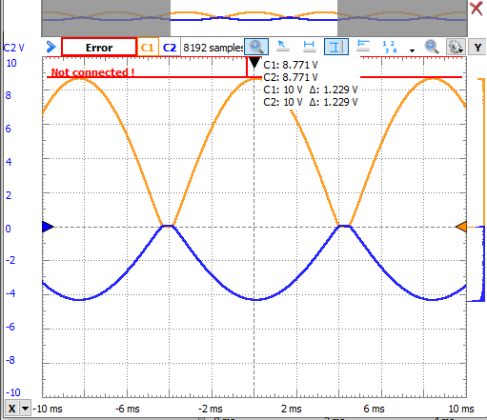**Figure 1**

The orange

line shows me

the voltage

output across

my 2.2k $Ω$

resistor.

**Figure 2**

This Circuit was

used for my rectifier

both with and without

a capacitor present in

the system. You can

see the capacitor in

series with my resistor

in the middle top

of my circuit.

Adding in a capacitor in series with the resistor dropped the total amplitude in the wave that we see in Figure 1. Both circuit diagrams can be seen below in Figures 3 and 4.

**Figure 3** **Figure 4**

After introducing the capacitor as described in Figures 2 and 3 My wave turned into a rippling DC wave. This was because the capacitor was charging and discharging, never letting the current stop flowing through the resistor. I was able to calculate an approximate ripple using Equation 1 below.

**Equation 1**

$$V_{ripple}=\frac{\frac{V_{avg}}{R}}{2fC}=\frac{V_{avg}}{2fCR}=\frac{4.0872V}{(2)(60Hz)(47e^{-6}C)(2200Ω)}=0.329mV$$

This equation gave me an expected ripple of 329mV however, when I checked the ripple on waveform using my circuit with the same values as listed in the equation, I got a ripple of 277mV. This can be seen below in Figure 5.

**Figure 5**

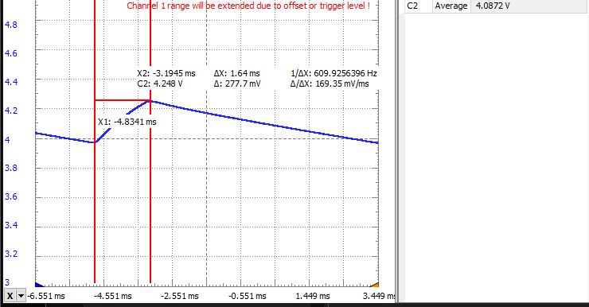

This led me to believe the Taylor series expanded equation I built my equation off results in a higher expected value than what is true. This hypothesis was confirmed when I then tried to create a circuit with a ripple of 333mV and a current of 4mA. Using Equation 1 I was able to separate it to determine the resistor and capacitor needed to produce this result. The equation I used along with its results can be found below in equation 2.

**Equation 2**

$$\frac{V_{avg}}{I}=R=\frac{4.0872V}{4mA}=1021Ω$$

$$V_{ripple}=\frac{I}{2fC}=\frac{4mA}{\left(2\right)\left(60Hz\right)\left(333mV\right)}=100μF$$

**Figure 6**

This confirmed my hypothesis from before as the experimental ripple is lower than the projected one. It also helped me find out capacitance has some relation to the Average voltage as even though I dropped the resistance to increase my current the Average voltage dropped too. This then lowered my current from 4mA to 3.8mA. If I wanted to continue this experiment to attempt to get a perfect ripple and current, I could probably drop both values by 20% and see where my experimental ripple and current fall after that.

Part two of this lab involved examining diode clamps. I started by setting up a basic diode clamp with a 1k $Ω$ resistor, a 1N4001 diode, and a 2-volt DC source all being run by a 5-amplitude sine wave with a frequency of 60 Hz. The Circuit design can be found below in Figure 7 and the actual circuit is Figure 8.

**Figure 7** **Figure 8**

My prediction for the wave this circuit would produce was a sine wave with flat tops and this was close to the result. The only difference was the top of the sine wave had a smaller sine wave on top with a different amplitude. This made me believe while the diode is conducting a different wave is being produced by the circuit than when it is not conducting. After playing around with this circuit we created another circuit that did a very similar thing, but this one allowed us to add a capacitor in parallel with one of our resistors to learn more about how it all works. This new circuit and diagram can be found below in Figures 9 and 10.

**Figure 9** **Figure 10**

This circuit was very similar to the previous circuit. However, in this one instead of a nice flat spot on top I had a bulge that was lower than my true wave but not flat. I was able to derive a formula by adding the Thevenin voltages together based on one DC and AC voltage and whether the diode was conducting. The results can be found in the table below.

|  |  |  |
| --- | --- | --- |
|  | Conducting Diode | Non-Conducting Diode |
| AC | $$V_{th}=V_{AC}\left(\frac{\frac{R_{2}R_{3}}{R_{2}+R_{3}}}{R_{1}+\frac{R_{2}R_{3}}{R_{2}+R_{3}}}\right)$$ | $$V_{th}=V_{AC}$$ |
| DC | $$V_{th}=V_{DC}\left(\frac{\frac{R_{1}R_{3}}{R_{1}+R_{3}}}{R_{2}+\frac{R_{1}R_{3}}{R_{1}+R_{3}}}\right)$$ | $$V_{th}=0$$ |

This allows us to look at what is happening in our circuit and guess what our graph will look like. While the diode is not conducting our wave should act like a normal sine wave. While our diode is conducting our AC and DC voltage equations should add together to give us a new equation for our voltage. Equation 3 below uses the values for components found in the circuit I am using to check this relationship.

**Equation 3**

$$R_{1}=1k Ω, R_{2}=2.2k Ω, R_{3}=1k Ω, V_{DC}=5V, V_{AC}=5sin⁡(ωt)$$

$$V_{th}=\frac{5sin⁡(ωt)}{0.407}+0.925$$

So, understanding this graph we should get a sine wave with a lower amplitude of 0.925 Volts high on our graph. Finally, I had to see what a capacitor in parallel with my $R_{3}$ resistor would result in and using what we already know about capacitors it should just cause my graph to phase shift its peak amplitude over. The final graph with the capacitor included can be found below in Figure 11.

**Figure 11**

**Conclusion:**

This lab revolved extensively around conceptualizing how diodes direct current in various circuits. A full wave rectifier can change an alternating current (AC) into a direct current(DC). I discovered Diodes had a voltage threshold and do not behave as the ideal model describes. A capacitor at the end of a rectifier can make the wave ripple and, the equation we use to calculate the ripple is not entirely correct. However, it is reliably wrong and consistently gave us values higher than what we found. The last thing I went over in the lab was designing a Voltage Divider Clamp to discover a second voltage source that can be used with a diode to limit peak voltage output.

**Sources**

[Lab 5](https://github.com/OwenGaustad2022/Electronics-330/blob/main/Labs/Lab5/Lab5.ipynb)