[www.linkedin.com/in/owenheaslip](http://www.linkedin.com/in/owenheaslip)

oheaslip@friars.providence.edu

(239) 216 - 2832

2842 Coach House Way, Naples, FL

For a Detailed View of any project, visit my Git Hub Repository Here:

<https://github.com/OwenHeaslip/Portfolio>

Table Of Contents

Page

Tableau - Data Visualization Projects 2

R Studio - Data Wrangling and Regression Projects 5

SQL – Database Building and Query Retrieval Projects 7

PowerBI – Data Visualization Projects 9

Who Will Win The 2024 Formula 1 Drivers Championship?

In this project, I was tasked to create an infographic. I chose to create a snapshot of the final stretch of the 2024 F1 World Driver’s Championship. This included what points were left up for grabs and how the final two contenders matched up against each other throughout the season thus far.

2

NHL Basic Stat Comparison

In this project, my goal was to provide a simple, yet intriguing comparison of some of the best player in the NHL by comparing basic statistical measures. Parameters allow users to flip between metric and aggregation types. While the middle charts give numerical and bar chart comparisons, the bottom chart ranks the players in the selected stat over the first ten years of their career.

3

Is the Cost of Your Beer at an MLB Game Worth IT?

In this project, I was tasked to recreate a visualization. The original viz displayed the cost of a beer across all MLB teams. However, to improve the design, I transformed the narrative to not only include price but also price per ounce. I also included team win percentage to see if you're getting a bang for your buck. By scrolling through the seasons, users can see trends in their desired team over time.

4

NFL Field Goal Analysis

In this project, I worked on filtering, wrangling, and summarizing the NFL's field goal data. The goal of the project was to utilize a logistic regression to predict the probability of making a field goal in outdoor games.

To begin the project, I filtered all plays to those that were field goals located in outdoor fields, removed N/As, and created bins for distances.

The resulting histogram shows a severe drop off in success rate starting at distances greater than 60 yds.

By running a regression using all three independent variables, I can see there is not significant evidence that temperature and wind will have a meaningful impact on the outcome, so, they will not be included in the final model.

Therefore, kick distance will be the sole contributor in predicting accuracy.

Original Model

Final Model

According to the confusion matrix, the final model produced 19 false negatives (type II errors) and 453 false positives (type I errors), but for the remaining 2597 observations, the model predicted the correct outcome.

Confusion Matrix

5

Who are the Most and Least Lucky teams in MLB History?

In this project, I used Lahman’s database to analyze historical trends in multiple variables for Major League Baseball. This predictive model aimed to predict the number of runs a team would score in a season based on runs, walks, hits, doubles, homeruns, stolen bases, and caught stealing. The model was exceptionally accurate with a R-squared of .92, and all variables were significant (except for triples).

Linear Regression Summary

To find the most and least lucky teams, I found the difference in predicted runs and actual runs. Teams with a large positive difference were lucky, while those with a large negative difference are the least lucky.

Least Lucky

Most Lucky

Actual > Predicted

Actual < Predicted

6

Innovation Lab Relational Database

In this project, I have built a multi-table relational database to store data on the usage of the Innovation Lab. The Innovation Lab is a room dedicated to rest and recovery for athletes at Providence College, and by storing data, coaches and other athletic staff can monitor and analyze usage patterns.

Design

7

Implementation

In the implementation stage, the goal is to create each table, define the variables used within each table, identify the data types for each variable, and establish the primary and foreign keys to relate the tables to one another.

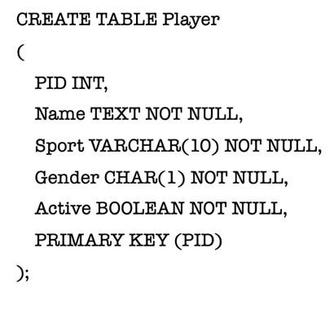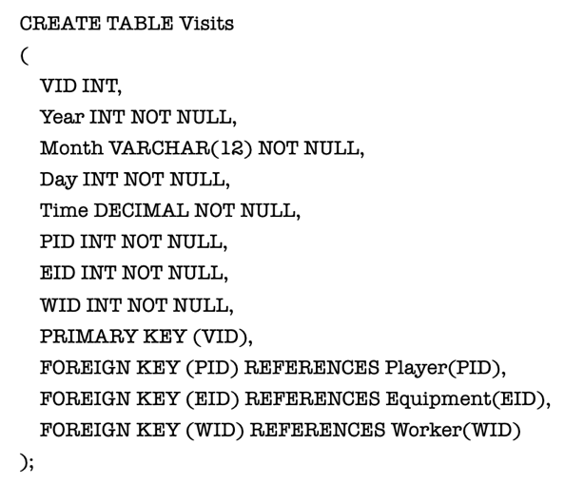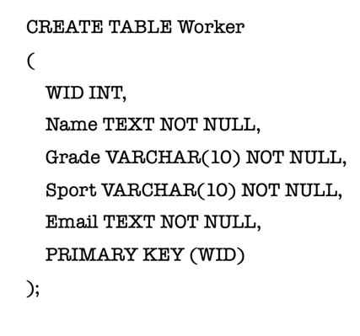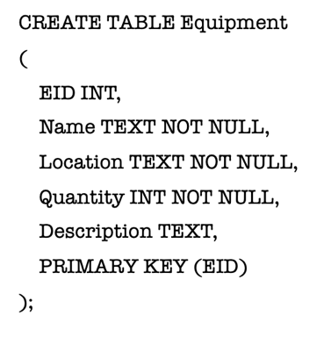

Query Retrieval

In this retrieval, the goal is to provide the top ten most visited players and how many times they have visited.

*SELECT P.Name AS PlayerName, COUNT(V.VID) AS VisitCount*

*FROM Visits V, Player P*

*WHERE V.PID = P.PID*

*GROUP BY P.Name*

*ORDER BY VisitCount DESC*

*LIMIT 10;*

*SELECT E.Name, COUNT(*) AS UsageCount*

*FROM Equipment E JOIN Visits V ON E.EID = V.EID*

*WHERE EXISTS ( SELECT \**

*FROM Visits V2 JOIN Player P ON V2.PID = P.PID*

*WHERE V2.EID = E.EID AND P.Gender = “F”)*

*GROUP BY E.Name*

*ORDER BY UsageCount DESC*

*LIMIT 1;*

In this retrieval, the goal is to use an exists function to find the most used equipment given that the visits were by females.

**More example queries can be found in Git Hub Repository**

8