TOURNEY

HOW LONG CAN YOU SURVIVE?

CONTENTS

| * Game Overview * Concept * Selling Points * Platform Minimum Requirements * Similar Titles * Synopsis * Game Objectives * Game Rules * Game Structure * Game Play   + Game Controls   + Game Camera   + HUD * Player * Enemies   + Enemy Spawn Points * Art   + Setting   + Level Design   + Audio * Minimum Viable Product (MVP) * Wishlist * Bibliography | TEAM PRODUCER  Owen Kuhn  PRODUCTION MANAGER  Owen Kuhn  PRODUCTION COORDINATOR  Owen Kuhn  GAME DESIGNERS  Owen Kuhn  SYSTEMS/IT COORDINATOR  Owen Kuhn  PROGRAMMERS  Owen Kuhn  TECHNICAL ARTISTS  Owen Kuhn  AUDIO ENGINEERS  Owen Kuhn  UX TESTERS  Owen Kuhn |
| --- | --- |

# GAME OVERVIEW

**Title**: Dungeon Tournament

**Platform**: MacOS

**Genre**: arena combat

**Rating**: ESRB Rating of E10+

**Target**: Casual Gamer

**Release Date**: April, 2022

**Publisher**: Owen Kuhn

**Description**: A top down arena style game where the player has been transported to a floating island and is forced to fight to survive

# CONCEPT

UH OH! You've been captured and forced to fight to the death! Navigate a floating arena while avoiding death and defeating enemies wave after wave. All you have is your trusty bow and arrow and an ace up your sleeve... A secret weapon, a magical arrow that can pierce through enemies and does double damage. See how many rounds you can last!

# SELLING POINTS

* Infinite gameplay
* Cohesive sound effects
* Multiplatform

# MIN. REQUIREMENTS

**PC / MAC / LINUX STANDALONE**

Generally everything made since 2004 should work

# OBJECTIVE

The goal is to survive for as long as possible as you clear the island of enemies each round. The difficulty increases as time goes on.

# SIMILAR TITLES

Originally my game was going to be inspired by Binding of Issac but I realized that the procedural generation and sheer quantity of items would be a lot to tackle. So I took that Idea and reduced it down to a single room, and a single weapon. Now the game more strongly resembles a 2D version of Call of Duty Zombies, where the goal is to survive waves of enemies for as long as possible.

# SYOPOSIS

You have been captured and forced to fight to the death on a floating island arena. Luckily you are a skilled archer with the power of magical arrows. See how long you can last.

# GAME RULES

The level is an enclosed floating island that the player cannot exit. Enemies spawn at 4 separate spawn points and the player must defeat them to move to the next round. After each round the player has the ability to upgrade one of 3 stats (health, damage, or speed). Enemies grow harder each round, the higher the difficulty, the better they get each round.

# GAME STRUCTURE



# GAME PLAY

## CONTROLS

**Movement**: WASD to move up, left, down, and right respectively

**Shooting**: Click to fire an arrow and use your mouse to aim

**Special Attack**: press space to fire your magical arrow once the bar on the bottom of the screen is full

## GAME CAMERA

The camera will follow the player as they move about the arena

## HUD

Upper left corner shows health, damage, and enemies remaining respectively

The bar on the bottom shows special attack loading progress, when full you can press space to fire your magical arrow

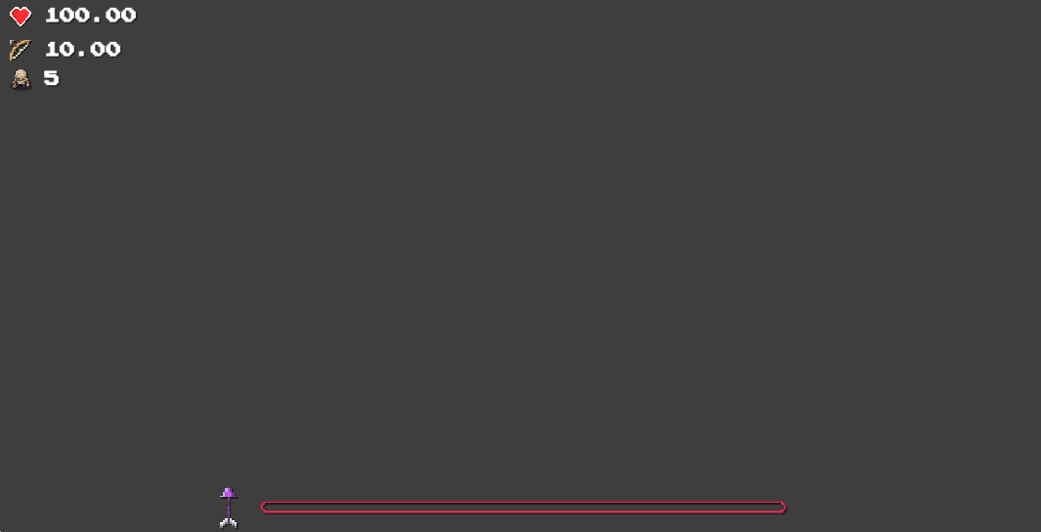

# PLAYER

|  | **Max Health**: 100  **Weapon**: bow & arrow  **Damage**: 10  **Vitality**: 0.5 (health per second)  **Speed**: 3 |
| --- | --- |

# ENEMIES

|  | **Name**: Zombie  **Base Health**: 50  **Weapon**: fist  **Base Damage**: 5  **Vitality**: 0 (health per second)  **Speed**: 1  **Name**: Ranged Zombie  **Base Health**: 50  **Weapon**: bow  **Base Damage**: 5  **Vitality**: 0 (health per second)  **Speed**: 1 |
| --- | --- |

## SPAWNING

Enemies spawn at the 4 designated spawn points on the island. 1 to the left. 1 to the right. And 2 above on the second level.

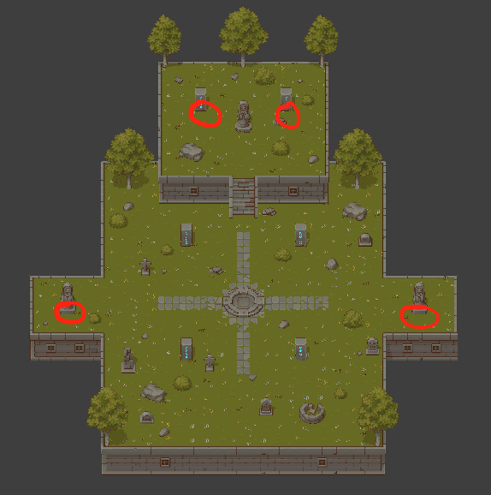

# ART

## SETTING

The game is set on a floating island arena where the player is forced to fight. (See image above)

## LEVEL DESIGN

The level consists of a floating island, populated with various plants and stone relics. This includes flowers, trees, bushes, statues, graves, pilars, etc... (See image above)

## AUDIO

| **Name** | **Category** | **Description** |
| --- | --- | --- |
| Arrow Fire | SFX | Played when an arrow is first released from a bow |
| Bow Draw Back | SFX | Played when a bow is being drawn |
| Arrow Hits | SFX | Played when an arrow hits an object or character |
| Zombie Hurt | SFX | Played when an enemy takes damage |
| Zombie Die | SFX | Played when an enemy dies |
| Player Hurt | SFX | Played when the player takes damage |
| Player Die | SFX | Played when the player dies |
| Countdown | SFX | Played for each second in the round countdown |
| Countdown Final | SFX | Played on the last second of the countdown |
| Click | SFX | Played when the user clicks a UI button |
| Menu Music | BG Music | Played during menu scenes |
| Game Music | BG Music | Played during game scenes |

# MVP

* 1 Character with a usable weapon
* Enemies that can attack character
* Ability to progress through rounds
* Built for PC/Mac/Linux

# WISHLIST

* More enemy types
* Differing level design after N rounds
* Better mid-round upgrades (multiple weapons)
* Better graphics

# BIBLIOGRAPHY

EVERYTHING IN CAINOS PIXEL ART FOLDER

2021. Pixel Art Top Down - Basic. [online] Available at: <https://assetstore.unity.com/packages/2d/environments/pixel-art-top-down-basic-187605#publisher> [Accessed 2 March 2022].

PLAYER & ENEMY SPRITE SHEET

Challener, S. (R., &amp; Sjölund, J. (wulax). (n.d.). Lpc Character Generator. Universal LPC Sprite Sheet Character Generator. Retrieved March 2, 2022, from https://sanderfrenken.github.io/Universal-LPC-Spritesheet-Character-Generator/. (License(s): CC-BY-SA 3.0, GPL 3.0.)

SKYBOX

2022. Free Stylized Skybox. [digital]. Retrieved March 5, 2022, from https://assetstore.unity.com/packages/2d/textures-materials/sky/free-stylized-skybox-212257#publisher

ROUNDED UI (ROUNDED5PX@4x for healthbars)

YouTube. (2021). Master ROUNDED corners for your UI | Unity UI tutorial. Retrieved April 6, 2022, from https://www.youtube.com/watch?v=gO4jnaxvMjk.

FONT (PRESS START 2P)

CodeMan38. (n.d.). Press Start 2P. Google fonts. Retrieved April 6, 2022, from https://fonts.google.com/specimen/Press+Start+2P?preview.text=500.00&amp;preview.text_type=custom

MENU BACKGROUND

By Darkmoon_Art from Pixabay; Retrieved From:

https://pixabay.com/illustrations/map-discovery-america-ship-train-3409359/

ARROW FIRE SFX

Everheat, “Arrow.wav.” Freesound, 4 Nov. 2013, https://freesound.org/people/EverHeat/sounds/205563/.

BOW DRAW BACK SFX

EminYILDIRIM. “Bow Loading.” Freesound, 21 Sept. 2020, https://freesound.org/people/EminYILDIRIM/sounds/536067/.

ARROW HITS SFX (multiple)

cyoung510. (2020, June 5). Arrow_.Hits_target.wav. Freesound. Retrieved April 8, 2022, from https://freesound.org/people/cyoung510/sounds/521242/

ZOMBIE HURT/DIE SFX (multiple)

Fenodyrie. (2021, April 2). Goblin dying in fight.wav. Freesound. Retrieved April 8, 2022, from https://freesound.org/people/Fenodyrie/sounds/565928/

PLAYER HURT SFX

micahlg. (2017, December 10). Male_hurt11. Freesound. Retrieved April 8, 2022, from https://freesound.org/people/micahlg/sounds/413174/

PLAYER DIE SFX

tonsil5. (2018, January 28). Grunt2 - death pain.wav. Freesound. Retrieved April 8, 2022, from https://freesound.org/people/tonsil5/sounds/416838/

MENU BACKGROUND MUSIC

Solarphasing. (2019, October 30). Dark cave background 2.wav. Freesound. Retrieved April 8, 2022, from https://freesound.org/people/SolarPhasing/sounds/490585/

GAME BACKGROUND MUSIC

Sirkoto51. “Castle Music Loop #1.” Freesound, 27 Jan. 2018, https://freesound.org/people/Sirkoto51/sounds/416632/.

PATHFINDING FOR ENEMIES (FREE)

Granberg, Aron. A* Pathfinding Project (Free Version). Retrieved March 28th, 2022, from https://arongranberg.com/astar/download

2D PATHFINDING AI TUTORIAL

Brackeys, Brackeys, director. 2D PATHFINDING - Enemy AI in Unity, YouTube, 2 June 2019, https://www.youtube.com/watch?v=jvtFUfJ6CP8. Accessed 28 Mar. 2022.

ROUNDED UI TUTORIAL

Coco Code. Master ROUNDED corners for your UI | Unity UI tutorial. YouTube, 4 Aug 2021, https://www.youtube.com/watch?v=gO4jnaxvMjk. Accessed 6 Apr. 2022.

MADE BY OWEN (ME)

* Arrow Art
* Broken Arrow Art
* Special Arrow Art
* Special Broken Arrow Art
* Heart Art
* Bow Art
* Button UI
* Dropdown UI
* TextInput UI
* Countdown SFX (normal and last)
* Click Button SFX