Databases Submission 3

Individual Work

Owen Kane - C13383511

Edmunds Electrics - Group B

Given the Feedback from the the lab here is our current iteration of the ERD diagram.

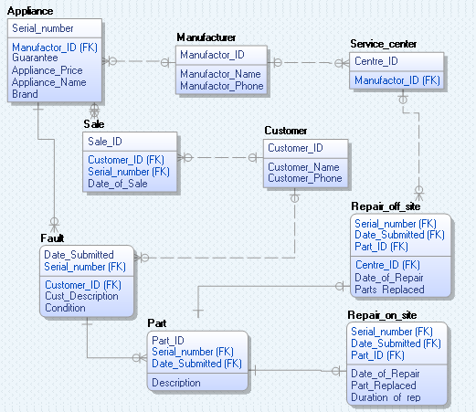

We removed Fault_ID from the fault table, we replaced it with Date_submitted as a primary key used to track a fault. We also added a new table called part to which it has a one to one relationship to both repair_off_site and repair_on_site as it previously made separate appearances in both tables.

We also removed “stock” from the appliance table as this was not a realistic way to track the stock of an item, instead we will use a count function to count the times the appliance name appears in the appliance table to get the stock of a appliance.

PL / SQL:

SET SERVEROUTPUT ON

DECLARE

useName APPLIANCE.APPLIANCE_NAME%TYPE:='&Enter_Appliance_Name';

useNum APPLIANCE.SERIAL_NUMBER%TYPE:=&Enter_Appliance_Serial_Num;

useMan APPLIANCE.MANUFACTOR_ID%TYPE;

useGuar APPLIANCE.GUARANTEE%TYPE;

usePrice APPLIANCE.APPLIANCE_PRICE%TYPE;

useBrand APPLIANCE.BRAND%TYPE;

BEGIN

IF stock_exists(useName) THEN

dbms_output.put_line('Appliance exists');

get_Appliance(useName, useMan, useGuar, usePrice, useBrand);

add_Appliance(useNum, useMAN, useGuar, usePrice, useName, useBrand);

ELSE

dbms_output.put_line('Appliance does not exists');

END IF;

EXCEPTION

WHEN OTHERS THEN

dbms_output.put_line('Error occurred '||SQLCODE||SQLERRM);

END;

------------

CREATE OR REPLACE FUNCTION stock_exists

(userName APPLIANCE.APPLIANCE_NAME%type) RETURN BOOLEAN

IS

AppName APPLIANCE.APPLIANCE_NAME%TYPE;

BEGIN

SELECT APPLIANCE.APPLIANCE_NAME INTO AppName FROM APPLIANCE

WHERE APPLIANCE.APPLIANCE_NAME LIKE userName;

RETURN TRUE;

EXCEPTION

WHEN NO_DATA_FOUND THEN

RETURN FALSE;

END stock_exists;

---------------

CREATE OR REPLACE PROCEDURE get_Appliance(

useName in APPLIANCE.APPLIANCE_NAME%TYPE,

useMan out APPLIANCE.MANUFACTOR_ID%TYPE,

useGuar out APPLIANCE.GUARANTEE%TYPE,

usePrice out APPLIANCE.APPLIANCE_PRICE%TYPE,

useBrand out APPLIANCE.BRAND%TYPE

) AS

BEGIN

SELECT MANUFACTOR_ID, GUARANTEE, APPLIANCE_PRICE, BRAND

INTO useMan, useGuar, usePrice, useBrand

FROM APPLIANCE

WHERE APPLIANCE.APPLIANCE_NAME LIKE useName;

EXCEPTION

WHEN NO_DATA_FOUND THEN

useMan:=000; useGuar:=000; usePrice:=000; useBrand:='Error';

END get_Appliance;

-----------

CREATE OR REPLACE PROCEDURE add_Appliance (

useNum in APPLIANCE.SERIAL_NUMBER%TYPE,

useMan in APPLIANCE.MANUFACTOR_ID%TYPE,

useGuar in APPLIANCE.GUARANTEE%TYPE,

usePrice in APPLIANCE.APPLIANCE_PRICE%TYPE,

useName in APPLIANCE.APPLIANCE_NAME%TYPE,

useBrand in APPLIANCE.BRAND%TYPE)

AS

BEGIN

insert into APPLIANCE VALUES (useNum, useMAN, useGuar, usePrice, useName, useBrand);

COMMIT;

END add_Appliance;

------------

CREATE TABLE LOGTABLE

(

tablename VARCHAR2(20),

opname CHAR(3) CHECK (opname IN ('INS', 'UPD', 'DEL')),

Uname VARCHAR2(20),

Sdate DATE,

Keyfield VARCHAR2(20)

);

-----------

CREATE OR REPLACE TRIGGER APPLIANCE_AI

AFTER INSERT ON APPLIANCE

FOR EACH ROW

BEGIN

INSERT INTO logtable VALUES('APPLIANCE', 'INS', TO_CHAR(USER), SYSDATE, :new.serial_number);

END;

-------------