Owen Kane C13383511

1- Introduction/explanation

Prims Algorithm finds a minium spanning tree for a conneted weighted undirected graph.It does this by findinga subset of edges, with the lowest weight, that together form a tree that includes every vertex. The algorithm continuously grows the size and weight of the tree for every edge added, starting at a single vertex until it reaches all vertices

2 – Inport graph
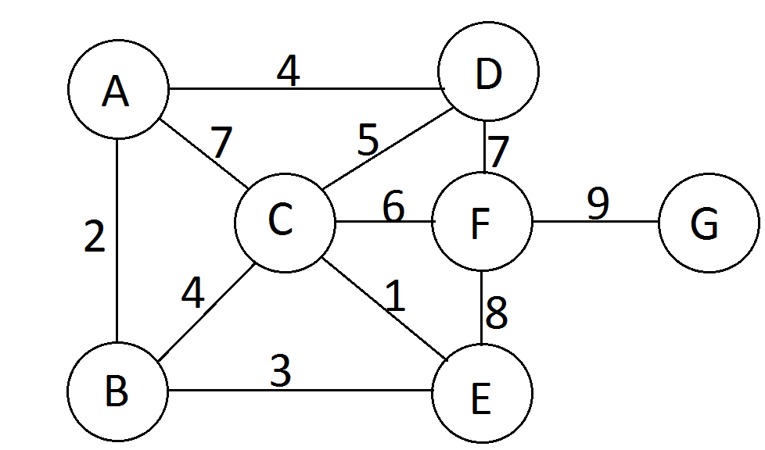
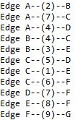
7 11
1 2 2
1 3 7
1 4 4
2 3 4
2 5 3
3 4 5
3 5 1
3 6 6
4 6 7
5 6 8
6 7 9

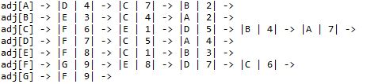
3 – Adjacency list diagram

4 – Step by step construction of the MST

The parent array is frist initialised to ∅ as it is currently unknow what it is connected to and the distance array is set each element to infinity as their distance or weight is currently unknown

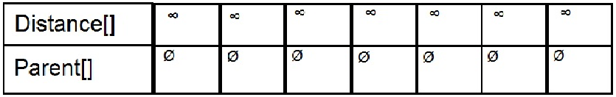
-----------------------------

Starting at vertex A, the array begins to be filled with data. We see that vertex A is connected to the vertices B, C and D, with their corresponding weight help in the parent array.

We add the edge {A} – [2] – {B} to the MST and it currently has a weight of 2 as it has the smallest distance
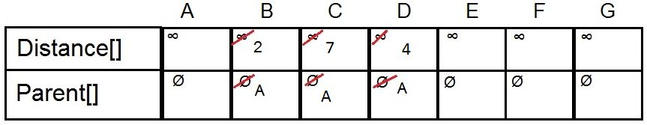
-----------------------------

We mark 2 as negative as the edge {A} – [2] – {B} has been visted, we mark visted edges as negative so they will not be used again. Now that we have visted B we can see that it has a connection to vertex E with a weight of 3.

Its also revealed a new edge to access C, from B, that have a lower weight that the first edge we found to C, now becuase of this we replace the old values in the Arrays at position C with 4 in the distance array and B in the parent array as the edge {B} – [4] – {C} has a lower weight than the edge {A} – [7] – {C}.

We now add the edge {B} – [3] – {E} to the MST and now it currently has a weight of 5,.
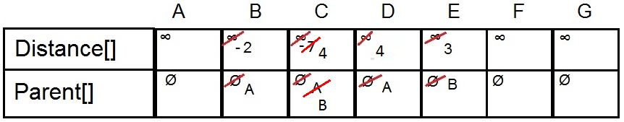
-----------------------------

We again, mark the weight of the last edge we visted as negative, to prevent duplication. From here we can again see another new edge connecting to vertex C that has a lower weight that the edge thats currently being stored in the Distance and parent array.

Now we must change the values being stored in position C in both arrays with 1 and E as the edge {E} – [1] -{C} has a lower weight than the edge {B} – [4] – {C}

We now add the lowest edge, which is {E} – [1] – {C}, to the MST and now it currently has a weight of 6.
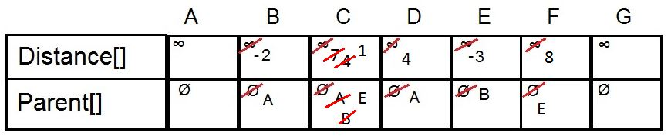
-----------------------------

Here we change the value in the arrays at position F, as the newly discovered edge {C} – [6] – {F} has a lower edge then the orignal edge {E} – [8] – {F}. We also marked the 4 as visted in the distance array at position D
We add the edge {A}--[4]--{D} as it is currently the lowest edge to the MST, which nows has a weight of 10.
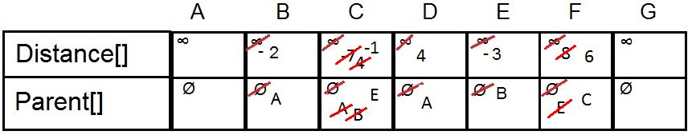
-----------------------------

We mark 4 as visted in the distance array at position D.
We now add the lowest edge, which is {C} – [6] – {F}, to the MST and now it currently has a weight of 16.
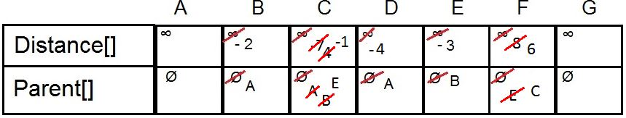
-----------------------------

We hard the value at postion F as visted
From the F vertex we can finally see the only remaining unvisted vertex G, now we can fill its information in the parent and distance arrays.
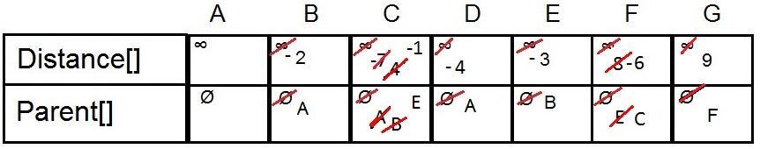
We now add the last edge, {F} – [9] – {G}, to the MST and now it currently has a weight of 25.
-----------------------------

We mark postion G in the arrays as visted. We look to see if there are any unvisted vertexs, since all vertexs are marked as visted we are finished
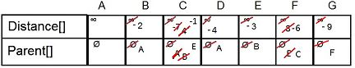
-----------------------------

5 – MST superimposed
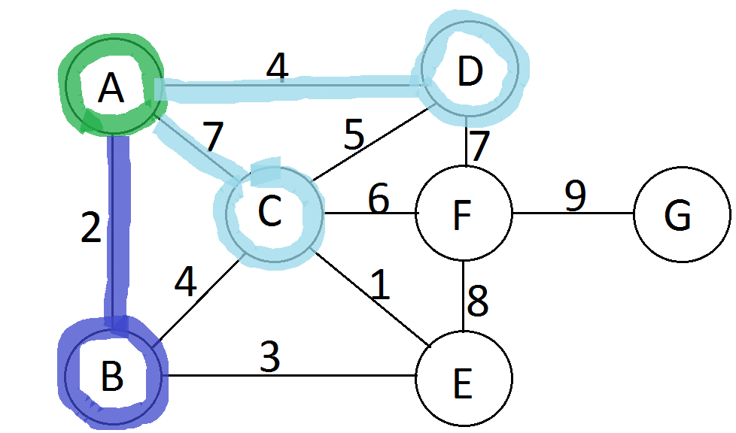

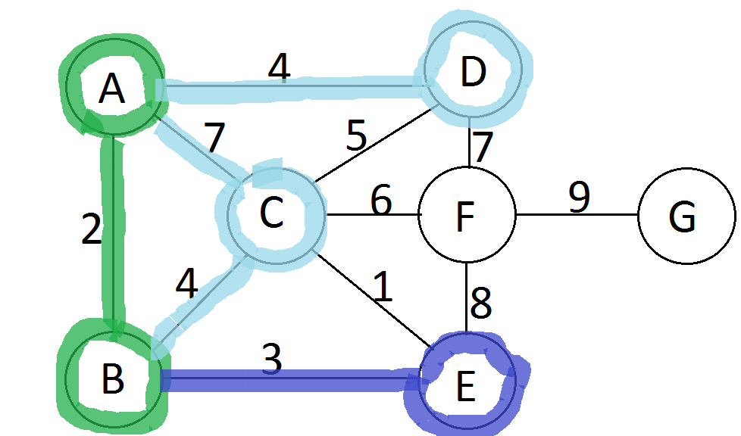
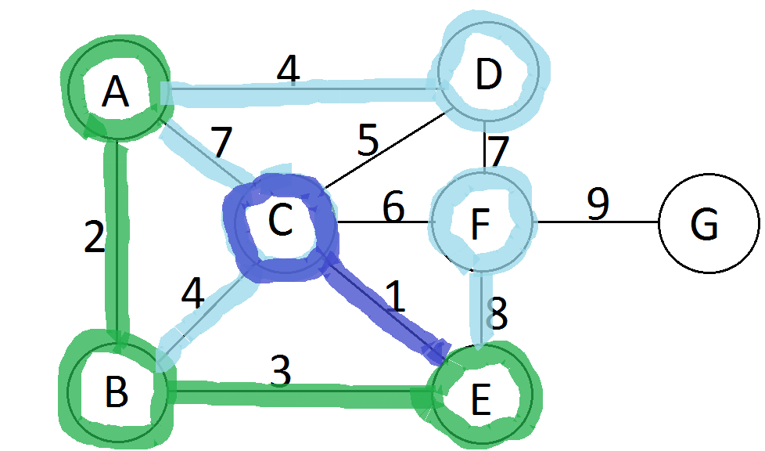
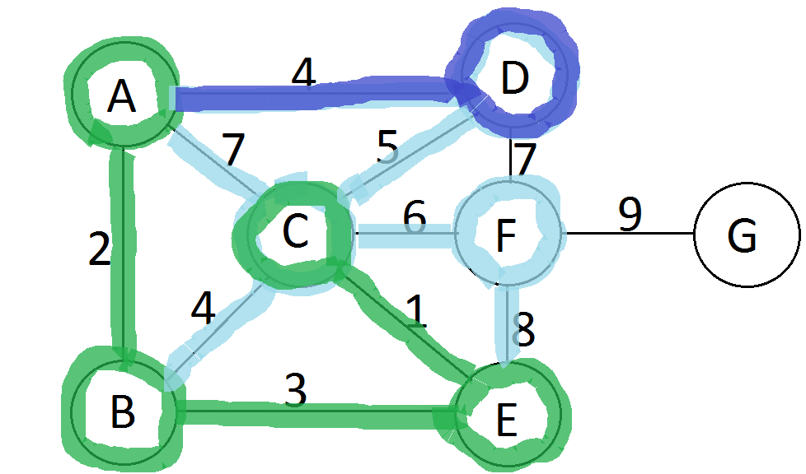
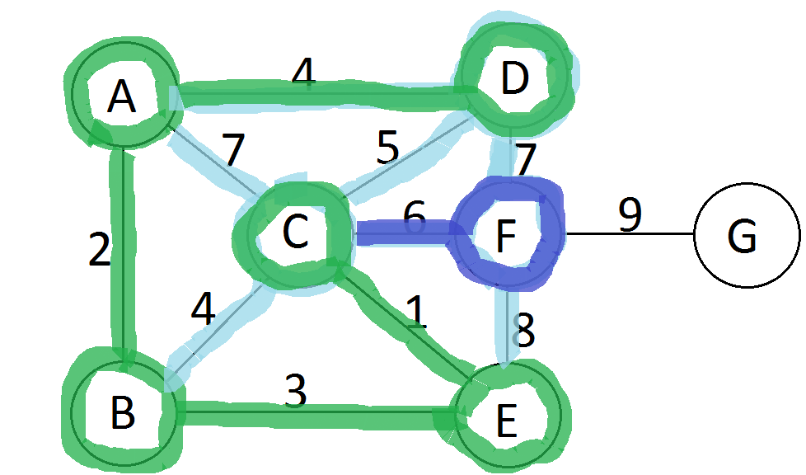
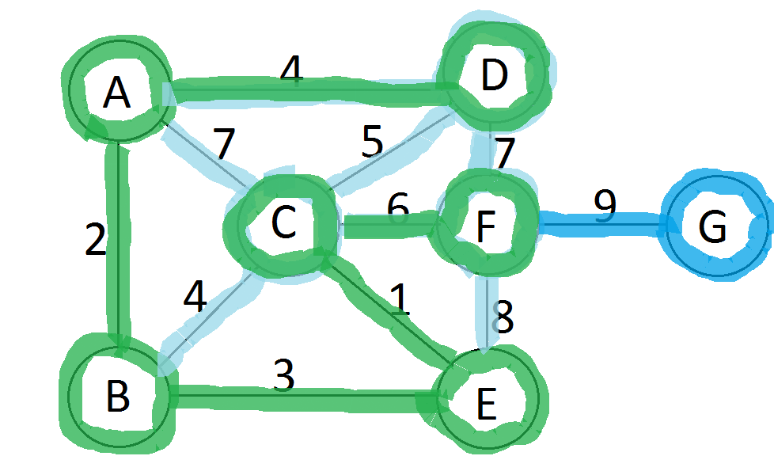
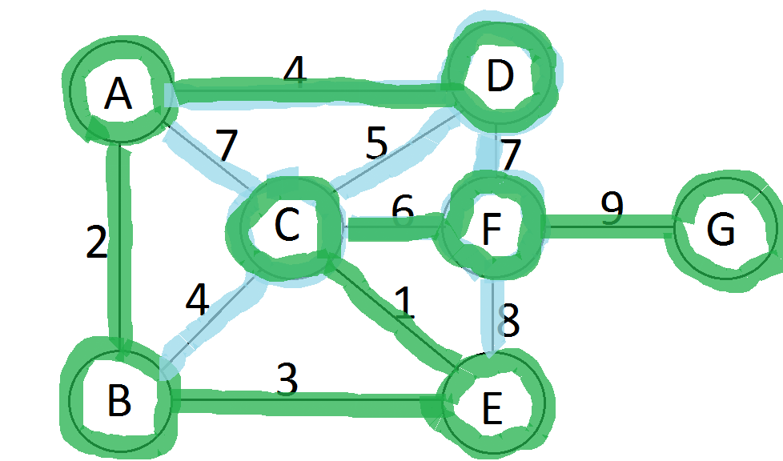

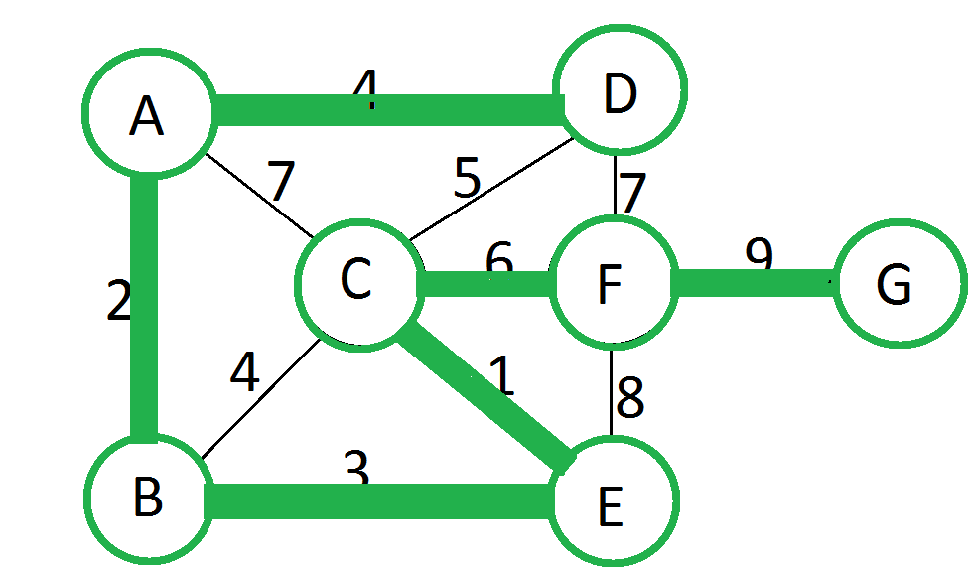

6 – All documented code
import java.io.*;
import java.util.Scanner;

class Heap
{
private int[] h; // heap array
private int[] hPos; // hPos[h[k]] == k
private int[] dist; // dist[v] = priority of v

private int N; // heap size

// The heap constructor gets passed from the Graph:
// 1. maximum heap size
// 2. reference to the dist[] array
// 3. reference to the hPos[] array
public Heap(int maxSize, int[] _dist, int[] _hPos)
{
N = 0;
h = new int[maxSize + 1];
dist = _dist;
hPos = _hPos;
}

public boolean isEmpty()
{
return N == 0;
}

public void siftUp( int k)
{
int v = h[k];

h[0] = 0;//Place a "dummy" node at the top of the heap
dist[0] = Integer.MIN_VALUE;//The distance is set to the lowest value to compare

//While the current dist element is < the dist value at element/2
while(dist[v] < dist[h[k / 2]]) {
//If it isnt found we sift up the value to the next val in hPos
h[k] = h[k / 2];
hPos[h[k]] = k;
//divide the current element by 2 to go the next level up
k = k / 2;
}
//We insert the vertex then into its correct position
h[k] = v;
hPos[v] = k;

}

public void siftDown( int k)
{
int v, j;

v = h[k];

//While not at the end of the array
while( k <= N/2) {
j = 2 * k;

//If the current element is < the size of the array and distance is > the next vertex
if(j < N && dist[h[j]] > dist[h[j + 1]]){
j++;//Move to the next element
}

//If the distance of the current vertex is < that vertex we are "sifting down"
//then break out of the current operation to stop
if(dist[v] <= dist[h[j]]){
break;
}
//if it isnt < then continue looking further down list
h[k] = h[j];
hPos[h[k]] = k;
k = j;
}
h[k] = v;
hPos[v] = k;

}

public void insert( int x)
{
h[++N] = x;
siftUp( N);
}

public int remove()
{
int v = h[1];
hPos[v] = 0; // v is no longer in heap
h[N+1] = 0; // put null node into empty spot

h[1] = h[N--];
siftDown(1);

return v;
}

}

class Graph {
class Node {
public int vert;
public int wgt;
public Node next;
}

// V = number of vertices
// E = number of edges
// adj[] is the adjacency lists array
private int V, E;
private Node[] adj;
private Node z;
private int[] mst;

// used for traversing graph
private int[] visited;
private int id;

// default constructor
public Graph(String graphFile) throws IOException
{
int u, v;
int e, wgt;
Node t;

FileReader fr = new FileReader(graphFile);
BufferedReader reader = new BufferedReader(fr);

String splits = " +"; // multiple whitespace as delimiter
String line = reader.readLine();
String[] parts = line.split(splits);
System.out.println("Parts[] = " + parts[0] + " " + parts[1]);

V = Integer.parseInt(parts[0]);
E = Integer.parseInt(parts[1]);

// create sentinel node
z = new Node();
z.next = z;

// create adjacency lists, initialised to sentinel node z
adj = new Node[V+1];
for(v = 1; v <= V; ++v)
adj[v] = z;

// read the edges
System.out.println("Reading edges from text file");
for(e = 1; e <= E; ++e)
{
line = reader.readLine();
parts = line.split(splits);
u = Integer.parseInt(parts[0]);
v = Integer.parseInt(parts[1]);
wgt = Integer.parseInt(parts[2]);

System.out.println("Edge " + toChar(u) + "--(" + wgt + ")--" + toChar(v));

t = adj[u];
adj[u] = new Node();
adj[u].vert = v;
adj[u].wgt = wgt;
adj[u].next = t;

t = adj[v];
adj[v] = new Node();
adj[v].vert = u;
adj[v].wgt = wgt;
adj[v].next = t;

}
}

// convert vertex into char for pretty printing
private char toChar(int u)
{
return (char)(u + 64);
}

// method to display the graph representation
public void display() {
int v;
Node n;

for(v=1; v<=V; ++v){
System.out.print("\nadj[" + toChar(v) + "] ->" );
for(n = adj[v]; n != z; n = n.next){
System.out.print(" |" + toChar(n.vert) + " | " + n.wgt + "| ->");
}
}
System.out.println("");
}

public void MST_Prim(int s)
{
int loop = 0;
int v, u;
int wgt, wgt_sum = 0;
int[] dist, parent, hPos;
Node t;

parent = new int[V + 1];
dist = new int[V + 1];
hPos = new int[V + 1];

for(v = 0; v <= V; v++) {
dist[v] = Integer.MAX_VALUE;//Initially all nodes are assumed to be an infinite distance away
parent[v] = 0;//treat 0 as a special NULL vertex
hPos[v] = 0;

}
//heap that is initially empty
Heap heap = new Heap(V + 1, dist,hPos);
//s (user inputed) is the root of the MST
heap.insert(s);
//Set the distance to be 0
dist[s] = 0;

System.out.println("\n\nStarting at vertex "+ toChar(s) + "\n");
while (!heap.isEmpty())//should repeat |V|-1 times
{
//add v to the MST
v = heap.remove();

//To show the building of the MST
System.out.println("Adding edge (" + toChar(parent[v]) + ")--[" + dist[v] + "]--(" + toChar(v) + ")");

//adding the current wait on to the total to find the weight of the MST
wgt_sum += dist[v];

//marks v as now in the MST
dist[v] = -dist[v];

//loop to continue while the parent node still has children
for (t = adj[v]; t != z; t = t.next)
{
//If the weight of the current vertex is less that
//the value currently in the dist array
if (t.wgt < dist[t.vert])
{
//put the weight into the dist array
dist[t.vert] = t.wgt;
//Add node to the parrent array
parent[t.vert] = v;

//If the vertex is NULL then insert next vertex
if (hPos[t.vert] == 0)
{
heap.insert(t.vert);
}
else //if not null sift up the vertex
{
heap.siftUp(hPos[t.vert]);
}
}
}
System.out.print("Current weight of MST = " + wgt_sum);
System.out.print("\n\n");
mst = parent;

/* //For displaying the contents of the parent and dist arrays
loop = loop + 1;
System.out.println("loop"+loop);

System.out.println("\nDistance Array contents: ");
for(int j = 1; j <= V; j ++)
{
System.out.println("" + dist[j] + ",");
}

System.out.println("Parent Array contents: ");
for(int j = 1; j <= V; j ++)
{
System.out.println("" + toChar(parent[j]) + ",");
}
*/
}
System.out.print("Total weight of MST = " + wgt_sum);
}

public void showMST()
{
System.out.print("\n\nMinimum Spanning tree parent array is:\n");
for(int v = 1; v <= V; ++v)
System.out.println(toChar(v) + " -> " + toChar(mst[v]));
System.out.println("");
}

}

public class PrimLists {
public static void main(String[] args) throws IOException
{
Scanner in = new Scanner(System.in);
System.out.println("Enter the file name");
String fname = in.nextLine();
System.out.println("Enter the starting vertex");
int s = in.nextInt();//s is set to the starting vertex
in.close();

Graph graph = new Graph(fname);
graph.display();
graph.MST_Prim(s);
graph.showMST();
}
}

7 – Screen captures of code outputs
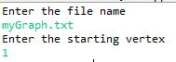
Here the users enters in the name of graph they want to find the MST of.
They also enter in their starting vertex
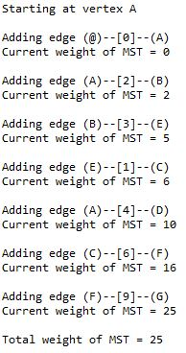
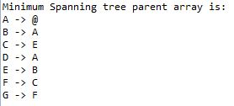
They programs prints out the starting vertex, then it prints out its what edge it is currently adding to the MST and the current weight of the MST

The program then prints out the parent array then ends

8 – conclusion
During this assignment I learned a vast amount about both Prims algorithm but also a lot about weighted connected graphs. I found that studying graph theory in maths last semester was very benifical as I was already fimilar with working with this type of graph
I also gained a lot more knowledge on heaps and how to implement, sort and how to iterate through them as perviously I was unsure on this, but now I am confident in my ability to work with heaps.

Through my reasearch on Prims algorithm I discovered many of its practical uses such as finding the best way to connect a network of homes you can use this algorithm to use the least amount of cable while visting each house.

Owen Kane C13383511

