Please read:
https://learn.unity.com/tutorial/publishing-for-ios#5ecfa875edbc2a00231dbfa4
https://learn.unity.com/tutorial/how-to-publish-to-ios-2019-3#5e340dd8edbc2a0020fb3e44
https://docs.unity3d.com/Manual/BuildSettingsiOS.html
https://docs.unity3d.com/Manual/UnityCloudBuildiOS.html

For remote debugging, expensive but worth it:
https://assetstore.unity.com/packages/tools/utilities/ar-foundation-editor-remote-168773

I used Unity 2019.4.13f1
You need to make your settings like below:

Import Packages:
- AR Foundation
- Input System
- ARKit Face Tracking
- ARKit XR Plugin

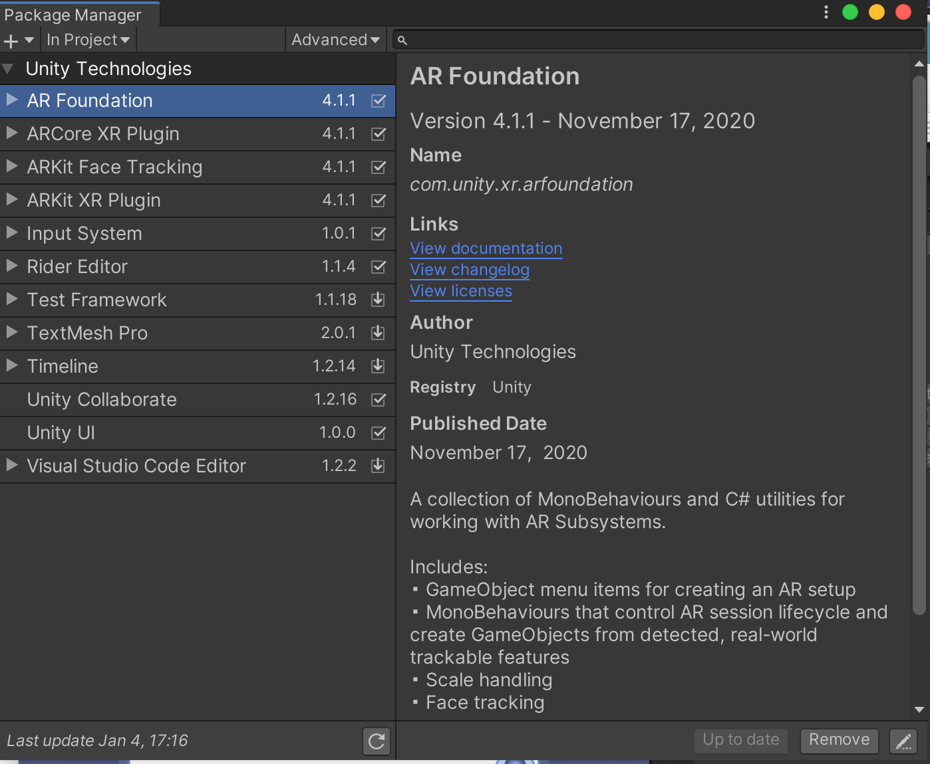

Add AR version of menu and games and set to iOS Platform:
- Select iOS and make sure you hit [Switch Platforms] button
- Add those scenes (drag them) into the hierarchy, and then hit [Add Open Scenes] button

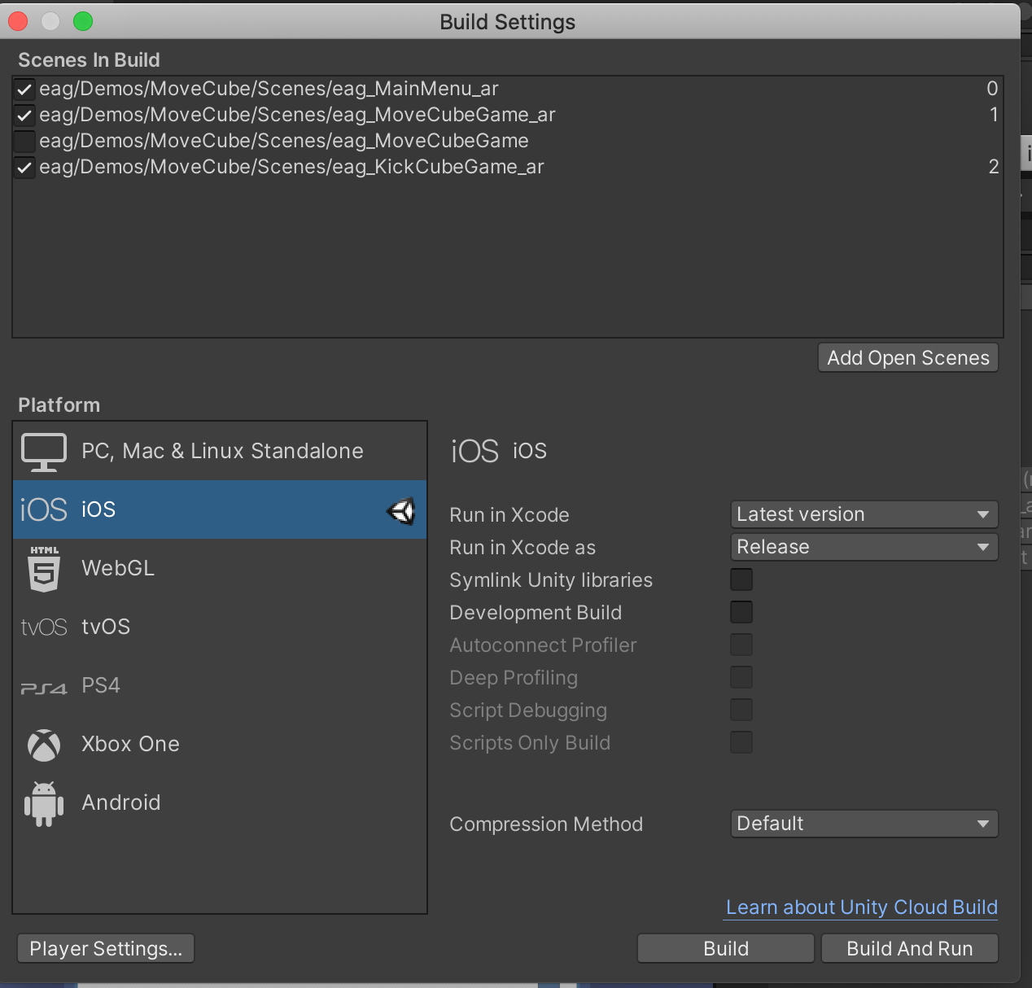

Set player settings:
- Allow Unsafe Code
- Bundle Identifier
- Target minimum iOS version: 12.0
- Active input handling: Both

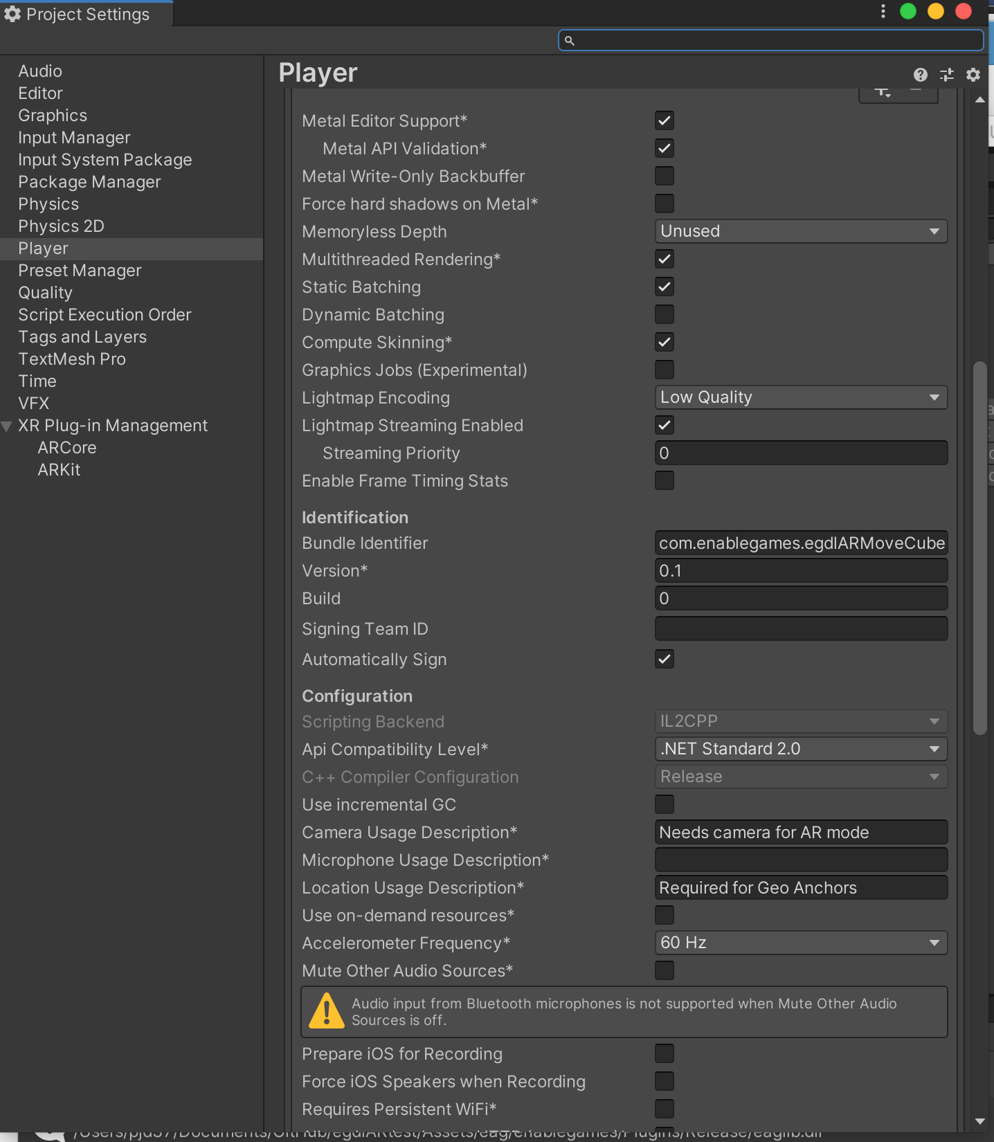

Scripting Define Symbols:
UNITY_POS_PROCESSING_STACK_V2;UNITY_XR_ARKIT_LOADER_ENABLED;UNITY_XR_ARKIT_FACE_TRACKING_ENABLED;UNITY_XR_ARKIT_FACE_TRACKING_ENABLED
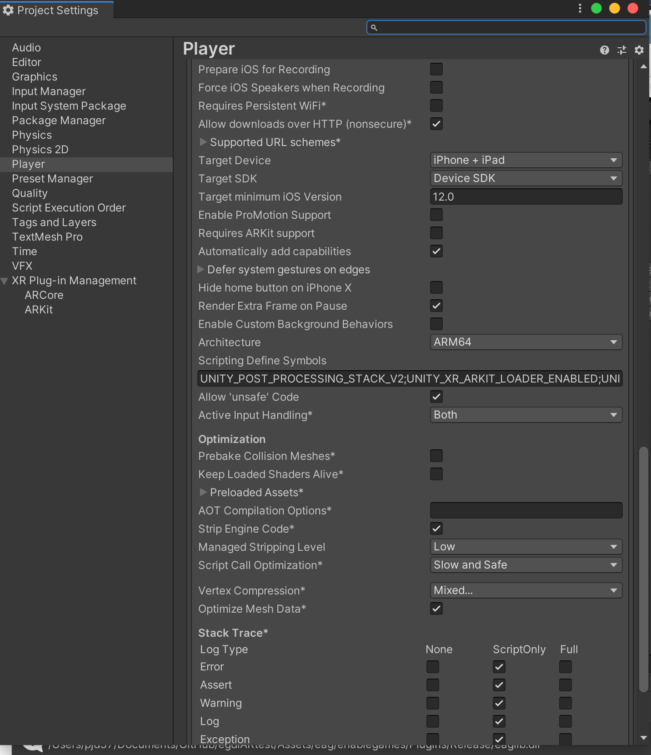

Set XR settings:
If you can’t check ARKit, then:
1. Delete the file Assets/XR/Loaders/NAME_OF_YOUR_XR_LOADER_Loader.asset.
2. Enable your XR Provider in XR Plug-in Management window.

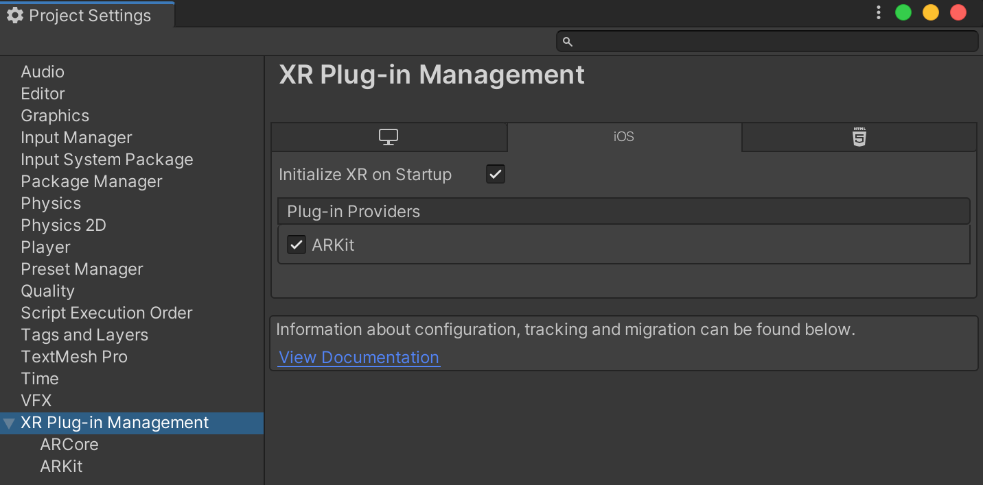

This is for Android AR (but doesn’t support body tracking yet)
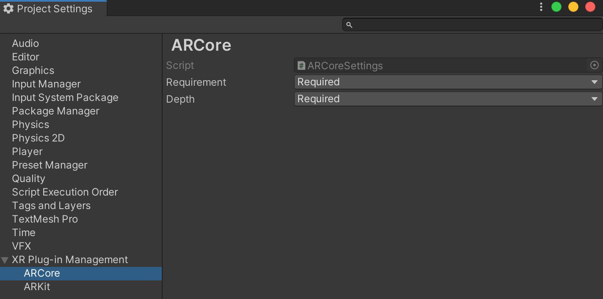
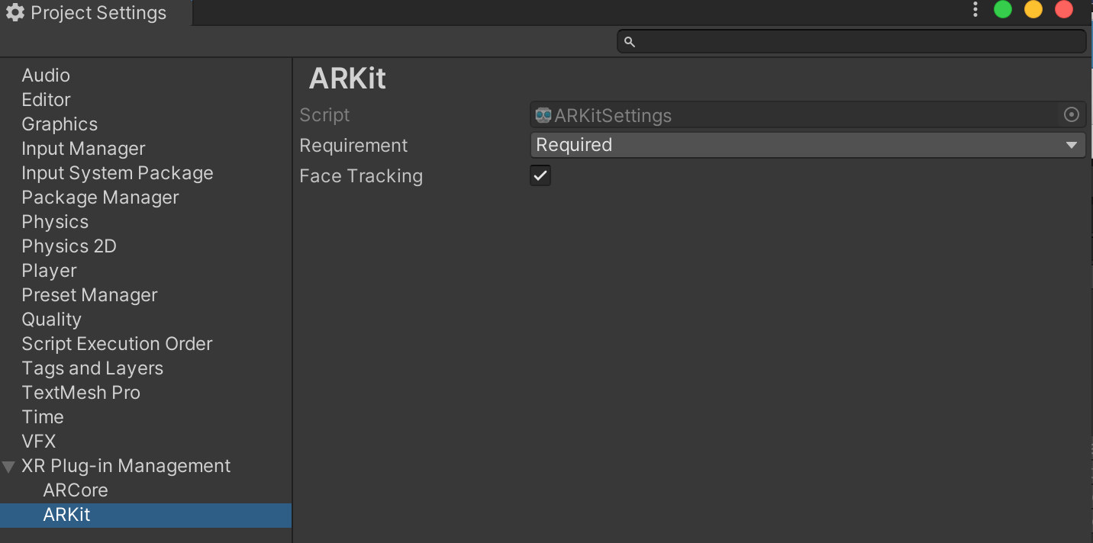

XCode Settings

Older MacOS/XCode Versions:
An app signed with a codesign version provided on an older macOS, like Catalina (10.15) will not run on iOS 15 because the lastest version you can install is Xcode 12.4.
Xcode 12.5 seems to change the behavior of codesigning. When installing you get the error message:
The code signature version is no longer supported. To solve, add
--generate-entitlement-der flag to OTHER_CODE_SIGN_FLAGS

For more details, see:

https://stackoverflow.com/questions/68467306/the-code-signature-version-is-no-longer-supported

Unsupported OS Version message:

If you get a message like this:
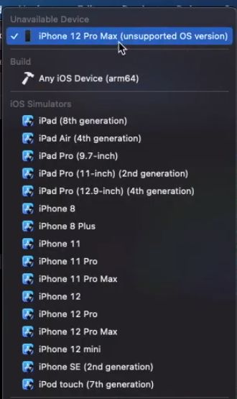
Then read this:
https://stackoverflow.com/questions/67863355/xcode-12-4-unsupported-os-version-after-iphone-ios-update-14-7

XCode Team Provisioning Profile:

IPhone Settings:

Make sure you have your Configuration Profile set in:
Settings > General > Profiles & Device Management
Or
Settings > General > VPN & Device Management

https://www.wikihow.com/Enable-Developer-Mode-on-an-iPhone

