Owen Morini

Getting Data Driven Answers from Surveys:
How College Students Manage Their Study Habits and Productivity Tools
Who

1. What is your class year?
Counts:
Junior 7
First-year 6
Sophomore 4
Senior 3
Graduate Student 1
Percentages:
Junior 33.33
First-year 28.57
Sophomore 19.05
Senior 14.29
Graduate Student 4.76
2. What is your major?
Major Counts:
Business 9
STEM 6
SLS 2
Health & Human Performance 1
Entrepreneurship 1
Art 1
Psychology 1
Major Percentages:
Business 42.86
STEM 28.57
SLS 9.52
Health & Human Performance 4.76
Entrepreneurship 4.76
Art 4.76
Psychology 4.76
3. What is your gender?
Gender Counts:
Male 16
Female 3
Transgender Female 1
Transgender Male 1

3. What is your gender?
Gender Percentages:
Male 76.19
Female 14.29
Transgender Female 4.76
Transgender Male 4.76
What
4. What primary method do you use to organize your studying?
Digital calendar 9
Mixture of calendar and memory 1
Personal memory 5
Physical planner 2
To-do list apps 2
no formal system 2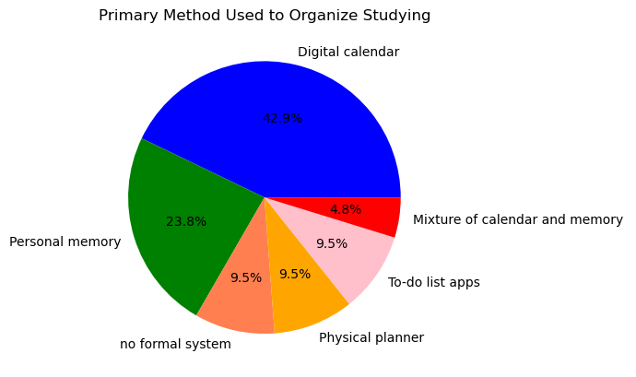
When
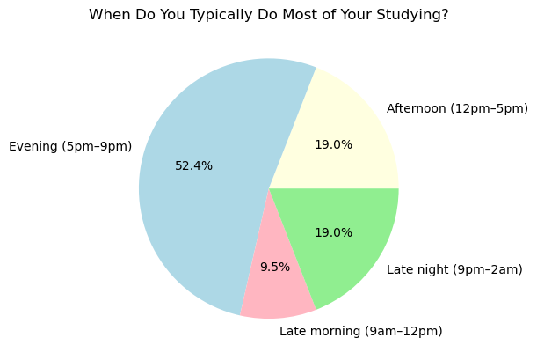
Where
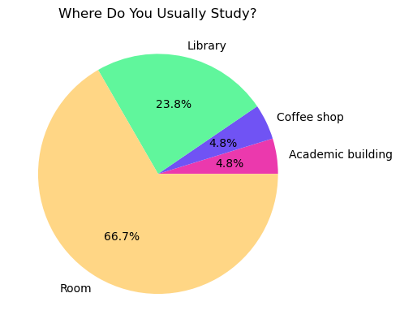
Why
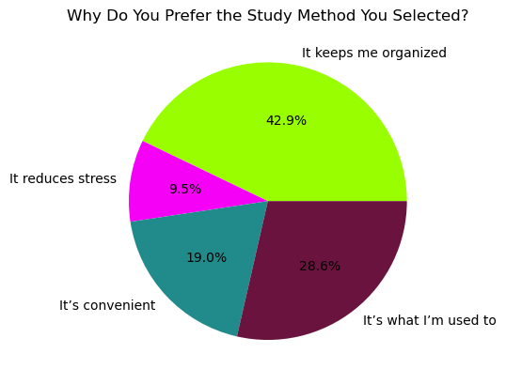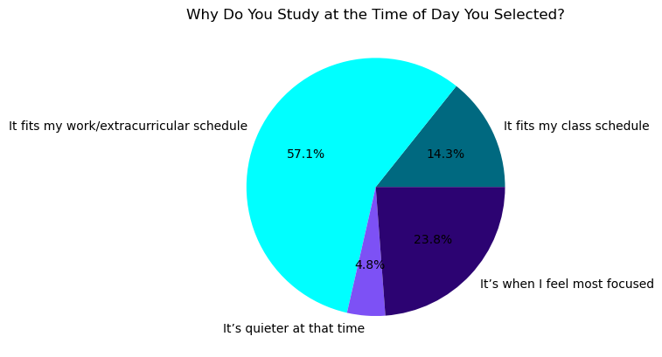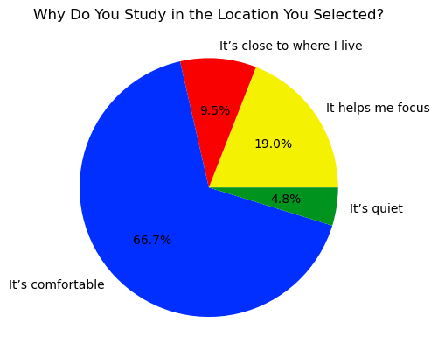

Extra Information
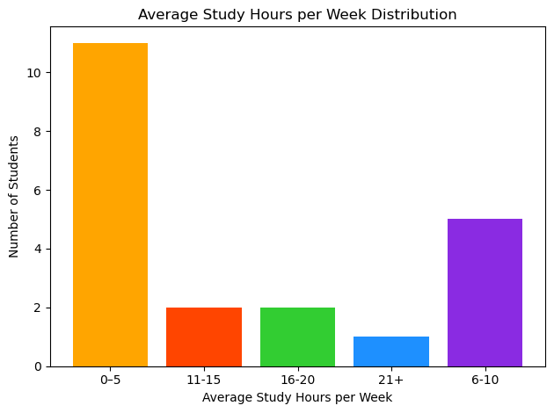
How
For this project I was tasked with using a survey to get data driven answers. My method for the survey was created a survey on Google Forms, as a quick an easy way to export a CSV file out. This way I took the CSV file from the survey and imported it into VS Code. I was roughly about two weeks to complete this project, where I was tasked with creatin the survey, exporting the data into a CSV, importing into VS Code, then finally using python to get data driven answers about the survey results.
The tools I used for the data analysis was the program called Python (version 3.x). In Python, I utilized the Pandas library for data manipulation and calculating percentages. I also used the Matplotlib library to create visuals that better helped explain my results. I of course initially used Google Forms to create the survey and gain the data first through multiple choice questions and then convert the results into a CSV.
A few limitations or weaknesses that comes with my project’s results are two main parts. The first limitation that is present is a small sample size which increases the margin of error and the chance to have a better generalization of the results. Second, I found that there is a demographic issue, where the sample came in at 76% male dominant and 42% business major, which limits the choices that would potentially be made by others.
A way that my project could be improved is definitely increased sample size for more solid results. The other improvement I can think of is a larger demographic including gender, major, and year.

