Laboratorio 5
Nombre: Owen Oviedo
Link GitHub: https://github.com/OwenOviedo/ICN292-Lab5-Oviedo-Owen

-- Consuta 1:
SELECT e.nom_empleado, COUNT(v.id_venta) AS cantidad
FROM empleado AS e
LEFT JOIN ventas AS v ON v.id_empleado = e.id_empleado
GROUP BY e.nom_empleado, e.id_empleado
ORDER BY cantidad DESC, e.nom_empleado;
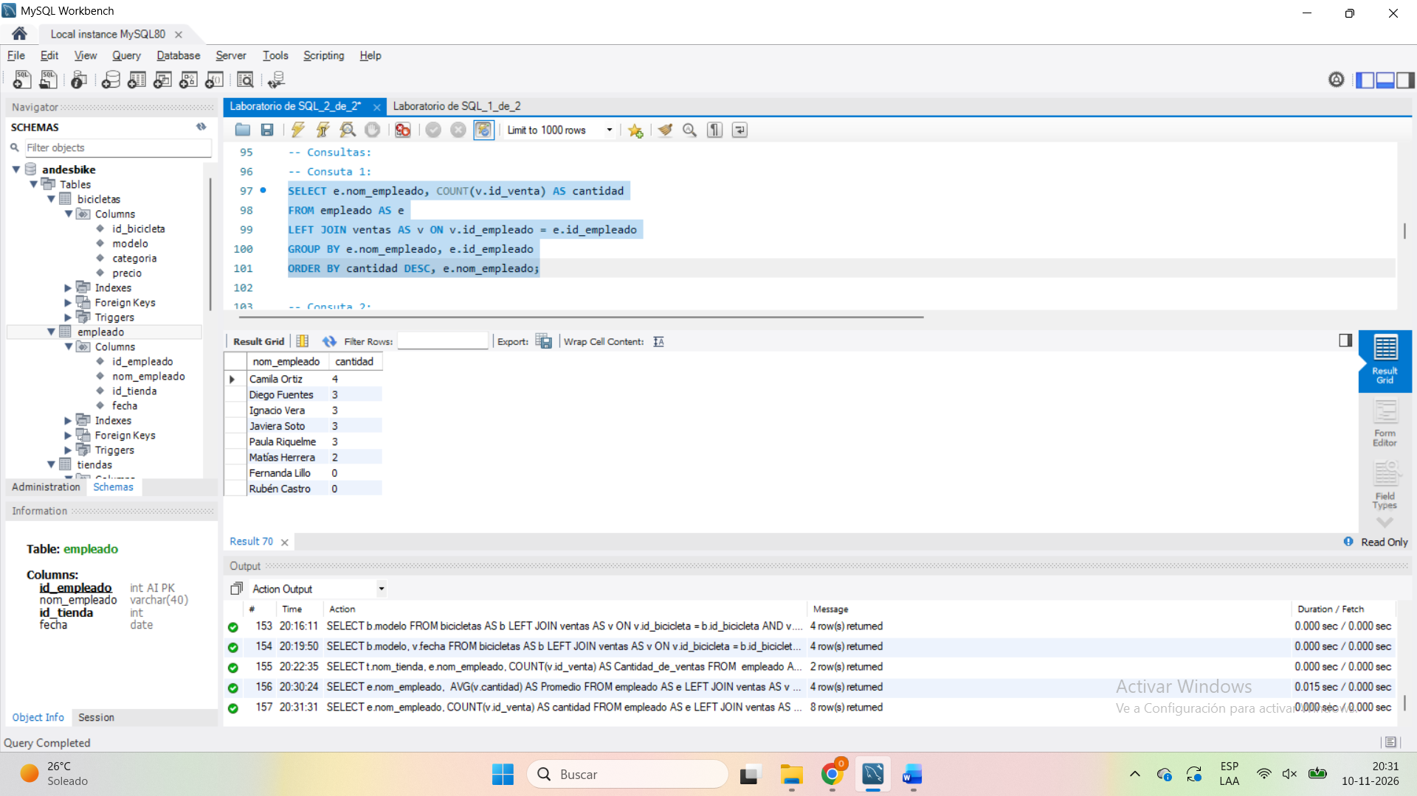

-- Consuta 2:
SELECT t.nom_tienda, COUNT(v.id_empleado) AS Cantidad_de_ventas, SUM(v.cantidad) AS Cantidad_de_unidades
FROM ventas AS v
RIGHT JOIN empleado AS e ON v.id_empleado = e.id_empleado
RIGHT JOIN tiendas AS t ON t.id_tienda = e.id_tienda
GROUP BY t.nom_tienda
ORDER BY Cantidad_de_unidades DESC;
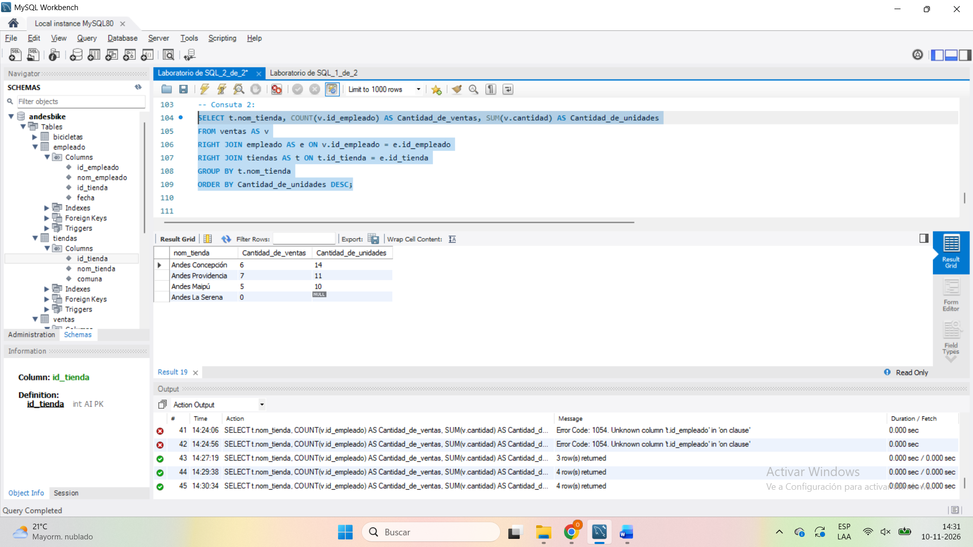

-- Consuta 3:
SELECT t.nom_tienda, e.nom_empleado
FROM tiendas AS t
LEFT JOIN empleado AS e ON e.id_tienda = t.id_tienda
WHERE nom_empleado IS NULL;
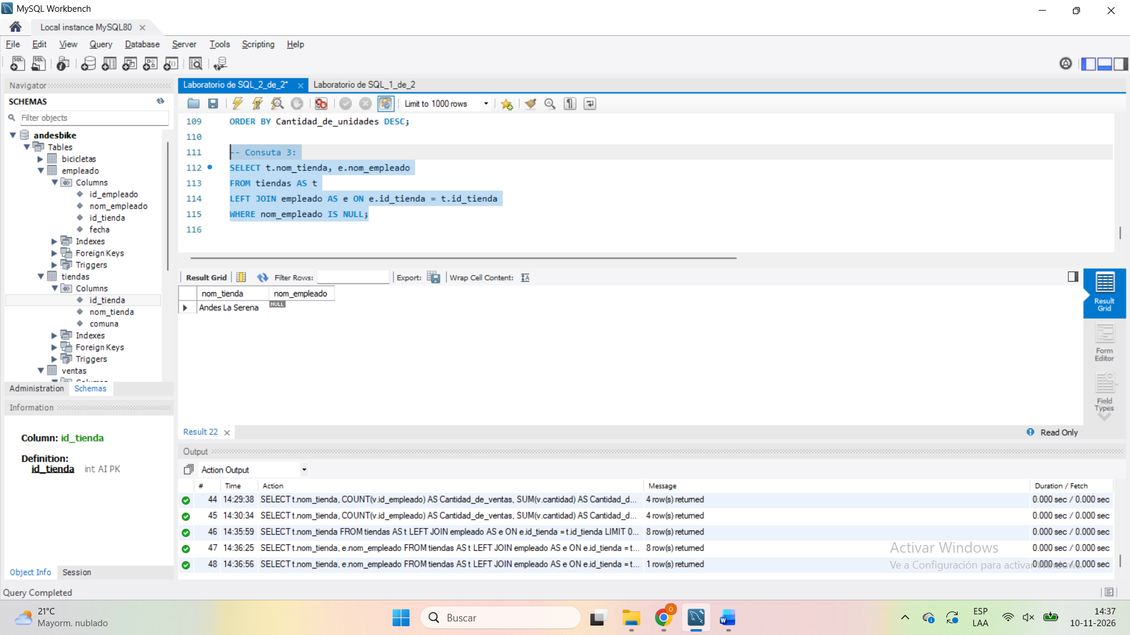

-- Consuta 4:
SELECT b.modelo
FROM bicicletas AS b
LEFT JOIN ventas AS v ON v.id_bicicleta = b.id_bicicleta AND v.fecha BETWEEN '2025-06-01' AND '2025-06-30'
WHERE v.fecha IS NULL;
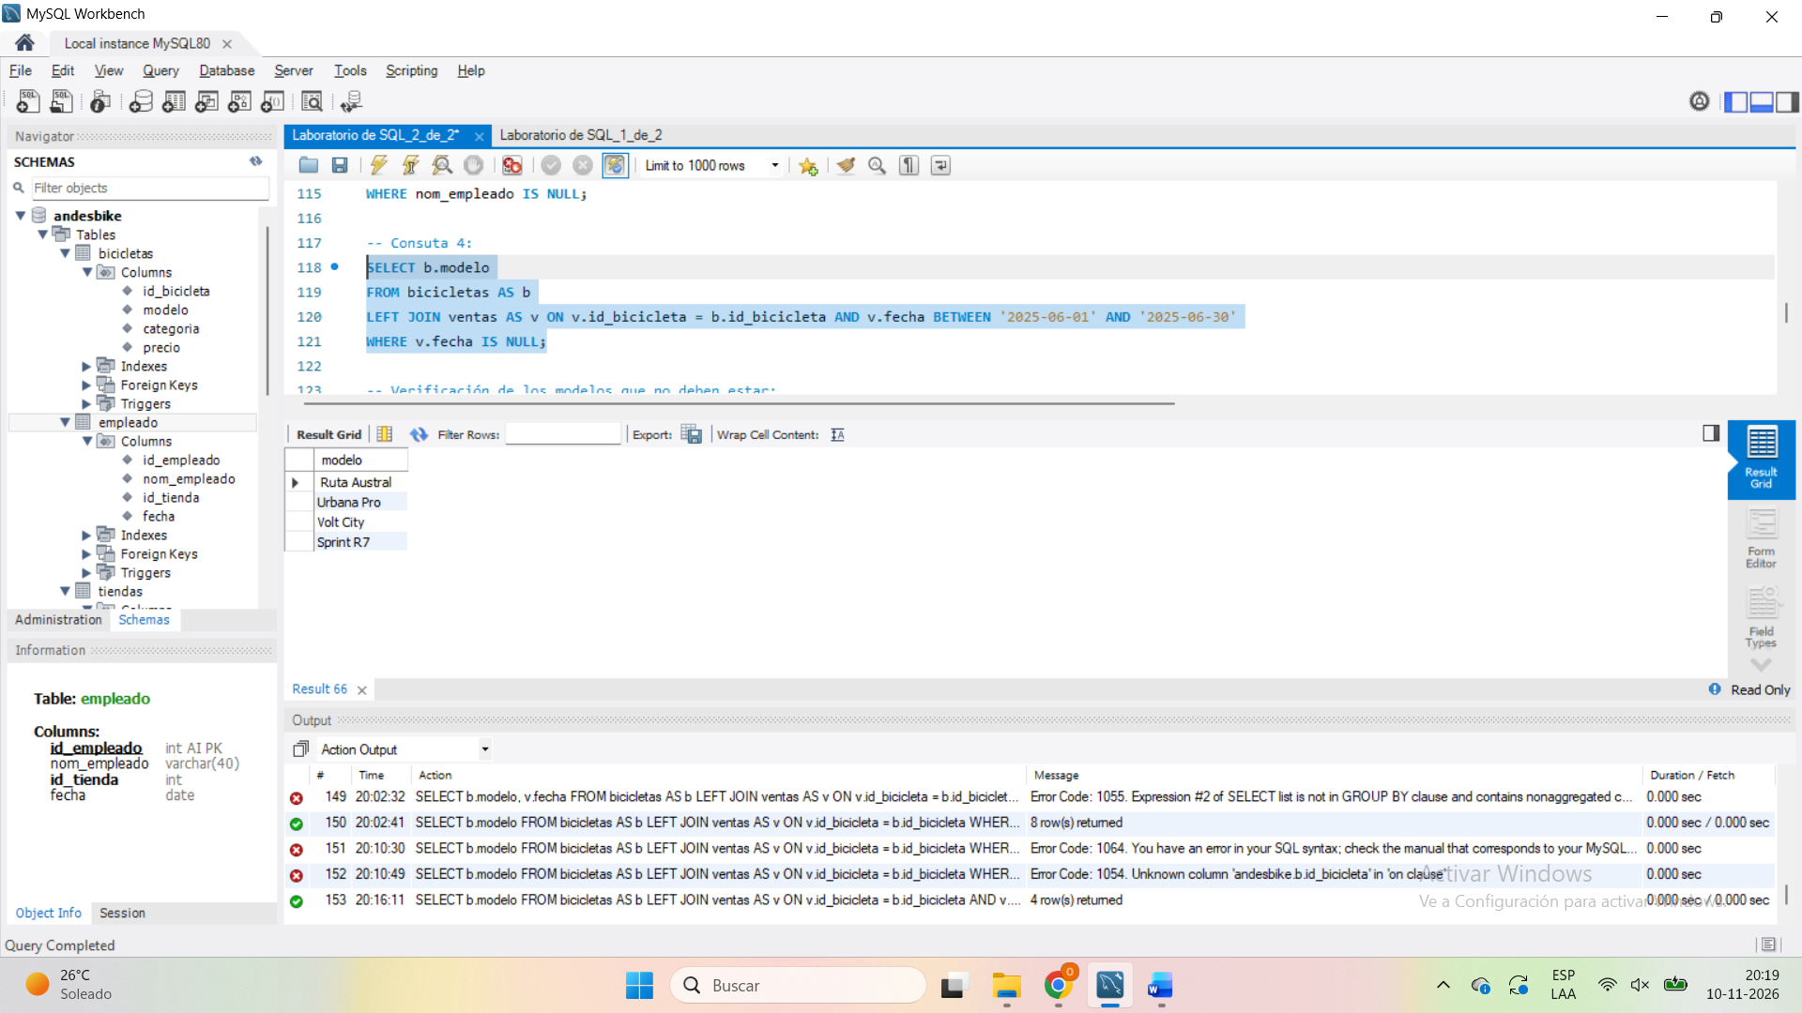
Se coloca en ese lugar de manera que todas las marcas que no registren ventas o que posean ventas en un rango diferente del mes de junio posean la columna de fecha nula, por lo que posteriormente se puede llamar todos los modelos que posean la fecha nula.

Si por ejemplo se colocaba como un Where posterior al JOIN, este mostrara las bicicletas que efectivamente tenían ventas en el mes de junio:
SELECT b.modelo, v.fecha
FROM bicicletas AS b
LEFT JOIN ventas AS v ON v.id_bicicleta = b.id_bicicleta
WHERE v.fecha BETWEEN '2025-06-01' AND '2025-06-30';
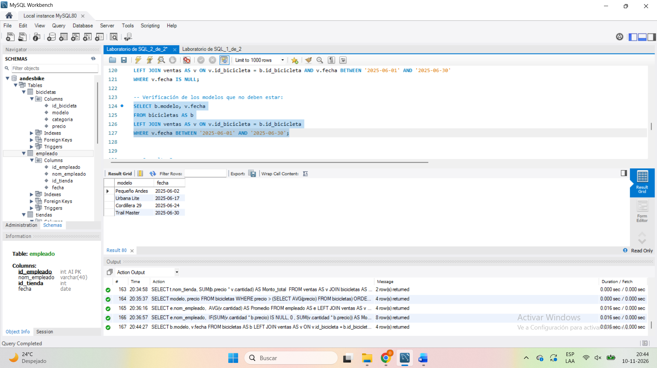

-- Consulta 5:
SELECT t.nom_tienda, e.nom_empleado, COUNT(v.id_venta) AS Cantidad_de_ventas
FROM empleado AS e
LEFT JOIN ventas AS v ON v.id_empleado = e.id_empleado
LEFT JOIN tiendas AS t ON t.id_tienda = e.id_tienda
GROUP BY t.nom_tienda, e.nom_empleado
HAVING COUNT(v.id_venta) = 0;
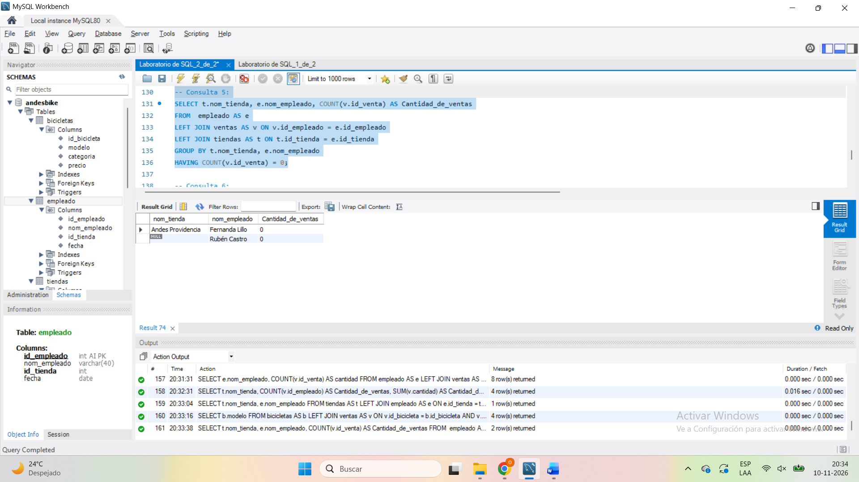

-- Consulta 6:
SELECT e.nom_empleado, j.nom_empleado, e.fecha, j.fecha, t.nom_tienda
FROM empleado AS e
JOIN empleado AS j ON e.id_tienda = j.id_tienda AND e.fecha <= j.fecha AND e.id_empleado < j.id_empleado
JOIN tiendas AS t ON e.id_tienda = t.id_tienda;
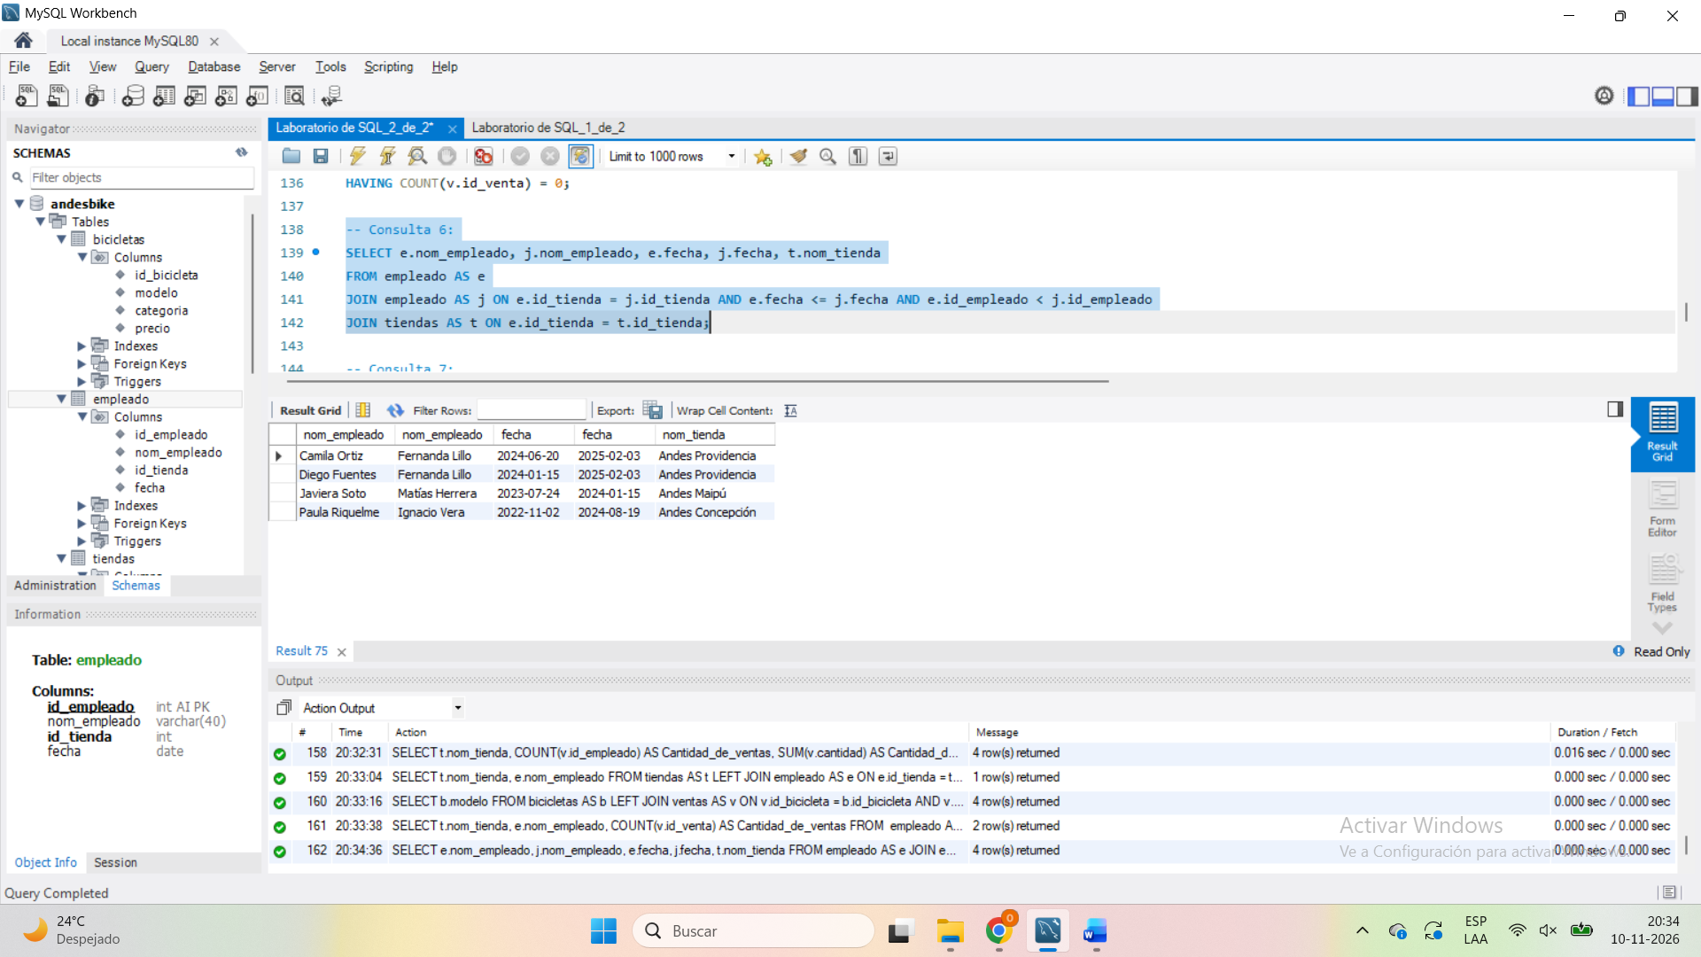

-- Consulta 7:
SELECT t.nom_tienda, SUM(b.precio * v.cantidad) AS Monto_total
FROM ventas AS v
JOIN bicicletas AS b ON b.id_bicicleta = v.id_bicicleta
JOIN empleado AS e ON e.id_empleado = v.id_empleado
JOIN tiendas AS t ON t.id_tienda = e.id_tienda
WHERE b.categoria IN ('Montaña', 'Ruta')
GROUP BY t.nom_tienda
HAVING Monto_total > 2000000
ORDER BY Monto_total DESC;
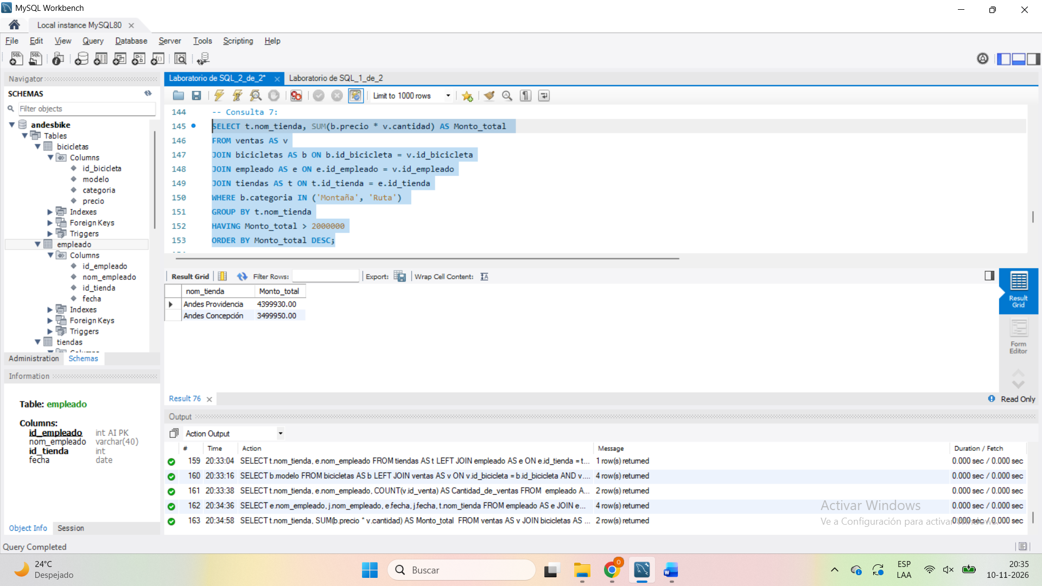

-- Consulta 8:
SELECT modelo, precio
FROM bicicletas
WHERE precio > (SELECT AVG(precio) FROM bicicletas)
ORDER BY precio DESC;
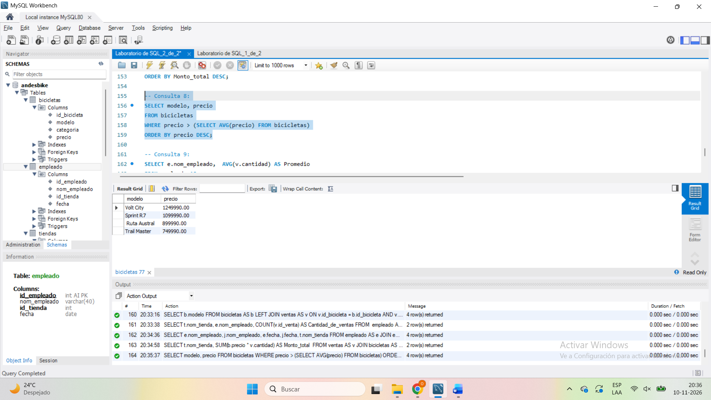
De esta manera se obtiene el valor promedio:
SELECT AVG(precio) AS valor_promedio FROM bicicletas;
Su valor es 657.490. 657490.000000

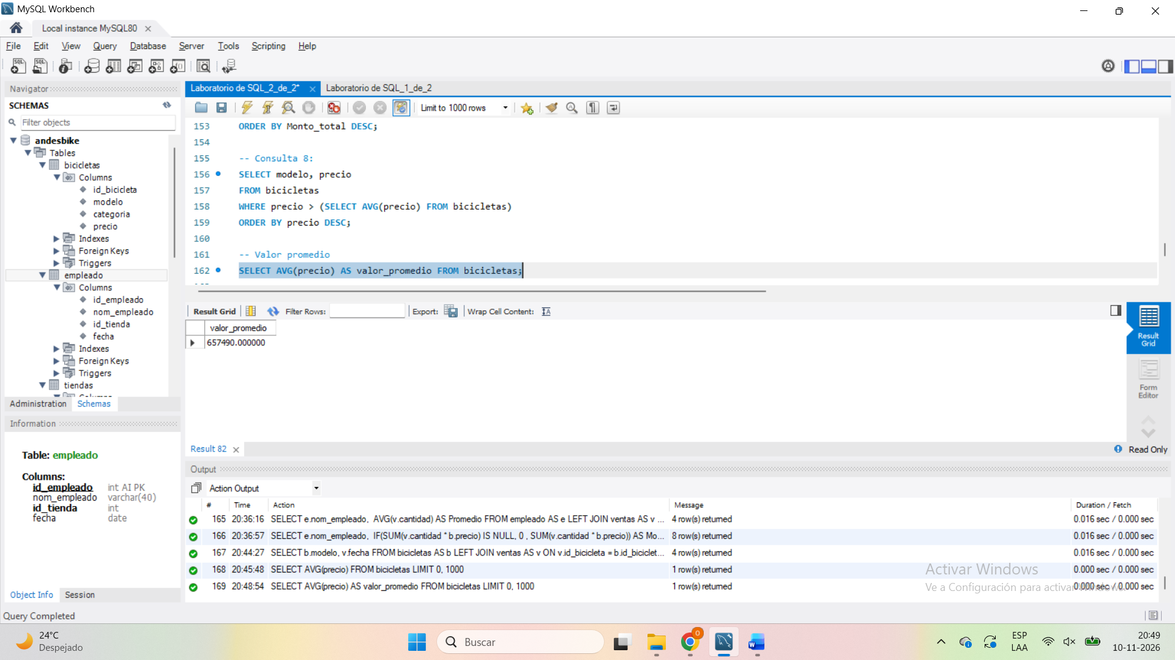

-- Consulta 9:
SELECT e.nom_empleado, AVG(v.cantidad) AS Promedio
FROM empleado AS e
LEFT JOIN ventas AS v ON v.id_empleado = e.id_empleado
GROUP BY e.nom_empleado
HAVING Promedio > (SELECT AVG(cantidad) FROM ventas)
ORDER BY Promedio DESC, e.nom_empleado ASC;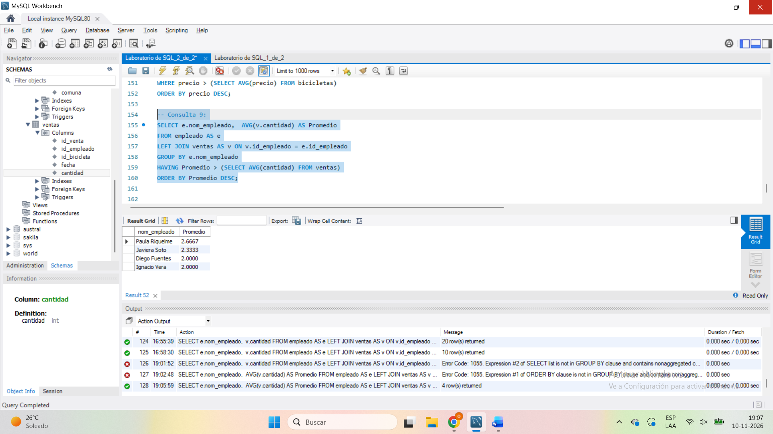

-- Consulta 10:
SELECT e.nom_empleado, SUM(v.cantidad * b.precio) AS Monto
FROM empleado AS e
LEFT JOIN ventas AS v ON v.id_empleado = e.id_empleado
LEFT JOIN bicicletas AS b ON b.id_bicicleta = v.id_bicicleta
GROUP BY e.nom_empleado
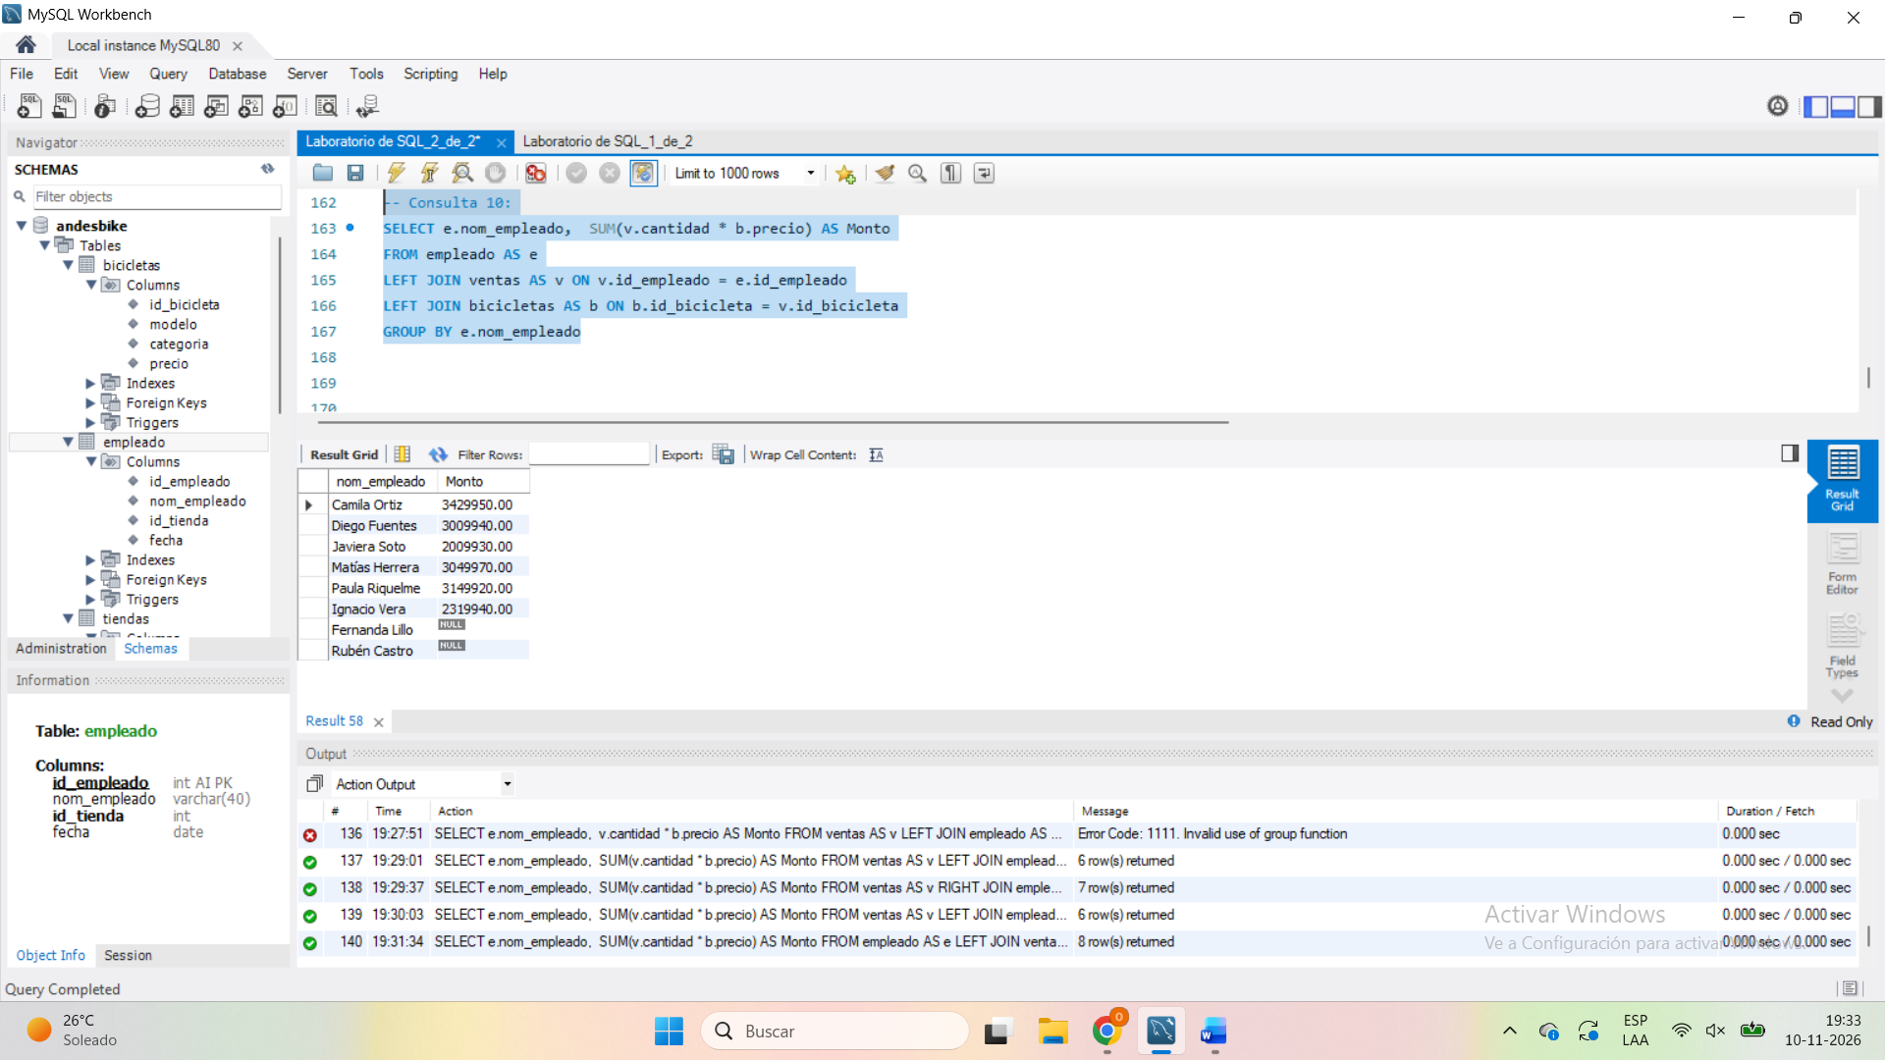

Debería de agregar un IF como se muestra:
IF(SUM(v.cantidad * b.precio) IS NULL, 0 , SUM(v.cantidad * b.precio)) AS Monto
En donde si el valor de la suma es nulo entonces el valor de la suma será cero, en coso que la suma sea diferente del valor nulo se tendrá el valor de la suma.
SELECT e.nom_empleado, IF(SUM(v.cantidad * b.precio) IS NULL, 0 , SUM(v.cantidad * b.precio)) AS Monto
FROM empleado AS e
LEFT JOIN ventas AS v ON v.id_empleado = e.id_empleado
LEFT JOIN bicicletas AS b ON b.id_bicicleta = v.id_bicicleta
GROUP BY e.nom_empleado
ORDER BY Monto DESC;
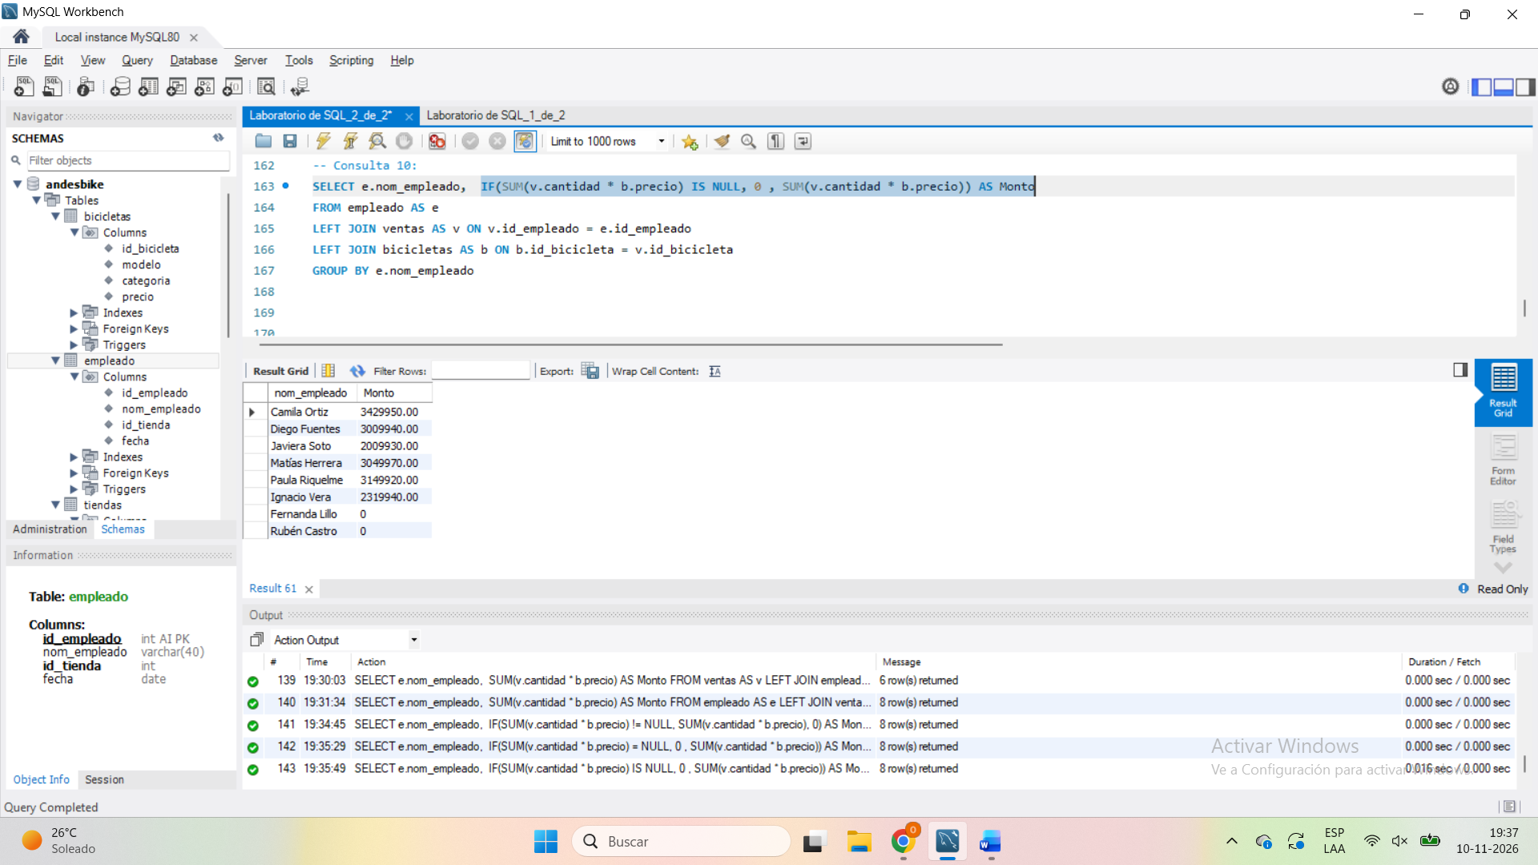

Pruebas de humanidad:
 | # | Time | Action | Message | Duration / Fetch
3 | 1 | 13:08:15 | CREATE DATABASE andesbike | 1 row(s) affected | 0.015 sec
3 | 2 | 13:08:24 | USE andesbike | 0 row(s) affected | 0.000 sec
0 | 3 | 13:08:34 | Create Table Tiendas ( ID_tienda AUTO_INCREMENT Not NULL, Nom_tienda Varchar(40) Not Null, Comuna Varchar(40), Primary key (ID_tienda) ) | Error Code: 1064. You have an error in your SQL syntax; check the manual that corresponds to your MySQL server version for the right syntax to use near 'AUTO_INCREMENT Not NULL, Nom_tienda Varchar(40) Not Null, Comuna Varchar(40), Pr' at line 2 | 0.000 sec
0 | 4 | 13:19:36 | CREATE TABLE ventas ( id_venta INT AUTO_INCREMENT NOT NULL, id_empleado INT NOT NULL, id_bicicleta INT NOT NULL, fecha DATE NOT NULL, cantidad INT NOT NULL, PRIMARY KEY (id_venta) | Error Code: 1064. You have an error in your SQL syntax; check the manual that corresponds to your MySQL server version for the right syntax to use near '' at line 7 | 0.000 sec
0 | 5 | 13:25:07 | SELECT * FROM tiendas LIMIT 0, 1000 | Error Code: 1146. Table 'andesbike.tiendas' doesn't exist | 0.000 sec
0 | 6 | 13:25:13 | INSERT INTO tiendas (nom_tienda, comuna) VALUES ('Andes Providencia', 'Providencia'), ('Andes Maipú', 'Maipú'), ('Andes Concepción ', 'Concepción'), ('Andes La Serena', 'La Serena') | Error Code: 1146. Table 'andesbike.tiendas' doesn't exist | 0.016 sec
3 | 7 | 13:25:27 | Create Table tiendas ( id_tienda INT AUTO_INCREMENT Not NULL, nom_tienda Varchar(40) Not Null, comuna Varchar(40) NOT NULL, Primary key (id_tienda) ) | 0 row(s) affected | 0.031 sec
0 | 8 | 13:25:30 | Create Table Empleado ( id_empleado INT AUTO_INCREMENT Not Null, nom_empleado Varchar(40) Not Null, id_tienda INT Not NULL, fecha Date, Primary Key (id_empleado), FOREIGN KEY (id_tienda) REFERENCES tiendas(id_autor) ) | Error Code: 3734. Failed to add the foreign key constraint. Missing column 'id_autor' for constraint 'empleado_ibfk_1' in the referenced table 'tiendas' | 0.000 sec
3 | 9 | 13:25:58 | Create Table Empleado ( id_empleado INT AUTO_INCREMENT Not Null, nom_empleado Varchar(40) Not Null, id_tienda INT Not NULL, fecha Date, Primary Key (id_empleado), FOREIGN KEY (id_tienda) REFERENCES tiendas(id_tienda) ) | 0 row(s) affected | 0.047 sec
3 | 10 | 13:26:01 | Create Table bicicletas ( id_bicicleta INT AUTO_INCREMENT Not Null, modelo Varchar(40) NOT NULL, categoria ENUM('Eléctrica','Infantil','Montaña','Ruta','Urbana') NOT NULL, precio DECIMAL(10,2) NOT NULL, PRIMARY KEY (id_bicicleta) ) | 0 row(s) affected | 0.000 sec
3 | 11 | 13:26:05 | CREATE TABLE ventas ( id_venta INT AUTO_INCREMENT NOT NULL, id_empleado INT NOT NULL, id_bicicleta INT NOT NULL, fecha DATE NOT NULL, cantidad INT NOT NULL, PRIMARY KEY (id_venta) ) | 0 row(s) affected | 0.016 sec
3 | 12 | 13:26:15 | INSERT INTO tiendas (nom_tienda, comuna) VALUES ('Andes Providencia', 'Providencia'), ('Andes Maipú', 'Maipú'), ('Andes Concepción ', 'Concepción'), ('Andes La Serena', 'La Serena') | 4 row(s) affected Records: 4 Duplicates: 0 Warnings: 0 | 0.015 sec
3 | 13 | 13:26:18 | SELECT * FROM tiendas LIMIT 0, 1000 | 4 row(s) returned | 0.000 sec / 0.000 sec
3 | 14 | 13:28:40 | DROP TABLE `andesbike`.`empleado` | 0 row(s) affected | 0.031 sec
3 | 15 | 13:29:01 | Create Table empleado ( id_empleado INT AUTO_INCREMENT Not Null, nom_empleado Varchar(40) Not Null, id_tienda INT, fecha Date, Primary Key (id_empleado), FOREIGN KEY (id_tienda) REFERENCES tiendas(id_tienda) ) | 0 row(s) affected | 0.031 sec
3 | 16 | 13:33:08 | INSERT INTO empleado (nom_empleado, id_tienda, fecha) VALUES ('Camila Ortiz', 1, '2024-06-20'), ('Diego Fuentes ', 1, '2024-01-15'), ('Javiera Soto', 2, '2023-07-24'), ('Matías Herrera', 2, '2024-01-15'), ('Paula Riquelme', 3, '2022-11-02'), ('Ignacio Vera', 3, '2024-08-19'), ('Fernanda Lillo', 1, '2025-02-03'), ('Rubén Castro', NULL, '2025-06-10') | 8 row(s) affected Records: 8 Duplicates: 0 Warnings: 0 | 0.016 sec
3 | 17 | 13:33:11 | SELECT * FROM empleado LIMIT 0, 1000 | 8 row(s) returned | 0.000 sec / 0.000 sec
3 | 18 | 13:42:35 | INSERT INTO bicicletas (modelo, categoria, precio) VALUES ('Cordillera 29', 'Montaña', 549990.00), (' Ruta Austral', 'Ruta', 899990.00), ('Urbana Pro', 'Urbana', 329990.00), ('Pequeño Andes', 'Infantil', 149990.00), ('Volt City', 'Eléctrica', 1249990.00), ('Trail Master', 'Montaña', 749990.00), ('Urbana Lite', 'Urbana', 229990.00), ('Sprint R7', 'Ruta', 1099990.00) | 8 row(s) affected Records: 8 Duplicates: 0 Warnings: 0 | 0.015 sec
3 | 19 | 13:42:44 | SELECT * FROM bicicletas LIMIT 0, 1000 | 8 row(s) returned | 0.000 sec / 0.000 sec
3 | 20 | 13:46:59 | SELECT * FROM bicicletas LIMIT 0, 1000 | 8 row(s) returned | 0.000 sec / 0.000 sec
3 | 21 | 13:58:11 | INSERT INTO ventas (id_empleado, id_bicicleta, fecha, cantidad) VALUES ( 1, 1, '2025-03-04', 2), ( 1, 3, '2025-03-18', 1), ( 1, 5, '2025-04-02', 1), ( 2, 2, '2025-03-04', 1), ( 2, 1, '2025-04-11', 3), ( 2, 7, '2025-05-06', 2), ( 3, 4, '2025-03-21', 4), ( 3, 3, '2025-04-15', 2), ( 3, 6, '2025-05-20', 1), ( 4, 1, '2025-03-27', 1), ( 4, 5, '2025-05-09', 2), ( 5, 2, '2025-04-08', 1), ( 5, 6, '2025-04-23', 2), ( 5, 4, '2025-06-02', 5), ( 6, 3, '2025-05-13', 3), ( 6, 7, '2025-06-17', 1), ( 6, 1, '2025-06-24', 2), ( 1, 6, '2025-06-30', 1) | 18 row(s) affected Records: 18 Duplicates: 0 Warnings: 0 | 0.000 sec
3 | 22 | 13:58:14 | SELECT * FROM ventas LIMIT 0, 1000 | 18 row(s) returned | 0.000 sec / 0.000 sec
3 | 23 | 14:03:03 | SELECT v.cantidad, v.id_empleado FROM ventas AS v JOIN empleado AS e ON v.id_empleado = e.id_empleado LIMIT 0, 1000 | 18 row(s) returned | 0.000 sec / 0.000 sec
3 | 24 | 14:03:34 | SELECT v.cantidad, v.id_empleado, e.nom_empleado FROM ventas AS v JOIN empleado AS e ON v.id_empleado = e.id_empleado LIMIT 0, 1000 | 18 row(s) returned | 0.015 sec / 0.000 sec
3 | 25 | 14:03:58 | SELECT e.nom_empleado, v.cantidad FROM ventas AS v JOIN empleado AS e ON v.id_empleado = e.id_empleado LIMIT 0, 1000 | 18 row(s) returned | 0.000 sec / 0.000 sec
3 | 26 | 14:04:41 | SELECT e.nom_empleado, v.cantidad FROM ventas AS v JOIN empleado AS e ON v.id_empleado = e.id_empleado ORDER BY cantidad LIMIT 0, 1000 | 18 row(s) returned | 0.000 sec / 0.000 sec
0 | 27 | 14:05:17 | SELECT e.nom_empleado, v.cantidad FROM ventas AS v JOIN empleado AS e ON v.id_empleado = e.id_empleado GROUP BY e.nom_empleado ORDER BY cantidad ASC LIMIT 0, 1000 | Error Code: 1055. Expression #2 of SELECT list is not in GROUP BY clause and contains nonaggregated column 'andesbike.v.cantidad' which is not functionally dependent on columns in GROUP BY clause; this is incompatible with sql_mode=only_full_group_by | 0.000 sec
3 | 28 | 14:06:13 | SELECT e.nom_empleado, v.cantidad FROM ventas AS v LEFT JOIN empleado AS e ON v.id_empleado = e.id_empleado ORDER BY cantidad ASC LIMIT 0, 1000 | 18 row(s) returned | 0.000 sec / 0.000 sec
3 | 29 | 14:07:21 | SELECT e.nom_empleado, v.cantidad FROM empleado AS e LEFT JOIN ventas AS v ON v.id_empleado = e.id_empleado ORDER BY cantidad ASC LIMIT 0, 1000 | 20 row(s) returned | 0.000 sec / 0.000 sec
3 | 30 | 14:08:14 | SELECT e.nom_empleado, v.cantidad FROM empleado AS e LEFT JOIN ventas AS v ON v.id_empleado = e.id_empleado ORDER BY cantidad ASC LIMIT 0, 1000 | 20 row(s) returned | 0.000 sec / 0.000 sec
3 | 31 | 14:08:42 | SELECT e.nom_empleado, v.cantidad FROM empleado AS e LEFT JOIN ventas AS v ON v.id_empleado = e.id_empleado ORDER BY cantidad ASC, e.nom_empleado DESC LIMIT 0, 1000 | 20 row(s) returned | 0.000 sec / 0.000 sec
3 | 32 | 14:09:21 | SELECT e.nom_empleado, v.cantidad FROM empleado AS e LEFT JOIN ventas AS v ON v.id_empleado = e.id_empleado ORDER BY e.nom_empleado DESC, cantidad ASC LIMIT 0, 1000 | 20 row(s) returned | 0.000 sec / 0.000 sec
0 | 33 | 14:09:44 | ORDER BY e.nom_empleado DESC, cantidad ASC | Error Code: 1064. You have an error in your SQL syntax; check the manual that corresponds to your MySQL server version for the right syntax to use near 'ORDER BY e.nom_empleado DESC, cantidad ASC' at line 1 | 0.000 sec
3 | 34 | 14:09:50 | SELECT e.nom_empleado, v.cantidad FROM empleado AS e LEFT JOIN ventas AS v ON v.id_empleado = e.id_empleado ORDER BY e.nom_empleado DESC, cantidad ASC LIMIT 0, 1000 | 20 row(s) returned | 0.000 sec / 0.000 sec
3 | 35 | 14:10:15 | SELECT e.nom_empleado, v.cantidad FROM empleado AS e LEFT JOIN ventas AS v ON v.id_empleado = e.id_empleado ORDER BY e.nom_empleado DESC, cantidad DESC LIMIT 0, 1000 | 20 row(s) returned | 0.000 sec / 0.000 sec
0 | 36 | 14:18:28 | SELECT t.nom_tienda, conunt(v.id_empleado) AS Cantidad_de_ventas, SUM(v.cantidad) AS Cantidad_de_unidades FROM ventas AS v JOIN empleado AS e ON v.id_empleado = t.id_empleado JOIN tiendas AS t ON t.id_tienda = e.id_tienda LIMIT 0, 1000 | Error Code: 1305. FUNCTION andesbike.conunt does not exist | 0.015 sec
0 | 37 | 14:20:41 | SELECT t.nom_tienda, conunt(v.id_empleado) AS Cantidad_de_ventas, v.cantidad AS Cantidad_de_unidades FROM ventas AS v JOIN empleado AS e ON v.id_empleado = t.id_empleado JOIN tiendas AS t ON t.id_tienda = e.id_tienda LIMIT 0, 1000 | Error Code: 1305. FUNCTION andesbike.conunt does not exist | 0.016 sec
0 | 38 | 14:21:17 | SELECT t.nom_tienda , v.cantidad AS Cantidad_de_unidades FROM ventas AS v JOIN empleado AS e ON v.id_empleado = t.id_empleado JOIN tiendas AS t ON t.id_tienda = e.id_tienda LIMIT 0, 1000 | Error Code: 1054. Unknown column 't.id_empleado' in 'on clause' | 0.000 sec
0 | 39 | 14:21:56 | SELECT t.nom_tienda, conunt(v.id_empleado) AS Cantidad_de_ventas, SUM(v.cantidad) AS Cantidad_de_unidades FROM ventas AS v JOIN empleado AS e ON v.id_empleado = t.id_empleado JOIN tiendas AS t ON t.id_tienda = e.id_tienda ORDER BY Cantidad_de_unidades ASC LIMIT 0, 1000 | Error Code: 1305. FUNCTION andesbike.conunt does not exist | 0.000 sec
0 | 40 | 14:23:30 | SELECT t.nom_tienda, COUNT(v.id_empleado) AS Cantidad_de_ventas, SUM(v.cantidad) AS Cantidad_de_unidades FROM ventas AS v JOIN empleado AS e ON v.id_empleado = t.id_empleado JOIN tiendas AS t ON t.id_tienda = e.id_tienda ORDER BY Cantidad_de_unidades ASC LIMIT 0, 1000 | Error Code: 1054. Unknown column 't.id_empleado' in 'on clause' | 0.000 sec
0 | 41 | 14:24:06 | SELECT t.nom_tienda, COUNT(v.id_empleado) AS Cantidad_de_ventas, SUM(v.cantidad) AS Cantidad_de_unidades FROM ventas AS v LEFT JOIN empleado AS e ON v.id_empleado = t.id_empleado LEFT JOIN tiendas AS t ON t.id_tienda = e.id_tienda GROUP BY t.nom_tienda ORDER BY Cantidad_de_unidades ASC LIMIT 0, 1000 | Error Code: 1054. Unknown column 't.id_empleado' in 'on clause' | 0.000 sec
0 | 42 | 14:24:56 | SELECT t.nom_tienda, COUNT(v.id_empleado) AS Cantidad_de_ventas, SUM(v.cantidad) AS Cantidad_de_unidades FROM ventas AS v LEFT JOIN empleado AS e ON v.id_empleado = t.id_empleado LEFT JOIN tiendas AS t ON t.id_tienda = e.id_tienda GROUP BY t.nom_tienda ORDER BY Cantidad_de_unidades ASC LIMIT 0, 1000 | Error Code: 1054. Unknown column 't.id_empleado' in 'on clause' | 0.000 sec
3 | 43 | 14:27:19 | SELECT t.nom_tienda, COUNT(v.id_empleado) AS Cantidad_de_ventas, SUM(v.cantidad) AS Cantidad_de_unidades FROM ventas AS v LEFT JOIN empleado AS e ON v.id_empleado = e.id_empleado LEFT JOIN tiendas AS t ON t.id_tienda = e.id_tienda GROUP BY t.nom_tienda ORDER BY Cantidad_de_unidades ASC LIMIT 0, 1000 | 3 row(s) returned | 0.000 sec / 0.000 sec
3 | 44 | 14:29:38 | SELECT t.nom_tienda, COUNT(v.id_empleado) AS Cantidad_de_ventas, SUM(v.cantidad) AS Cantidad_de_unidades FROM ventas AS v RIGHT JOIN empleado AS e ON v.id_empleado = e.id_empleado RIGHT JOIN tiendas AS t ON t.id_tienda = e.id_tienda GROUP BY t.nom_tienda ORDER BY Cantidad_de_unidades ASC LIMIT 0, 1000 | 4 row(s) returned | 0.000 sec / 0.000 sec
3 | 45 | 14:30:34 | SELECT t.nom_tienda, COUNT(v.id_empleado) AS Cantidad_de_ventas, SUM(v.cantidad) AS Cantidad_de_unidades FROM ventas AS v RIGHT JOIN empleado AS e ON v.id_empleado = e.id_empleado RIGHT JOIN tiendas AS t ON t.id_tienda = e.id_tienda GROUP BY t.nom_tienda ORDER BY Cantidad_de_unidades DESC LIMIT 0, 1000 | 4 row(s) returned | 0.000 sec / 0.000 sec
3 | 46 | 14:35:59 | SELECT t.nom_tienda FROM tiendas AS t LEFT JOIN empleado AS e ON e.id_tienda = t.id_tienda LIMIT 0, 1000 | 8 row(s) returned | 0.000 sec / 0.000 sec
3 | 47 | 14:36:25 | SELECT t.nom_tienda, e.nom_empleado FROM tiendas AS t LEFT JOIN empleado AS e ON e.id_tienda = t.id_tienda LIMIT 0, 1000 | 8 row(s) returned | 0.000 sec / 0.000 sec
3 | 48 | 14:36:56 | SELECT t.nom_tienda, e.nom_empleado FROM tiendas AS t LEFT JOIN empleado AS e ON e.id_tienda = t.id_tienda WHERE nom_empleado IS NULL LIMIT 0, 1000 | 1 row(s) returned | 0.000 sec / 0.000 sec
0 | 49 | 14:43:30 | SELECT b.modelo, v.fecha FROM bicicletas AS b RIGHT JOIN ventas AS v ON v.id_bicicletas = b.id_bicicletas LIMIT 0, 1000 | Error Code: 1054. Unknown column 'v.id_bicicletas' in 'on clause' | 0.015 sec
3 | 50 | 14:45:13 | SELECT b.modelo, v.fecha FROM bicicletas AS b RIGHT JOIN ventas AS v ON v.id_bicicleta = b.id_bicicleta LIMIT 0, 1000 | 18 row(s) returned | 0.000 sec / 0.000 sec
0 | 51 | 14:46:25 | SELECT b.modelo, v.fecha FROM bicicletas AS b RIGHT JOIN ventas AS v ON v.id_bicicleta = b.id_bicicleta WHERE v-fecha BETWEEN 2025-6-1 AND 2025-6-30 LIMIT 0, 1000 | Error Code: 1054. Unknown column 'v' in 'where clause' | 0.000 sec
3 | 52 | 14:46:35 | SELECT b.modelo, v.fecha FROM bicicletas AS b RIGHT JOIN ventas AS v ON v.id_bicicleta = b.id_bicicleta WHERE v.fecha BETWEEN 2025-6-1 AND 2025-6-30 LIMIT 0, 1000 | 0 row(s) returned | 0.000 sec / 0.000 sec
3 | 53 | 14:47:23 | SELECT b.modelo, v.fecha FROM bicicletas AS b RIGHT JOIN ventas AS v ON v.id_bicicleta = b.id_bicicleta WHERE v.fecha BETWEEN 2025-06-01 AND 2025-06-30 LIMIT 0, 1000 | 0 row(s) returned | 0.000 sec / 0.000 sec
3 | 54 | 14:47:29 | SELECT b.modelo, v.fecha FROM bicicletas AS b LEFT JOIN ventas AS v ON v.id_bicicleta = b.id_bicicleta WHERE v.fecha BETWEEN 2025-06-01 AND 2025-06-30 LIMIT 0, 1000 | 0 row(s) returned | 0.000 sec / 0.000 sec
3 | 55 | 14:47:49 | SELECT b.modelo, v.fecha FROM bicicletas AS b LEFT JOIN ventas AS v ON v.id_bicicleta = b.id_bicicleta LIMIT 0, 1000 | 19 row(s) returned | 0.000 sec / 0.000 sec
3 | 56 | 14:48:17 | SELECT b.modelo, v.fecha FROM bicicletas AS b LEFT JOIN ventas AS v ON v.id_bicicleta = b.id_bicicleta HAVING v.fecha BETWEEN 2025-06-01 AND 2025-06-30 LIMIT 0, 1000 | 0 row(s) returned | 0.000 sec / 0.000 sec
3 | 57 | 14:49:09 | SELECT b.modelo, v.fecha FROM bicicletas AS b LEFT JOIN ventas AS v ON v.id_bicicleta = b.id_bicicleta WHERE v.fecha BETWEEN '2025-06-01' AND '2025-06-30' LIMIT 0, 1000 | 4 row(s) returned | 0.000 sec / 0.000 sec
0 | 58 | 14:57:05 | SELECT t.nom_tienda, e.nom_empleado, COUNT(v.id_venta) AS Cantidad_de_ventas FROM empleado AS e LIMIT 0, 1000 | Error Code: 1054. Unknown column 't.nom_tienda' in 'field list' | 0.000 sec
0 | 59 | 15:02:04 | SELECT t.nom_tienda, e.nom_empleado, COUNT(v.id_venta) AS Cantidad_de_ventas FROM empleado AS e LEFT JOIN tiendas AS t ON t.id_tienda = e.id_tienda LEFT JOIN ventas AS v ON v.id_empleado = e.id_empleado LIMIT 0, 1000 | Error Code: 1140. In aggregated query without GROUP BY, expression #1 of SELECT list contains nonaggregated column 'andesbike.t.nom_tienda'; this is incompatible with sql_mode=only_full_group_by | 0.016 sec
0 | 60 | 15:02:37 | SELECT t.nom_tienda, e.nom_empleado, COUNT(v.id_venta) AS Cantidad_de_ventas FROM empleado AS e LEFT JOIN tiendas AS t ON t.id_tienda = e.id_tienda LEFT JOIN ventas AS v ON v.id_empleado = e.id_empleado WHERE COUNT(v.id_venta) = 0 LIMIT 0, 1000 | Error Code: 1111. Invalid use of group function | 0.000 sec
0 | 61 | 15:03:32 | SELECT t.nom_tienda, e.nom_empleado, COUNT(v.id_venta) AS Cantidad_de_ventas FROM ventas AS v RIGHT JOIN tiendas AS t ON t.id_tienda = e.id_tienda RIGHT JOIN empleado AS e ON v.id_empleado = e.id_empleado WHERE COUNT(v.id_venta) = 0 LIMIT 0, 1000 | Error Code: 1111. Invalid use of group function | 0.000 sec
0 | 62 | 15:03:41 | SELECT t.nom_tienda, e.nom_empleado, COUNT(v.id_venta) AS Cantidad_de_ventas FROM ventas AS v RIGHT JOIN tiendas AS t ON t.id_tienda = e.id_tienda RIGHT JOIN empleado AS e ON v.id_empleado = e.id_empleado LIMIT 0, 1000 | Error Code: 1054. Unknown column 'e.id_tienda' in 'on clause' | 0.000 sec
0 | 63 | 15:03:56 | SELECT t.nom_tienda, e.nom_empleado, COUNT(v.id_venta) AS Cantidad_de_ventas FROM ventas AS v RIGHT JOIN empleado AS e ON v.id_empleado = e.id_empleado RIGHT JOIN tiendas AS t ON t.id_tienda = e.id_tienda LIMIT 0, 1000 | Error Code: 1140. In aggregated query without GROUP BY, expression #1 of SELECT list contains nonaggregated column 'andesbike.t.nom_tienda'; this is incompatible with sql_mode=only_full_group_by | 0.000 sec
0 | 64 | 15:04:31 | SELECT t.nom_tienda, e.nom_empleado, COUNT(v.id_venta) AS Cantidad_de_ventas FROM ventas AS v RIGHT JOIN empleado AS e ON v.id_empleado = e.id_empleado RIGHT JOIN tiendas AS t ON t.id_tienda = e.id_tienda GROUP BY e.nom_empleado HAVING COUNT(v.id_venta) = 0 LIMIT 0, 1000 | Error Code: 1055. Expression #1 of SELECT list is not in GROUP BY clause and contains nonaggregated column 'andesbike.t.nom_tienda' which is not functionally dependent on columns in GROUP BY clause; this is incompatible with sql_mode=only_full_group_by | 0.000 sec
0 | 65 | 15:05:47 | SELECT t.nom_tienda, e.nom_empleado, COUNT(v.id_venta) AS Cantidad_de_ventas FROM ventas AS v RIGHT JOIN empleado AS e ON v.id_empleado = e.id_empleado RIGHT JOIN tiendas AS t ON t.id_tienda = e.id_tienda HAVING COUNT(v.id_venta) = 0 LIMIT 0, 1000 | Error Code: 1140. In aggregated query without GROUP BY, expression #1 of SELECT list contains nonaggregated column 'andesbike.t.nom_tienda'; this is incompatible with sql_mode=only_full_group_by | 0.000 sec
0 | 66 | 15:06:20 | SELECT t.nom_tienda, e.nom_empleado, COUNT(v.id_venta) AS Cantidad_de_ventas FROM ventas AS v RIGHT JOIN empleado AS e ON v.id_empleado = e.id_empleado RIGHT JOIN tiendas AS t ON t.id_tienda = e.id_tienda GROUP BY e.nom_empleado HAVING COUNT(v.id_venta) = 0 LIMIT 0, 1000 | Error Code: 1055. Expression #1 of SELECT list is not in GROUP BY clause and contains nonaggregated column 'andesbike.t.nom_tienda' which is not functionally dependent on columns in GROUP BY clause; this is incompatible with sql_mode=only_full_group_by | 0.000 sec
0 | 67 | 15:14:52 | SELECT t.nom_tienda, e.nom_empleado, COUNT(v.id_venta) AS Cantidad_de_ventas FROM empleado AS e LEFT JOIN ventas AS e ON v.id_empleado = e.id_empleado LEFT JOIN tiendas AS t ON t.id_tienda = e.id_tienda GROUP BY e.nom_empleado HAVING COUNT(v.id_venta) = 0 LIMIT 0, 1000 | Error Code: 1066. Not unique table/alias: 'e' | 0.000 sec
0 | 68 | 15:15:03 | SELECT t.nom_tienda, e.nom_empleado, COUNT(v.id_venta) AS Cantidad_de_ventas FROM empleado AS e LEFT JOIN ventas AS v ON v.id_empleado = e.id_empleado LEFT JOIN tiendas AS t ON t.id_tienda = e.id_tienda GROUP BY e.nom_empleado HAVING COUNT(v.id_venta) = 0 LIMIT 0, 1000 | Error Code: 1055. Expression #1 of SELECT list is not in GROUP BY clause and contains nonaggregated column 'andesbike.t.nom_tienda' which is not functionally dependent on columns in GROUP BY clause; this is incompatible with sql_mode=only_full_group_by | 0.000 sec
0 | 69 | 15:16:10 | SELECT t.nom_tienda, e.nom_empleado, COUNT(v.id_venta) AS Cantidad_de_ventas FROM empleado AS e LEFT JOIN ventas AS v ON v.id_empleado = e.id_empleado LEFT JOIN tiendas AS t ON t.id_tienda = e.id_tienda LIMIT 0, 1000 | Error Code: 1140. In aggregated query without GROUP BY, expression #1 of SELECT list contains nonaggregated column 'andesbike.t.nom_tienda'; this is incompatible with sql_mode=only_full_group_by | 0.000 sec
3 | 70 | 15:17:24 | SELECT t.nom_tienda, e.nom_empleado, COUNT(v.id_venta) AS Cantidad_de_ventas FROM empleado AS e LEFT JOIN ventas AS v ON v.id_empleado = e.id_empleado LEFT JOIN tiendas AS t ON t.id_tienda = e.id_tienda GROUP BY t.nom_tienda, e.nom_empleado LIMIT 0, 1000 | 8 row(s) returned | 0.000 sec / 0.000 sec
3 | 71 | 15:17:32 | SELECT t.nom_tienda, e.nom_empleado, COUNT(v.id_venta) AS Cantidad_de_ventas FROM empleado AS e LEFT JOIN ventas AS v ON v.id_empleado = e.id_empleado LEFT JOIN tiendas AS t ON t.id_tienda = e.id_tienda GROUP BY t.nom_tienda, e.nom_empleado HAVING COUNT(v.id_venta) = 0 LIMIT 0, 1000 | 2 row(s) returned | 0.015 sec / 0.000 sec
0 | 72 | 15:22:14 | SELECT e.nom_empleado, e.fecha, t.nom_tienda FROM empleados AS e LEFT JOIN tiendas AS t ON t.id_empleado = e.id_empleado LIMIT 0, 1000 | Error Code: 1146. Table 'andesbike.empleados' doesn't exist | 0.000 sec
0 | 73 | 15:22:41 | SELECT e.nom_empleado, e.fecha, t.nom_tienda FROM empleados AS e LEFT JOIN tiendas AS t ON t.id_empleado = e.id_empleado GROUP BY e.nom_empleado, e.fecha LIMIT 0, 1000 | Error Code: 1146. Table 'andesbike.empleados' doesn't exist | 0.000 sec
0 | 74 | 15:23:31 | SELECT e.nom_empleado, e.fecha, t.nom_tienda FROM empleados AS e LEFT JOIN tiendas AS t ON t.id_tienda = e.id_tienda GROUP BY e.nom_empleado, e.fecha LIMIT 0, 1000 | Error Code: 1146. Table 'andesbike.empleados' doesn't exist | 0.000 sec
0 | 75 | 15:23:46 | SELECT e.nom_empleado, e.fecha, t.nom_tienda FROM empleados AS e LEFT JOIN tiendas AS t ON t.id_tienda = e.id_tienda GROUP BY e.nom_empleado LIMIT 0, 1000 | Error Code: 1146. Table 'andesbike.empleados' doesn't exist | 0.000 sec
0 | 76 | 15:23:50 | SELECT e.nom_empleado, e.fecha, t.nom_tienda FROM empleados AS e LEFT JOIN tiendas AS t ON t.id_tienda = e.id_tienda LIMIT 0, 1000 | Error Code: 1146. Table 'andesbike.empleados' doesn't exist | 0.000 sec
0 | 77 | 15:24:37 | SELECT e.nom_empleado, e.fecha, t.nom_tienda FROM empleados AS e LEFT JOIN tiendas AS t ON t.id_tienda = e.id_tienda GROUP BY e.nom_empleado LIMIT 0, 1000 | Error Code: 1146. Table 'andesbike.empleados' doesn't exist | 0.000 sec
0 | 78 | 15:25:13 | SELECT e.nom_empleado, e.fecha, t.nom_tienda FROM empleados AS e LEFT JOIN tiendas AS t ON t.id_tienda = e.id_tienda GROUP BY t.nom_tienda LIMIT 0, 1000 | Error Code: 1146. Table 'andesbike.empleados' doesn't exist | 0.000 sec
0 | 79 | 15:25:23 | SELECT e.nom_empleado, e.fecha, t.nom_tienda FROM empleados AS e LEFT JOIN tiendas AS t ON t.id_tienda = e.id_tienda LIMIT 0, 1000 | Error Code: 1146. Table 'andesbike.empleados' doesn't exist | 0.000 sec
0 | 80 | 15:25:25 | SELECT e.nom_empleado, e.fecha, t.nom_tienda FROM empleados AS e LEFT JOIN tiendas AS t ON t.id_tienda = e.id_tienda GROUP BY t.nom_tienda LIMIT 0, 1000 | Error Code: 1146. Table 'andesbike.empleados' doesn't exist | 0.000 sec
0 | 81 | 15:38:18 | SELECT e.nom_empleado, j.nom_empleado, e.fecha, t.nom_tienda FROM empleados AS e JOIN empleados AS j ON e.id_tienda = j.id_tienda LIMIT 0, 1000 | Error Code: 1146. Table 'andesbike.empleados' doesn't exist | 0.000 sec
0 | 82 | 15:41:39 | SELECT e.nom_empleado, j.nom_empleado, e.fecha, j.fecha, t.nom_tienda FROM empleados AS e JOIN empleados AS j ON e.id_tienda = j.id_tienda AND j>e JOIN tiendas AS t ON e.id_tienda = t.id_tienda LIMIT 0, 1000 | Error Code: 1146. Table 'andesbike.empleados' doesn't exist | 0.000 sec
0 | 83 | 15:42:31 | SELECT e.nom_empleado, j.nom_empleado, e.fecha, j.fecha, t.nom_tienda FROM empleados AS e JOIN empleados AS j ON e.id_tienda = j.id_tienda AND j.fecha>e.fecha JOIN tiendas AS t ON e.id_tienda = t.id_tienda LIMIT 0, 1000 | Error Code: 1146. Table 'andesbike.empleados' doesn't exist | 0.000 sec
0 | 84 | 15:43:01 | SELECT e.nom_empleado, j.nom_empleado, e.fecha, j.fecha, t.nom_tienda FROM empleados AS e JOIN empleados AS j ON e.id_tienda = j.id_tienda AND j != e JOIN tiendas AS t ON e.id_tienda = t.id_tienda LIMIT 0, 1000 | Error Code: 1146. Table 'andesbike.empleados' doesn't exist | 0.000 sec
0 | 85 | 15:45:30 | SELECT e.nom_empleado, j.nom_empleado, e.fecha, j.fecha, t.nom_tienda FROM empleados AS e JOIN empleados AS j ON e.id_tienda = j.id_tienda AND e.fecha < j.fecha JOIN tiendas AS t ON e.id_tienda = t.id_tienda LIMIT 0, 1000 | Error Code: 1146. Table 'andesbike.empleados' doesn't exist | 0.000 sec
3 | 86 | 15:47:13 | SELECT e.nom_empleado, j.nom_empleado, e.fecha, j.fecha, t.nom_tienda FROM empleado AS e JOIN empleado AS j ON e.id_tienda = j.id_tienda AND e.fecha <= j.fecha JOIN tiendas AS t ON e.id_tienda = t.id_tienda LIMIT 0, 1000 | 12 row(s) returned | 0.000 sec / 0.000 sec
3 | 87 | 15:47:53 | SELECT e.nom_empleado, j.nom_empleado, e.fecha, j.fecha, t.nom_tienda FROM empleado AS e JOIN empleado AS j ON e.id_tienda = j.id_tienda AND e.fecha < j.fecha AND e.nom_empleado != j.nom_empleado JOIN tiendas AS t ON e.id_tienda = t.id_tienda LIMIT 0, 1000 | 5 row(s) returned | 0.000 sec / 0.000 sec
3 | 88 | 15:50:02 | SELECT e.nom_empleado, j.nom_empleado, e.fecha, j.fecha, t.nom_tienda FROM empleado AS e JOIN empleado AS j ON e.id_tienda = j.id_tienda AND e.fecha <= j.fecha AND e.nom_empleado != j.nom_empleado JOIN tiendas AS t ON e.id_tienda = t.id_tienda LIMIT 0, 1000 | 5 row(s) returned | 0.000 sec / 0.000 sec
3 | 89 | 15:56:28 | SELECT e.nom_empleado, j.nom_empleado, e.fecha, j.fecha, t.nom_tienda FROM empleado AS e JOIN empleado AS j ON e.id_tienda = j.id_tienda AND e.fecha <= j.fecha AND e.id_empleado < j.id_empleado JOIN tiendas AS t ON e.id_tienda = t.id_tienda LIMIT 0, 1000 | 4 row(s) returned | 0.000 sec / 0.000 sec
3 | 90 | 15:57:01 | SELECT t.nom_tienda, e.nom_empleado, COUNT(v.id_venta) AS Cantidad_de_ventas FROM empleado AS e LEFT JOIN ventas AS v ON v.id_empleado = e.id_empleado LEFT JOIN tiendas AS t ON t.id_tienda = e.id_tienda GROUP BY t.nom_tienda, e.nom_empleado HAVING COUNT(v.id_venta) = 0 LIMIT 0, 1000 | 2 row(s) returned | 0.000 sec / 0.000 sec
0 | 91 | 16:03:04 | SELECT t.nom_tienda, SUM(b.precio * v.cantidad) AS Monto_total FROM ventas AS v JOIN bicicletas AS b ON b.id_bicicleta = v.id_bicicleta JOIN tiendas AS t ON t.id_empleado = v.id_empleado GROUP BY t.nom_tienda HAVING Monto_total > 2000000 LIMIT 0, 1000 | Error Code: 1054. Unknown column 't.id_empleado' in 'on clause' | 0.016 sec
0 | 92 | 16:13:47 | SELECT t.nom_tienda, SUM(b.precio * v.cantidad) AS Monto_total FROM ventas AS v JOIN bicicletas AS b ON b.id_bicicleta = v.id_bicicleta FROM empleados AS e ON e.id_empleado = v.id_empleado JOIN tiendas AS t ON t.id_tienda = e.id_tienda GROUP BY t.nom_tienda HAVING Monto_total > 2000000 | Error Code: 1064. You have an error in your SQL syntax; check the manual that corresponds to your MySQL server version for the right syntax to use near 'FROM empleados AS e ON e.id_empleado = v.id_empleado JOIN tiendas AS t ON t.id_t' at line 4 | 0.000 sec
0 | 93 | 16:14:53 | SELECT t.nom_tienda, SUM(b.precio * v.cantidad) AS Monto_total FROM ventas AS v JOIN bicicletas AS b ON b.id_bicicleta = v.id_bicicleta JOIN empleados AS e ON e.id_empleado = v.id_empleado JOIN tiendas AS t ON t.id_tienda = e.id_tienda GROUP BY t.nom_tienda HAVING Monto_total > 2000000 LIMIT 0, 1000 | Error Code: 1146. Table 'andesbike.empleados' doesn't exist | 0.000 sec
3 | 94 | 16:15:06 | SELECT t.nom_tienda, SUM(b.precio * v.cantidad) AS Monto_total FROM ventas AS v JOIN bicicletas AS b ON b.id_bicicleta = v.id_bicicleta JOIN empleado AS e ON e.id_empleado = v.id_empleado JOIN tiendas AS t ON t.id_tienda = e.id_tienda GROUP BY t.nom_tienda HAVING Monto_total > 2000000 LIMIT 0, 1000 | 3 row(s) returned | 0.000 sec / 0.000 sec
0 | 95 | 16:17:15 | SELECT t.nom_tienda, SUM(b.precio * v.cantidad) AS Monto_total FROM ventas AS v JOIN bicicletas AS b ON b.id_bicicleta = v.id_bicicleta HAVING categoria IS ('Montaña' OR 'Ruta') JOIN empleado AS e ON e.id_empleado = v.id_empleado JOIN tiendas AS t ON t.id_tienda = e.id_tienda GROUP BY t.nom_tienda HAVING Monto_total > 2000000 | Error Code: 1064. You have an error in your SQL syntax; check the manual that corresponds to your MySQL server version for the right syntax to use near '('Montaña' OR 'Ruta') JOIN empleado AS e ON e.id_empleado = v.id_empleado JOIN' at line 4 | 0.000 sec
0 | 96 | 16:18:38 | FROM ventas AS v JOIN bicicletas AS b ON b.id_bicicleta = v.id_bicicleta JOIN empleado AS e ON e.id_empleado = v.id_empleado JOIN tiendas AS t ON t.id_tienda = e.id_tienda GROUP BY t.nom_tienda HAVING Monto_total > 2000000 AND categoria IS ('Montaña' OR 'Ruta') ORDER BY Monto_total DESC | Error Code: 1064. You have an error in your SQL syntax; check the manual that corresponds to your MySQL server version for the right syntax to use near 'FROM ventas AS v JOIN bicicletas AS b ON b.id_bicicleta = v.id_bicicleta JOIN em' at line 1 | 0.000 sec
0 | 97 | 16:20:30 | SELECT t.nom_tienda, SUM(b.precio * v.cantidad) AS Monto_total FROM ventas AS v JOIN bicicletas AS b ON b.id_bicicleta = v.id_bicicleta JOIN empleado AS e ON e.id_empleado = v.id_empleado JOIN tiendas AS t ON t.id_tienda = e.id_tienda GROUP BY t.nom_tienda HAVING Monto_total > 2000000 AND categoria IN ('Montaña', 'Ruta') ORDER BY Monto_total DESC LIMIT 0, 1000 | Error Code: 1054. Unknown column 'categoria' in 'having clause' | 0.000 sec
0 | 98 | 16:21:10 | SELECT t.nom_tienda, b.categoria, SUM(b.precio * v.cantidad) AS Monto_total FROM ventas AS v JOIN bicicletas AS b ON b.id_bicicleta = v.id_bicicleta JOIN empleado AS e ON e.id_empleado = v.id_empleado JOIN tiendas AS t ON t.id_tienda = e.id_tienda GROUP BY t.nom_tienda HAVING Monto_total > 2000000 AND b.categoria IN ('Montaña', 'Ruta') ORDER BY Monto_total DESC LIMIT 0, 1000 | Error Code: 1055. Expression #2 of SELECT list is not in GROUP BY clause and contains nonaggregated column 'andesbike.b.categoria' which is not functionally dependent on columns in GROUP BY clause; this is incompatible with sql_mode=only_full_group_by | 0.000 sec
0 | 99 | 16:21:20 | SELECT t.nom_tienda, SUM(b.precio * v.cantidad) AS Monto_total FROM ventas AS v JOIN bicicletas AS b ON b.id_bicicleta = v.id_bicicleta JOIN empleado AS e ON e.id_empleado = v.id_empleado JOIN tiendas AS t ON t.id_tienda = e.id_tienda GROUP BY t.nom_tienda HAVING Monto_total > 2000000 AND b.categoria IN ('Montaña', 'Ruta') ORDER BY Monto_total DESC LIMIT 0, 1000 | Error Code: 1054. Unknown column 'b.categoria' in 'having clause' | 0.000 sec
0 | 100 | 16:22:59 | SELECT t.nom_tienda, SUM(b.precio * v.cantidad) AS Monto_total FROM ventas AS v JOIN bicicletas AS b ON b.id_bicicleta = v.id_bicicleta WHERE b.categoria IN ('Montaña', 'Ruta') JOIN empleado AS e ON e.id_empleado = v.id_empleado JOIN tiendas AS t ON t.id_tienda = e.id_tienda GROUP BY t.nom_tienda HAVING Monto_total > 2000000 ORDER BY Monto_total DESC | Error Code: 1064. You have an error in your SQL syntax; check the manual that corresponds to your MySQL server version for the right syntax to use near 'JOIN empleado AS e ON e.id_empleado = v.id_empleado JOIN tiendas AS t ON t.id_ti' at line 5 | 0.000 sec
3 | 101 | 16:23:28 | SELECT t.nom_tienda, SUM(b.precio * v.cantidad) AS Monto_total FROM ventas AS v JOIN bicicletas AS b ON b.id_bicicleta = v.id_bicicleta JOIN empleado AS e ON e.id_empleado = v.id_empleado JOIN tiendas AS t ON t.id_tienda = e.id_tienda WHERE b.categoria IN ('Montaña', 'Ruta') GROUP BY t.nom_tienda HAVING Monto_total > 2000000 ORDER BY Monto_total DESC LIMIT 0, 1000 | 2 row(s) returned | 0.000 sec / 0.000 sec
0 | 102 | 16:26:44 | SELECT modelo, precio FROM bicicletas WHERE precio > AVG(precio) ORDER BY precio DESC LIMIT 0, 1000 | Error Code: 1111. Invalid use of group function | 0.000 sec
0 | 103 | 16:27:07 | SELECT modelo, precio FROM bicicletas WHERE precio > AVG(precio) GROUP BY modelo, precio ORDER BY precio DESC LIMIT 0, 1000 | Error Code: 1111. Invalid use of group function | 0.000 sec
0 | 104 | 16:27:17 | SELECT modelo, precio FROM bicicletas WHERE precio > AVG(precio) GROUP BY modelo ORDER BY precio DESC LIMIT 0, 1000 | Error Code: 1111. Invalid use of group function | 0.000 sec
0 | 105 | 16:27:52 | SELECT modelo, precio FROM bicicletas WHERE precio > AVG(precio) ORDER BY precio DESC LIMIT 0, 1000 | Error Code: 1111. Invalid use of group function | 0.000 sec
0 | 106 | 16:30:19 | SELECT modelo, precio FROM bicicletas GROUP BY modelo HAVING precio > AVG(precio) ORDER BY precio DESC LIMIT 0, 1000 | Error Code: 1055. Expression #2 of SELECT list is not in GROUP BY clause and contains nonaggregated column 'andesbike.bicicletas.precio' which is not functionally dependent on columns in GROUP BY clause; this is incompatible with sql_mode=only_full_group_by | 0.000 sec
0 | 107 | 16:30:26 | SELECT modelo, precio FROM bicicletas GROUP BY modelo HAVING precio > AVG(precio) ORDER BY precio DESC LIMIT 0, 1000 | Error Code: 1055. Expression #2 of SELECT list is not in GROUP BY clause and contains nonaggregated column 'andesbike.bicicletas.precio' which is not functionally dependent on columns in GROUP BY clause; this is incompatible with sql_mode=only_full_group_by | 0.000 sec
0 | 108 | 16:30:33 | SELECT modelo, precio FROM bicicletas GROUP BY precio HAVING precio > AVG(precio) ORDER BY precio DESC LIMIT 0, 1000 | Error Code: 1055. Expression #1 of SELECT list is not in GROUP BY clause and contains nonaggregated column 'andesbike.bicicletas.modelo' which is not functionally dependent on columns in GROUP BY clause; this is incompatible with sql_mode=only_full_group_by | 0.000 sec
3 | 109 | 16:31:36 | SELECT e.nom_empleado, j.nom_empleado, e.fecha, j.fecha, t.nom_tienda FROM empleado AS e JOIN empleado AS j ON e.id_tienda = j.id_tienda AND e.fecha <= j.fecha AND e.id_empleado < j.id_empleado JOIN tiendas AS t ON e.id_tienda = t.id_tienda LIMIT 0, 1000 | 4 row(s) returned | 0.000 sec / 0.000 sec
3 | 110 | 16:35:22 | SELECT modelo, precio FROM bicicletas GROUP BY id_bicicleta HAVING precio > AVG(precio) ORDER BY precio DESC LIMIT 0, 1000 | 0 row(s) returned | 0.000 sec / 0.000 sec
3 | 111 | 16:37:06 | SELECT e.nom_empleado, v.cantidad FROM empleado AS e LEFT JOIN ventas AS v ON v.id_empleado = e.id_empleado ORDER BY e.nom_empleado DESC, cantidad DESC LIMIT 0, 1000 | 20 row(s) returned | 0.015 sec / 0.000 sec
0 | 112 | 16:42:45 | SELECT e.nom_empleado, COUNT(v.id_ventas) FROM empleado AS e LEFT JOIN ventas AS v ON v.id_empleado = e.id_empleado GROUP BY e.nom_empleado ORDER BY e.nom_empleado DESC, cantidad DESC LIMIT 0, 1000 | Error Code: 1054. Unknown column 'v.id_ventas' in 'field list' | 0.000 sec
0 | 113 | 16:43:01 | SELECT e.nom_empleado, COUNT(v.id_venta) FROM empleado AS e LEFT JOIN ventas AS v ON v.id_empleado = e.id_empleado GROUP BY e.nom_empleado ORDER BY e.nom_empleado DESC, cantidad DESC LIMIT 0, 1000 | Error Code: 1055. Expression #2 of ORDER BY clause is not in GROUP BY clause and contains nonaggregated column 'andesbike.v.cantidad' which is not functionally dependent on columns in GROUP BY clause; this is incompatible with sql_mode=only_full_group_by | 0.000 sec
0 | 114 | 16:43:40 | SELECT e.nom_empleado, COUNT(v.id_venta) FROM empleado AS e LEFT JOIN ventas AS v ON v.id_empleado = e.id_empleado GROUP BY e.nom_empleado, e.id_empleado ORDER BY e.nom_empleado DESC, cantidad DESC LIMIT 0, 1000 | Error Code: 1055. Expression #2 of ORDER BY clause is not in GROUP BY clause and contains nonaggregated column 'andesbike.v.cantidad' which is not functionally dependent on columns in GROUP BY clause; this is incompatible with sql_mode=only_full_group_by | 0.000 sec
3 | 115 | 16:44:09 | SELECT e.nom_empleado, COUNT(v.id_venta) AS cantidad FROM empleado AS e LEFT JOIN ventas AS v ON v.id_empleado = e.id_empleado GROUP BY e.nom_empleado, e.id_empleado ORDER BY e.nom_empleado DESC, cantidad DESC LIMIT 0, 1000 | 8 row(s) returned | 0.000 sec / 0.000 sec
3 | 116 | 16:44:34 | SELECT e.nom_empleado, COUNT(v.id_venta) AS cantidad FROM empleado AS e LEFT JOIN ventas AS v ON v.id_empleado = e.id_empleado GROUP BY e.nom_empleado, e.id_empleado ORDER BY cantidad DESC LIMIT 0, 1000 | 8 row(s) returned | 0.000 sec / 0.000 sec
3 | 117 | 16:45:08 | SELECT e.nom_empleado, COUNT(v.id_venta) AS cantidad FROM empleado AS e LEFT JOIN ventas AS v ON v.id_empleado = e.id_empleado GROUP BY e.nom_empleado, e.id_empleado ORDER BY cantidad DESC, e.nom_empleado LIMIT 0, 1000 | 8 row(s) returned | 0.015 sec / 0.000 sec
3 | 118 | 16:45:42 | SELECT e.nom_empleado, COUNT(v.id_venta) AS cantidad FROM empleado AS e LEFT JOIN ventas AS v ON v.id_empleado = e.id_empleado GROUP BY e.nom_empleado, e.id_empleado ORDER BY cantidad DESC LIMIT 0, 1000 | 8 row(s) returned | 0.000 sec / 0.000 sec
3 | 119 | 16:46:16 | SELECT e.nom_empleado, COUNT(v.id_venta) AS cantidad FROM empleado AS e LEFT JOIN ventas AS v ON v.id_empleado = e.id_empleado GROUP BY e.nom_empleado, e.id_empleado ORDER BY cantidad DESC, e.nom_empleado LIMIT 0, 1000 | 8 row(s) returned | 0.000 sec / 0.000 sec
3 | 120 | 16:48:54 | SELECT modelo, precio FROM bicicletas WHERE precio > (SELECT AVG(precio) FROM bicicletas) ORDER BY precio DESC LIMIT 0, 1000 | 4 row(s) returned | 0.000 sec / 0.000 sec
3 | 121 | 16:53:14 | SELECT t.nom_tienda, e.nom_empleado FROM tiendas AS t LEFT JOIN empleado AS e ON e.id_tienda = t.id_tienda WHERE nom_empleado IS NULL LIMIT 0, 1000 | 1 row(s) returned | 0.016 sec / 0.000 sec
0 | 122 | 16:55:04 | SELECT e.nom_empleado, v.cantidad FROM empleado AS e LEFT JOIN ventas AS v ON v.id_empleado = e.id_empleado GROUP BY e.nom_empleado ORDER BY cantidad DESC LIMIT 0, 1000 | Error Code: 1055. Expression #2 of SELECT list is not in GROUP BY clause and contains nonaggregated column 'andesbike.v.cantidad' which is not functionally dependent on columns in GROUP BY clause; this is incompatible with sql_mode=only_full_group_by | 0.000 sec
3 | 123 | 16:55:12 | SELECT e.nom_empleado, v.cantidad FROM empleado AS e LEFT JOIN ventas AS v ON v.id_empleado = e.id_empleado LIMIT 0, 1000 | 20 row(s) returned | 0.000 sec / 0.000 sec
3 | 124 | 16:55:39 | SELECT e.nom_empleado, v.cantidad FROM empleado AS e LEFT JOIN ventas AS v ON v.id_empleado = e.id_empleado ORDER BY v.cantidad DESC LIMIT 0, 1000 | 20 row(s) returned | 0.000 sec / 0.000 sec
3 | 125 | 16:58:30 | SELECT e.nom_empleado, v.cantidad FROM empleado AS e LEFT JOIN ventas AS v ON v.id_empleado = e.id_empleado WHERE v.cantidad > (SELECT AVG(cantidad) FROM ventas) ORDER BY v.cantidad DESC LIMIT 0, 1000 | 10 row(s) returned | 0.000 sec / 0.000 sec
0 | 126 | 19:01:52 | SELECT e.nom_empleado, v.cantidad FROM empleado AS e LEFT JOIN ventas AS v ON v.id_empleado = e.id_empleado GROUP BY e.nom_empleado HAVING AVG(v.cantidad) > (SELECT AVG(cantidad) FROM ventas) ORDER BY v.cantidad DESC LIMIT 0, 1000 | Error Code: 1055. Expression #2 of SELECT list is not in GROUP BY clause and contains nonaggregated column 'andesbike.v.cantidad' which is not functionally dependent on columns in GROUP BY clause; this is incompatible with sql_mode=only_full_group_by | 0.000 sec
0 | 127 | 19:02:48 | SELECT e.nom_empleado, AVG(v.cantidad) AS Promedio FROM empleado AS e LEFT JOIN ventas AS v ON v.id_empleado = e.id_empleado GROUP BY e.nom_empleado HAVING Promedio > (SELECT AVG(cantidad) FROM ventas) ORDER BY v.cantidad DESC LIMIT 0, 1000 | Error Code: 1055. Expression #1 of ORDER BY clause is not in GROUP BY clause and contains nonaggregated column 'andesbike.v.cantidad' which is not functionally dependent on columns in GROUP BY clause; this is incompatible with sql_mode=only_full_group_by | 0.000 sec
3 | 128 | 19:05:59 | SELECT e.nom_empleado, AVG(v.cantidad) AS Promedio FROM empleado AS e LEFT JOIN ventas AS v ON v.id_empleado = e.id_empleado GROUP BY e.nom_empleado HAVING Promedio > (SELECT AVG(cantidad) FROM ventas) ORDER BY Promedio DESC LIMIT 0, 1000 | 4 row(s) returned | 0.000 sec / 0.000 sec
3 | 129 | 19:07:18 | SELECT e.nom_empleado, AVG(v.cantidad) AS Promedio FROM empleado AS e LEFT JOIN ventas AS v ON v.id_empleado = e.id_empleado GROUP BY e.nom_empleado HAVING Promedio > (SELECT AVG(cantidad) FROM ventas) ORDER BY Promedio DESC LIMIT 0, 1000 | 4 row(s) returned | 0.000 sec / 0.000 sec
3 | 130 | 19:07:20 | SELECT e.nom_empleado, AVG(v.cantidad) AS Promedio FROM empleado AS e LEFT JOIN ventas AS v ON v.id_empleado = e.id_empleado GROUP BY e.nom_empleado HAVING Promedio > (SELECT AVG(cantidad) FROM ventas) ORDER BY Promedio DESC LIMIT 0, 1000 | 4 row(s) returned | 0.000 sec / 0.000 sec
0 | 131 | 19:26:01 | SELECT e.nom_empleado, v.cantidad * b.precio AS Monto FROM ventas AS v LEFT JOIN ventas AS v ON v.id_empleado = e.id_empleado LEFT JOIN bicicletas AS b ON b.id_bicicleta = v.id_bicicleta LIMIT 0, 1000 | Error Code: 1066. Not unique table/alias: 'v' | 0.000 sec
0 | 132 | 19:26:12 | SELECT e.nom_empleado, v.cantidad * b.precio AS Monto FROM ventas AS v LEFT JOIN ventas AS v ON v.id_empleado = e.id_empleado LEFT JOIN bicicletas AS b ON b.id_bicicleta = v.id_bicicleta GROUP BY e.nom_empleado LIMIT 0, 1000 | Error Code: 1066. Not unique table/alias: 'v' | 0.000 sec
0 | 133 | 19:26:30 | SELECT e.nom_empleado, v.cantidad * b.precio AS Monto FROM ventas AS v LEFT JOIN empleado AS e ON v.id_empleado = e.id_empleado LEFT JOIN bicicletas AS b ON b.id_bicicleta = v.id_bicicleta GROUP BY e.nom_empleado LIMIT 0, 1000 | Error Code: 1055. Expression #2 of SELECT list is not in GROUP BY clause and contains nonaggregated column 'andesbike.v.cantidad' which is not functionally dependent on columns in GROUP BY clause; this is incompatible with sql_mode=only_full_group_by | 0.000 sec
0 | 134 | 19:26:55 | SELECT e.nom_empleado, v.cantidad * b.precio AS Monto FROM ventas AS v LEFT JOIN empleado AS e ON v.id_empleado = e.id_empleado LEFT JOIN bicicletas AS b ON b.id_bicicleta = v.id_bicicleta GROUP BY e.nom_empleado LIMIT 0, 1000 | Error Code: 1055. Expression #2 of SELECT list is not in GROUP BY clause and contains nonaggregated column 'andesbike.v.cantidad' which is not functionally dependent on columns in GROUP BY clause; this is incompatible with sql_mode=only_full_group_by | 0.000 sec
0 | 135 | 19:26:57 | SELECT e.nom_empleado, v.cantidad * b.precio AS Monto FROM ventas AS v LEFT JOIN empleado AS e ON v.id_empleado = e.id_empleado LEFT JOIN bicicletas AS b ON b.id_bicicleta = v.id_bicicleta GROUP BY e.nom_empleado LIMIT 0, 1000 | Error Code: 1055. Expression #2 of SELECT list is not in GROUP BY clause and contains nonaggregated column 'andesbike.v.cantidad' which is not functionally dependent on columns in GROUP BY clause; this is incompatible with sql_mode=only_full_group_by | 0.000 sec
0 | 136 | 19:27:51 | SELECT e.nom_empleado, v.cantidad * b.precio AS Monto FROM ventas AS v LEFT JOIN empleado AS e ON v.id_empleado = e.id_empleado LEFT JOIN bicicletas AS b ON b.id_bicicleta = v.id_bicicleta GROUP BY e.nom_empleado, SUM(Monto) LIMIT 0, 1000 | Error Code: 1111. Invalid use of group function | 0.000 sec
3 | 137 | 19:29:01 | SELECT e.nom_empleado, SUM(v.cantidad * b.precio) AS Monto FROM ventas AS v LEFT JOIN empleado AS e ON v.id_empleado = e.id_empleado LEFT JOIN bicicletas AS b ON b.id_bicicleta = v.id_bicicleta GROUP BY e.nom_empleado LIMIT 0, 1000 | 6 row(s) returned | 0.000 sec / 0.000 sec
3 | 138 | 19:29:37 | SELECT e.nom_empleado, SUM(v.cantidad * b.precio) AS Monto FROM ventas AS v RIGHT JOIN empleado AS e ON v.id_empleado = e.id_empleado RIGHT JOIN bicicletas AS b ON b.id_bicicleta = v.id_bicicleta GROUP BY e.nom_empleado LIMIT 0, 1000 | 7 row(s) returned | 0.000 sec / 0.000 sec
3 | 139 | 19:30:03 | SELECT e.nom_empleado, SUM(v.cantidad * b.precio) AS Monto FROM ventas AS v LEFT JOIN empleado AS e ON v.id_empleado = e.id_empleado LEFT JOIN bicicletas AS b ON b.id_bicicleta = v.id_bicicleta GROUP BY e.nom_empleado LIMIT 0, 1000 | 6 row(s) returned | 0.000 sec / 0.000 sec
3 | 140 | 19:31:34 | SELECT e.nom_empleado, SUM(v.cantidad * b.precio) AS Monto FROM empleado AS e LEFT JOIN ventas AS v ON v.id_empleado = e.id_empleado LEFT JOIN bicicletas AS b ON b.id_bicicleta = v.id_bicicleta GROUP BY e.nom_empleado LIMIT 0, 1000 | 8 row(s) returned | 0.000 sec / 0.000 sec
3 | 141 | 19:34:45 | SELECT e.nom_empleado, IF(SUM(v.cantidad * b.precio) != NULL, SUM(v.cantidad * b.precio), 0) AS Monto FROM empleado AS e LEFT JOIN ventas AS v ON v.id_empleado = e.id_empleado LEFT JOIN bicicletas AS b ON b.id_bicicleta = v.id_bicicleta GROUP BY e.nom_empleado LIMIT 0, 1000 | 8 row(s) returned | 0.000 sec / 0.000 sec
3 | 142 | 19:35:29 | SELECT e.nom_empleado, IF(SUM(v.cantidad * b.precio) = NULL, 0 , SUM(v.cantidad * b.precio)) AS Monto FROM empleado AS e LEFT JOIN ventas AS v ON v.id_empleado = e.id_empleado LEFT JOIN bicicletas AS b ON b.id_bicicleta = v.id_bicicleta GROUP BY e.nom_empleado LIMIT 0, 1000 | 8 row(s) returned | 0.000 sec / 0.000 sec
3 | 143 | 19:35:49 | SELECT e.nom_empleado, IF(SUM(v.cantidad * b.precio) IS NULL, 0 , SUM(v.cantidad * b.precio)) AS Monto FROM empleado AS e LEFT JOIN ventas AS v ON v.id_empleado = e.id_empleado LEFT JOIN bicicletas AS b ON b.id_bicicleta = v.id_bicicleta GROUP BY e.nom_empleado LIMIT 0, 1000 | 8 row(s) returned | 0.016 sec / 0.000 sec
3 | 144 | 19:57:58 | SELECT b.modelo, v.fecha FROM bicicletas AS b LEFT JOIN ventas AS v ON v.id_bicicleta = b.id_bicicleta WHERE v.fecha BETWEEN '2025-06-01' AND '2025-06-30' LIMIT 0, 1000 | 4 row(s) returned | 0.000 sec / 0.000 sec
0 | 145 | 19:59:00 | SELECT b.modelo, v.fecha FROM bicicletas AS b LEFT JOIN ventas AS v ON v.id_bicicleta = b.id_bicicleta WHERE v.fecha IN NOT (BETWEEN '2025-06-01' AND '2025-06-30') | Error Code: 1064. You have an error in your SQL syntax; check the manual that corresponds to your MySQL server version for the right syntax to use near 'NOT (BETWEEN '2025-06-01' AND '2025-06-30')' at line 4 | 0.000 sec
0 | 146 | 19:59:14 | SELECT b.modelo, v.fecha FROM bicicletas AS b LEFT JOIN ventas AS v ON v.id_bicicleta = b.id_bicicleta WHERE v.fecha IS NOT (BETWEEN '2025-06-01' AND '2025-06-30') | Error Code: 1064. You have an error in your SQL syntax; check the manual that corresponds to your MySQL server version for the right syntax to use near '(BETWEEN '2025-06-01' AND '2025-06-30')' at line 4 | 0.000 sec
3 | 147 | 20:00:56 | SELECT b.modelo, v.fecha FROM bicicletas AS b LEFT JOIN ventas AS v ON v.id_bicicleta = b.id_bicicleta WHERE v.fecha NOT BETWEEN '2025-06-01' AND '2025-06-30' LIMIT 0, 1000 | 14 row(s) returned | 0.000 sec / 0.000 sec
3 | 148 | 20:02:20 | SELECT b.modelo, v.fecha FROM bicicletas AS b LEFT JOIN ventas AS v ON v.id_bicicleta = b.id_bicicleta WHERE v.fecha NOT BETWEEN '2025-06-01' AND '2025-06-30' OR v.fecha IS NULL LIMIT 0, 1000 | 15 row(s) returned | 0.000 sec / 0.000 sec
0 | 149 | 20:02:32 | SELECT b.modelo, v.fecha FROM bicicletas AS b LEFT JOIN ventas AS v ON v.id_bicicleta = b.id_bicicleta WHERE v.fecha NOT BETWEEN '2025-06-01' AND '2025-06-30' OR v.fecha IS NULL GROUP BY b.modelo LIMIT 0, 1000 | Error Code: 1055. Expression #2 of SELECT list is not in GROUP BY clause and contains nonaggregated column 'andesbike.v.fecha' which is not functionally dependent on columns in GROUP BY clause; this is incompatible with sql_mode=only_full_group_by | 0.000 sec
3 | 150 | 20:02:41 | SELECT b.modelo FROM bicicletas AS b LEFT JOIN ventas AS v ON v.id_bicicleta = b.id_bicicleta WHERE v.fecha NOT BETWEEN '2025-06-01' AND '2025-06-30' OR v.fecha IS NULL GROUP BY b.modelo LIMIT 0, 1000 | 8 row(s) returned | 0.000 sec / 0.000 sec
0 | 151 | 20:10:30 | SELECT b.modelo FROM bicicletas AS b LEFT JOIN ventas AS v ON v.id_bicicleta = b.id_bicicleta WHERE v.fecha NOT BETWEEN '2025-06-01' AND '2025-06-30' OR v.fecha IS NULL GROUP BY b.modelo HAVING b.modelo NOT IN (SELECT(modelo FROM bicicletas LEFT JOIN ventas AS v ON v.id_bicicleta = b.id_bicicleta WHERE v.fecha BETWEEN '2025-06-01' AND '2025-06-30')) | Error Code: 1064. You have an error in your SQL syntax; check the manual that corresponds to your MySQL server version for the right syntax to use near 'FROM bicicletas LEFT JOIN ventas AS v ON v.id_bicicleta = b.id_bicicleta WHERE v' at line 6 | 0.000 sec
0 | 152 | 20:10:49 | SELECT b.modelo FROM bicicletas AS b LEFT JOIN ventas AS v ON v.id_bicicleta = b.id_bicicleta WHERE v.fecha NOT BETWEEN '2025-06-01' AND '2025-06-30' OR v.fecha IS NULL GROUP BY b.modelo HAVING b.modelo NOT IN (SELECT modelo FROM bicicletas LEFT JOIN ventas AS v ON v.id_bicicleta = b.id_bicicleta WHERE v.fecha BETWEEN '2025-06-01' AND '2025-06-30') LIMIT 0, 1000 | Error Code: 1054. Unknown column 'andesbike.b.id_bicicleta' in 'on clause' | 0.000 sec
3 | 153 | 20:16:11 | SELECT b.modelo FROM bicicletas AS b LEFT JOIN ventas AS v ON v.id_bicicleta = b.id_bicicleta AND v.fecha BETWEEN '2025-06-01' AND '2025-06-30' WHERE v.fecha IS NULL LIMIT 0, 1000 | 4 row(s) returned | 0.000 sec / 0.000 sec
3 | 154 | 20:19:50 | SELECT b.modelo, v.fecha FROM bicicletas AS b LEFT JOIN ventas AS v ON v.id_bicicleta = b.id_bicicleta WHERE v.fecha BETWEEN '2025-06-01' AND '2025-06-30' LIMIT 0, 1000 | 4 row(s) returned | 0.000 sec / 0.000 sec
3 | 155 | 20:22:35 | SELECT t.nom_tienda, e.nom_empleado, COUNT(v.id_venta) AS Cantidad_de_ventas FROM empleado AS e LEFT JOIN ventas AS v ON v.id_empleado = e.id_empleado LEFT JOIN tiendas AS t ON t.id_tienda = e.id_tienda GROUP BY t.nom_tienda, e.nom_empleado HAVING COUNT(v.id_venta) = 0 LIMIT 0, 1000 | 2 row(s) returned | 0.000 sec / 0.000 sec
3 | 156 | 20:30:24 | SELECT e.nom_empleado, AVG(v.cantidad) AS Promedio FROM empleado AS e LEFT JOIN ventas AS v ON v.id_empleado = e.id_empleado GROUP BY e.nom_empleado HAVING Promedio > (SELECT AVG(cantidad) FROM ventas) ORDER BY Promedio DESC, e.nom_empleado ASC LIMIT 0, 1000 | 4 row(s) returned | 0.015 sec / 0.000 sec
3 | 157 | 20:31:31 | SELECT e.nom_empleado, COUNT(v.id_venta) AS cantidad FROM empleado AS e LEFT JOIN ventas AS v ON v.id_empleado = e.id_empleado GROUP BY e.nom_empleado, e.id_empleado ORDER BY cantidad DESC, e.nom_empleado LIMIT 0, 1000 | 8 row(s) returned | 0.000 sec / 0.000 sec
3 | 158 | 20:32:31 | SELECT t.nom_tienda, COUNT(v.id_empleado) AS Cantidad_de_ventas, SUM(v.cantidad) AS Cantidad_de_unidades FROM ventas AS v RIGHT JOIN empleado AS e ON v.id_empleado = e.id_empleado RIGHT JOIN tiendas AS t ON t.id_tienda = e.id_tienda GROUP BY t.nom_tienda ORDER BY Cantidad_de_unidades DESC LIMIT 0, 1000 | 4 row(s) returned | 0.016 sec / 0.000 sec
3 | 159 | 20:33:04 | SELECT t.nom_tienda, e.nom_empleado FROM tiendas AS t LEFT JOIN empleado AS e ON e.id_tienda = t.id_tienda WHERE nom_empleado IS NULL LIMIT 0, 1000 | 1 row(s) returned | 0.000 sec / 0.000 sec
3 | 160 | 20:33:16 | SELECT b.modelo FROM bicicletas AS b LEFT JOIN ventas AS v ON v.id_bicicleta = b.id_bicicleta AND v.fecha BETWEEN '2025-06-01' AND '2025-06-30' WHERE v.fecha IS NULL LIMIT 0, 1000 | 4 row(s) returned | 0.000 sec / 0.000 sec
3 | 161 | 20:33:38 | SELECT t.nom_tienda, e.nom_empleado, COUNT(v.id_venta) AS Cantidad_de_ventas FROM empleado AS e LEFT JOIN ventas AS v ON v.id_empleado = e.id_empleado LEFT JOIN tiendas AS t ON t.id_tienda = e.id_tienda GROUP BY t.nom_tienda, e.nom_empleado HAVING COUNT(v.id_venta) = 0 LIMIT 0, 1000 | 2 row(s) returned | 0.000 sec / 0.000 sec
3 | 162 | 20:34:36 | SELECT e.nom_empleado, j.nom_empleado, e.fecha, j.fecha, t.nom_tienda FROM empleado AS e JOIN empleado AS j ON e.id_tienda = j.id_tienda AND e.fecha <= j.fecha AND e.id_empleado < j.id_empleado JOIN tiendas AS t ON e.id_tienda = t.id_tienda LIMIT 0, 1000 | 4 row(s) returned | 0.000 sec / 0.000 sec
3 | 163 | 20:34:58 | SELECT t.nom_tienda, SUM(b.precio * v.cantidad) AS Monto_total FROM ventas AS v JOIN bicicletas AS b ON b.id_bicicleta = v.id_bicicleta JOIN empleado AS e ON e.id_empleado = v.id_empleado JOIN tiendas AS t ON t.id_tienda = e.id_tienda WHERE b.categoria IN ('Montaña', 'Ruta') GROUP BY t.nom_tienda HAVING Monto_total > 2000000 ORDER BY Monto_total DESC LIMIT 0, 1000 | 2 row(s) returned | 0.000 sec / 0.000 sec
3 | 164 | 20:35:37 | SELECT modelo, precio FROM bicicletas WHERE precio > (SELECT AVG(precio) FROM bicicletas) ORDER BY precio DESC LIMIT 0, 1000 | 4 row(s) returned | 0.000 sec / 0.000 sec
3 | 165 | 20:36:16 | SELECT e.nom_empleado, AVG(v.cantidad) AS Promedio FROM empleado AS e LEFT JOIN ventas AS v ON v.id_empleado = e.id_empleado GROUP BY e.nom_empleado HAVING Promedio > (SELECT AVG(cantidad) FROM ventas) ORDER BY Promedio DESC, e.nom_empleado ASC LIMIT 0, 1000 | 4 row(s) returned | 0.016 sec / 0.000 sec
3 | 166 | 20:36:57 | SELECT e.nom_empleado, IF(SUM(v.cantidad * b.precio) IS NULL, 0 , SUM(v.cantidad * b.precio)) AS Monto FROM empleado AS e LEFT JOIN ventas AS v ON v.id_empleado = e.id_empleado LEFT JOIN bicicletas AS b ON b.id_bicicleta = v.id_bicicleta GROUP BY e.nom_empleado ORDER BY Monto DESC LIMIT 0, 1000 | 8 row(s) returned | 0.016 sec / 0.000 sec

