Travel Behavior Analysis Using The National Household Travel Survey (NHTS)

Cive 202 - Engineering Analysis II

Team Members: Madison Osborn, Owen Schafer, Chayse Brian Jeanneret

Professor Wissam Kontar

Date of Submission: 05/08/2026

Technical Executive Summary 3
Non-technical executive summary 3
Introduction 4
Scope of work 4
Project Goals 4
Research question 1 - Which households make longer trips, and does the number of family members affect this? 4
Research question 2 - Does the Income level of the household affect the chosen mode of transportation? 5
Project Deliverables 5
Database Description and Preparation 6
Data source 6
Variables 6
Data Cleaning 6
Methodology 6
Research question 1: Which households make longer trips, and does the number of family members affect this? 6
Research question 2: Does the Income level of the household affect the chosen mode of transportation? 6
Functional development 7
Results and Analysis 7
Question 1: Household Size vs Trip Distance 7
Question 2: Income Level vs Mode of Transportation 8
Discussion of Bias and Ethics in Coding 9
Conclusion 9
References 10

Technical Executive Summary
The Goal of this project was to use the 2022 National Household Travel Survey (NHTS) to identify travel behaviors of communities across the Midwest using data about households, vehicles, people, and trips. The two research questions that guided the analysis of the data were: (1) Which households make longer trips, and does the number of family members affect this? And (2) Does the Income level of the household affect the chosen mode of transportation? Making the data easy to use required the cleaning of missing values, filtering Midwestern households, standardizing data, and merging datasets using the questions defined earlier. Python packages including Pandas, NumPy, and Matplotlib were used to process and visualize the data. Statistical analysis of this data included descriptive metrics, grouped comparisons, and a visualization of data with bar charts, boxplots, and summary tables. The results showed that larger households took more trips than those of smaller households. This is likely due to the greater number of places each person needed to go, including school, work, sports, and shared household obligations. The more a household made, the more likely they were to have driven vehicles such as SUVs, along with sedan-sized cars. The number of households that reported having cars dramatically increased as the income level increased. To represent this data, bar graphs were used as they give a clear and concise picture of the trend found in the data.

Non-technical executive summary
The goal of this project was to examine how people in the Midwest travel and what trends we could find in those trips using the 2022 National Household Travel Survey (NHTS). The two questions that led this research were: (1) Which households make longer trips, and does the number of family members affect this? And (2) Does the Income level of the household affect the chosen mode of transportation? To create a proper analysis of these two questions, several databases were combined. This analysis showed that the larger the household, the more trips they made, and the more money the household made, there was a dramatic the increase in the number of households that reported having vehicles. By understanding the transportation trends of households in the Midwest, transportation agencies can get a better understanding and make better decisions about road systems, transportation investment, and equitable access to transportation resources.

Introduction

Travel behavior is essential in transportation planning, infrastructure design, and policy creation. The National Household Travel Survey (NHTS) provides a database with information on households, individuals, vehicles, and trips from surveys across the U.S. Examining the travel patterns of the Midwest will allow for trends to be analyzed and will allow for a greater understanding of all the factors that affect travel behavior. The coalition of Midwest Departments of Transportation requested an analysis of the travel behavior of communities in the Midwest using the combination of several NHTS databases. The client requested cross-level research of the databases with two research questions designed to show some of the most important trends in travel in the Midwest. The research questions chosen were (1) Which households make longer trips, and does the number of family members affect the trip distance? (2) Does household income level affect the chosen mode of transportation?

Scope of work

Project Goals

The goals of this project are to understand the travel behavior of households to aid in transportation planning and policy development. A Coalition of Midwestern Departments of Transportation has asked us to utilize the National Household Travel Survey to conduct a cross-level analysis of the NHTS dataset. The coalition has requested a quantitative analysis addressing our first research question: Which households make longer trips, and does the number of family members affect this? They have also requested a quantitative analysis of our second research question: Does the Income level of the household affect the chosen mode of transportation?

Research question 1 - Which households make longer trips, and does the number of family members affect this?

Coding Tasks:
- Install packages
- Plot graphs
  - Graph one: Trip length of households in the Midwest
  - Graph two: Trip lengths compared to household
- Organize outputs in a clear and understandable way
- Annotate code

Research Tasks:
- Trip lengths across the Midwest
- Types of households across the Midwest
- Trip lengths compared to households across the Midwest

Research question 2 - Does the Income level of the household affect the chosen mode of transportation?

Coding tasks:
- Install packages
- Plot graphs
  - Graph one: Income level of households across the Midwest
  - Graph two: Level of income compared to mode of transportation
- Organize outputs in a clear and understandable way
- Annotate code
Research Tasks:
- Income level across the Midwest
- Mode of transportation across the Midwest
- The effect of income on the mode of transportations

Project Deliverables

Deliverable | File Type | Due Date
Python Code | Jupyter Notebook | 5/8/26
Annotated Code Document | Jupyter Notebook | 5/8/26
GitHub | GitHub Repository + README | 5/8/26
Engineering TImesheet | .xlsx | 5/8/26
Gantt Chart | .xlsx | 5/8/26
Scope of work | Word Document | 5/8/26
Non-Technical Summary | Word Document | 5/8/26
Technical Report | Word Document | 5/8/26
Analysis of Bias/Ethics | Word Document | 5/8/26

Database Description and Preparation

Data source
- Household Dataset
- Vehicle Dataset
- Person Dataset
- Trip Dataset
- NHTS Codeboo

Variables
- Household size
- Household income
- Trip miles
- Transportation Mode
- Region/State

Data Cleaning
The datasets were filtered for the Midwest states, and only missing values for all of the key variables were removed or categorized appropriately. The datasets are merged to contain household IDs and Person IDs.

Methodology

Research question 1: Which households make longer trips, and does the number of family members affect this?
Household sizes are compared to the trip distances using grouped summary statistics and boxplots. The average, median, minimum, and maximum values for trip length were calculated using the household size.

Research question 2: Does the Income level of the household affect the chosen mode of transportation?
Income categories were compared to the chosen modes of transportation using a grouped bar chart and a percentage distribution. The modes of transportation were grouped into categories: Automobile/Car/Stationwagon, Motorcycle/Moped, Other truck, Pickup Truck, Recreational Vehicle, SUV, Van, and Something else.

Functional development
Python functions were developed to:
- Clean and Filter Midwest data
- Merge Multiple Datasets
- Calculate summary statistics
- Generate plots

Results and Analysis

Question 1: Household Size vs Trip Distance
From the data provided, we can conclude that the larger the household size, the more trips they made. From the graph, you can see that a household with ten members averaged 5.4 trips per day, with the max being 6 and the min being 5. Households with 5 members averaged 2.5 trips with a max of 2.6 and a min of 2.4. Households with one member averaged 1.2 trips, with the max and min being very close to that. This graph followed a trend of the larger the household, the more trips were made. Household sizes of 8 are a bit of an outlier, with an average of 2.1 trips and a max of 2.8, and a min of 1.8. There are many reasons why larger households would take more trips than smaller ones. This would include a greater variability in schedules; more people means more schedules to accommodate. There are more mandatory trips, such as school drop-off/pickups, extracurricular activities, and childcare-related travel (grocery stores, doctors' appointments, dentist appointments). If a larger family only has one vehicle that can contribute to extra trips.
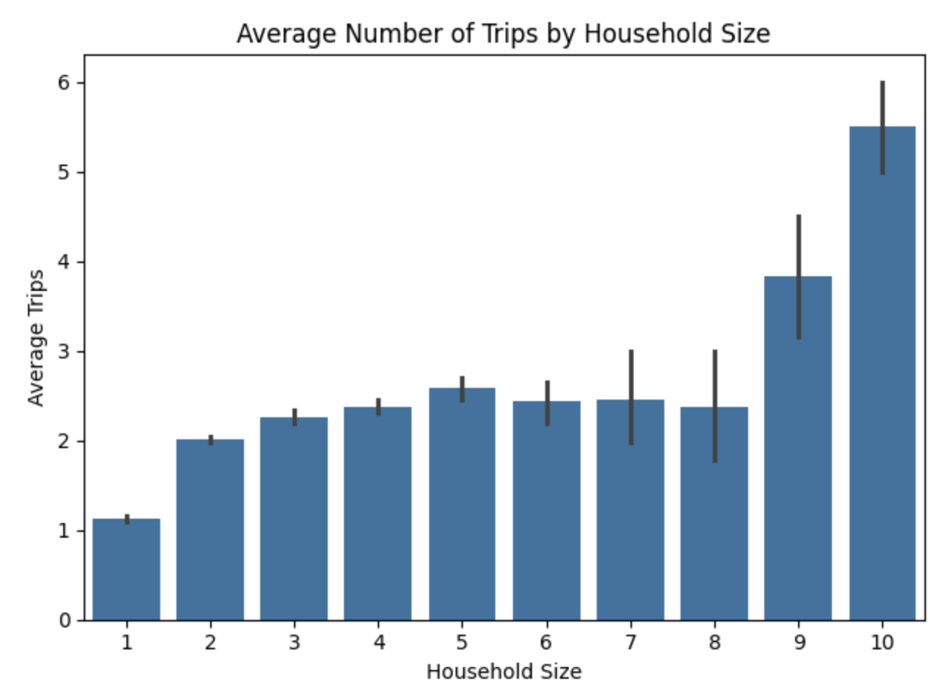
Fig. 1

Question 2: Income Level vs Mode of Transportation
The level of income greatly impacts the number of households that have vehicles. Households in the 50,000 to 74,999 bracket tend to drive Sudan-sized cars more than any other income bracket. The number of households in the 10,000 to 14,999 and 15,000 to 24,999 brackets has very different representations. The 10K to 15K reports driving SUV-sized vehicles, while the 15K to 25K reports driving pickup trucks and SUVs. This should be because the income bracket of 15K to 25K consists of farmers and ranchers who need a more practical vehicle for their livelihoods. The income bracket of 175,000 and more reported driving Sudans and SUVs. The reason for this is that SUVs and sedans that households with larger incomes can comfortably afford to purchase nicer and larger vehicles than others. These types of vehicles are comfortable and convenient, coming in thousands of makes and models. They have larger interiors, ride smoother, and typically have advanced climate control. These types of vehicles are also more fit to families with the larger space and increased safety.
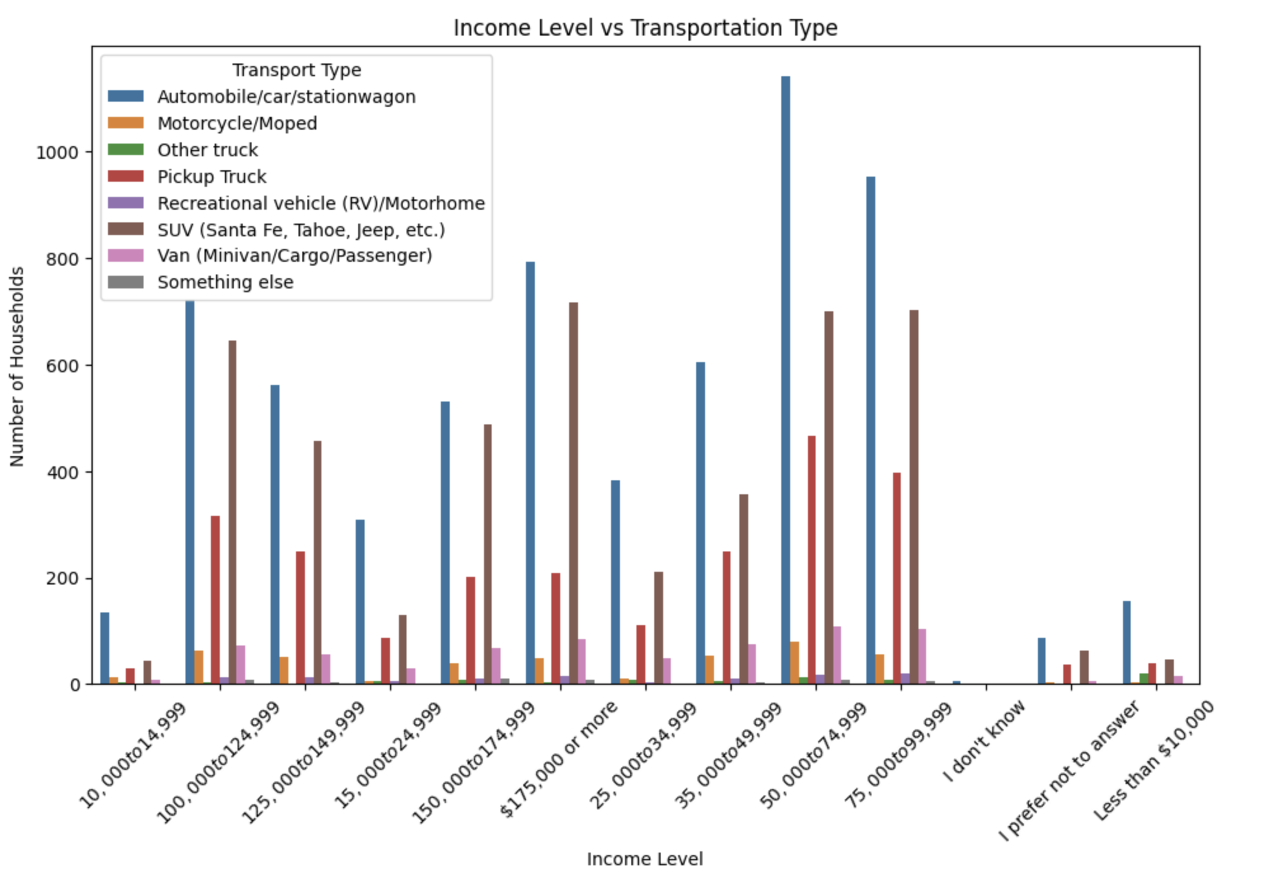
Fig. 2

Discussion of Bias and Ethics in Coding
There are a few important things when it comes to coding decisions for this project. It first has to be taken into consideration that the code is done based on the NHTS census means that not every person is accounted for, and there are gaps in the data. Certain populations may be under- or over-represented, and communities like rural areas and lower-income regions may not have the means of completing the census, leaving the data lacking in some demographics. Choices made in the cleaning of the data can also affect the results, such as removing missing values, grouping income into categories, or simplifying the modes of transportation. These choices can unintentionally strengthen preexisting inequalities, especially when the data is used to inform transportation planning. It is important to realise that there are limitations to the data, so it is crucial to maintain transparency and consider how the results may affect certain groups.

Conclusion
The results showed that the size of a household and the income of the household have effects on the trends seen in transportation. Based on the first question, which households make longer trips, and does the number of family members affect the trip distance? It was found that larger households take more trips in large part because they have more people with more needs. This greater number of trips can have some effects on local transportation systems. There can be an increase in traffic volume in residential and suburban areas, which requires a greater need for multi-stop trip support. This could include implementing bus systems in regions where household numbers are larger. There is also an increased need for school and extracurricular-related transportation. This means that the transportation system would have to prioritize efficient road networks and intersection design in densely populated areas. Along with improving school zones. From the second research question, Does household income level affect the chosen mode of transportation? The trends showed that the larger the household income, the more likely they were to have vehicles. This means in areas of higher income, it would be beneficial to implement more efficient transportation systems that would allow for a larger number of vehicles in those regions. These findings demonstrate that travel behavior is heavily influenced by household size and income level, this indicated that there is a need for greater transportation planning in the Midwest's future.

References

National Household Travel Survey. U.S. Department of Transportation, Federal Highway Administration, NHTS website.

