#### ECSE 551 Machine Learning for Engineers

Mini-Project 1

Lab Report

Fei Peng

260712440

Yukai Zhang

260710915

Yi Zhu

260716006

**Possible to do:** 10 fold CV Accuracy vs Learning Rate

    Comparison of computing cost

1. Accuracy and Time (Convergence speed) → output stored in drive (see next page)
   * In terms of learning rate ✔
   * In terms of stopping criteria ✔
   * In terms of maximum iteration ✔
   * In terms of momentum parameter beta ✔
   * In terms of add/normalizing/removing features ✔

**Link to LaTex:** [**https://www.overleaf.com/6559471667dsgswdxfnnbv**](https://www.overleaf.com/6559471667dsgswdxfnnbv)

**(Original Image Files are stored in “Testing Result Images” in our shared folder, use that in Latex for higher resolution)**

Hepatitis data:

* Stopping Criteria: (chosen due to **time and accuracy trade-off**)
  + Max_iter: 10000
  + Epsilon: 5e-3
* Beta: 0.99
* Learning Rate: 0.01

Bankruptcy data: (**still need to find a better model**)

* Stopping Criteria:
  + Max_iter: 25000
  + Epsilon: 1e-3
* Beta: 0.99
* Learning Rate: 0.1

*Abstract -* Logistic regression is one of the most popular linear classification techniques in machine learning and it has been widely used in binary classification and predictions. In this mini-project, we investigated and evaluated the performance of logistic regression by implementing it using two benchmark datasets: *Hepatitis* and *Bankruptcy.* Both two datasets were pre-processed to explore their characteristics, thereby achieving the best outcome in the following training. Fitting, predicting and testing were then performed to train and compare different models. The accuracy evaluations were analysed, and detailed results will be presented in the following parts of this report. Among them, we found that the accuracy of the logistic regression classifier could be improved by normalizing the datasets, changing order of the model, or removing certain features of the  numerical datasets.

1. Introduction.

In recent years, machine learning has been adapted to many different fields, including medical research and financial analysis [4]. As one of the most feasible and efficient classification methods, logistic regression is widely used to predict binary outcomes. The main objective of this project is to implement a logistic regression classifier and investigate its accuracy using k-fold cross validation, as well as analysis the impact of data preprocessing on the validation accuracy. We took the probabilistic views to process the binary classification. In probabilistic approaches we focused on discriminative learning which directly estimates the probability of y (i.e., output class/label) given x (i.e., input data). Using Bayes’ Rule, the logistic function (also known as sigmoid function) could be obtained, which takes a linear function of x as independent variable (wTx), and produces the conditional probability P(y|x).

The most critical task of implementing the logistic regression algorithm was to find the linear term *w* (i.e., weights) that produces the minimum error/maximum accuracy in prediction while ensuring the efficiency of this algorithm. This was achieved using gradient descent with momentum [5], and tweaking the hyperparameters (e.g., learning rate, momentum term, and stopping criteria) of the fit function. It was found that, with a carefully chosen set of hyperparameters, accuracy could be increased while remaining satisfying training efficiency.

During data pre-processing, normalization was performed and proved to increase the accuracy. While analysing the characteristics of the datasets, it was noticeable that some features of input *x* satisfies the null hypothesis [6], which means that these features are not helping discriminate between two classes and should be removed to improve performance. Moreover, through the distribution of the two classes of the two datasets, it was discovered that the entropy of classes could affect the accuracy of the model, resulting in the model accuracy for hepatitis data (with higher entropy) being higher than that of bankruptcy data. Last but not least, properly increasing the order of the model (order 3 for bankruptcy data) would also help increase accuracy. These aspects will be further discussed.

1. Datasets

Data preprocessing usually lays the groundwork for the later data analysis and helps it yield a higher accuracy efficiently. In this project, the following data preprocessing had been performed.

2.1. Entropy analysis

Both datasets *Bankruptcy* and *Hepatitis* are examples of binary classification. The distributions of each class are shown in Figure 2.1. The uncertainty in prediction can be quantified by the entropy of each dataset with formula (1):

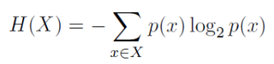（1）

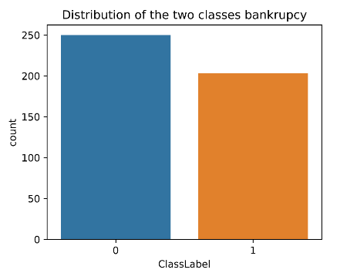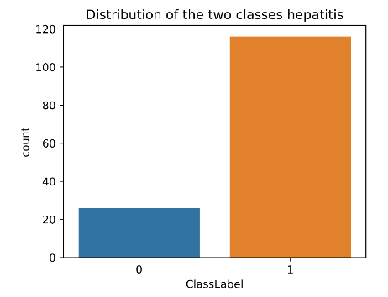

Figure 2.1: (left) Bankruptcy data class distribution and (right) Hepatitis data class distribution

    The entropies for *Bankruptcy* and *Hepatitis* datasets are 0.99222 and 0.68681 respectively. This result shows that the future prediction made upon the bankruptcy dataset is likely to be less accurate compared to that upon the hepatitis dataset.

2.2. Features analysis

For the purpose of gaining a better understanding toward the dataset, the distributions of each feature in both classes are plotted. Some of the plots are shown in Figure 2.2:

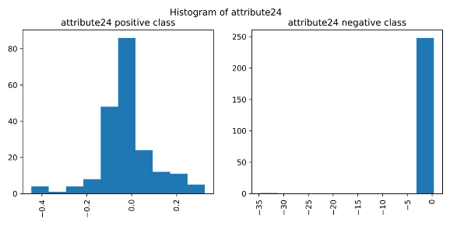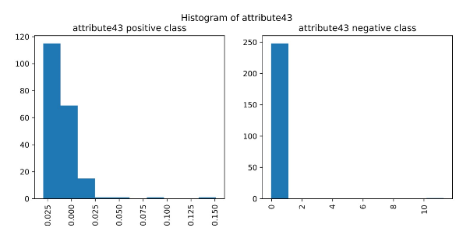

Note that both pairs of plots come from *Bankruptcy* dataset and in each pair, the distribution of positive class is shown on the left, otherwise right. When comparing positive and negative classes, it is noticeable that the data distribution differs greatly in attribute 24 but slightly in attribute 43. This indicates that features with similar distribution to attribute 43 will have little contribution in the prediction process and should be considered as null distribution. Kolmogorov-Smirnov method [3] was performed to efficiently find all null distributions. Attributes 43 and 60 in the Bankruptcy dataset were identified. The removal of these two features may improve the performance of the machine learning process. The Kolmogorov-Smirnov method, however, failed to yield a promising result in the Hepatitis dataset because of the existence of multiple binary features. The effect of removing features with null distribution will be further discussed in the result section.

2.3 Data Shuffling

It was found that the *Bankruptcy* dataset is ordered by class label. Proceeding without shuffling the data would result in some validation/training sets all filled by data from one class. Thus, rows will be shuffled every time after importation. Doing so will also help reduce the variance and generalize the algorithm, therefore the *Hepatitis* dataset should also be shuffled.

2.4 Data Normalization

Normalizing the data into z-score can centralize the value distribution of the data while keeping its precision [2]. When a calculation involves large float numbers, they can easily trigger overflow/underflow and lose precision without normalization. Calculating the gradient with high order data is an example of that. Luckily, using z-score should help prevent introducing such errors and thus increase the model accuracy.

1. Results

Multiple experiments have been conducted to evaluate the performance of the logistic regression with respect to different hyperparameters and data preprocessing techniques. The detailed results are shown below:

3.1. Learning Rate:

Learning rate is a parameter that determines the step size on the way approaching a (local) minimum. A large step size can accelerate the convergence but can also result in jumping over the desired solution (oscillate forever). A small step size can avoid skipping the solution but is very time consuming. To find a learning rate best fit for each model, values between 0.0005 and 5 are tested. The performance/processing time vs. logarithm of learning rate are shown in figures 3.1:

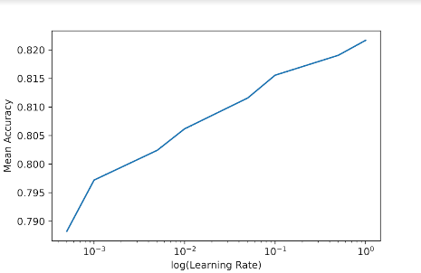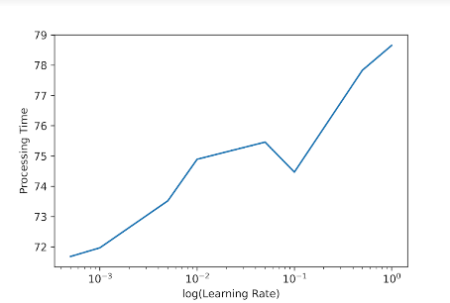

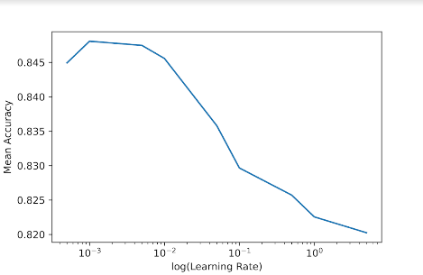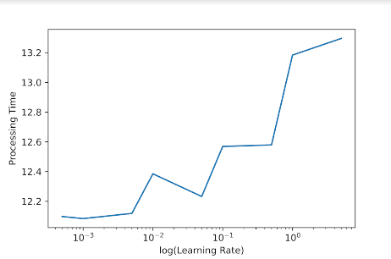

It is noticeable that for both datasets, the processing time required increases as the rise of the learning rate with some fluctuations. The mean accuracy of the *Bankruptcy* data remains growing but that of the *Hepatitis* data decreases dramatically after the learning rate increases beyond 0.01. For the purpose of improving the accuracy while saving the computational power, learning rates of 0.1 and 0.01 are selected for the *Bankruptcy* and *Hepatitis* dataset respectively.

3.2 Stopping Criteria:

Theoretically, if a model suits the data distribution, the training accuracy will keep increasing with the number of iterations. However, failing to set up a proper stopping criteria will not only waste the computational power but also lead to overfitting [1]. In this case, max iteration and epsilon (threshold of minimum gradient) are introduced as the upper limits of iterations. In this experiment, the *max iteration* term is sampled from 500 to 25000 and the epsilon term is sampled from 1e-3 to 0.5.  The plots of accuracy/processing time versus max iteration/epsilon are shown in Figure 3.2.

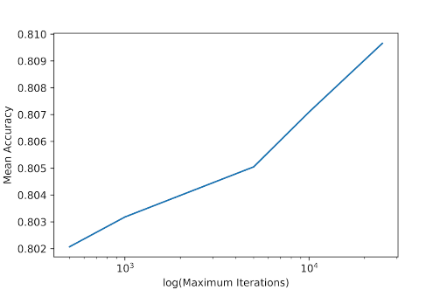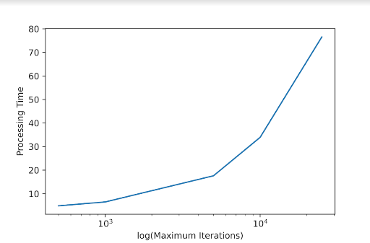

Figure 3.2.1: Mean accuracy (left) and Processing time (right) with respect to log of Max. Iteration

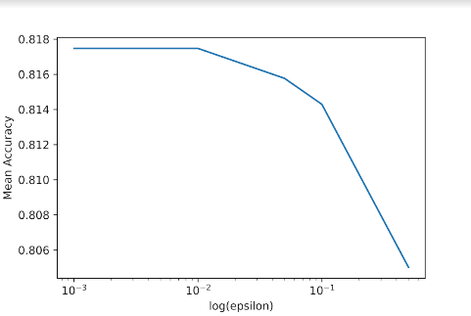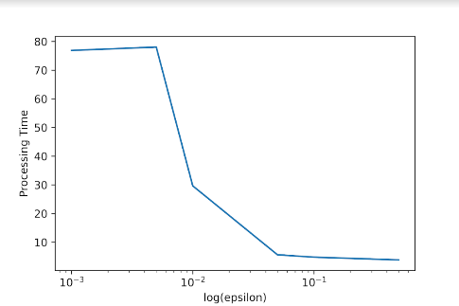

Figure 3.2.2: Mean accuracy (left) and Processing time (right) with respect to log of epsilon

Note that all the data displayed come from the *Bankruptcy* dataset. The *Hepatitis* dataset has a similar trend and will not be displayed. The plots confirm that in a reasonable iteration range, accuracy tends to rise as the maximum iteration increases and the minimum acceptable gradient decreases. For the trade-off between accuracy and efficiency, 25000 iterations with an epsilon of 1e-3 is selected for the *Bankruptcy* dataset and (10000, 5e-3) is selected for the *Hepatitis* dataset.

3.3 Momentum Gradient Descent Constant - Beta:

When a regular gradient descent method is performed, it is very unlikely that the algorithm can move directly from the starting point to the (local) minimum. Instead, the path usually oscillates back and forth around that optimum shortcut. As described in part 3.1, this oscillation will have a larger amplitude if the learning rate is high. A *momentum gradient descent* method can be used to flatten this oscillation and take a rather straightforward approach in the search of the minimum point. It does so by calculating the weighted sum of the current gradient and the previous step size and then using it as the new step size. β value is in charge of controlling the weight of the previous step size, if β is set to 0, it becomes equivalent to a regular gradient descent method [5]. In this experiment, value β is tested in the range of 0 to 0.999 and its results are shown in Figure 3.3:

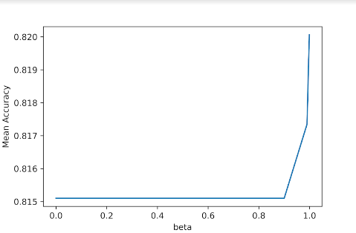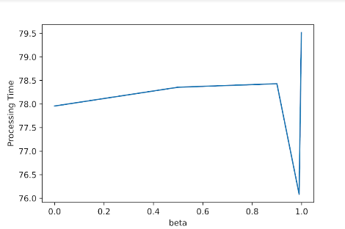

The data displayed all come from *Bankruptcy* dataset. The trends of that in the *Hepatitis* dataset is also very similar to those above. According to the figures, a beta of 0.99 yields the best overall performance regarding the accurateness and efficiency.

3.4 Normalization

    During data preprocessing, it was discovered that most of the features in Bankruptcy data are near-zero float numbers. Therefore, calculation could easily lose precision due to overflow/underflow. To improve model accuracy, data should be normalized before performing training or validation. The normalization technique used in this project is called z-score [2] which calculates the mean (j) and standard deviation (j) for each feature (j) of the training data, perform xj-jj for both the training and validation data. Therefore the model accuracy could be improved by bringing more precision to the calculation of gradient. During the testing, it was found that the overflow/underflow warning indeed disappeared after normalization. It is shown in figure 3.4 that compared to that of without normalization, the validation accuracy of the normalized original dataset is higher. This advantage is even pronounced when more features (higher order) are added into the dataset, which will be discussed later.

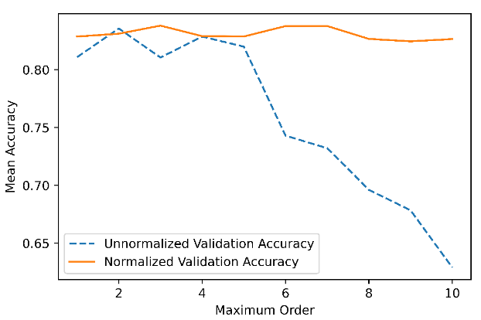

Figure 3.4: Comparison between with and without normalization.

3.5 Removing features

    As discussed previously in Datasets, null distributions in the Bankruptcy dataset were found using Kolmogorov-Smirnov method [3]. This means that the distribution of some attributes in two classes are similar and may not be useful for model training and class prediction. Attribute 43 and 60 of Bankruptcy dataset were identified to be unhelpful for improving model accuracy, therefore were removed during training and validation. However, it came out that the mean validation accuracy and training efficiency did not vary significantly from before, as shown in Figure 3.5. One of the assumptions that could explain this result is that the linear term, *w*, of the log-odds ratio (i.e., the independent variable, wTx, of the logistic function) as already taken care of the weight of each attribute, therefore removing any attribute would not have much impact on the accuracy.

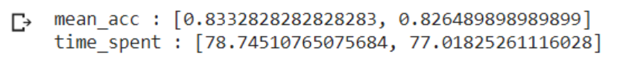

Figure 3.5: Mean accuracy and training time before (on the left) and after (on the right) removing features for Bankruptcy data.

3.6 Adding features

    The approach of adding more features to the dataset was also adopted to improve model accuracy. The order of each attribute in the Bankruptcy dataset was increased and added to the original dataset. As shown in Figure 3.6, the blue curve indicates the training accuracy, while the orange curve represents the validation accuracy. It clearly shows that when the order is increased to around 3, the maximum validation accuracy is achieved. However, continuing increasing the order could cause the overfitting issue when the order is greater than 4 [1], which means that the training accuracy remains increasing but the validation accuracy starts to decrease. Therefore, order 3 was chosen to be the most suitable model for training Bankruptcy data. However, this approach was tested to be ineffective for Hepatitis data due to the fact that most of the features are binary.

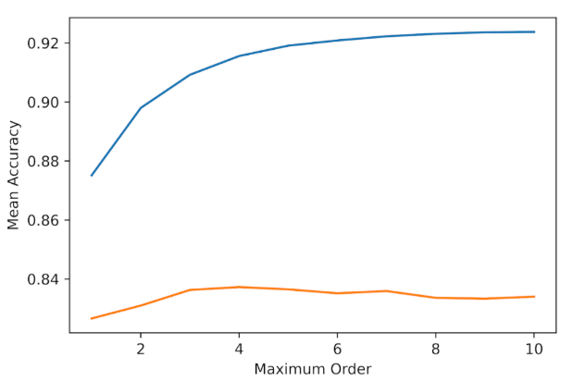

Figure 3.6: The training and validation accuracy vs. order of Bankruptcy data.

1. Discussion and conclusion:

In conclusion, the logistic regression classifier implemented in this project performed as expected overall on the two datasets, *Bankruptcy* and *Hepatitis*. Here are the two representative confusion matrices, shown in Figure 4 (a) and (b), calculated during testing to measure the accuracy, precision and sensitivity of the models. The selected model used for calculating the confusion matrix was the one that performed the best during testing (as explained in the previous section). The accuracy for the best Hepatitis model could achieve 92.86%, with 96% specificity. However the number of instances in this dataset is too small (only 142 total) to take any common measurements, therefore 5-fold validation was performed to obtain this confusion matrix. Moreover, this is one of the best case scenarios, thus more testing should be performed, ideally with more instances, in the future to obtain a convincing average accuracy. For the best Bankruptcy model, the accuracy reached 84.09%, while the precision was 82.61% and the sensitivity was 86.36%. These measurements confirmed the previous hypothesis, that higher accuracy could be achieved with higher entropy.

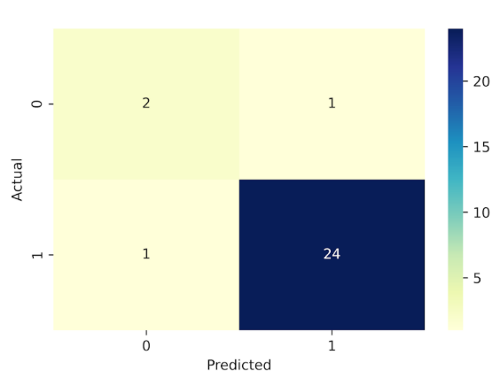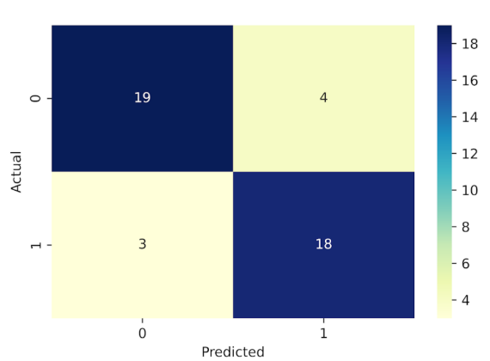

1. Hepatitis (b) Bankruptcy

Figure 4: The Confusion Matrix. (a) Hepatitis (b) Bankruptcy

Other types of model, more types of gradient descent, explore genetic learning

Possible directions for future investigation could include choosing other types of model (e.g., with log, exponential, or interaction terms), exploring more efficient but complex gradient descent algorithms, and comparing logistic regression with genetic learning as Hepatitis is a relatively small dataset. These aspects should help not only improve model accuracy, but also accelerate the training process.

1. Statement of Contributions

The workload of this project is distributed equally between the team members (i.e., the three authors of this report): Yi Zhu implemented the fit function for training datasets, and explored various gradient descent algorithms to improve the computation speed. Fei Peng was responsible for developing the k-fold partition, predict and accuracy evaluation (i.e., accu_eval) functions for predicting the classes/labels of the input data and evaluating the model accuracy, as well as performing thorough testing of the models. Yukai was in charge of data pre-processing and model selection, which helped to significantly improve the model accuracy

References (in our google drive)

[1] H. Allamy, "METHODS TO AVOID OVER-FITTING AND UNDER-FITTING IN SUPERVISED MACHINE LEARNING (COMPARATIVE STUDY)," 12/27 2014.

[2] A. E. Curtis, T. A. Smith, B. A. Ziganshin, and J. A. Elefteriades, "The Mystery of the Z-Score," (in eng), *Aorta (Stamford),* vol. 4, no. 4, pp. 124-130, 2016, doi: 10.12945/j.aorta.2016.16.014.

[3] T. Liu, "A Kolmogorov-Smirnov type test for two inter-dependent random variables," *arXiv preprint arXiv:1802.09899,* 2018.

[4] T. Peña, S. Martínez, and B. Abudu, "Bankruptcy Prediction: A Comparison of Some Statistical and Machine Learning Techniques," in *Computational Methods in Economic Dynamics*, H. Dawid and W. Semmler Eds. Berlin, Heidelberg: Springer Berlin Heidelberg, 2011, pp. 109-131.

[5] S. Ruder, "An overview of gradient descent optimization algorithms," *arXiv preprint arXiv:1609.04747,* 2016.

[6] R. W. Vitral, M. J. Campos, and M. R. Fraga, "The null hypothesis," *American journal of orthodontics and dentofacial orthopedics : official publication of the American Association of Orthodontists, its constituent societies, and the American Board of Orthodontics,* vol. 144, no. 4, pp. 498-9, 2013, doi: 10.1016/j.ajodo.2013.08.010.

1. Appendix

Learning rate:

当learning rate 在 0.0005 - 5 之间 Bankruptcy 的准确率随着learning rate 的提高而提高

Hepatitis 的准确率大部分情况会随着learning rate 的提高而降低.

目前猜测是因为bankruptcy数据量大, 数据分布在higher dimention 中有多个local minimum. 大跨步随机跳动反而更可能找到error 最低点

Maximum iteration 和 epsilon

在没有额外的退出条件时, Maximum iteration 和 epsilon几乎可以起到相同的作用. Bankruptcy 测试中我们主要选择25000次iteration和1e-3的epsilon, Hepatitis 用的是10000次iteration和5e-3的epsilon. 单独提高iteration次数或者降低epsilon不会对数据造成影响, 因为另外一个因素将变成实验次数的主导因数.

Beta:

Beta 是momentum gradient descent 的一个系数, 值越大, descent时受到上一轮gradient的影响也就越大. Beta为0 的时候是普通的gradient descent (无momentum). 两组实验数据都证明beta = 0.99 在时间, 准确度上有不错的优势. 但是beta的影响图像受随机因素影响很厉害, 有时beta 0.99会出现时间, 准确度都不尽人意的情况

两组实验学习过程中的training acc 和 validation acc的图像以及对应的confusion matrix都放在confusion matrix 文件夹里了.

1. Learning rate:

When the learning rate is between 0.0005-5, the accuracy of Bankruptcy increases with the increase of the learning rate. In most cases, the accuracy of Hepatitis will decrease as the learning rate increases. The current guess is because the amount of bankruptcy data is large, and the data is distributed in the higher dimension with multiple local minimums. Random jumps in large steps are more likely to find the lowest point of error.

1. Maximum iteration and epsilon

In the absence of additional exit conditions, Maximum iteration and epsilon can almost play the same role. In the Bankruptcy test, we mainly choose 25000 iterations and 1e-3 epsilon, and Hepatitis uses 10000 iterations and 5e-3 epsilon. Increasing the number of iterations or reducing epsilon alone will not affect the data, because another factor will become the dominant factor of the number of experiments.

1. Beta:

Beta is a coefficient of momentum gradient descent. The larger the value, the greater the descent will be affected by the previous round of gradient. When Beta is 0, it is normal gradient descent (no momentum). Both sets of experimental data prove that beta = 0.99 has a good advantage in terms of time and accuracy. However, the influence of beta image is greatly affected by random factors. Sometimes beta 0.99 will appear in time, and the accuracy is not satisfactory.

Citation:

To calculate the weights in logistic regression, likelihood of the data is calculated based on the probability of correctly classifying training the data given the model parameters. The goal is to maximize the likelihood. However, it is numerically unstable we will process the log-likelihood. The maximize likelihood is minimize the loss entropy, which measures how many bits of information we would need to correct the errors made by the model. We will take the derivative to calculate the minimum, which is know as the gradient descent process. The basic algorithm is shown in the below: where ak is the learning rate we chose for the iteration k.