Download and install Istio
Go to the Istio release page to download the installation file for your OS

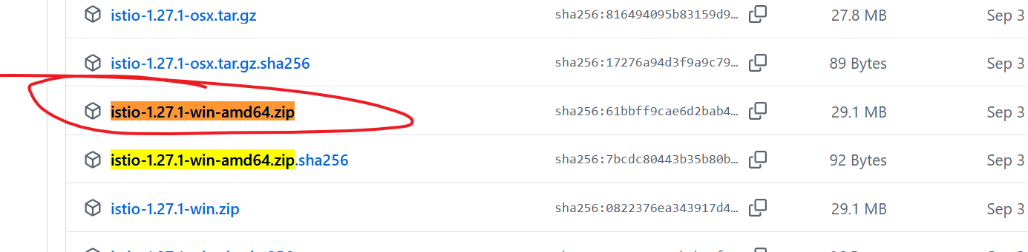
add istio to path
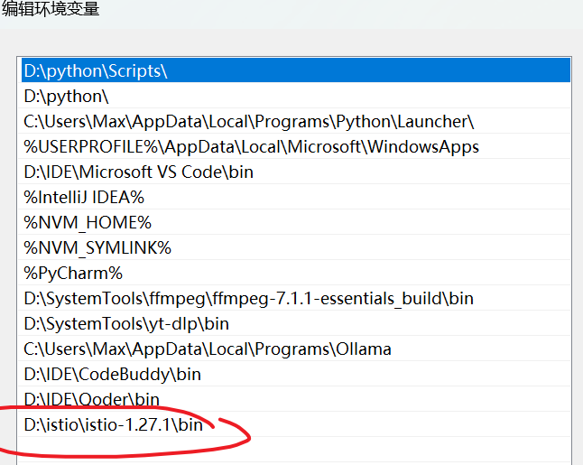

Install Istio using the demo profile, without any gateways
minikube start
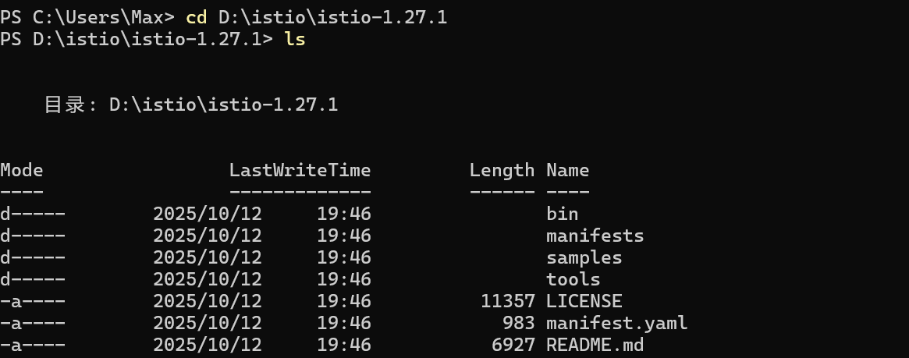
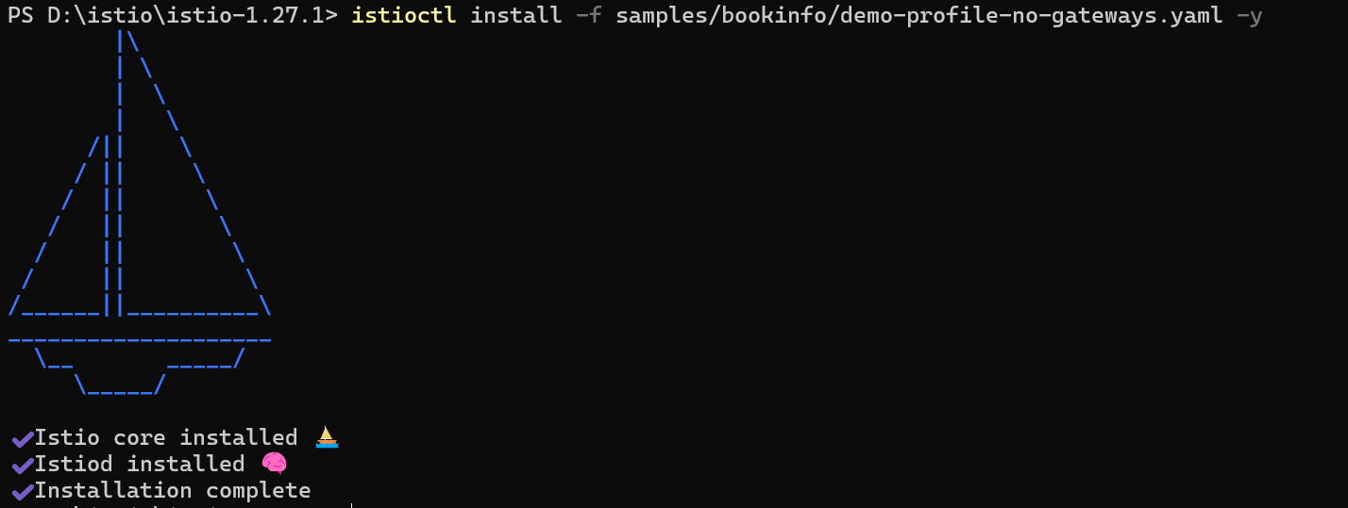
Add a namespace label to instruct Istio to automatically inject Envoy sidecar proxies when you deploy your application later
verify CRD
Install CRD
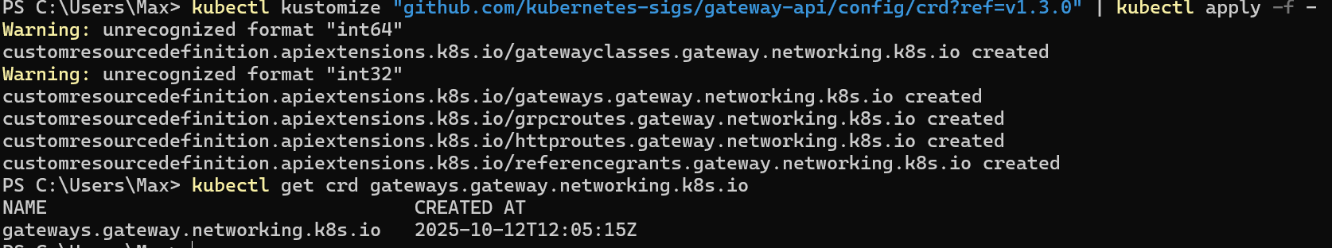

Deploy the sample application

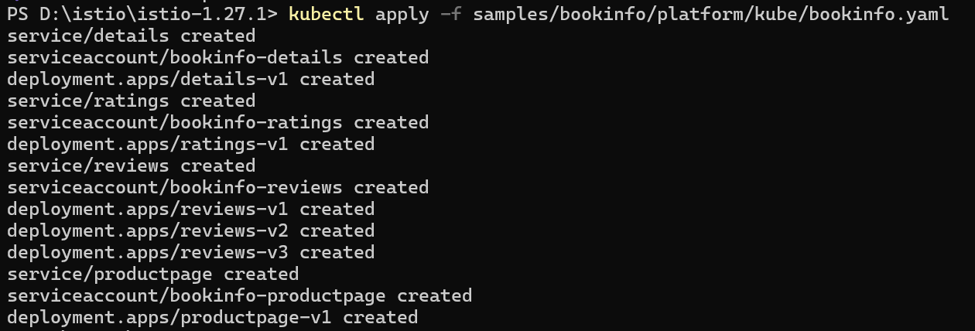
The application will start. As each pod becomes ready, the Istio sidecar will be deployed along with it.
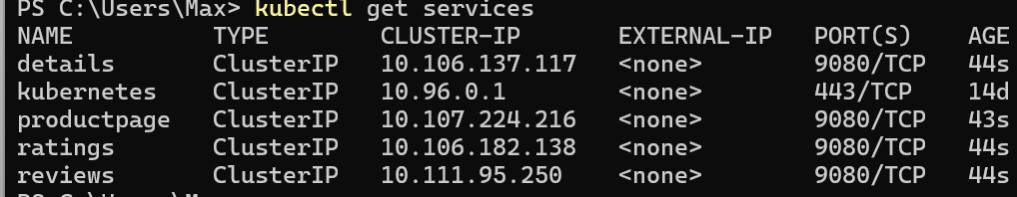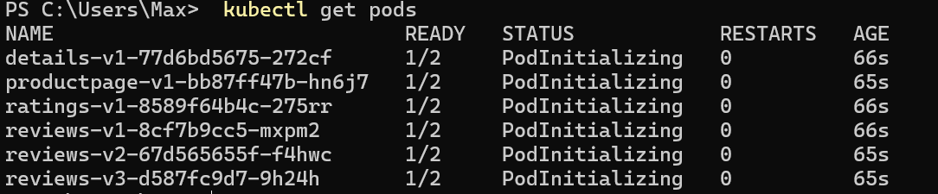
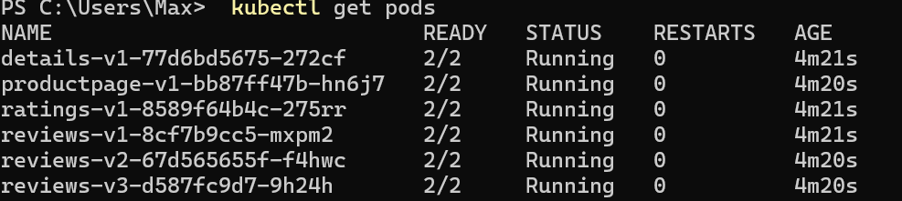
Note that the pods show READY 2/2, confirming they have their application container and the Istio sidecar container.
Validate that the app is running inside the cluster by checking for the page title in the response:

Open the application to outside traffic
Create a Kubernetes Gateway for the Bookinfo application:
By default, Istio creates a LoadBalancer service for a gateway. As we will access this gateway by a tunnel, we don’t need a load balancer. If you want to learn about how load balancers are configured for external IP addresses, read the ingress gateways documentation.
Change the service type to ClusterIP by annotating the gateway
To check the status of the gateway, run:
Access the application
You will connect to the Bookinfo productpage service through the gateway you just provisioned. To access the gateway, you need to use the kubectl port-forward command
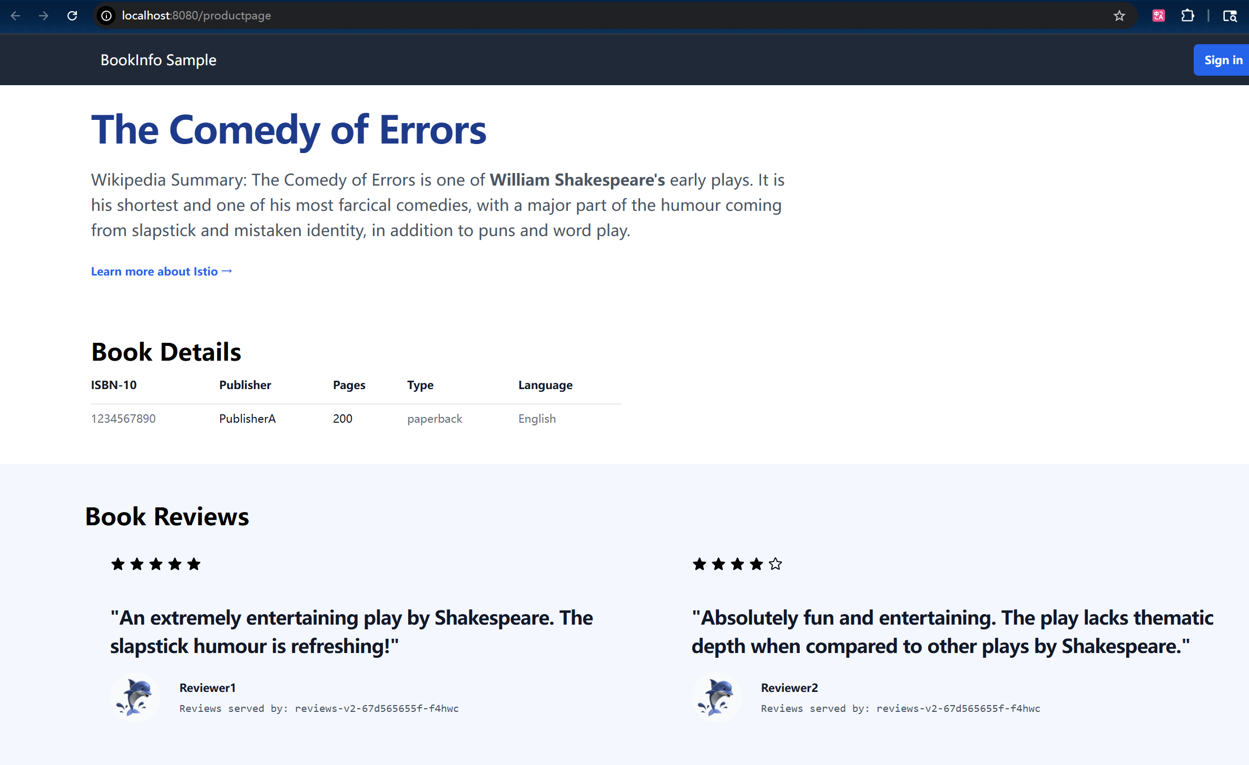
View the dashboard
Install Kiali and the other addons and wait for them to be deployed.
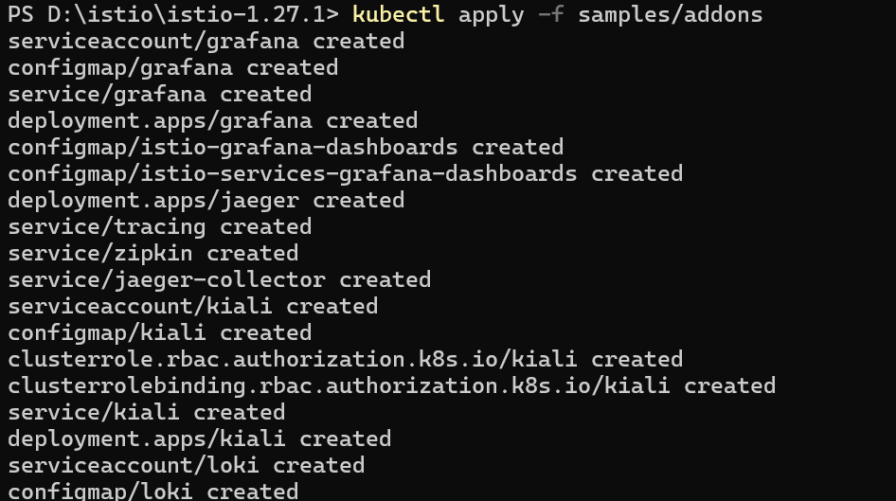

Access the Kiali dashboard.
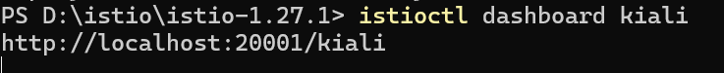
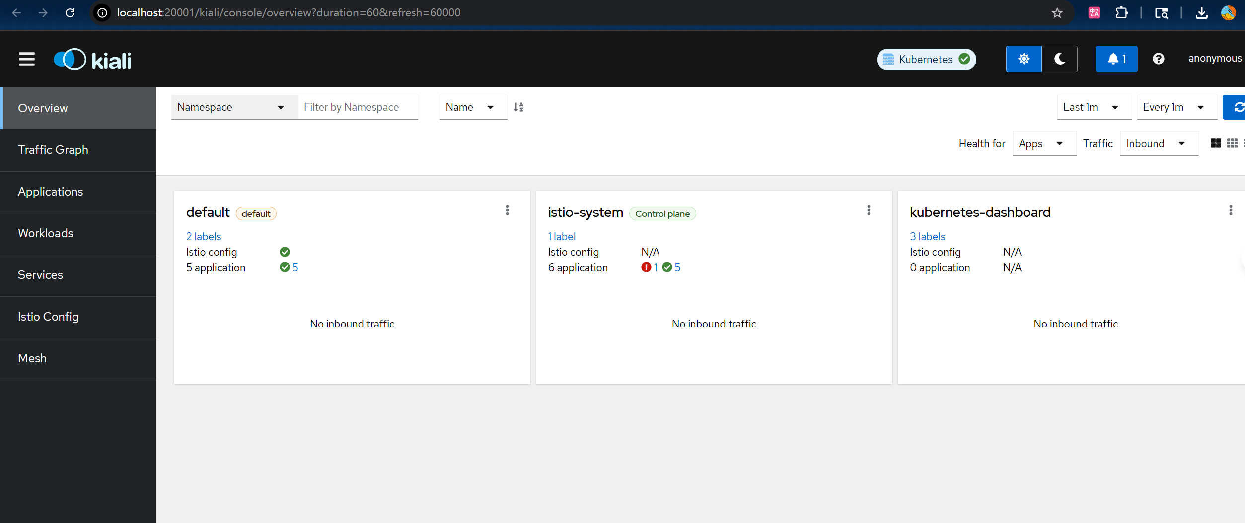
In the left navigation menu, select Graph and in the Namespace drop down, select default.

To see trace data, you must send requests to your service. The number of requests depends on Istio’s sampling rate and can be configured using the Telemetry API. With the default sampling rate of 1%, you need to send at least 100 requests before the first trace is visible. To send 100 requests to the productpage service, use the following command:
