Traffic Management
Istio's traffic management feature allows you to easily control the flow of traffic and API calls between services. It does not rely on modifying application code, but is implemented by configuring the Envoy proxy deployed next to the service.
The following are several core concepts and resources in Istio traffic management:
1. Virtual Services
Function: Define a set of rules for routing traffic to a specific service. This is the core part of Istio's traffic routing function.
Core function: It decouples the target address (virtual host) of the client request from the actual workload (service instance) that handles the request.
Typical uses:
A/B testing: Send a portion of user traffic (for example, users from a specific browser) to the new version of the service.
Canary rollouts: Send a small portion (such as 10%) of traffic to the new version, and then gradually increase the traffic proportion after verification. [1] * Multi-service aggregation: expose multiple microservices through a virtual domain name, and let the virtual service distribute traffic to different backend real services based on information such as the requested URL path.
2. Destination Rules
Function: define how to handle traffic after the virtual service routes it to the "real" destination.
Core functions:
Define service subsets: usually group instances based on the service version (such as v1, v2). Virtual services can use these subsets to implement version routing.
Configure load balancing strategy: you can set the load balancing mode, such as Round Robin, Random, Least Request, etc.
Configure connection pool and anomaly detection: for example, set circuit breakers. When a service instance fails continuously, it will be temporarily removed from the load balancing pool to prevent the failure from spreading.
3. Gateways
Function: Manages traffic in and out of the service mesh, serving as the entry or exit point of the service mesh.
Core Function: Gateway configuration is applied to independent Envoy proxies running at the edge of the mesh, not the sidecar proxies next to the service. It is primarily responsible for configuring L4-L6 layer content such as ports, protocols, and TLS certificates.
Working Method: Gateways are typically bound to a virtual service, which defines application layer (L7) routing rules, thereby enabling fine-grained control of gateway traffic.
4. Service Entries
Function: Manually add an external service (a service not within the Istio service mesh) to the Istio internal service registry.
Core Function: Once added successfully, services within the mesh can access this external service just like accessing internal services, and can use Istio's traffic management capabilities (such as timeouts, retries, fault injection, etc.) to control access to external services.
5. Network Resilience and Testing
In addition to routing, Istio also provides a series of features to enhance service reliability, which are also configured through the above resources:
Timeouts: Set timeouts for service calls to prevent the entire request chain from being dragged down due to a slow response from a service.
Retries: Automatically retry when a call fails to cope with transient failures such as network jitter or temporary unavailability of services.
Circuit Breakers: Set thresholds such as the number of concurrent connections and request failure rate for services. When the threshold is reached, the circuit is "broken" to prevent more requests from flowing to the problematic service instance. [cite:-1]
Fault Injection: A testing method that can artificially inject delays or errors (such as returning HTTP 500) into service calls to test the fault tolerance of applications.
In summary, Istio provides a very powerful and flexible traffic management mechanism by combining resources such as virtual services, destination rules, and gateways. It allows developers and operations personnel to implement advanced features such as canary release, A/B testing, and fault recovery without modifying any business code, greatly improving the flexibility and robustness of the microservice architecture.
Request routing
Deploy the Bookinfo sample application.
We have done this in the last lab
But we also need to define the service versions
Istio uses subsets, in destination rules, to define versions of a service. Run the following command to create default destination rules for the Bookinfo services:
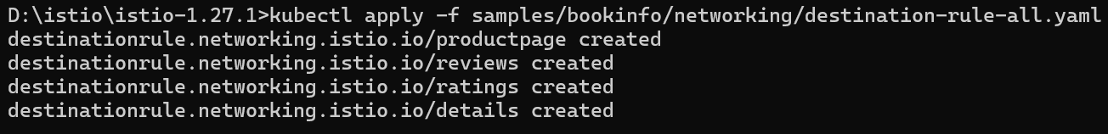
display the destination rules with the following command
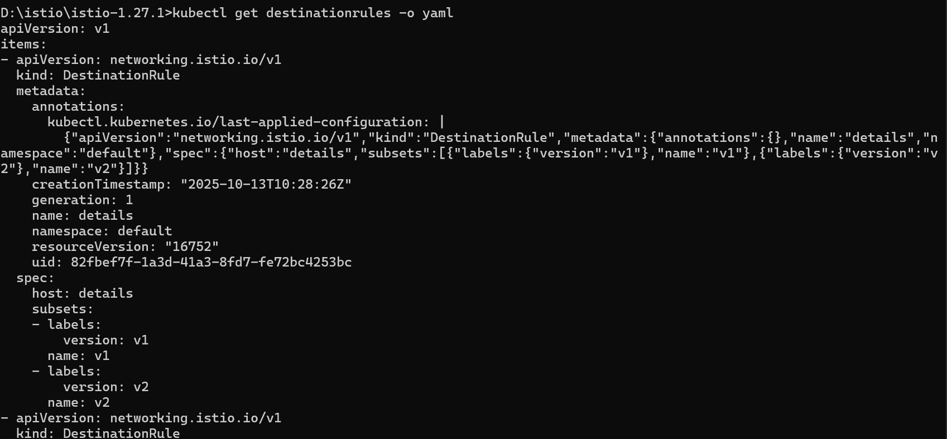
Route to Version 1
Run the following command to create the route rules
Istio uses virtual services to define route rules. Run the following command to apply virtual services that will route all traffic to v1 of each microservice
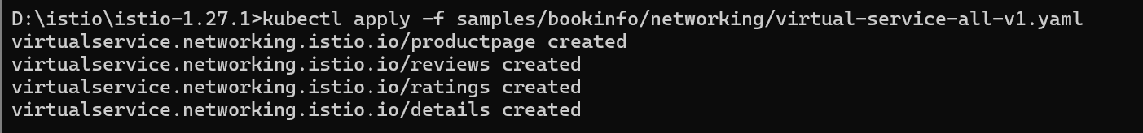

Display the defined routes with the following command
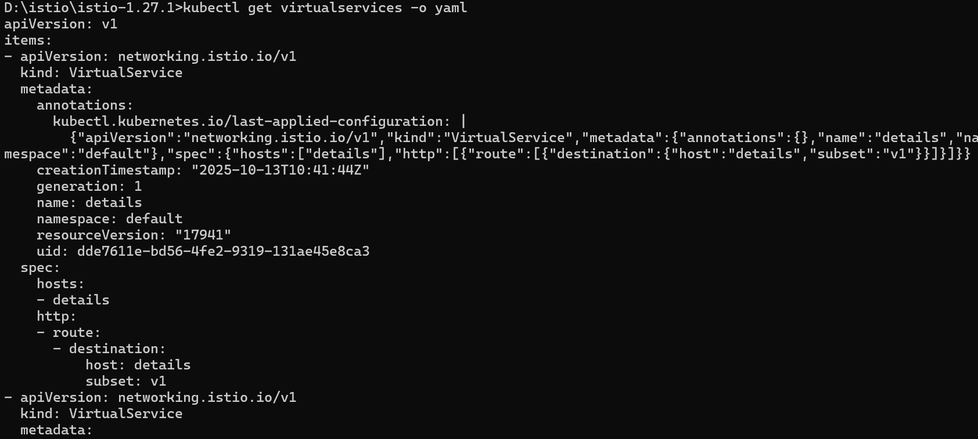
Test the new routing configuration
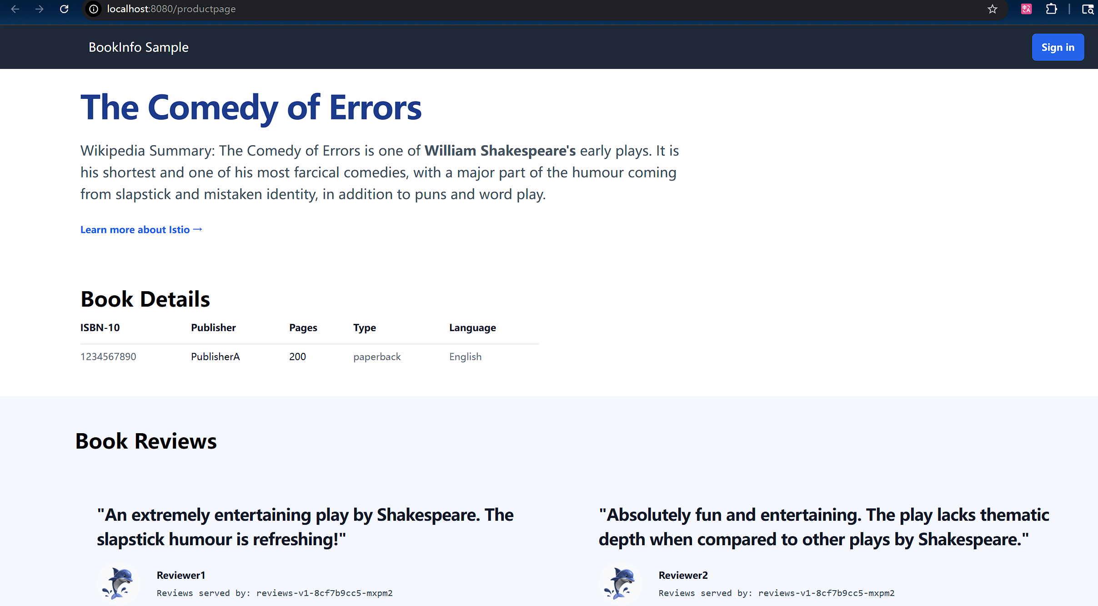
Route based on user identity
Run the following command to enable user-based routing

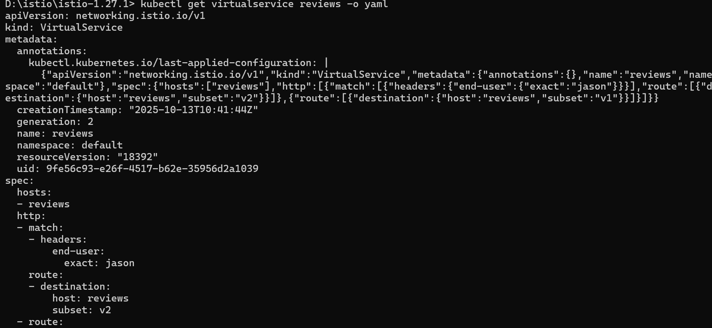
Login in as jason:

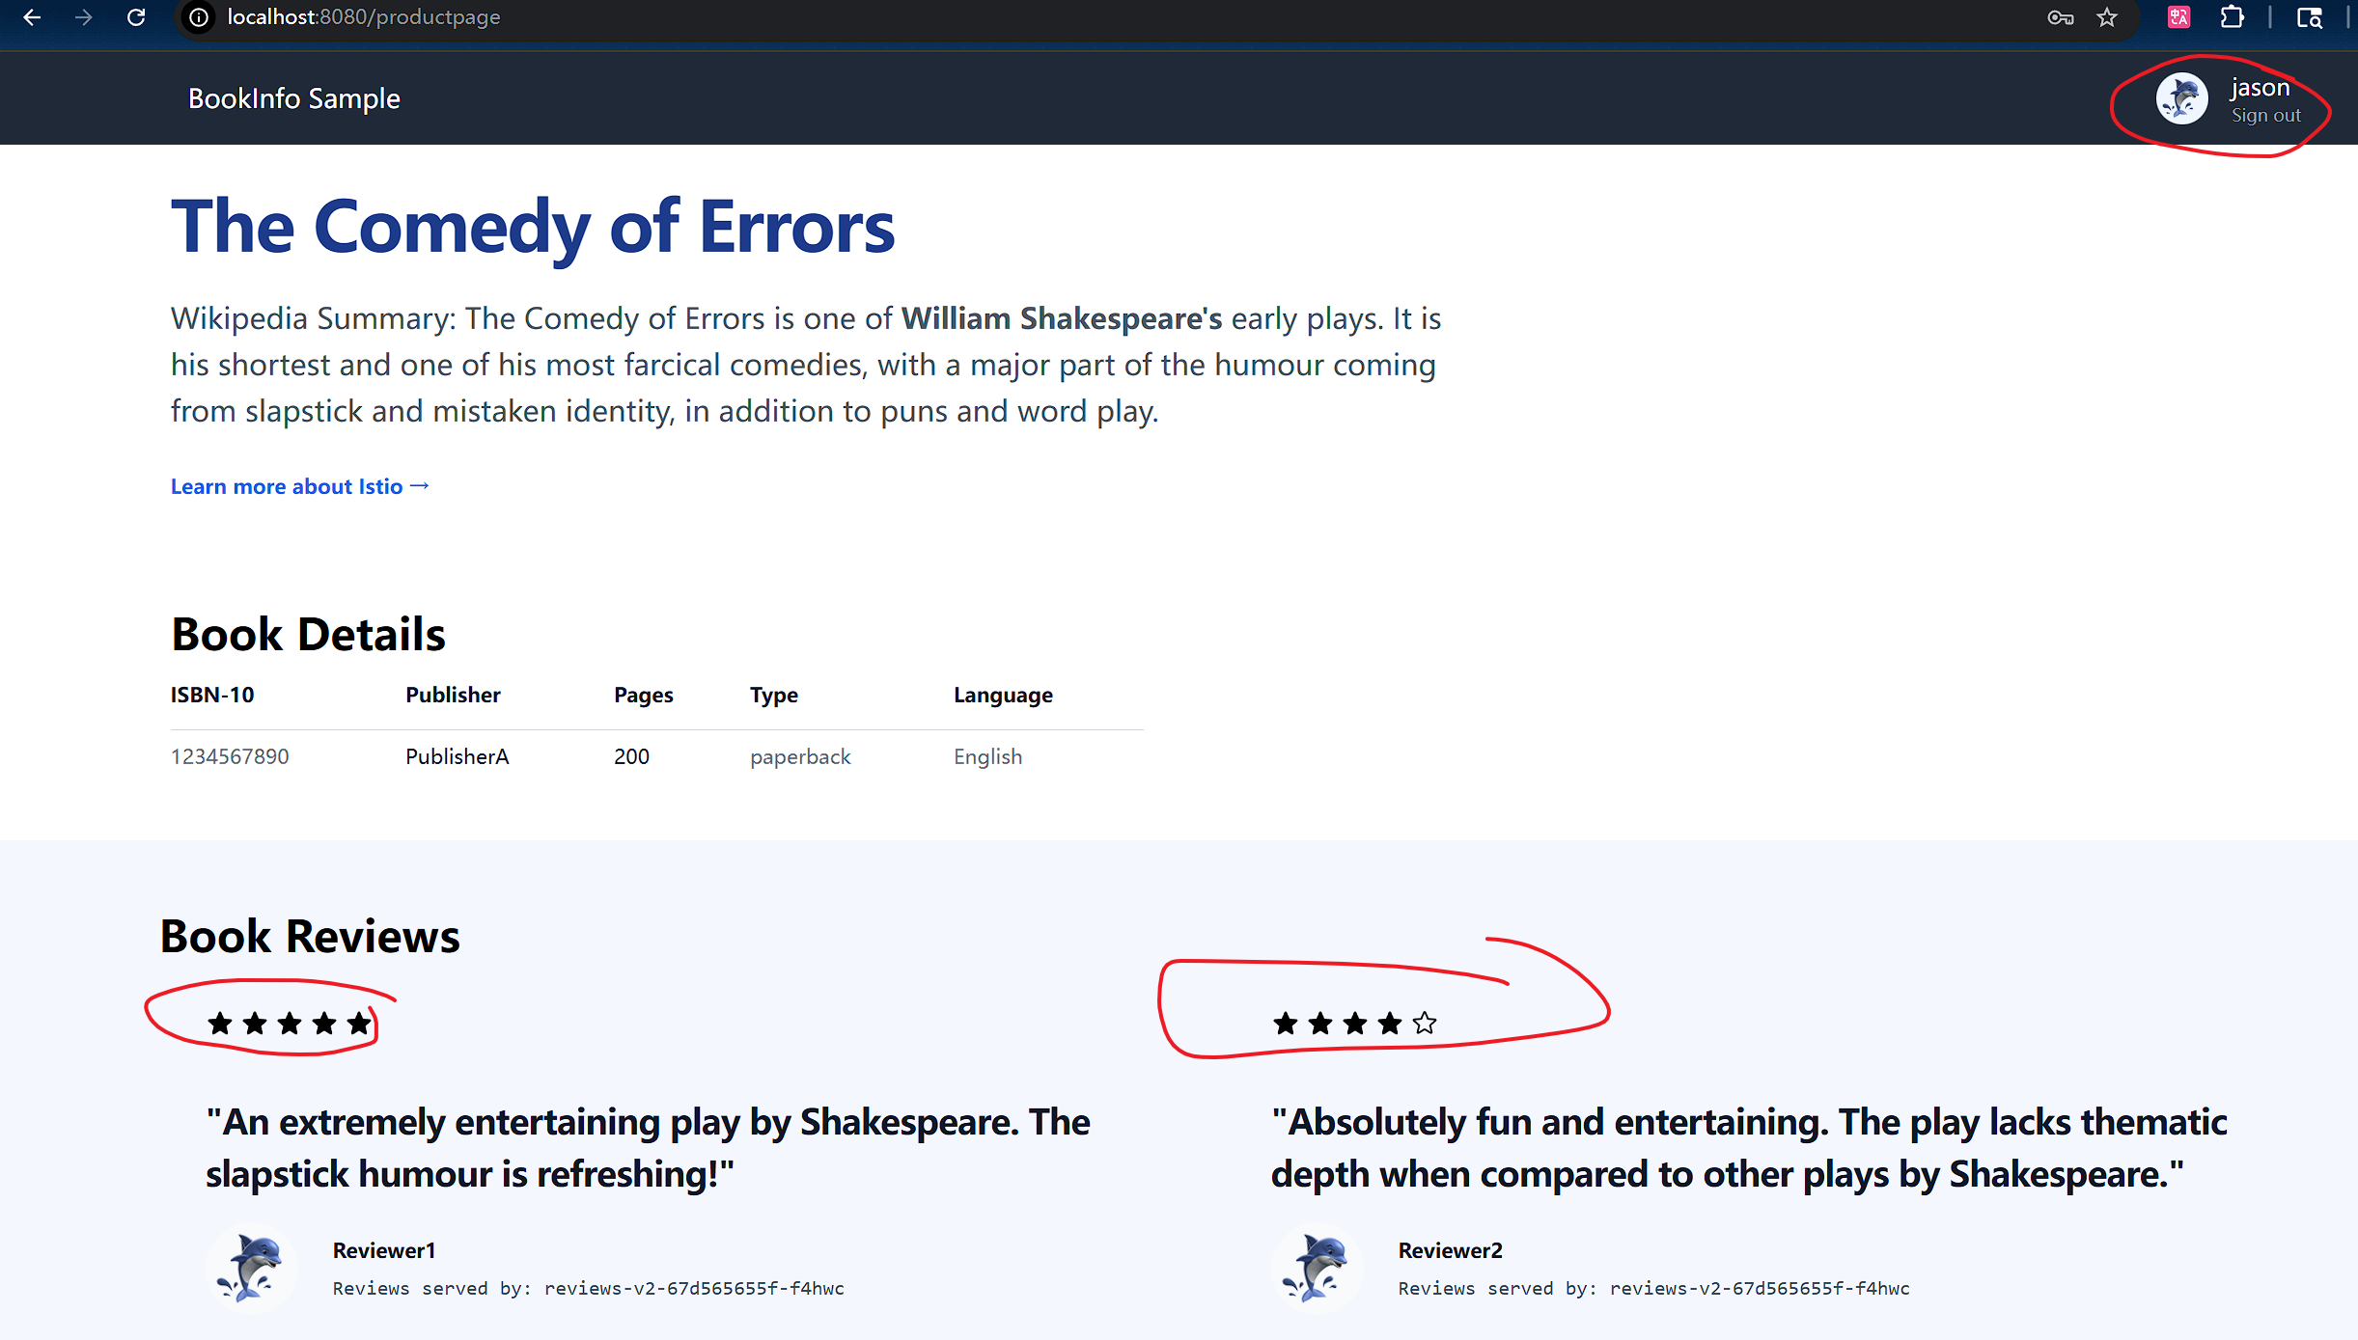

Login as other user:
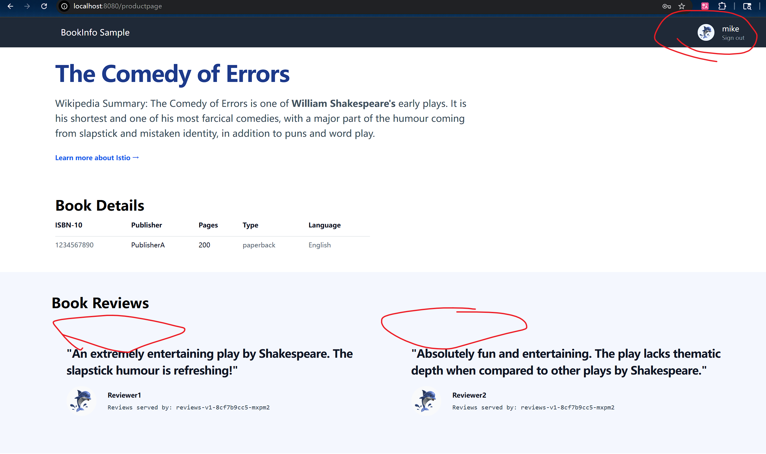

traffic is routed to reviews:v1 for all users except Jason

Fault-injection
Injecting an HTTP delay fault

Create a fault injection rule to delay traffic coming from the test user jason

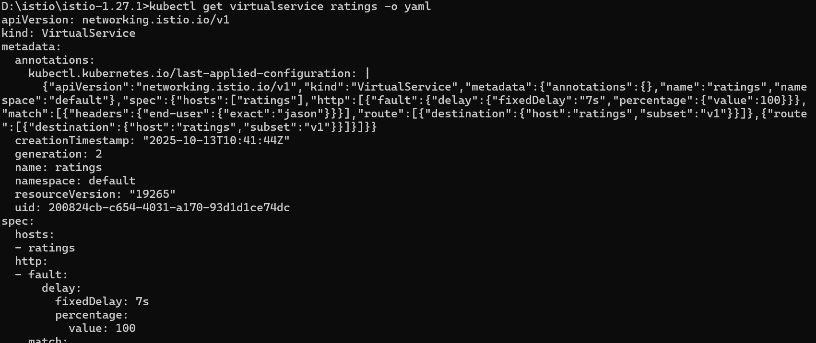

Testing the delay configuration
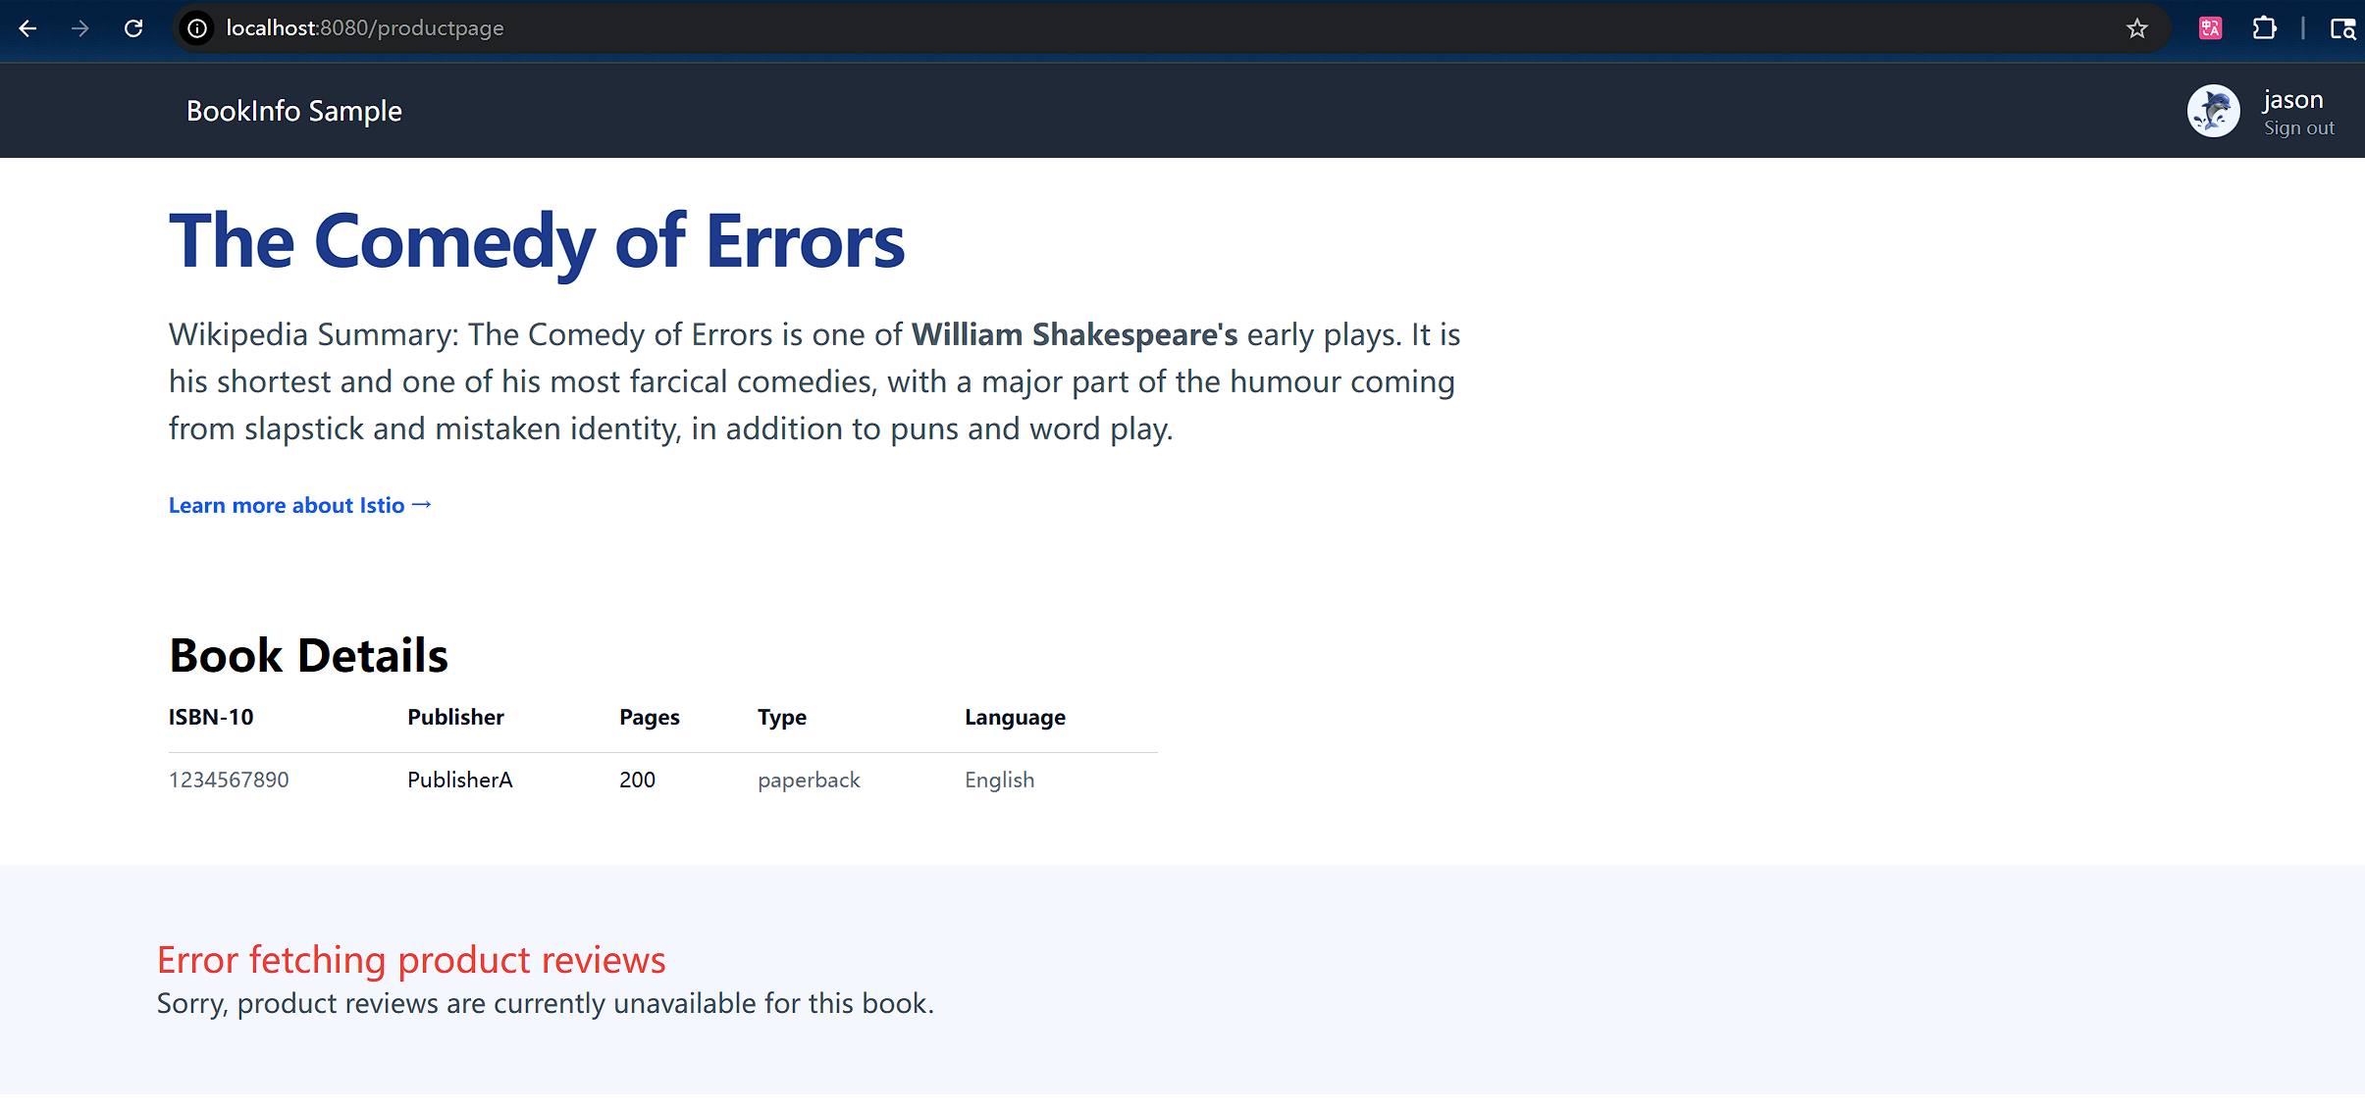
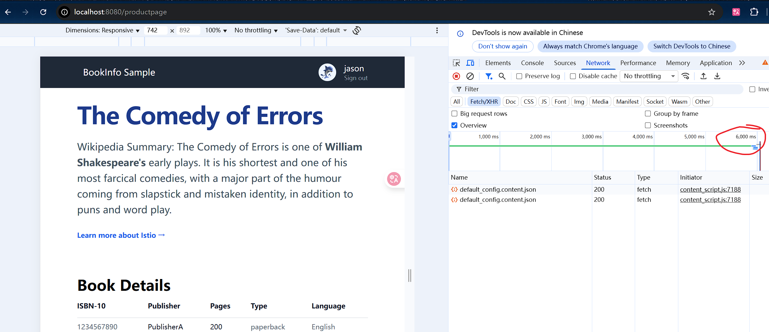

Injecting an HTTP abort fault
Create a fault injection rule to send an HTTP abort for user jason
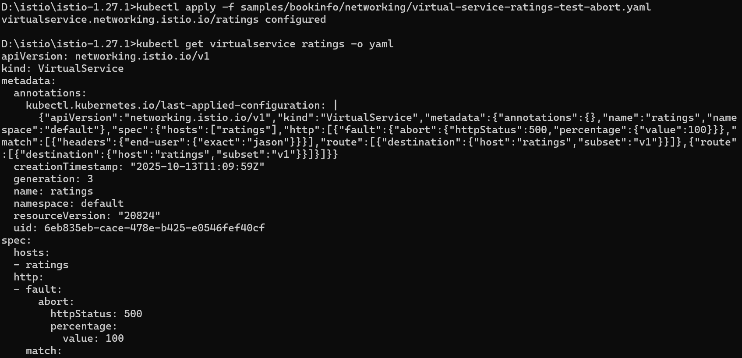
Testing the abort configuration
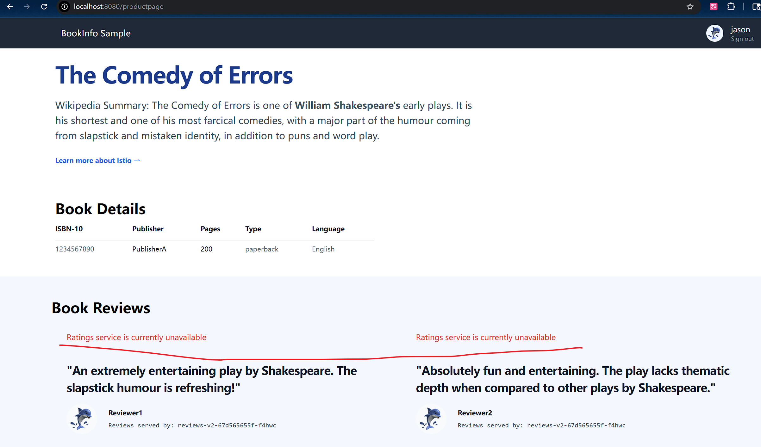

Traffic shifting

Apply weight-based routing
To get started, run this command to route all traffic to the v1 version
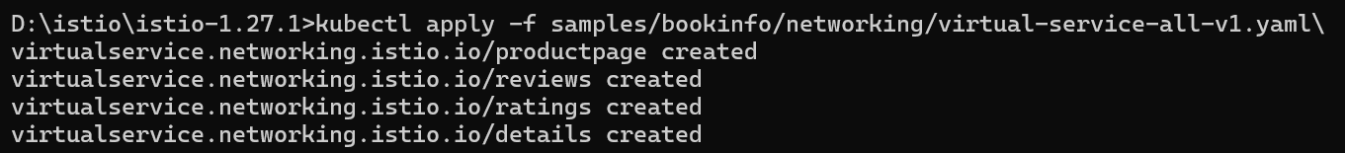
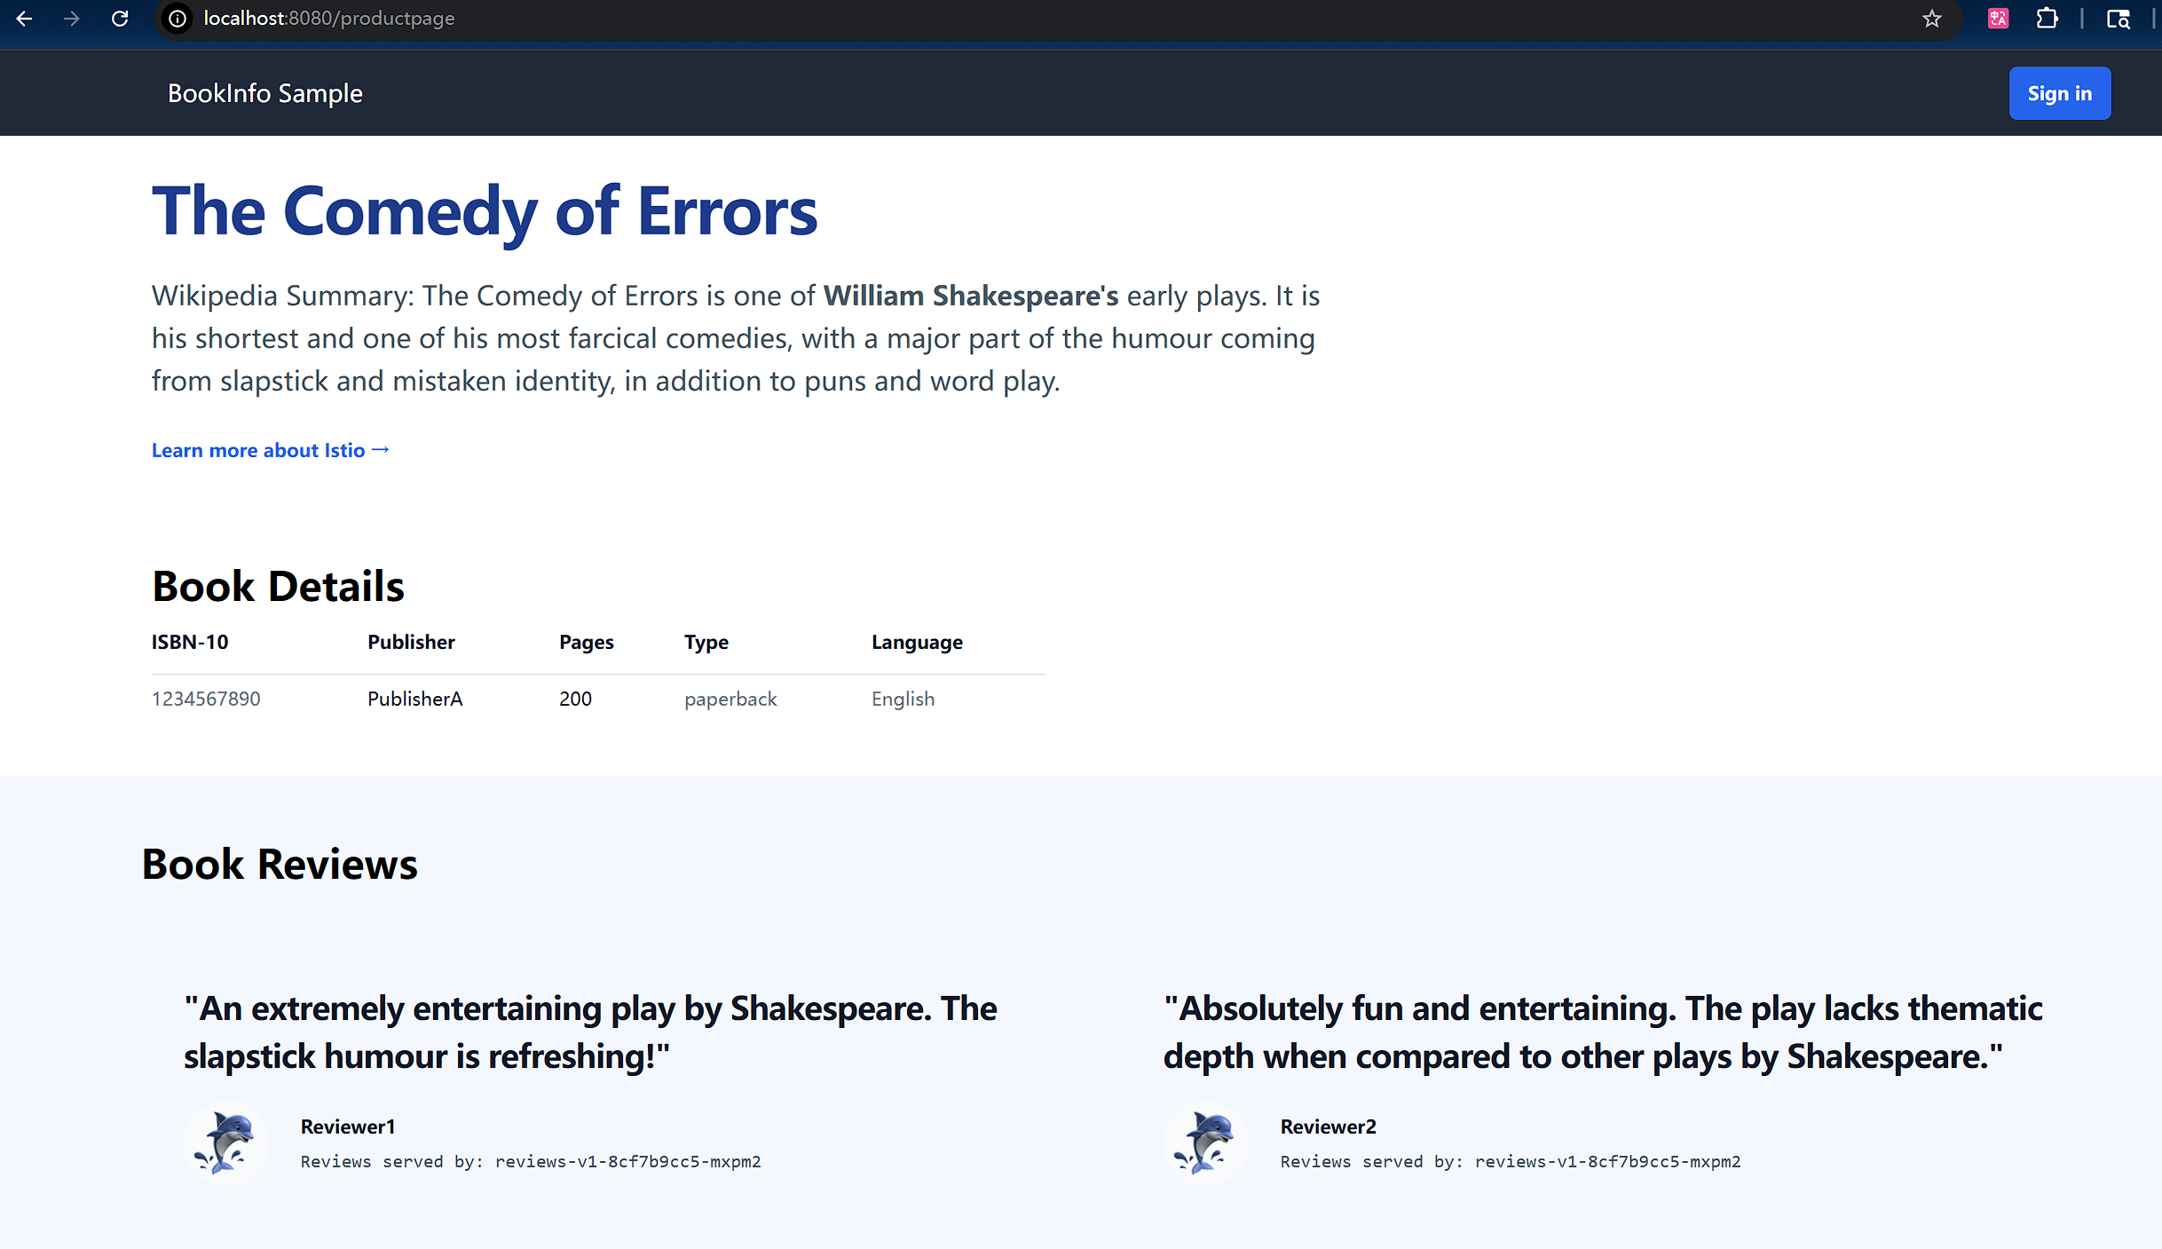
Notice that the reviews part of the page displays with no rating stars, no matter how many times you refresh. This is because you configured Istio to route all traffic for the reviews service to the version reviews:v1 and this version of the service does not access the star ratings service.
Transfer 50% of the traffic from reviews:v1 to reviews:v3 with the following command:
Wait a few seconds for the new rules to propagate and then confirm the rule was replaced
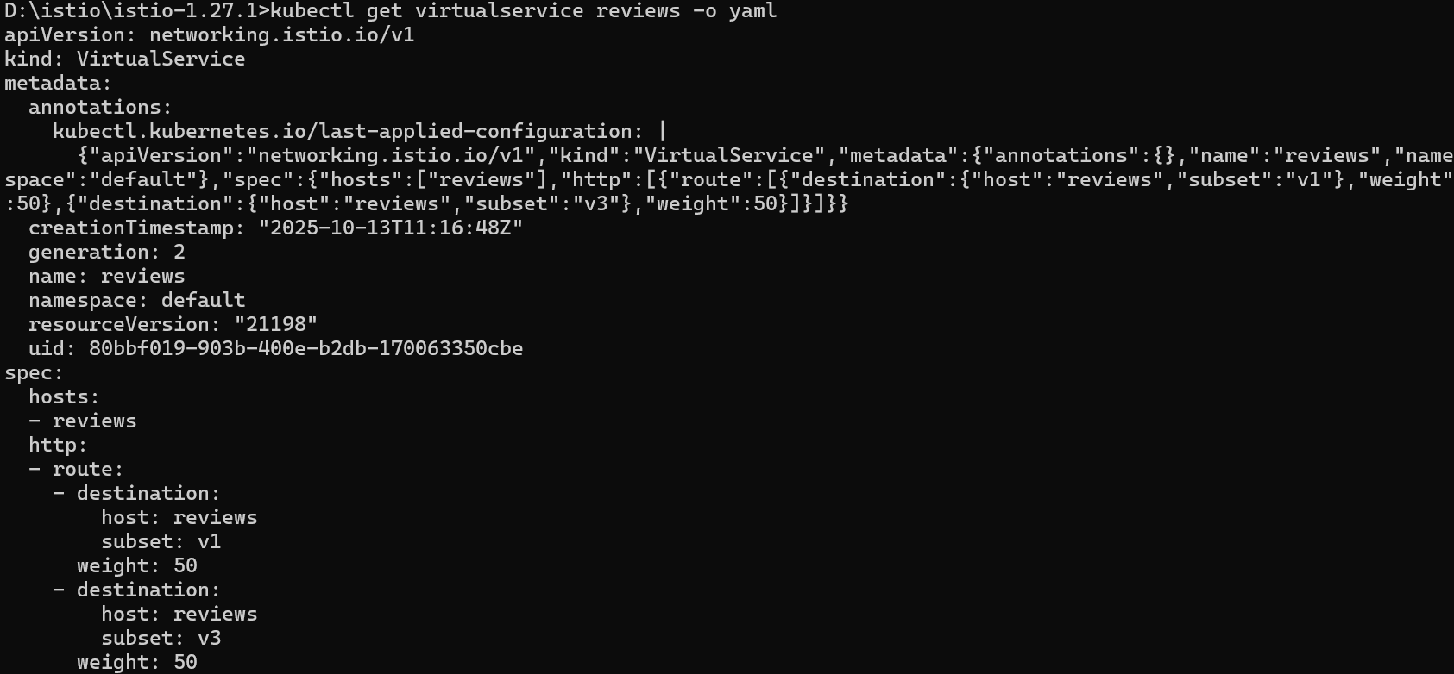

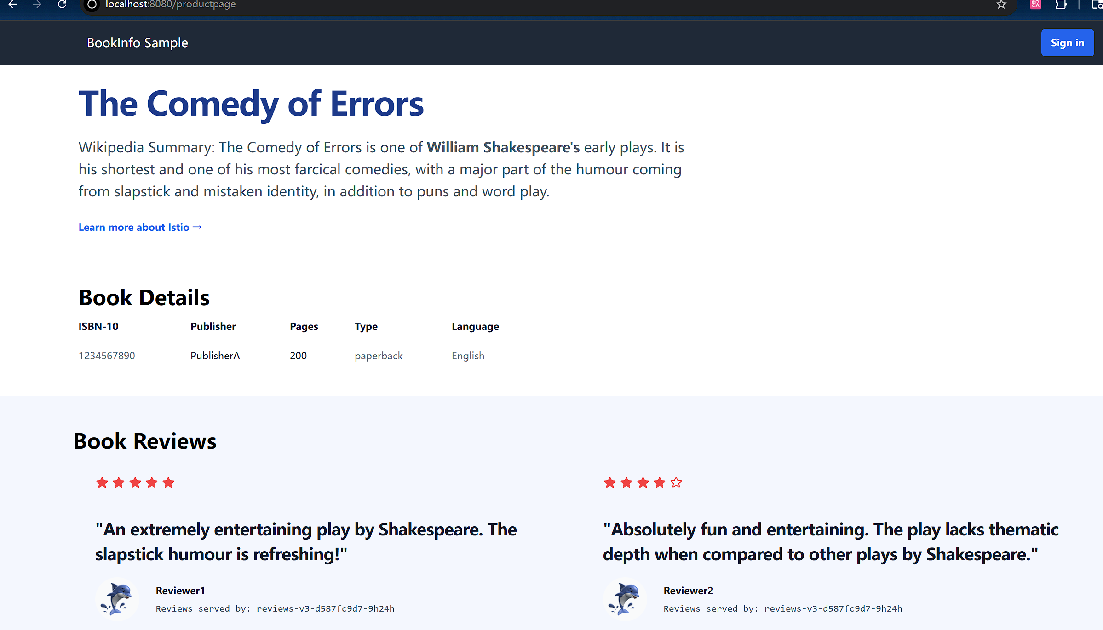
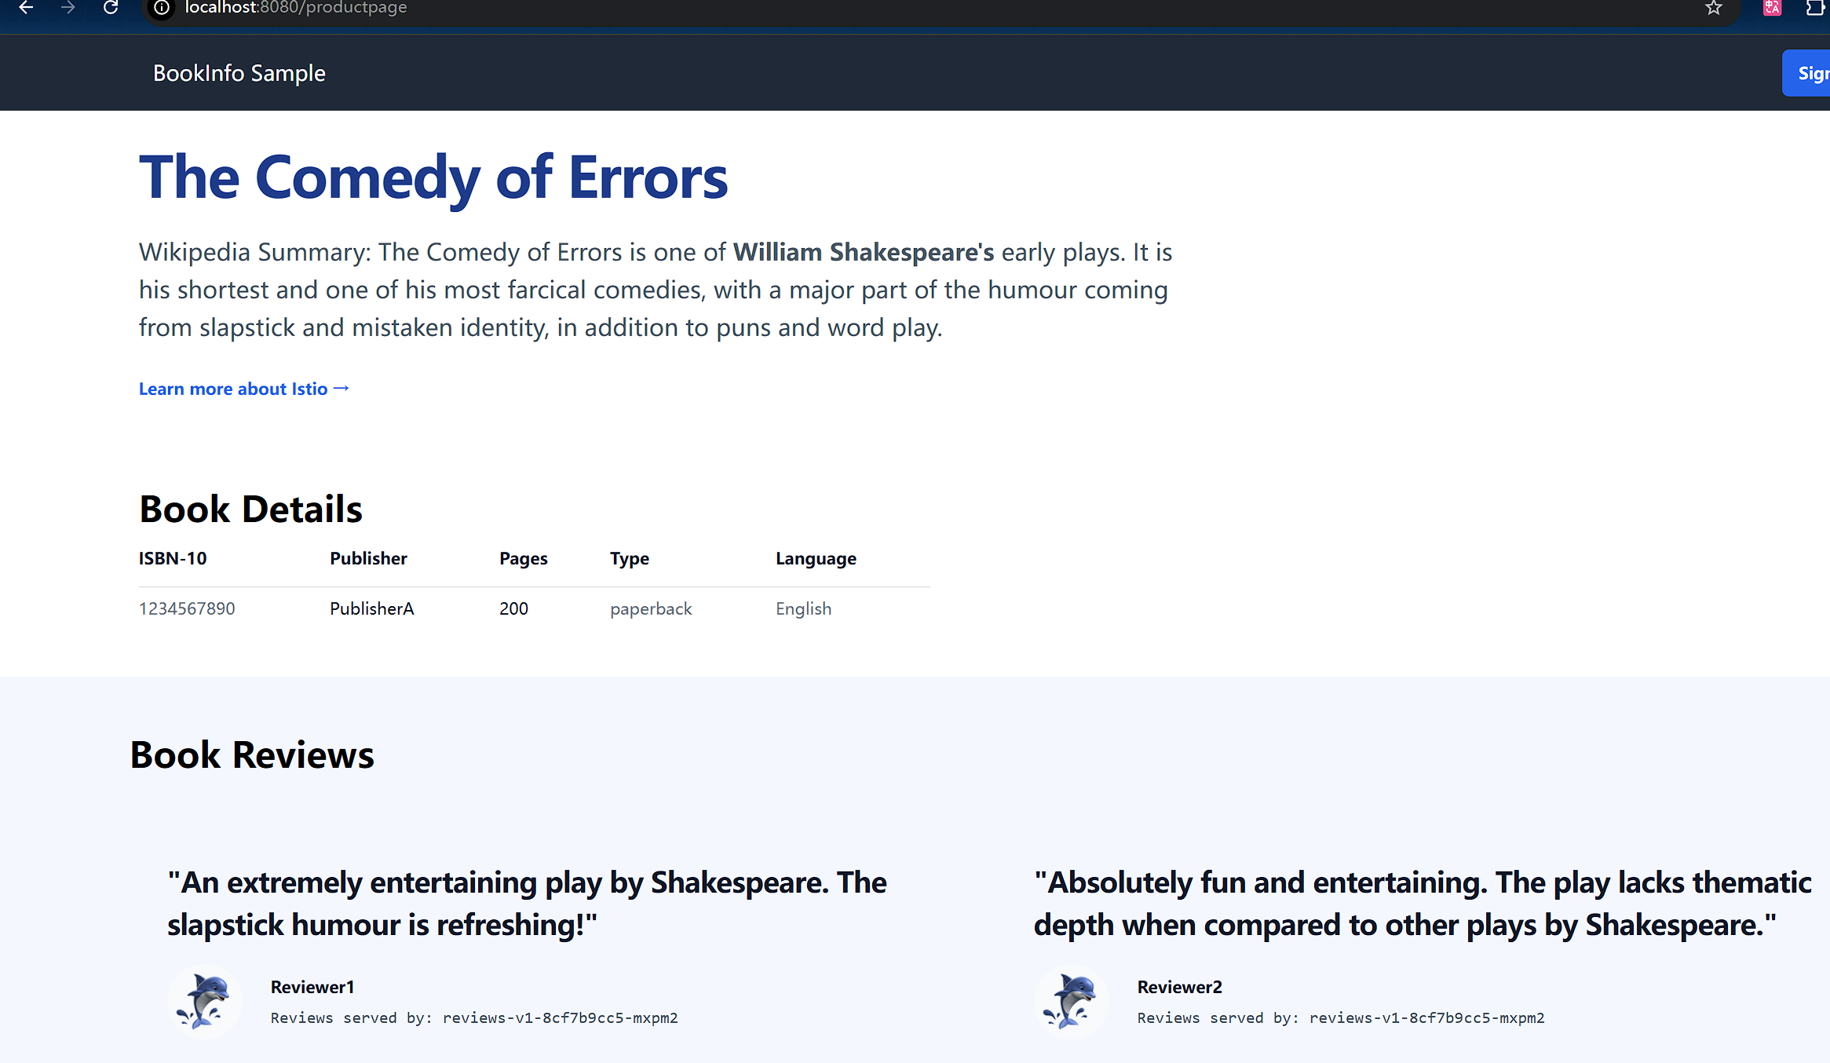
Refresh the /productpage in your browser and you now see red colored star ratings approximately 50% of the time. This is because the v3 version of reviews accesses the star ratings service, but the v1 version does not.

can route 100% of the traffic to reviews:v3 by applying this virtual service
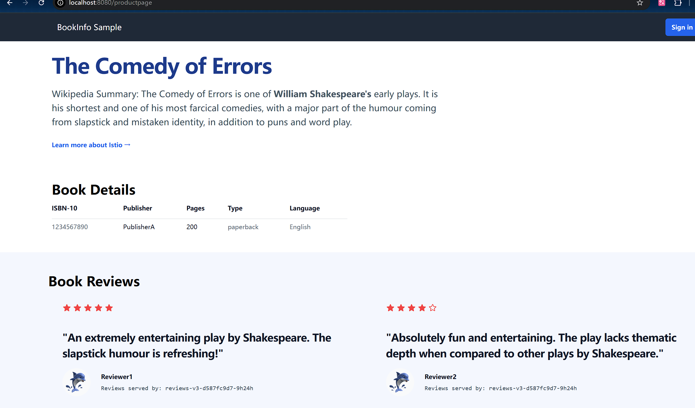
Refresh the /productpage several times. Now you will always see book reviews with red colored star ratings for each review

Circuit Breaking
Circuit breaking is an important pattern for creating resilient microservice applications. Circuit breaking allows you to write applications that limit the impact of failures, latency spikes, and other undesirable effects of network peculiarities.
Start the httpbin sample
Configuring the circuit breaker
Create a destination rule to apply circuit breaking settings when calling the httpbin service
Verify the destination rule was created correctly
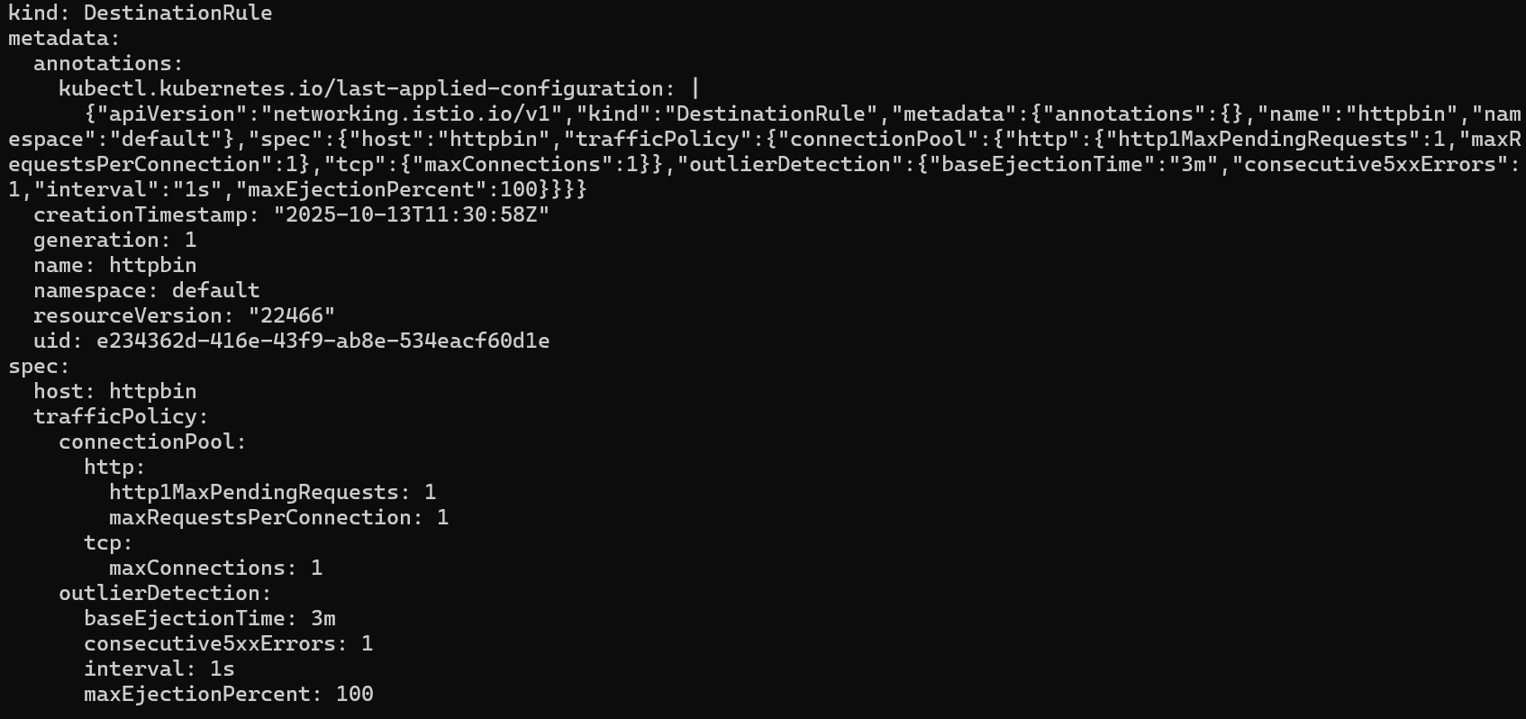

Adding a client

Tripping the circuit breaker

