Start minikube and config the environment
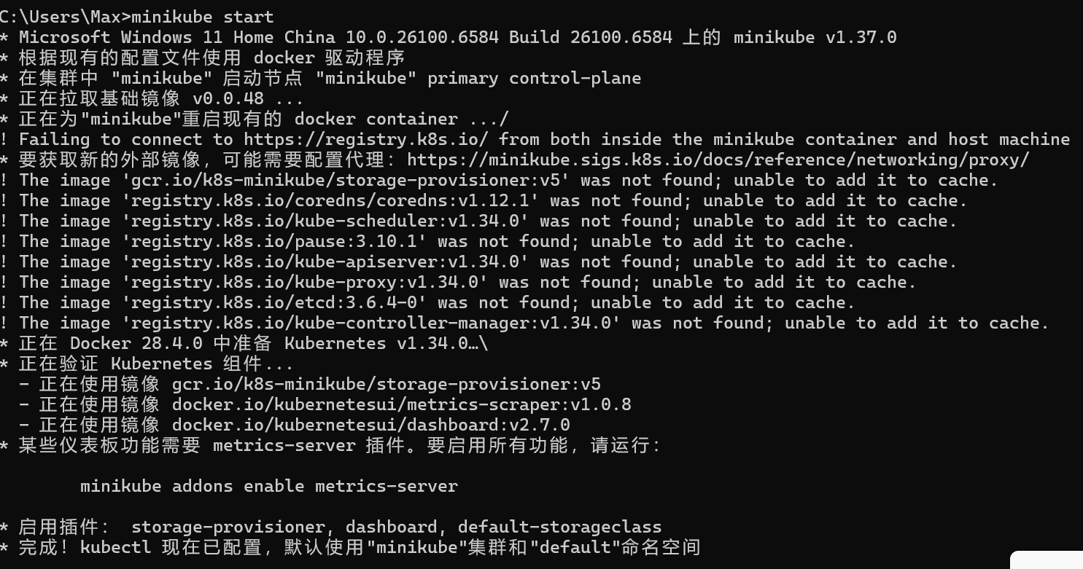
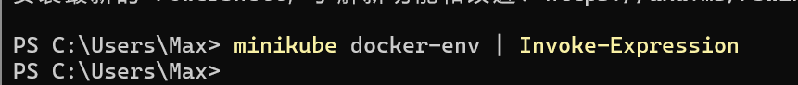

Install Knative Serving
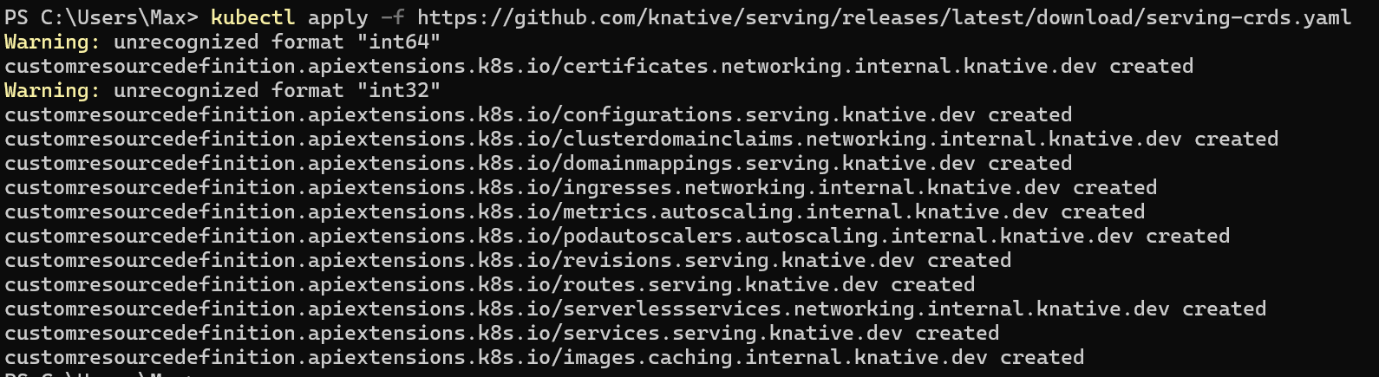

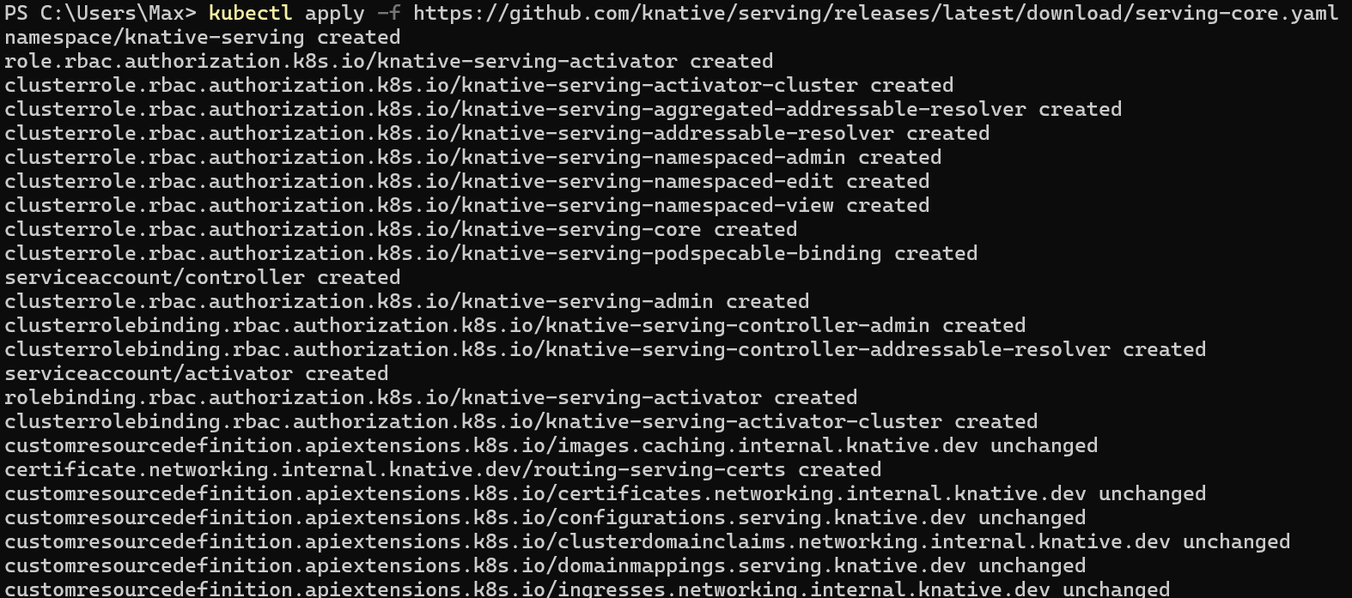
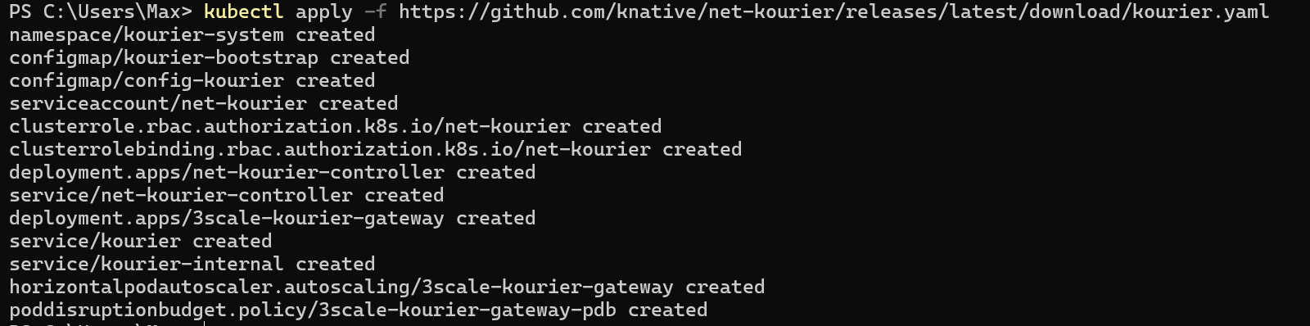
Config Knative Serving to make Kourier as default network achievement
Make a kourier-patch.yaml file
And write:
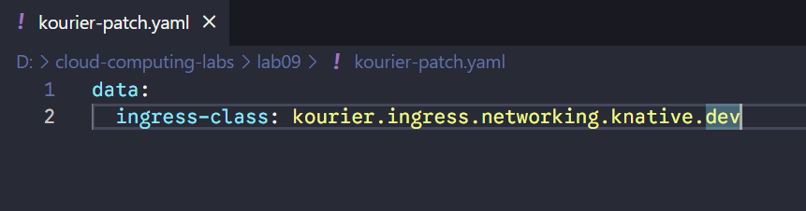

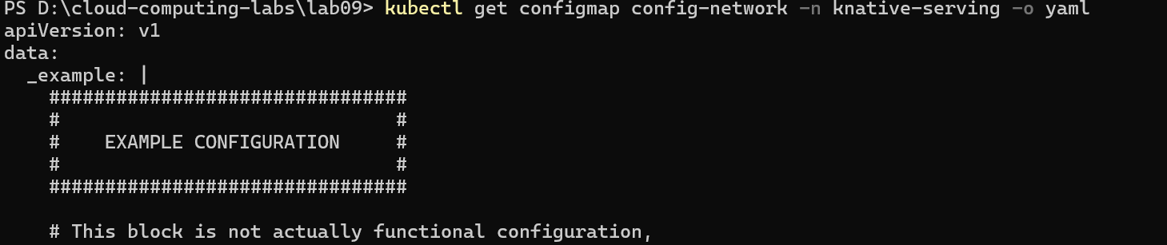
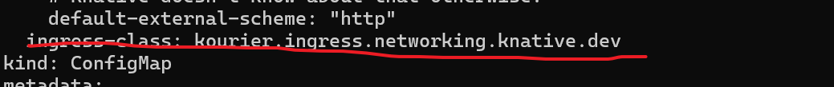

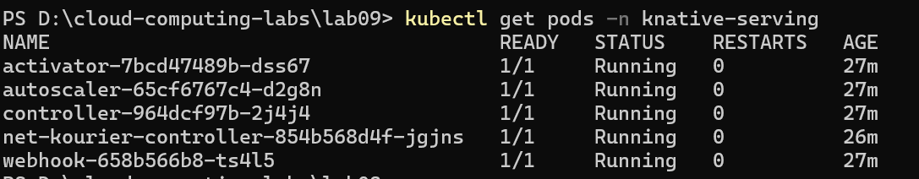

Install Knative Eventing
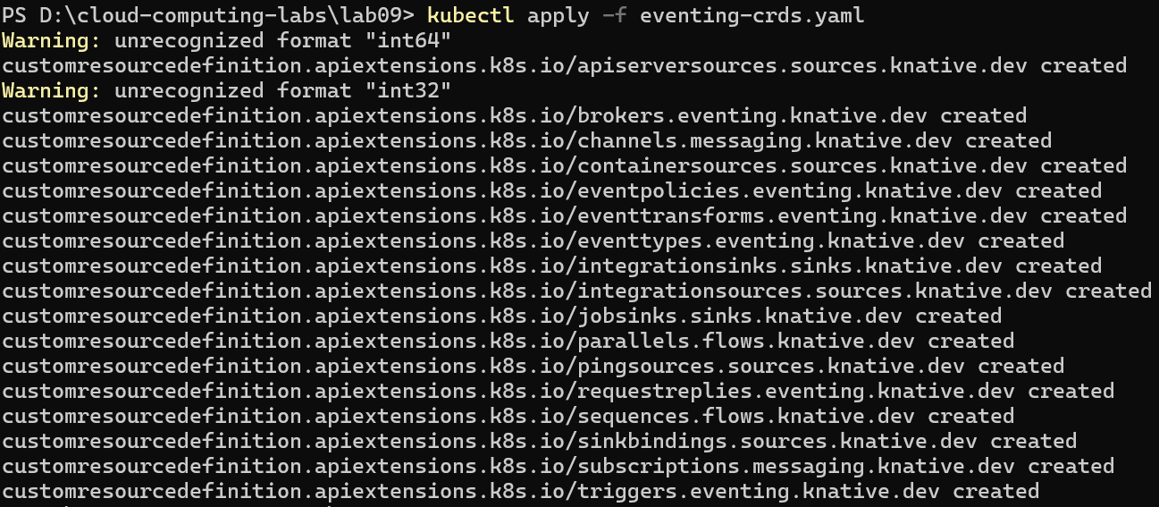
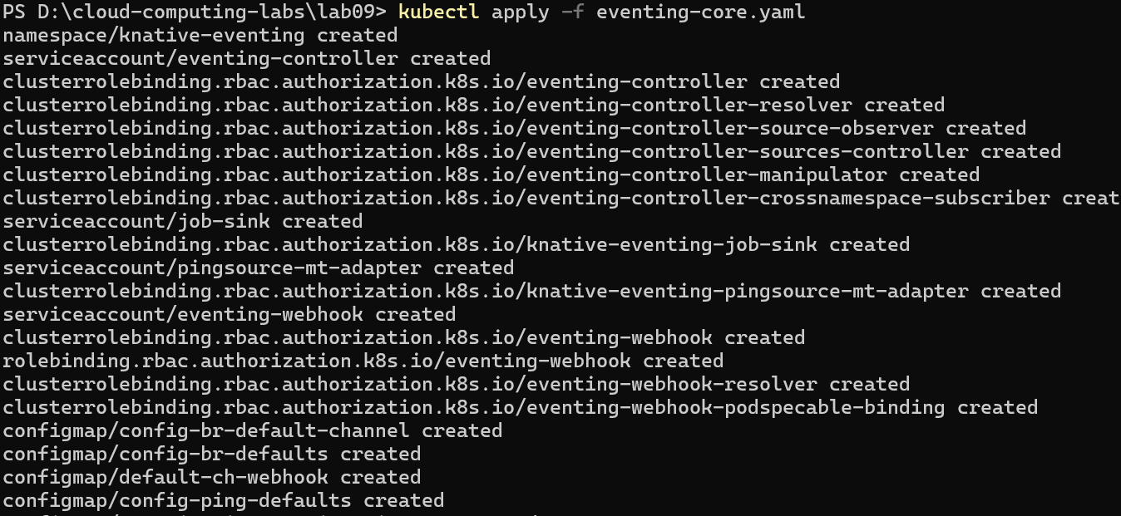
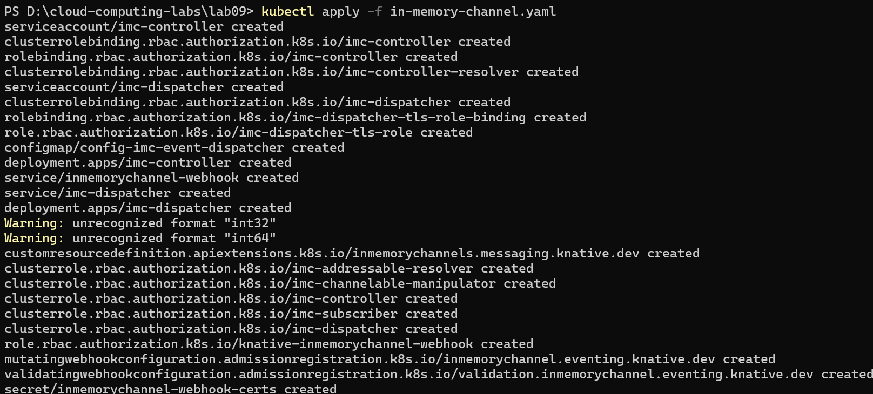
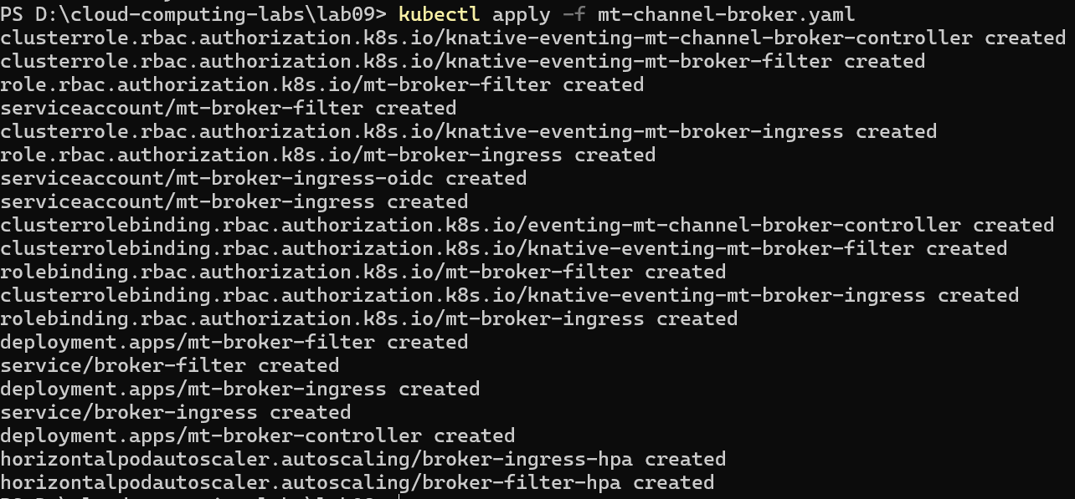
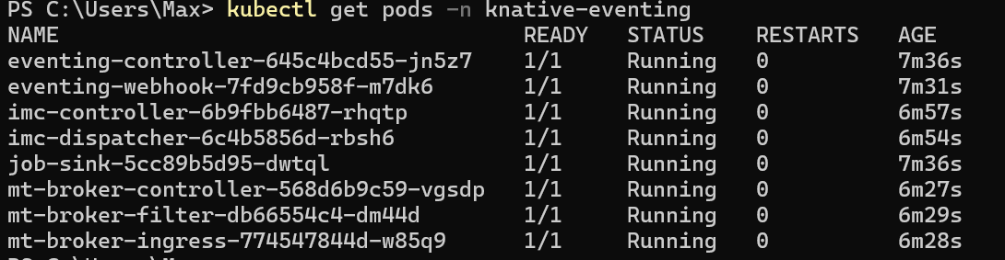

Knative Functions

Install kn CLI

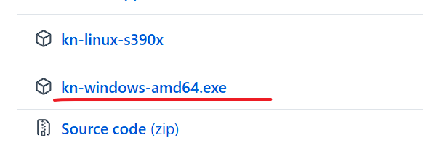
add kn.exe to Path
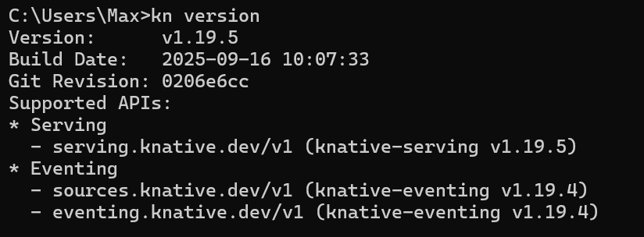

Install func plugin
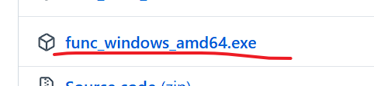
Rename to kn-func.exe

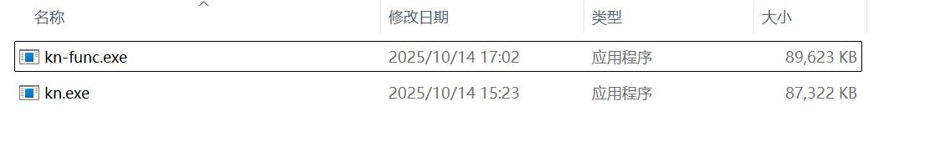
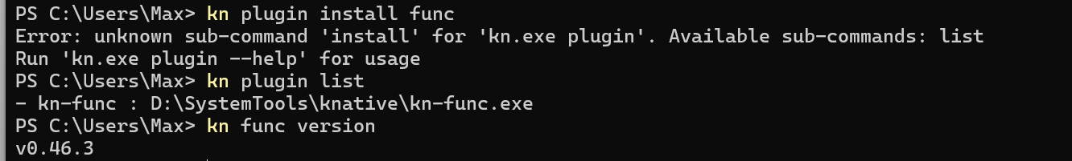
Create a function
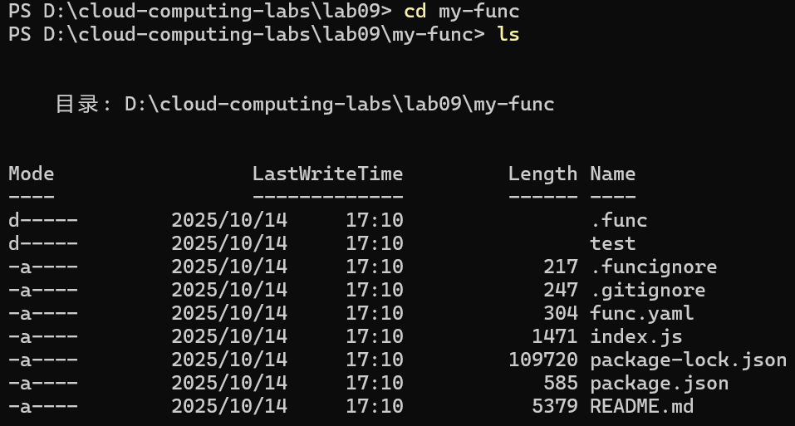

Build function locally(use local registry)
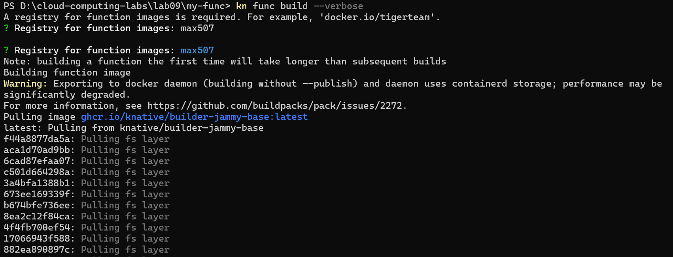
Note: The output of this command will show the Docker build log. After the build is successful, the image my-func:latest will be stored directly in the Minikube Docker environment, and the Kubernetes cluster can pull it directly without pushing it to Docker Hub or other remote repositories.

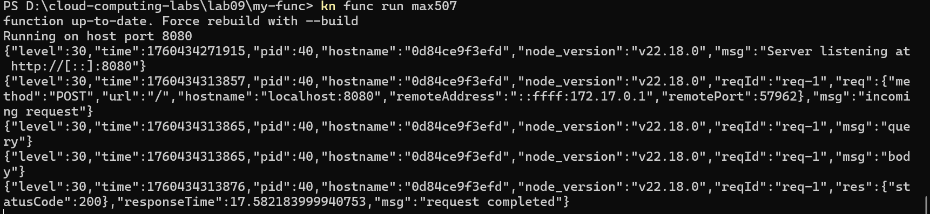
The function has successfully run
Skip the Deploying a function part
Deploy function to to minikube

Knative Serving
Deploying a Knative service
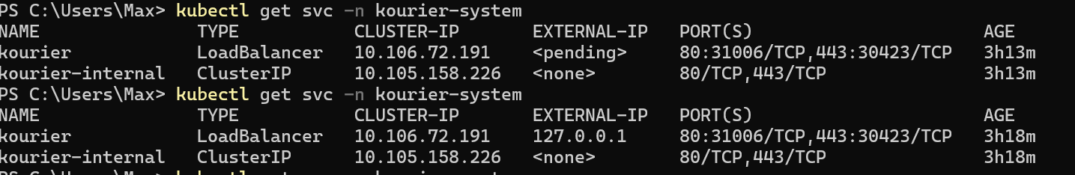
minikube tunnel to enable windows to acccess service inside minikube cluster
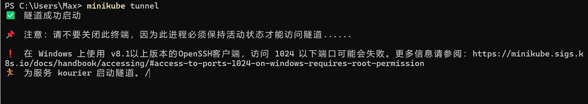
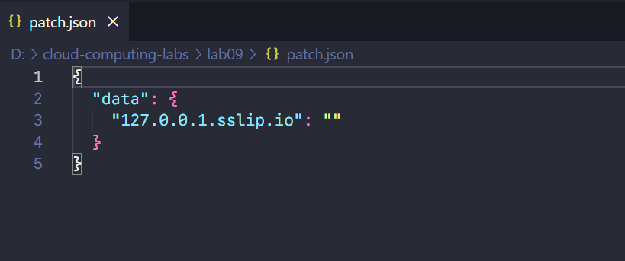
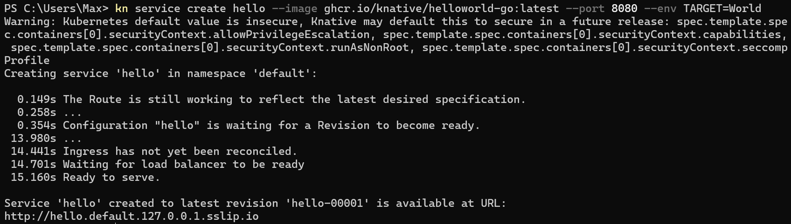
Autoscaling
List Knative Service
Access Knative Service
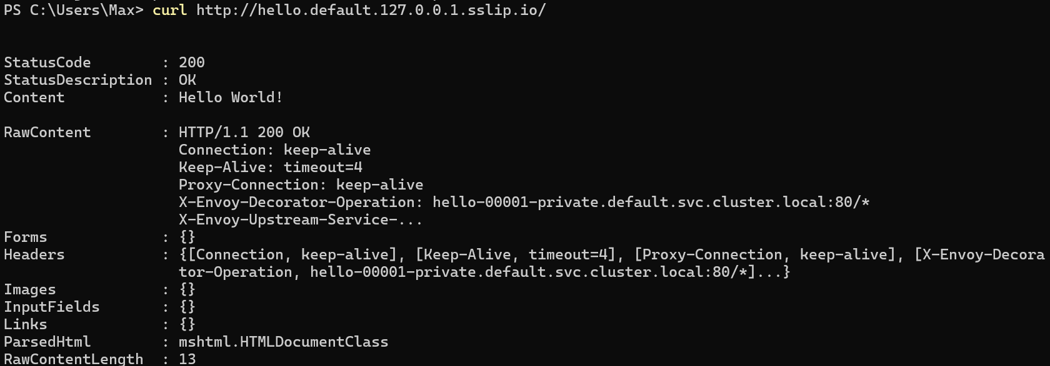
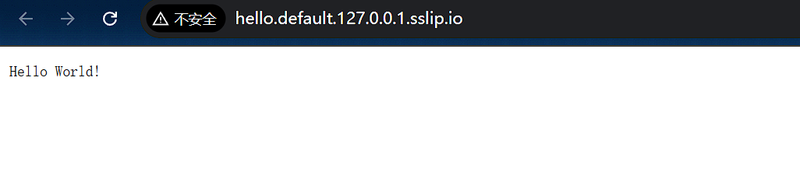

Observe autosaling
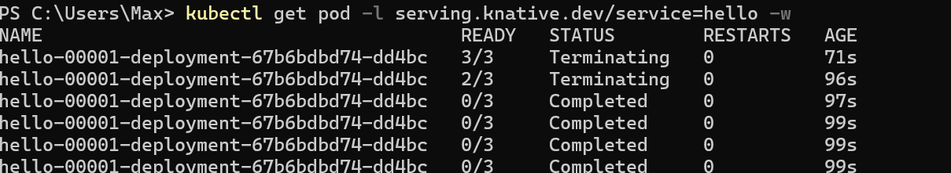

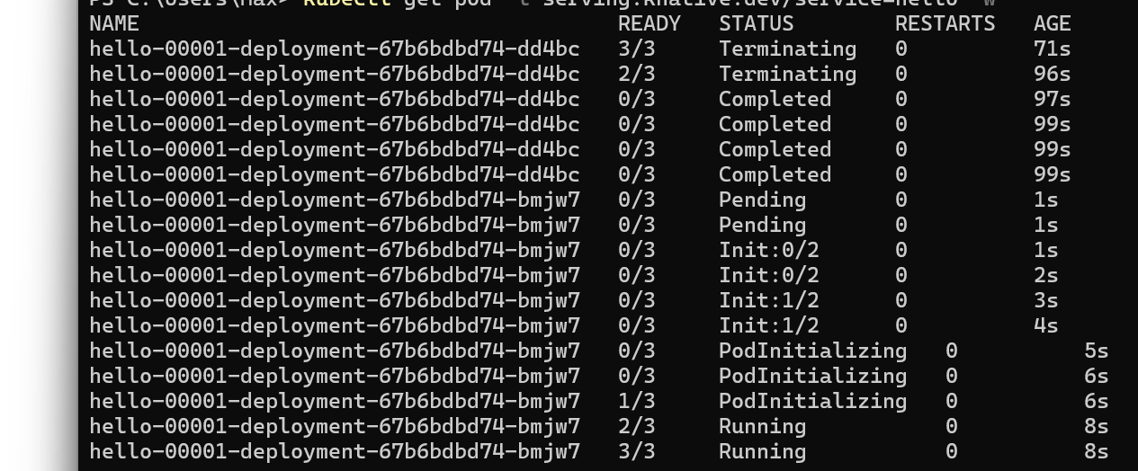

Traffic splitting
Creating a new Revision
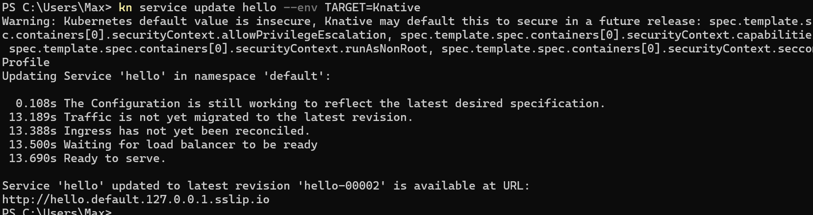
Access the new Revision
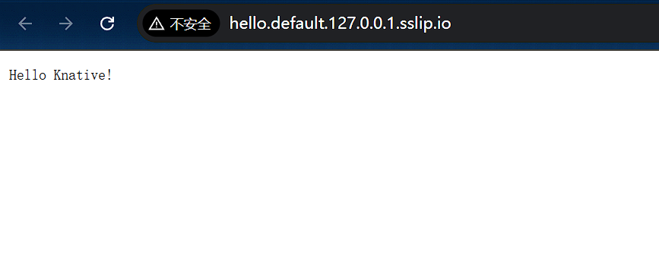
View existing Revisions
When running the kn command, the relevant column is TRAFFIC. You can see that 100% of traffic is going to the latest Revision, hello-00002, which is on the row with the highest GENERATION. 0% of traffic is going to the Revision hello-00001.
When you create a new Revision of a Knative Service, Knative defaults to directing 100% of traffic to this latest Revision. You can change this default behavior by specifying how much traffic you want each Revision to receive.
Splitting traffic between Revisions
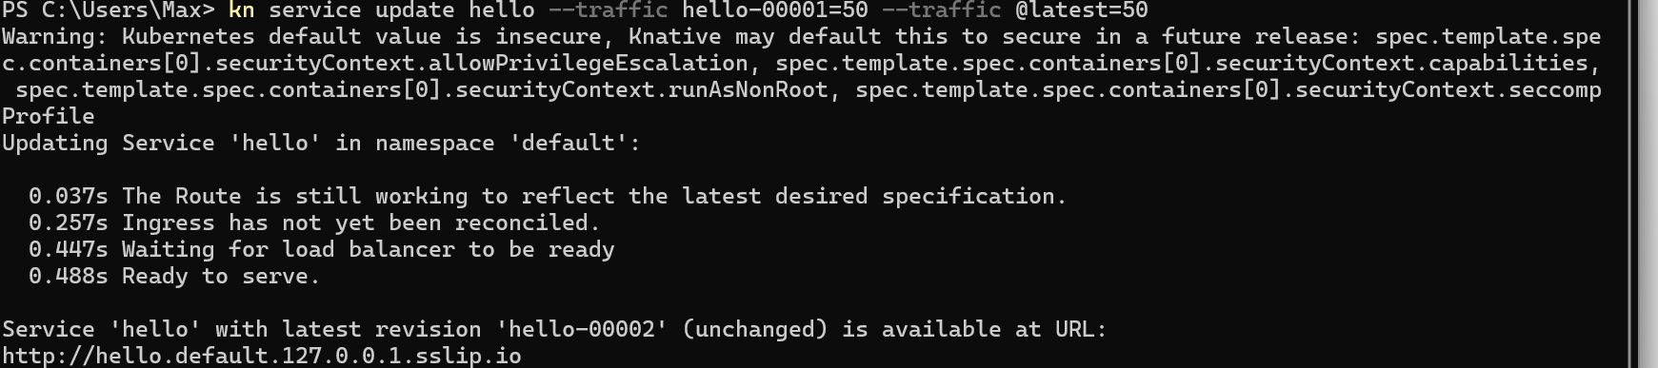
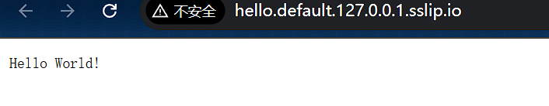
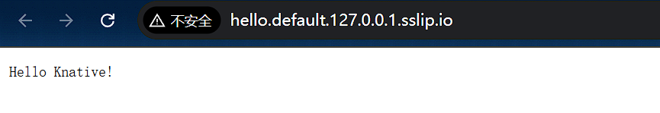
Knative Eventing
Knative Eventing provides you with helpful tools that can be used to create event-driven applications, by easily attaching event sources, triggers, and other options to your Knative Services

Sources, Brokers, and Triggers
Using a Knative Service as a source
Create the CloudEvents Player Service
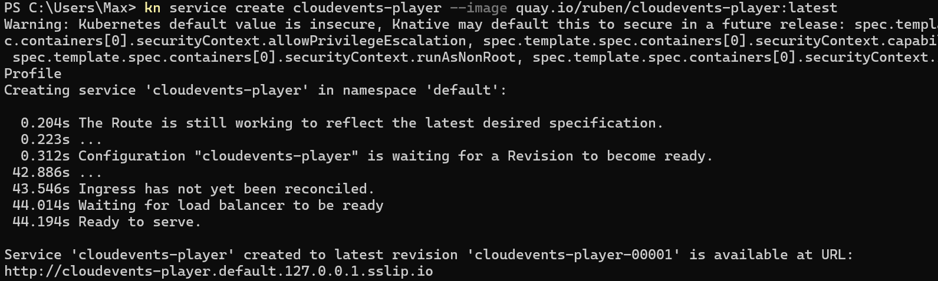
The service is now running but it doesn't know where the broker is so let's create a SinkBinding between the service and the broker.
Examining the CloudEvents Player

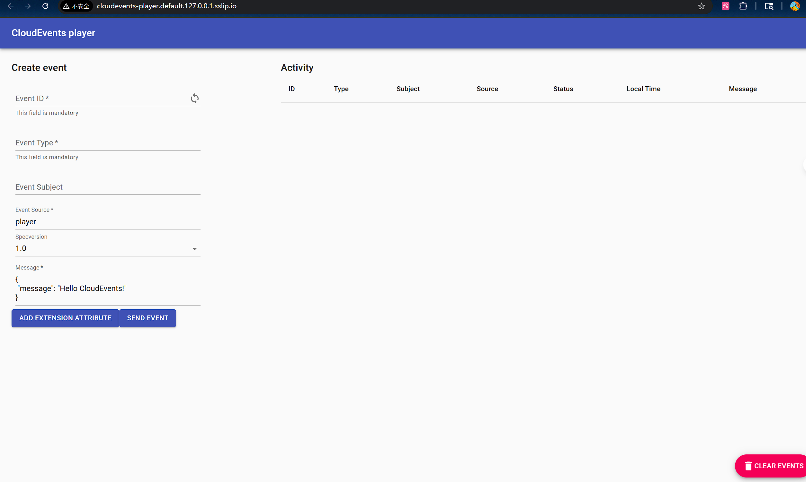
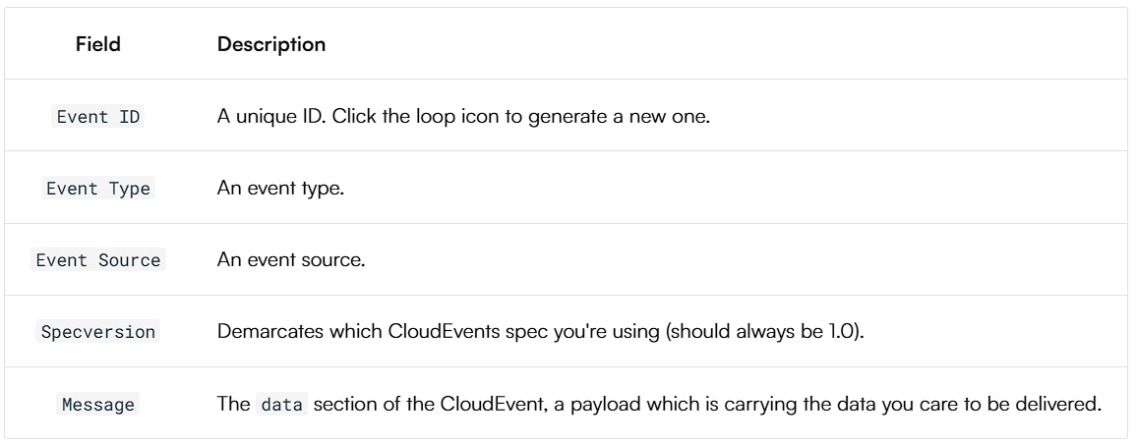
Sending an event

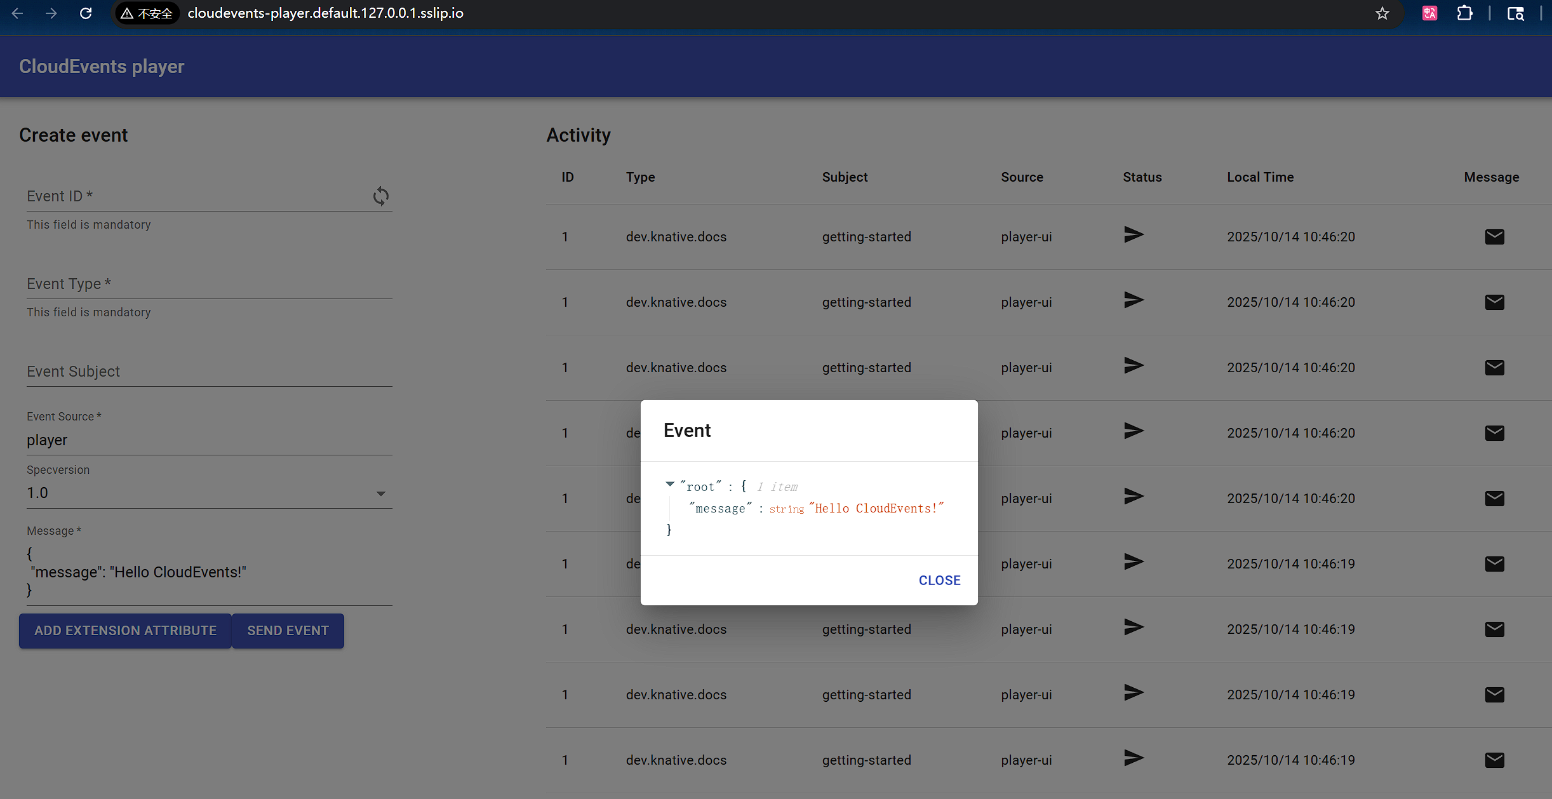
Using Triggers and sinks
Creating first Trigger
Create a Trigger that listens for CloudEvents from the event source and places them into the sink, which is also the CloudEvents Player app.

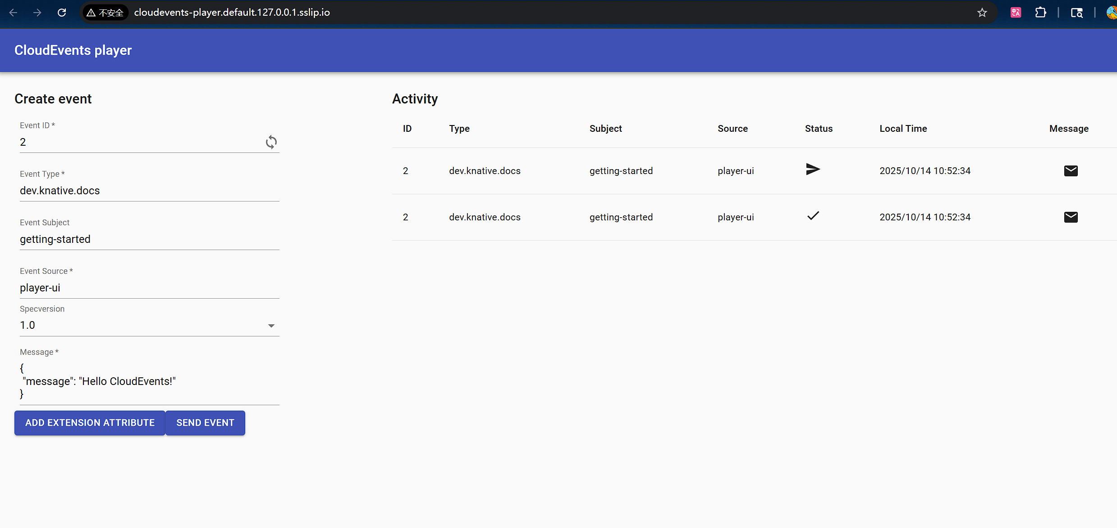
Now, when we go back to the CloudEvents Player and send an event, we see that CloudEvents are both sent and received by the CloudEvents Player

