Install kubectl, helm,curl
Windows environment:
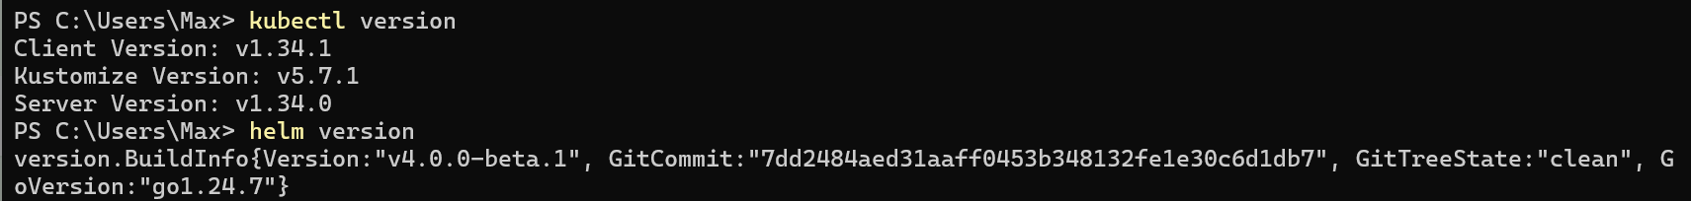
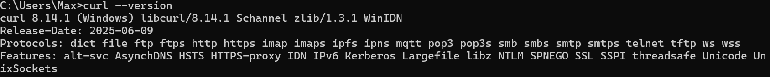
WSL environment:
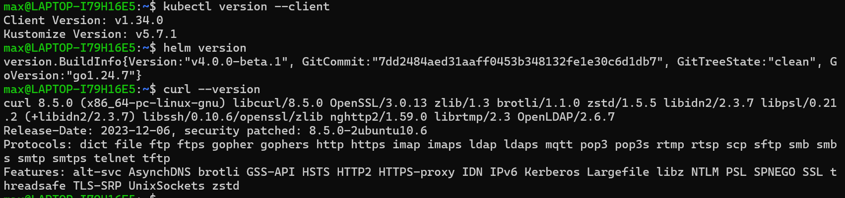

Install Kserve Quickstart Environment
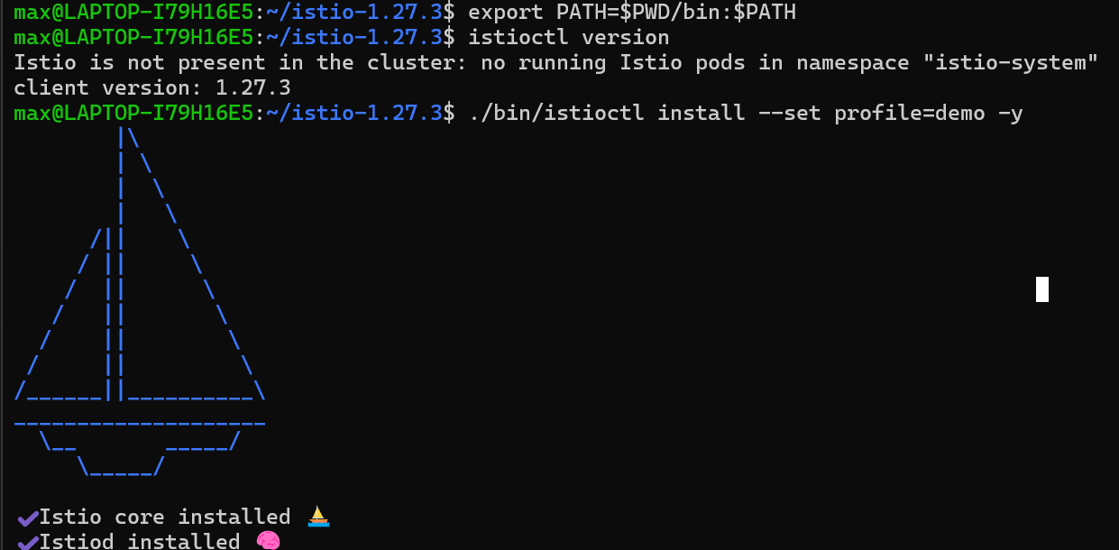
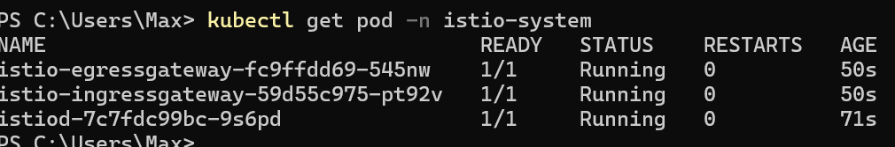
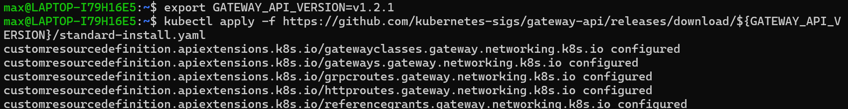
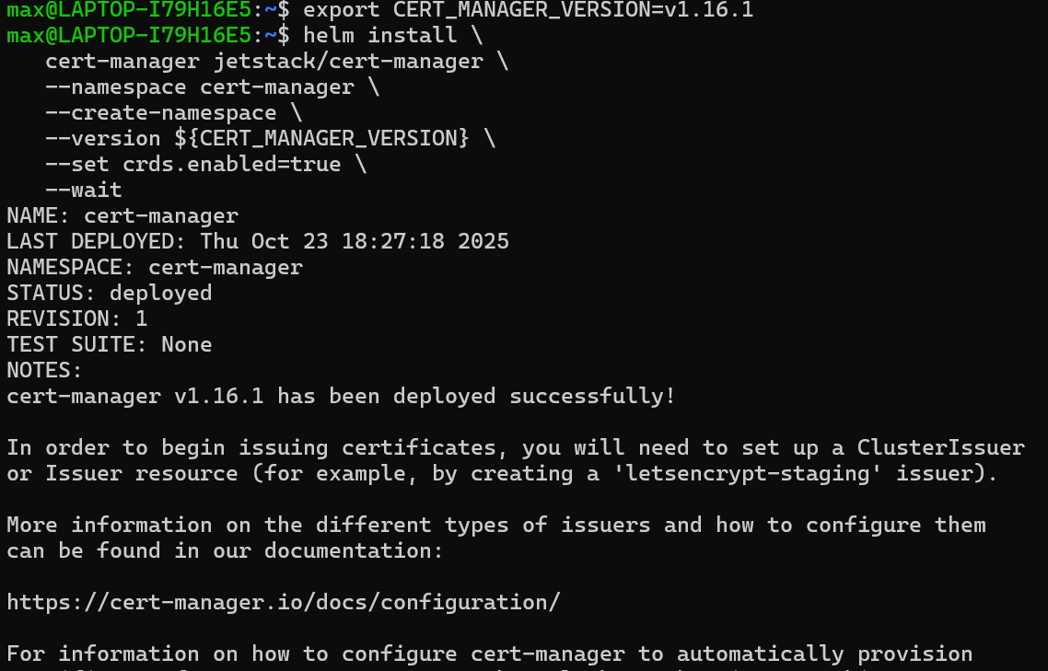
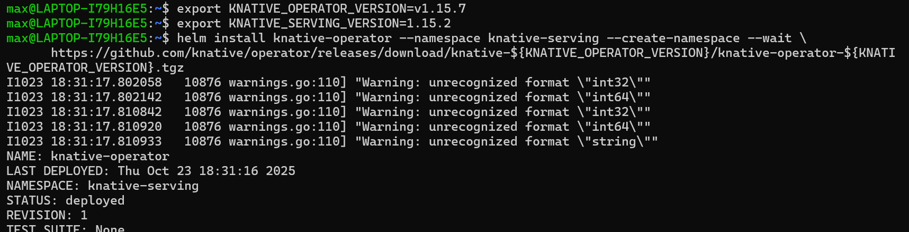
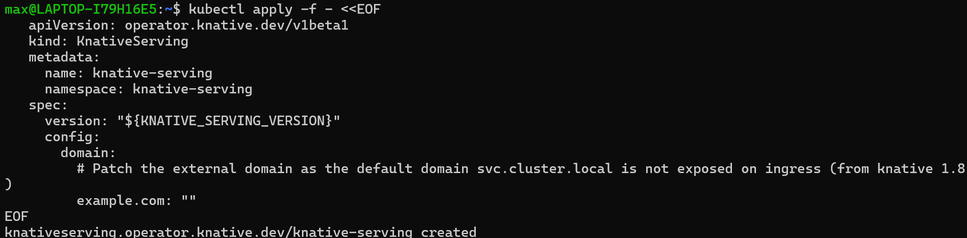
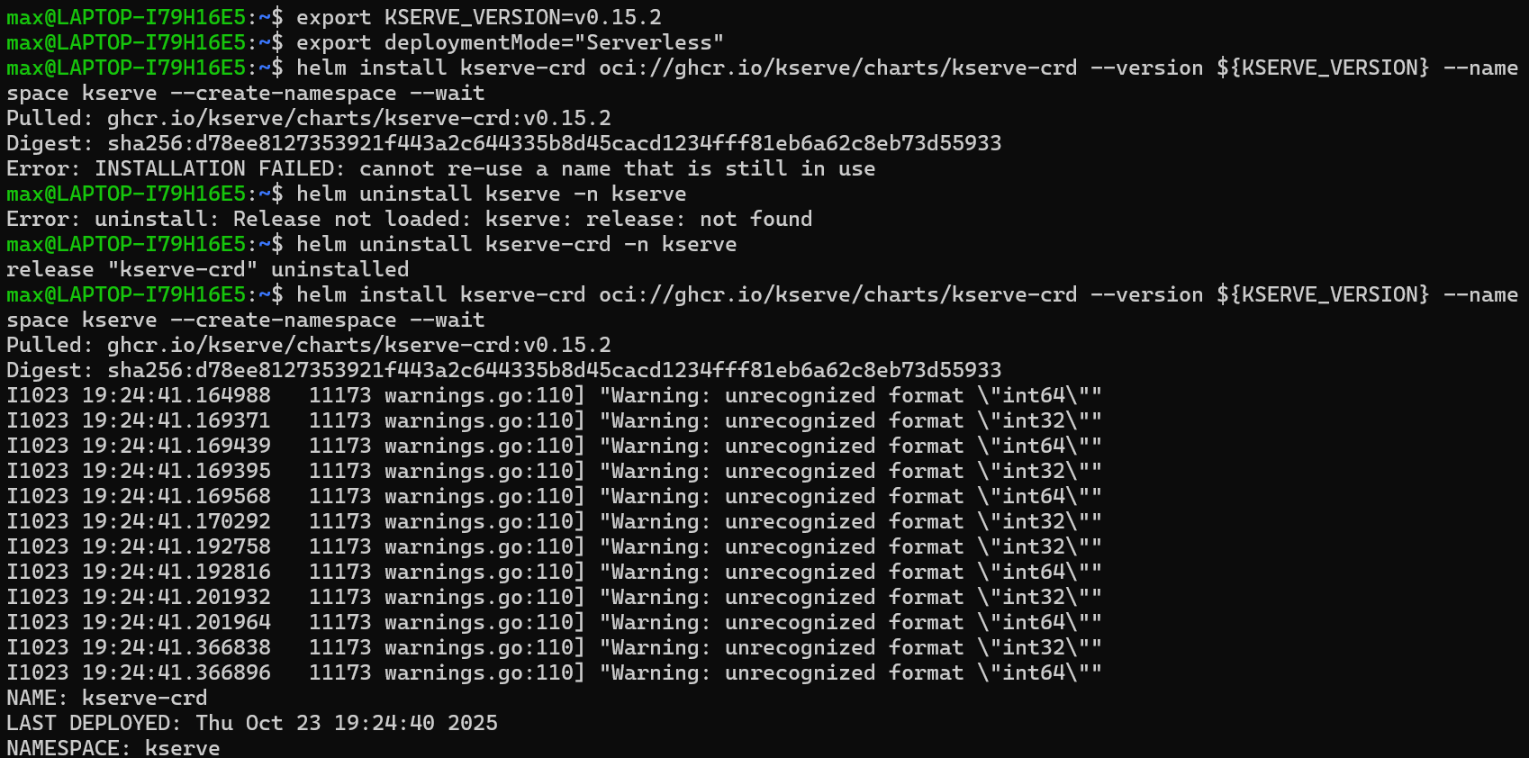
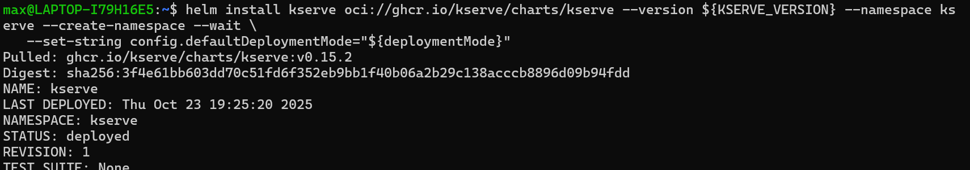

Deploy predictive Inference Service
- create a namespace
- Create an Inference service
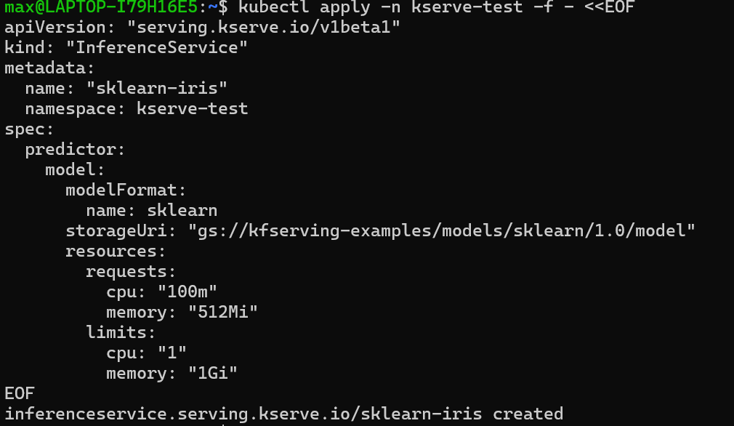
- Check Inference service status
kubectl get inferenceservices sklearn-iris -n kserve-test
Wait for a while

- determine the ingress IP and ports
Minikube doesn't connect to cloud providers (such as AWS, GCP, and Azure) to automatically assign an external public IP address.

Services of the LoadBalancer type in Minikube don't automatically obtain an external IP address, but they still expose the service through a NodePort.
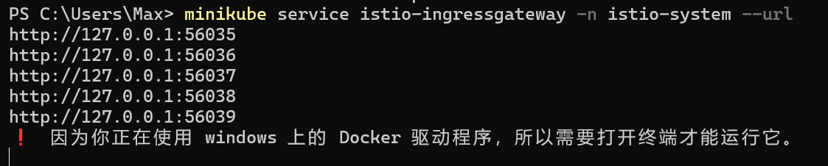

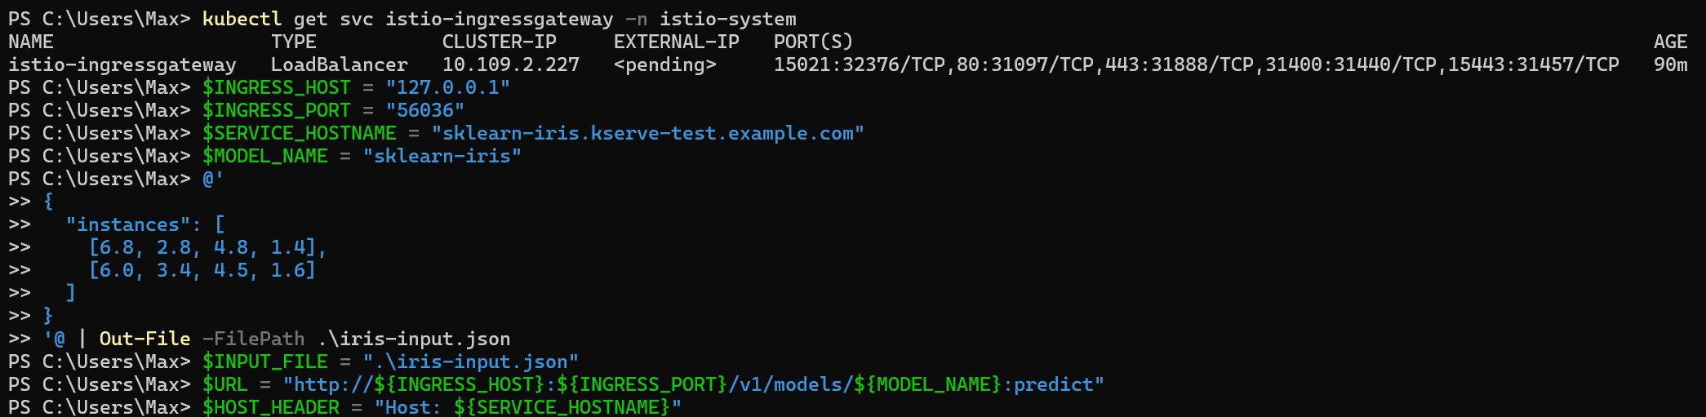
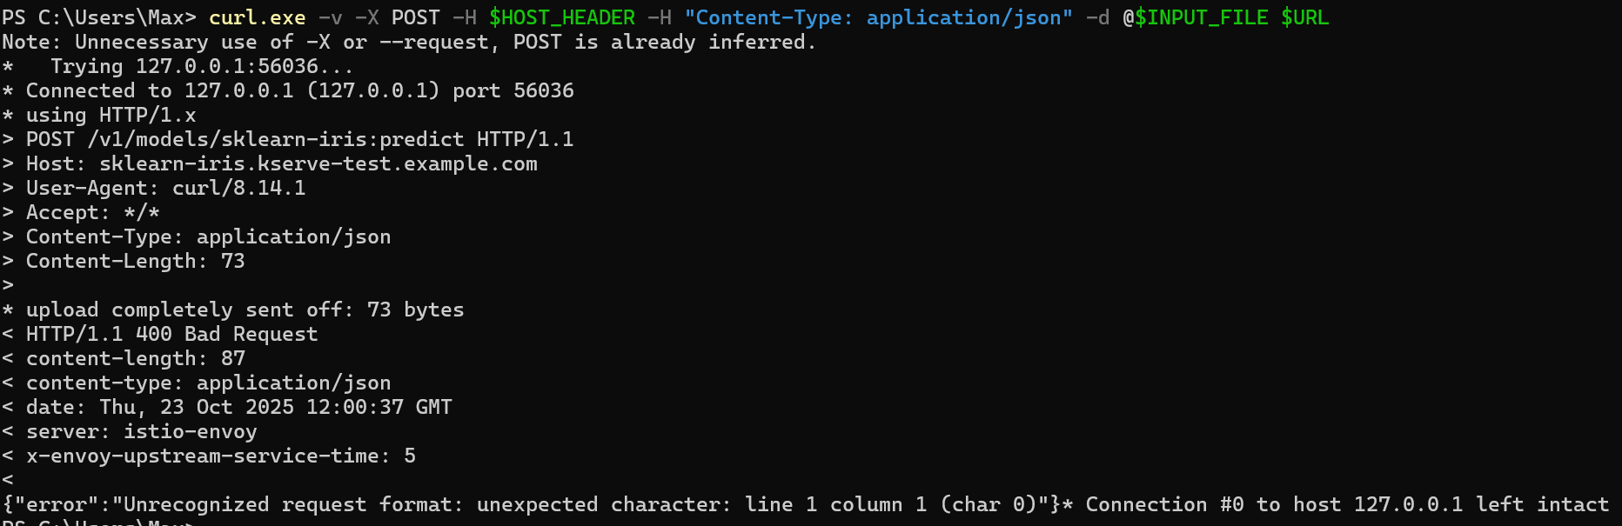

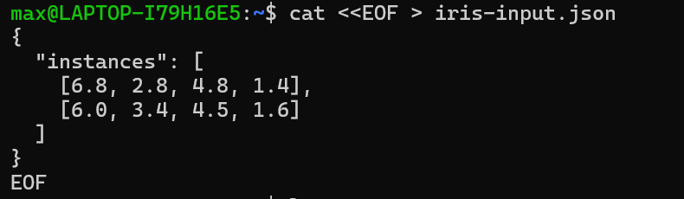

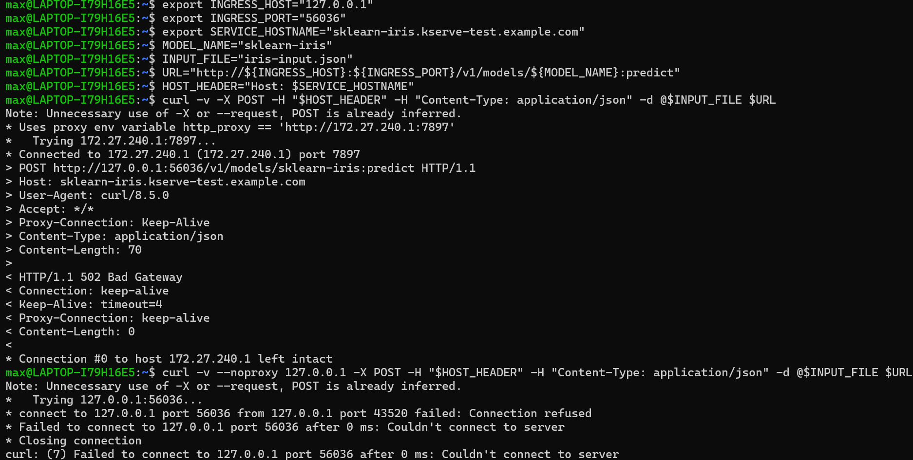

Delete original InferenceService and create a new one
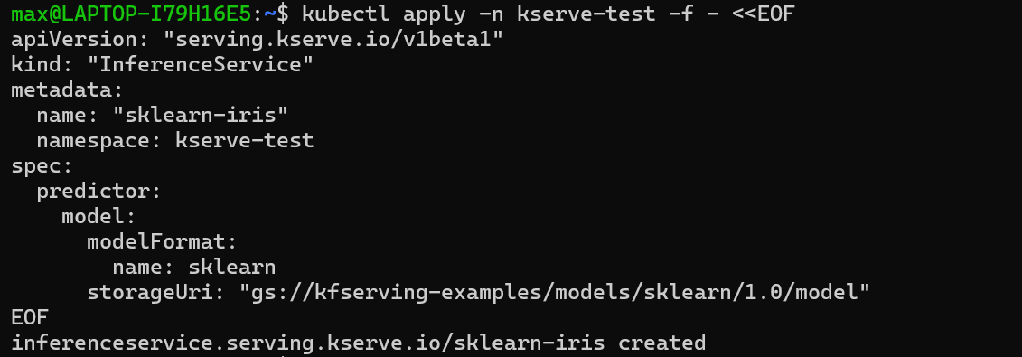

Wait for initializing
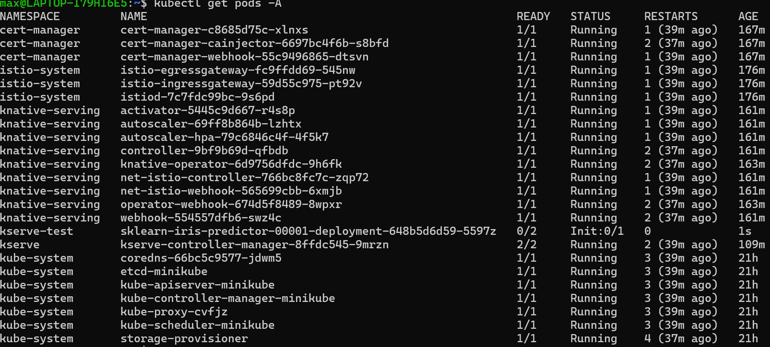
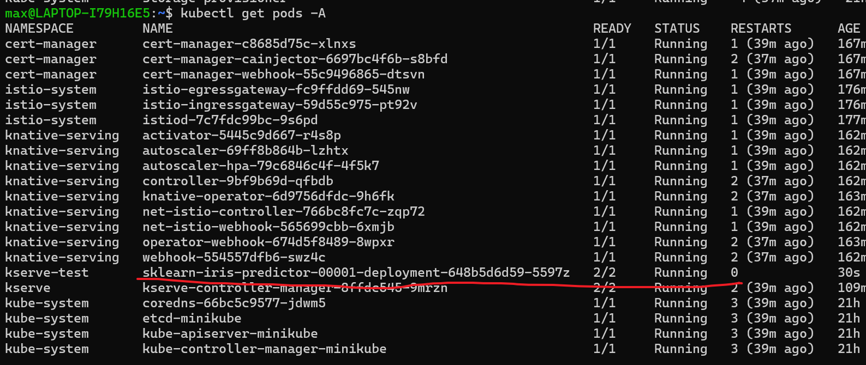
Check the new inferenceservice status
Our kubernetes cluster is not running in an environment that supports external load balancers
So we do Port Forward for testing purposes.
kubectl port-forward: This command establishes a secure TCP tunnel between your local machine (localhost) and the istio-ingressgateway Service within the Kubernetes cluster.

Traffic forwarding: This command forwards all traffic sent to your local machine (localhost:8080) through this tunnel, unmodified, to the Istio gateway (istio-ingressgateway) within the cluster on port 80.

curl request:

Your curl command sends a request to http://localhost:8080 (your local machine).

This request is captured by port-forward and forwarded to the Istio gateway within the cluster.

Key Point: The -H "Host: ${SERVICE_HOSTNAME}" HTTP header tells the Istio gateway, "Although this request is coming from localhost, please pretend it's destined for ${SERVICE_HOSTNAME} (e.g., sklearn-iris.kserve-test.example.com)."

Based on this Host header information, the Istio gateway correctly routes the request to the sklearn-iris inference service created by KServe.
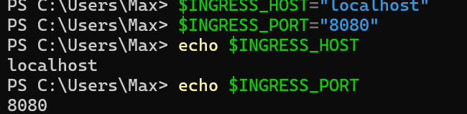
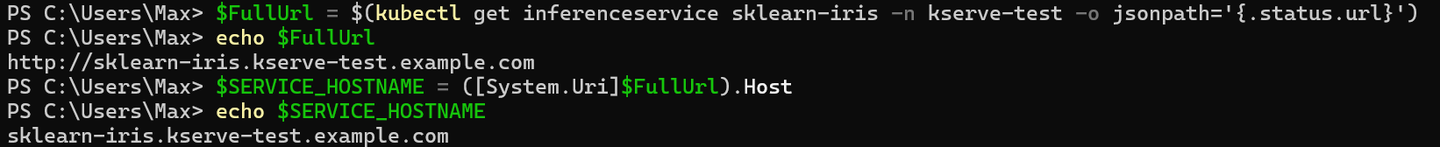
Prepare the iris-input.json file
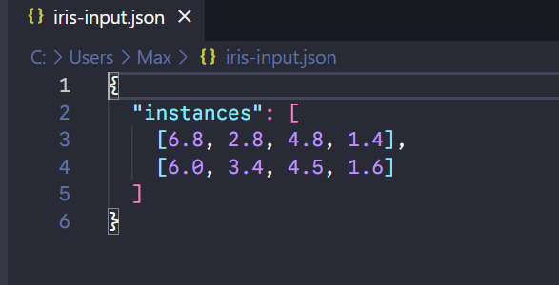
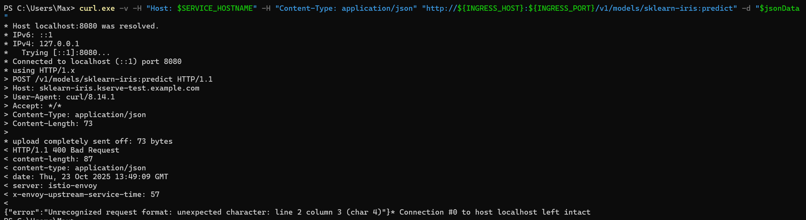
This indicates that the server (Istio/Envoy) received your Content-Type: application/json header and attempted to parse the data you sent ( $jsonData ) as JSON. However, it failed at line 2, column 3.

This almost certainly means that your $jsonData variable contains multiple lines (for example, indented "pretty" JSON), rather than the single-line, compressed JSON string the server expects.

When you loaded iris-input.json using Get-Content -Raw , it preserved all line breaks (\r\n) in the file. When you passed this multi-line string to curl.exe using -d "$jsonData" , these line breaks were sent along, causing the server-side JSON parsing to fail.

Solution:
Instead of pre-reading the file contents in PowerShell, use curl's @ syntax to let curl.exe read the file itself. This is consistent with the logic of your original Bash script (-d @./iris-input.json).
curl.exe knows how to handle -d "@filename" correctly. It reads the file, (usually) strips out newlines, and POSTs it as a single block of data. This completely bypasses the PowerShell variable and newline issues.
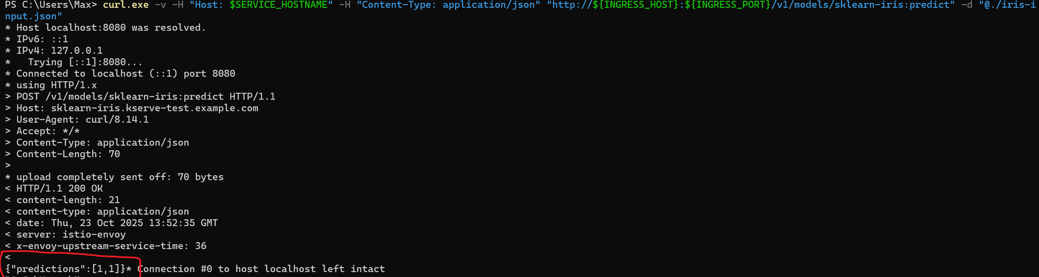
Finally success
We see two predictions returned (i.e. {"predictions": [1, 1]}). Both sets of data points sent for inference correspond to the flower with index 1. In this case, the model predicts that both flowers are "Iris Versicolour".

