AFYALINK
Engineering Technical Specification & Milestone 1 Implementation Pack
A complete engineering blueprint for building the professional credential intake foundation, secure document platform, admin review workflow, and scalable architecture for future facility access and regulatory integrations.

Document Item | Detail
Prepared for | Afyalink founding/build team
Document type | Engineering specification / solution architecture / build execution plan
Primary scope | Milestone 1: professional registration, credential intake, consent, payment reference, admin review, audit logs
Recommended architecture | Modular monolith with strict domain boundaries; service-ready when scale demands it
Recommended stack | Laravel backend/domain core, React/Next.js or Inertia frontend, PostgreSQL, Redis, private object storage, Docker, CI/CD
Date | 11 May 2026

Engineering position
Do not start by building everything. Build a secure professional credential intake foundation first. Every future Afyalink module depends on identity, credential records, document security, audit logs, payments, and workflow state management being correct from day one.

Table of Contents
- 1. Engineering Goal and System Boundary
- 2. Recommended Technology Stack
- 3. System Architecture
- 4. Core Domain Model
- 5. Milestone 1 Functional Requirements
- 6. API Contract
- 7. Database Engineering Specification
- 8. Security and Privacy Engineering
- 9. Secure Document Handling Design
- 10. Payment Engineering Design
- 11. Workflow and State Machines
- 12. Infrastructure, DevOps, and Deployment
- 13. Testing, QA, and Release Gates
- 14. Milestone 1 Engineering Backlog
- 15. Definition of Done and Handover Checklist
- 16. References

1. Engineering Goal and System Boundary
This document defines the next critical Afyalink artifact after the business/workplan document: the technical engineering specification. It is written for developers, technical leads, security reviewers, and product owners. Its purpose is to convert the Afyalink concept into buildable modules, data models, APIs, infrastructure decisions, test gates, and milestone tickets.
Milestone 1 boundary
Milestone 1 must deliver the foundation: professional onboarding, credential upload, consent capture, payment reference or M-PESA-ready payment domain, admin review, application status tracking, private file storage, and audit logging. Regulatory API automation, interview scoring, and facility marketplace come after this foundation is stable.

1.1 Engineering objectives
- Create a secure, production-grade credential intake system for healthcare professionals.
- Establish strict user roles, permissions, and auditable workflows before facility access is enabled.
- Store sensitive documents privately with no direct public links and with full traceability.
- Design database tables and APIs so regulatory verification, interviews, facility access, and recommendations can be added without rewriting the core.
- Use a modular monolith architecture to move fast while maintaining clean domain boundaries.
- Implement security controls based on OWASP ASVS, OWASP Top 10, and privacy-by-design principles.

1.2 Non-goals for Milestone 1
- Do not build a full facility marketplace yet.
- Do not expose professional documents to facilities yet.
- Do not build automated regulatory-body integrations unless a verified API is already available.
- Do not build a complex AI matching engine yet.
- Do not over-engineer microservices before the workflows and data model are proven.

2. Recommended Technology Stack
Afyalink is sensitive because it handles identity documents, professional licenses, employment credentials, payment data, facility access, and future interview scoring. The stack should prioritize correctness, security, auditability, speed of development, and maintainability.
Layer | Recommended choice | Reason
Backend/domain core | Laravel 13 / PHP 8.3+ | Fast delivery, strong ecosystem, queues, policies, validation, migrations, testing, scheduler, and excellent admin/API productivity.
Frontend | React with Next.js App Router, or Laravel Inertia + React | Modern UI, component-based development, server rendering where useful, strong developer ecosystem.
Database | PostgreSQL | Strong relational integrity, transactions, JSONB, indexes, constraints, audit-friendly design, production reliability.
Cache/queue | Redis | Queue jobs, rate limiting, sessions, cache, background notification and verification tasks.
Storage | S3-compatible private object storage such as AWS S3 or Cloudflare R2 | Private credentials storage, signed links, encryption, versioning, and scalable file handling.
Payments | M-PESA Daraja API | Kenya/East Africa payment integration for professional interview/verification fees and facility subscriptions.
Authentication | Laravel Sanctum/Fortify, MFA-ready | First-party SPA authentication, session security, password reset, 2FA, and policy-based authorization.
Admin UI | Filament, custom Laravel admin, or React dashboard | Fast admin development; role-protected workflows; extensible verification and review panels.
DevOps | Docker, GitHub Actions, Nginx/Caddy, managed PostgreSQL, backups | Reproducible builds, automated tests, stable deployment, easier developer onboarding.
Monitoring | Sentry, structured logs, uptime checks, audit logs | Detect errors, trace sensitive actions, and support compliance and incident response.

Stack recommendation
Build Milestone 1 as a Laravel modular monolith. Use React/Next.js if you want a very polished external web experience, or Laravel Inertia + React if you want faster full-stack delivery with fewer moving parts. Avoid microservices until Afyalink has real scale and clear module boundaries.

3. System Architecture
Afyalink should begin as a modular monolith: one deployable backend application, but internally separated into domains. This gives startup speed without locking the platform into poor design.
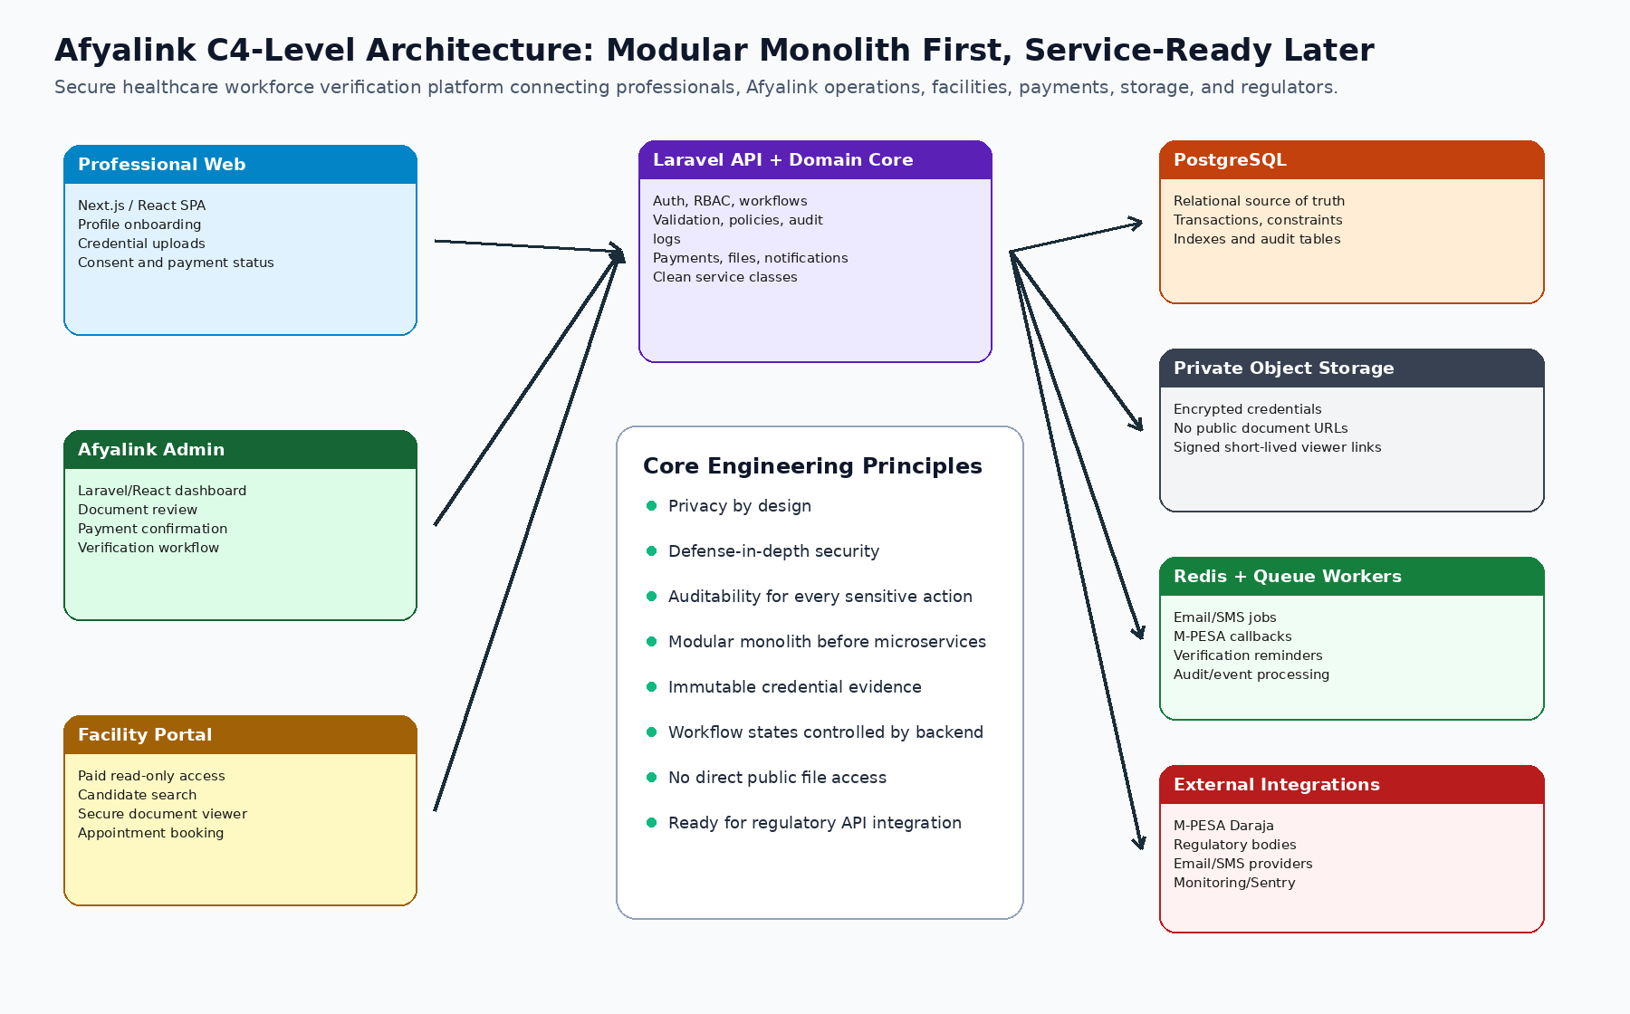

3.1 Domain modules
Domain | Responsibilities | Owns these tables/services
Identity & Access | Users, roles, permissions, sessions, password reset, MFA-ready access policies | users, roles, permissions, role_user, sessions
Professional Profile | Professional bio, license number, profession, experience, location, availability | professionals, professional_profiles
Credential Documents | Document upload, classification, review, secure storage, versioning | professional_credentials, document_versions
Consent | Consent capture, consent versioning, IP/device capture, legal text versions | consents, consent_versions
Payments | Payment intents, manual payment references, M-PESA callbacks, reconciliation | payments, payment_events
Application Workflow | Application status transitions, review queues, admin notes | applications, application_events
Audit | Immutable logging of sensitive actions | audit_logs
Notifications | Email/SMS notifications and queued delivery | notifications, notification_events
Facility Access - later | Facility onboarding, subscriptions, candidate viewing, appointments | facilities, facility_users, subscriptions, candidate_views

3.2 Architecture rules
- All sensitive state transitions must happen on the backend, never only in the frontend.
- Every document access, payment confirmation, status change, login failure, and admin review action must be written to audit_logs.
- Files must never be stored in a public web directory.
- Database constraints must enforce core integrity; application validation alone is not enough.
- Background jobs should handle notifications, payment callback processing, document virus scanning, and future regulatory reminders.
- Build feature modules with service classes and policy classes so code remains testable and easy to split later.

4. Core Domain Model
The domain model below defines the main objects the engineering team should use consistently in code, database design, APIs, and UI labels.
Entity | Meaning | Important fields
User | Login identity for professionals, admins, and later facility users | name, email, phone, password_hash, status, last_login_at
Role | Permission grouping | professional, admin, reviewer, interviewer, facility_admin, facility_viewer, super_admin
Professional | Healthcare worker profile | profession, regulatory_body_id, license_number, county, years_experience
Application | A professional's submission package | professional_id, status, submitted_at, reviewed_by, review_status
Credential | Uploaded proof document | document_type, storage_key, checksum, review_status, version
Consent | Legal permission to process and verify data | consent_type, consent_version, ip_address, accepted_at
Payment | Fee payment attempt or confirmed transaction | amount, method, reference, provider_status, internal_status
AuditLog | Immutable security/business event | actor_id, action, entity_type, entity_id, metadata, ip_address
Facility | Employer or health facility, added later | facility_name, license/registration proof, status, subscription_status

5. Milestone 1 Functional Requirements

5.1 Professional onboarding
- A professional shall register using name, email, phone, and password.
- The system shall verify email before allowing final application submission.
- The professional shall complete a profile including profession, regulatory body, license number, county, years of experience, availability, and work preferences.
- The system shall validate required fields and prevent incomplete application submission.
- The professional shall view current application status from a dashboard.

5.2 Credential upload
- The professional shall upload CV, ID/passport, professional license, academic certificates, and optional experience letters.
- Each upload shall be stored privately and linked to document_type.
- The system shall calculate checksum/hash for every uploaded file to detect replacement and tampering.
- The system shall limit file type and size according to server-side validation rules.
- Admin shall review every document and mark it accepted, rejected, or needs replacement.

5.3 Consent and submission
- The professional shall accept explicit consent before submitting the application.
- Consent shall be versioned so Afyalink can prove which wording the professional accepted.
- Application submission shall run as a database transaction: validate profile, validate minimum documents, validate consent, create application event, set status to submitted.

5.4 Admin review
- Admin shall see a queue of submitted applications.
- Admin shall view professional profile and uploaded documents using private access.
- Admin shall update document review statuses and add internal notes.
- Admin shall confirm manual payment reference in Milestone 1 or reconcile M-PESA transactions if integration is enabled.
- Admin shall move application status to ready_for_verification after documents and payment pass checks.
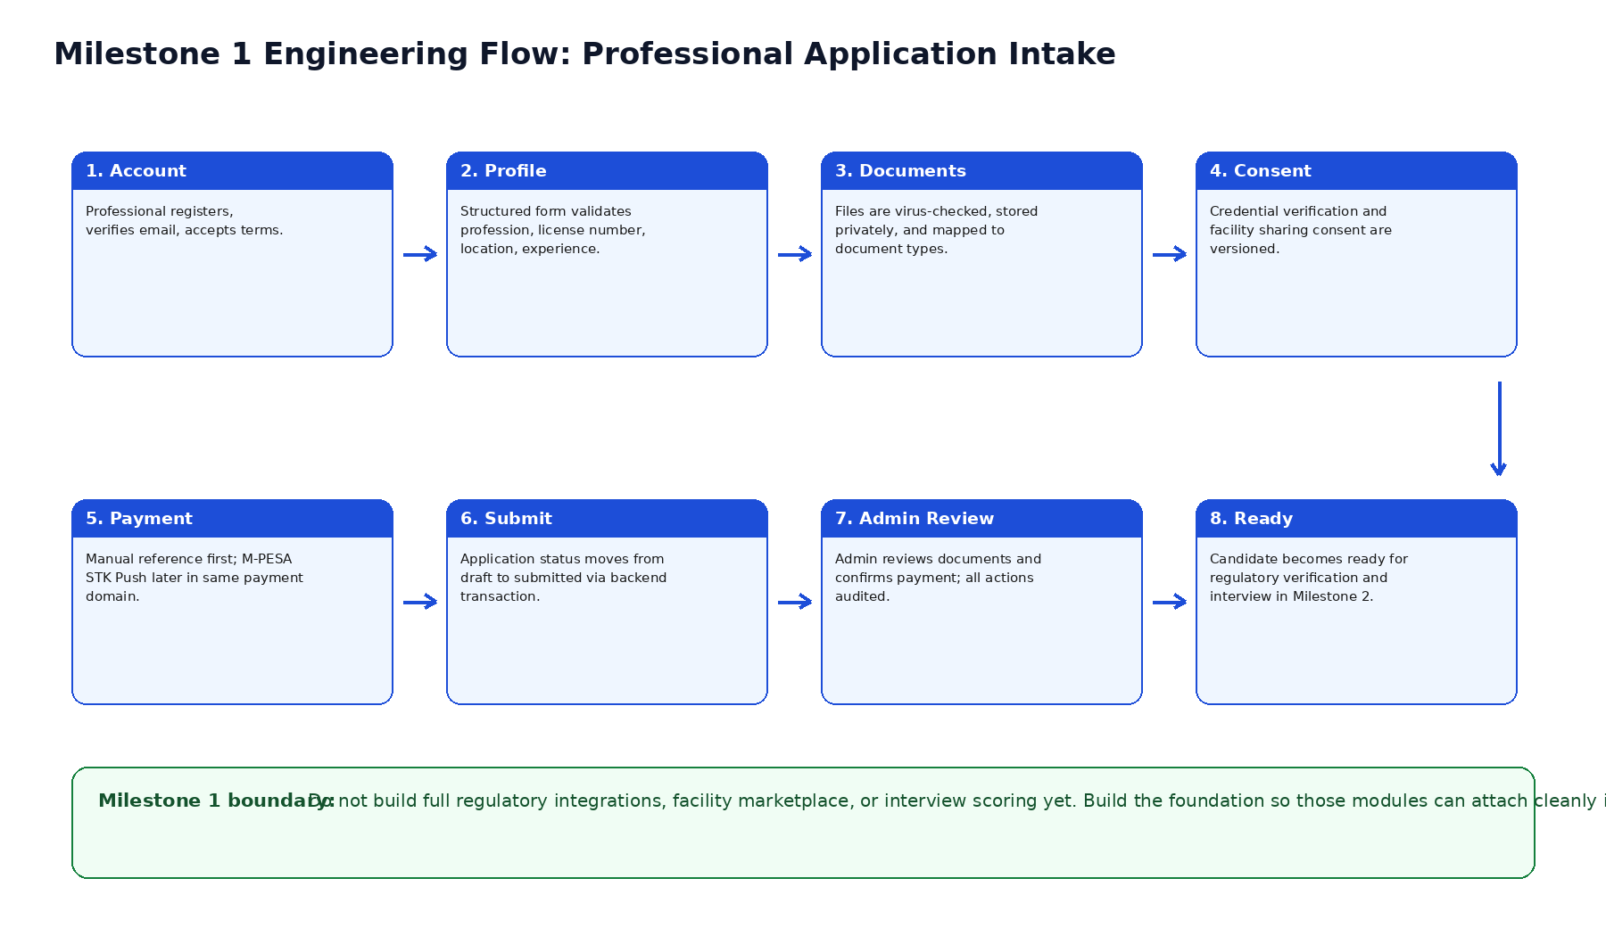

6. API Contract
Use RESTful JSON APIs with versioned routes. All endpoints must require authentication unless explicitly marked public. Backend authorization policies must enforce role access.
Area | Endpoint | Method | Purpose
Auth | /api/v1/auth/register | POST | Create professional account
Auth | /api/v1/auth/login | POST | Create session/token
Auth | /api/v1/auth/logout | POST | Destroy session/token
Profile | /api/v1/professional/profile | GET | Fetch current professional profile
Profile | /api/v1/professional/profile | PUT | Update professional profile
Documents | /api/v1/professional/credentials | POST | Upload credential document
Documents | /api/v1/professional/credentials/{id} | DELETE | Delete draft document before submission
Consent | /api/v1/professional/consents | POST | Accept consent version
Application | /api/v1/professional/application/submit | POST | Submit application
Application | /api/v1/professional/application/status | GET | Return application status timeline
Payment | /api/v1/payments/manual-reference | POST | Submit manual payment reference
Payment | /api/v1/payments/mpesa/stk | POST | Start M-PESA STK push when enabled
Payment | /api/v1/payments/mpesa/callback | POST | Receive M-PESA callback
Admin | /api/v1/admin/applications | GET | List applications with filters
Admin | /api/v1/admin/applications/{id} | GET | Read application details
Admin | /api/v1/admin/credentials/{id}/review | PATCH | Review uploaded document
Admin | /api/v1/admin/payments/{id}/confirm | PATCH | Confirm manual payment
Admin | /api/v1/admin/applications/{id}/status | PATCH | Move workflow status
Files | /api/v1/files/{id}/secure-view | GET | Return authorized short-lived document view

6.1 API response standard
{
"success": true,
"message": "Application submitted successfully",
"data": {
"application_id": "app_01HX...",
"status": "submitted",
"next_step": "payment_review"
},
"meta": {
"request_id": "req_01HX...",
"timestamp": "2026-05-11T10:30:00+03:00"
}
}

6.2 Error response standard
{
"success": false,
"message": "Validation failed",
"error_code": "VALIDATION_ERROR",
"errors": {
"license_number": ["License number is required."],
"professional_license_document": ["Professional license document is required."]
},
"meta": {
"request_id": "req_01HX..."
}
}

7. Database Engineering Specification
The database must enforce the integrity of identity, credentials, payments, status transitions, and audit logs. Use UUID/ULID primary keys for externally visible IDs. Avoid exposing auto-increment IDs in frontend routes.
Table | Purpose | Key constraints/indexes
users | Authentication identity | unique email, unique phone where applicable, status index
roles / permissions | Access control | unique role names, many-to-many user roles
professionals | Professional profile | unique user_id, index license_number, regulatory_body_id
applications | Submission workflow | unique active application per professional, status index
professional_credentials | Document metadata | professional_id index, checksum index, status index
consent_versions | Legal text versions | unique consent type + version
consents | Accepted consent events | user_id index, accepted_at, version FK
payments | Payment records | unique provider reference, status index
payment_events | Provider callback history | payment_id index, provider_event_id unique if supplied
application_events | Workflow timeline | application_id index, actor_id index
audit_logs | Immutable sensitive action trail | actor_id index, entity index, created_at index

7.1 Draft PostgreSQL schema
-- Use UUID or ULID strategy depending on framework conventions.
-- Laravel can use ulid() for sortable unique IDs.

CREATE TABLE users (
id UUID PRIMARY KEY,
name VARCHAR(180) NOT NULL,
email VARCHAR(180) NOT NULL UNIQUE,
phone VARCHAR(40) UNIQUE,
password_hash TEXT NOT NULL,
status VARCHAR(40) NOT NULL DEFAULT 'active',
email_verified_at TIMESTAMPTZ,
last_login_at TIMESTAMPTZ,
created_at TIMESTAMPTZ NOT NULL DEFAULT now(),
updated_at TIMESTAMPTZ NOT NULL DEFAULT now()
);

CREATE TABLE regulatory_bodies (
id UUID PRIMARY KEY,
name VARCHAR(220) NOT NULL,
country_code CHAR(2) NOT NULL DEFAULT 'KE',
verification_method VARCHAR(60) NOT NULL DEFAULT 'manual',
website_url TEXT,
created_at TIMESTAMPTZ NOT NULL DEFAULT now()
);

CREATE TABLE professionals (
id UUID PRIMARY KEY,
user_id UUID NOT NULL UNIQUE REFERENCES users(id),
profession VARCHAR(120) NOT NULL,
regulatory_body_id UUID REFERENCES regulatory_bodies(id),
license_number VARCHAR(120) NOT NULL,
license_expiry_date DATE,
id_number_encrypted TEXT,
county VARCHAR(120),
years_experience NUMERIC(4,1) DEFAULT 0,
availability VARCHAR(80),
preferred_work_location VARCHAR(180),
bio TEXT,
created_at TIMESTAMPTZ NOT NULL DEFAULT now(),
updated_at TIMESTAMPTZ NOT NULL DEFAULT now(),
CONSTRAINT professionals_license_body_unique UNIQUE (regulatory_body_id, license_number)
);

CREATE TABLE applications (
id UUID PRIMARY KEY,
professional_id UUID NOT NULL REFERENCES professionals(id),
status VARCHAR(60) NOT NULL DEFAULT 'draft',
submitted_at TIMESTAMPTZ,
reviewed_by UUID REFERENCES users(id),
review_notes TEXT,
created_at TIMESTAMPTZ NOT NULL DEFAULT now(),
updated_at TIMESTAMPTZ NOT NULL DEFAULT now()
);

CREATE TABLE professional_credentials (
id UUID PRIMARY KEY,
professional_id UUID NOT NULL REFERENCES professionals(id),
application_id UUID REFERENCES applications(id),
document_type VARCHAR(80) NOT NULL,
original_filename VARCHAR(255) NOT NULL,
storage_disk VARCHAR(60) NOT NULL DEFAULT 'private',
storage_key TEXT NOT NULL,
mime_type VARCHAR(120) NOT NULL,
file_size_bytes BIGINT NOT NULL,
checksum_sha256 CHAR(64) NOT NULL,
review_status VARCHAR(60) NOT NULL DEFAULT 'pending',
reviewed_by UUID REFERENCES users(id),
reviewed_at TIMESTAMPTZ,
admin_comment TEXT,
created_at TIMESTAMPTZ NOT NULL DEFAULT now()
);

CREATE TABLE consent_versions (
id UUID PRIMARY KEY,
consent_type VARCHAR(80) NOT NULL,
version VARCHAR(30) NOT NULL,
title VARCHAR(220) NOT NULL,
body TEXT NOT NULL,
active BOOLEAN NOT NULL DEFAULT true,
created_at TIMESTAMPTZ NOT NULL DEFAULT now(),
UNIQUE(consent_type, version)
);

CREATE TABLE consents (
id UUID PRIMARY KEY,
user_id UUID NOT NULL REFERENCES users(id),
consent_version_id UUID NOT NULL REFERENCES consent_versions(id),
accepted BOOLEAN NOT NULL DEFAULT true,
ip_address INET,
user_agent TEXT,
accepted_at TIMESTAMPTZ NOT NULL DEFAULT now()
);

CREATE TABLE payments (
id UUID PRIMARY KEY,
user_id UUID NOT NULL REFERENCES users(id),
application_id UUID REFERENCES applications(id),
amount NUMERIC(12,2) NOT NULL,
currency CHAR(3) NOT NULL DEFAULT 'KES',
method VARCHAR(40) NOT NULL,
provider VARCHAR(40),
provider_reference VARCHAR(160),
internal_status VARCHAR(60) NOT NULL DEFAULT 'pending',
provider_status VARCHAR(60),
confirmed_by UUID REFERENCES users(id),
confirmed_at TIMESTAMPTZ,
created_at TIMESTAMPTZ NOT NULL DEFAULT now(),
updated_at TIMESTAMPTZ NOT NULL DEFAULT now()
);

CREATE TABLE audit_logs (
id UUID PRIMARY KEY,
actor_id UUID REFERENCES users(id),
action VARCHAR(160) NOT NULL,
entity_type VARCHAR(120),
entity_id UUID,
ip_address INET,
user_agent TEXT,
metadata JSONB NOT NULL DEFAULT '{}'::jsonb,
created_at TIMESTAMPTZ NOT NULL DEFAULT now()
);
CREATE INDEX audit_logs_entity_idx ON audit_logs(entity_type, entity_id);
CREATE INDEX audit_logs_actor_created_idx ON audit_logs(actor_id, created_at DESC);
CREATE INDEX credentials_professional_idx ON professional_credentials(professional_id);
CREATE INDEX applications_status_idx ON applications(status);

7.2 Required workflow statuses
Status | Owner | Meaning
draft | Professional | Profile/application is being edited.
submitted | System | Application submitted and locked for review.
payment_pending | Professional/Admin | Payment not confirmed.
payment_confirmed | Admin/System | Payment reference or M-PESA transaction confirmed.
document_review | Admin | Credentials are being reviewed.
needs_correction | Professional | One or more documents or profile fields require correction.
ready_for_verification | Admin | Milestone 1 target status; candidate ready for regulatory verification.
ready_for_interview | Admin | Milestone 2 status after verification preparation.
rejected | Admin | Application rejected with documented reason.

8. Security and Privacy Engineering
Afyalink must be built as a security-first platform. Healthcare credential data is sensitive, employment-impacting, and must be protected with strong access control and auditability.
Screenshot limitation
No web platform can guarantee prevention of screenshots or external camera capture. Engineering should instead prevent downloads, prevent direct file access, disable normal print/copy actions, watermark every viewer session, log every access, and enforce legal/contractual restrictions.

8.1 Security control baseline
Control area | Required implementation
Authentication | Strong password policy, email verification, password reset, login rate limiting, optional MFA for admins.
Authorization | RBAC with backend policies. Professional users access only their records; admins access according to assigned role.
Session security | Secure cookies, SameSite protection, CSRF protection, short admin idle timeout.
API security | Input validation, request throttling, JSON schema consistency, no sensitive data in logs.
File security | Private storage, file type validation, virus/malware scanning queue, checksum, signed short-lived view links.
Encryption | TLS in transit, encrypted disks/storage, encrypted sensitive fields such as ID numbers where possible.
Audit logging | Immutable audit events for admin actions, document access, payment events, status changes, login events.
Secrets | No secrets in code. Use environment variables or secret manager. Rotate production credentials.
Backups | Encrypted automated database backups, restore testing, retention policy.
Monitoring | Error monitoring, uptime monitoring, suspicious activity alerts, security log review.

8.2 RBAC matrix
Action | Professional | Reviewer | Admin | Super Admin | Facility Viewer later
Create own profile | Yes | No | No | No | No
Upload own credentials | Yes | No | No | No | No
View own application status | Yes | No | No | No | No
View all applications | No | Yes | Yes | Yes | No
Review documents | No | Yes | Yes | Yes | No
Confirm payments | No | No | Yes | Yes | No
Change critical system settings | No | No | No | Yes | No
View published candidate summary | No | No | Yes | Yes | Yes
Download credential documents | No | No | No by default | Emergency only | No

8.3 Threat model summary
Threat | Risk | Engineering mitigation
Broken access control | Facility or professional sees records they should not access | Backend policy checks, object-level authorization, test cases for every role.
Credential document leak | Sensitive documents exposed | Private storage, no public URLs, signed links, watermarking, audit logs.
Admin abuse | Internal user misuses access | Least privilege, audit logs, admin MFA, supervisor review.
Payment fraud | False payment reference accepted | Admin reconciliation, provider callback verification, unique provider references.
Data tampering | Document or score modified silently | Checksums, immutable events, versioned records, audit metadata.
Credential stuffing | User accounts compromised | Rate limiting, MFA, password policy, suspicious login alerting.
SQL injection | Database compromise | ORM parameter binding, validation, security tests, no raw SQL unless reviewed.
Malicious file upload | Malware enters system | MIME validation, size limits, virus scanning, file isolation.

9. Secure Document Handling Design
Credential documents are among Afyalink's most sensitive assets. The document architecture must prevent casual leakage, unauthorized downloads, and uncontrolled sharing.
- Professional uploads document through authenticated endpoint.
- Backend validates MIME type, extension, file size, and required document type.
- Backend calculates SHA-256 checksum and stores only metadata in PostgreSQL.
- File is saved to private object storage using a non-guessable storage key.
- File is queued for malware scan and thumbnail/preview generation where applicable.
- Admin views file through secure viewer endpoint after authorization policy check.
- Facility access in future uses a read-only viewer with dynamic watermark and no raw file download endpoint.

9.1 Facility read-only viewer engineering for later milestones
- Render PDF/image previews server-side instead of exposing original files.
- Overlay dynamic watermark: facility name, viewer email, timestamp, candidate ID, session ID.
- Use short-lived signed URLs with one-time or session-bound access where possible.
- Disable browser download/print controls in the viewer UI, while recognizing this is a deterrent, not a guarantee.
- Log every page view and file open event to candidate_views and audit_logs.
- Use legal terms and facility contracts to prohibit screenshots, downloads, redistribution, or unauthorized use.

10. Payment Engineering Design
The payment domain should support manual payment confirmation in Milestone 1, while being designed for direct M-PESA Daraja integration without rewriting application logic.
Phase | Implementation | Notes
Milestone 1 minimum | Manual payment reference submission and admin confirmation | Fast to launch; requires human reconciliation.
Milestone 1 enhanced | M-PESA STK Push payment intent and callback endpoint | Better UX; needs Daraja credentials and callback configuration.
Milestone 2+ | Automated reconciliation, receipts, refund/reversal handling | Use payment_events for provider callback history.

10.1 Payment state machine
pending -> reference_submitted -> under_review -> confirmed
pending -> stk_requested -> provider_success -> confirmed
pending -> stk_requested -> provider_failed -> failed
under_review -> rejected
confirmed -> refunded -- later milestone
confirmed -> disputed -- later milestone

11. Workflow and State Machines
Afyalink must treat workflows as first-class engineering objects. Do not update statuses randomly across controllers. Use service classes or a workflow/state-machine library to validate transitions.
Transition | Allowed actor | Validation required
draft -> submitted | Professional | Profile complete, required documents uploaded, consent accepted.
submitted -> payment_pending | System | Submission created, payment not confirmed.
payment_pending -> payment_confirmed | Admin/System | Payment reference verified or provider success callback validated.
payment_confirmed -> document_review | Admin | Application assigned to reviewer.
document_review -> needs_correction | Reviewer/Admin | At least one document rejected or profile issue found.
needs_correction -> submitted | Professional | Corrections completed.
document_review -> ready_for_verification | Reviewer/Admin | Required documents accepted and payment confirmed.
any review state -> rejected | Admin | Documented reason required.

12. Infrastructure, DevOps, and Deployment
Milestone 1 should have local, staging, and production environments. Staging is not optional because credential workflows and file permissions must be tested before production use.
Environment | Purpose | Requirements
Local | Developer machine | Docker Compose for app, PostgreSQL, Redis, local object storage emulator or private disk.
Staging | Pre-production testing | Separate database/storage, test M-PESA credentials, seed test accounts, HTTPS.
Production | Live Afyalink platform | Managed DB, private storage, HTTPS, backups, monitoring, restricted admin access.

12.1 Recommended repository structure
afyalink/
backend/
app/
Domains/
Identity/
Professionals/
Credentials/
Applications/
Payments/
Audit/
Notifications/
Http/
Controllers/Api/V1/
Requests/
Resources/
Policies/
Jobs/
Services/
database/
migrations/
seeders/
tests/
Feature/
Unit/
frontend/ # if using separate Next.js frontend
app/
components/
lib/
tests/
infra/
docker-compose.yml
nginx/
github-actions/
docs/
architecture/
api-contracts/
runbooks/

12.2 CI/CD pipeline
- Developer opens pull request.
- Pipeline installs dependencies and checks formatting/linting.
- Run backend unit and feature tests.
- Run frontend type check and build.
- Run database migration check.
- Run security dependency audit where available.
- Deploy automatically to staging after merge to main.
- Production deploy requires manual approval until the team matures.

12.3 Operational runbooks required
- How to restore database backup.
- How to rotate M-PESA/API credentials.
- How to disable a compromised admin account.
- How to investigate suspicious document access.
- How to export audit logs for investigation.
- How to respond to a suspected data breach.

13. Testing, QA, and Release Gates
Afyalink should not ship Milestone 1 without test coverage for authentication, authorization, file uploads, workflow transitions, and admin review. Bugs in these areas can create legal, financial, and trust risks.
Test type | Required coverage
Unit tests | Services, validators, payment state transitions, workflow transitions.
Feature/API tests | Register, login, profile update, document upload, consent, submit application, admin review.
Authorization tests | Every role blocked from unauthorized records and actions.
File tests | Wrong MIME rejected, large files rejected, private storage verified, checksum stored.
Payment tests | Manual reference submission, admin confirmation, duplicate reference prevention.
Audit tests | Sensitive actions create audit log records.
E2E tests | Full professional application journey and admin review journey.
Security QA | OWASP Top 10 checklist, rate limiting, CSRF, secure cookies, no public file access.

13.1 Release gate checklist
- No public file URL can access uploaded credentials.
- Professional cannot access another professional's profile, files, application, or payment.
- Reviewer cannot perform super-admin-only actions.
- Admin status changes are audited.
- Application cannot be submitted without required profile fields, documents, consent, and payment path.
- Backups are configured and restore procedure is documented.
- Staging test data has passed a complete end-to-end demo.

14. Milestone 1 Engineering Backlog
The following backlog converts the specification into implementation tickets. The team can import these into Jira, Linear, GitHub Projects, or Trello.
Ticket | Engineering task | Acceptance criteria
ENG-001 | Initialize Laravel backend project with Docker, PostgreSQL, Redis | App boots locally; migrations run; health endpoint returns OK.
ENG-002 | Set up authentication and roles | Professional/admin roles exist; login/logout/password reset work; routes protected.
ENG-003 | Create professional profile module | Professional can create/update profile; required validation enforced.
ENG-004 | Create regulatory bodies seed data | Admin can manage or seed regulatory body list; professional selects one.
ENG-005 | Build credential upload service | Files stored privately; metadata/checksum saved; invalid files rejected.
ENG-006 | Build consent versioning | Active consent text displayed; accepted consent stores version, IP, timestamp.
ENG-007 | Build application submission workflow | Submission validates profile/documents/consent and changes status transactionally.
ENG-008 | Build payment reference module | Professional submits reference; admin confirms/rejects; payment state audited.
ENG-009 | Build admin application list | Admin filters by status, date, profession, payment state.
ENG-010 | Build admin application detail | Admin views profile, documents, payment, notes, timeline.
ENG-011 | Build document review actions | Admin marks accepted/rejected/needs replacement; professional sees correction request.
ENG-012 | Build audit log service | All sensitive actions write structured audit entries.
ENG-013 | Build notifications | Email notifications for submission, correction, payment confirmation, ready for verification.
ENG-014 | Create frontend professional dashboard | User sees profile completeness, required docs, status, payment status.
ENG-015 | Create frontend admin dashboard | Admin sees metrics and review queue.
ENG-016 | Add automated tests | Critical flows have unit/feature tests and role authorization tests.
ENG-017 | Deploy staging | HTTPS staging environment works with private storage and test DB.
ENG-018 | Milestone 1 demo and hardening | End-to-end demo passes; release gate checklist complete.

14.1 Suggested 4-week execution plan
Week | Focus | Output
Week 1 | Project setup, auth, roles, database foundation | Local app running; user roles; base migrations; seed data.
Week 2 | Professional profile, credential upload, consent | Professional can complete profile and upload required documents privately.
Week 3 | Payment reference, application workflow, admin review | Application can be submitted; admin can review documents and payment.
Week 4 | Testing, security hardening, staging deployment, demo | Milestone 1 demo-ready platform with release checklist passed.

15. Definition of Done and Handover Checklist
Area | Done means
Code | Feature merged, reviewed, linted, tested, and documented.
Security | Authorization tests pass, private file access verified, sensitive actions audited.
Database | Migrations are reversible where possible; constraints and indexes added.
UI | Responsive screens for professional and admin flows; clear error messages.
API | Endpoints versioned, documented, validated, and tested.
Deployment | Staging deployed with HTTPS, env vars, DB, storage, Redis, backups.
Operations | Runbooks available for backup restore, breach response, admin disable, secret rotation.
Demo | A professional can register, submit, upload documents, accept consent, submit payment reference; admin can review and move application to ready_for_verification.

Milestone 1 success statement
Milestone 1 is complete when a professional can submit a secure application and an admin can move it to ready_for_verification with private credentials and auditable actions.

16. References
These references should guide the engineering team when implementing framework, security, database, payment, and privacy controls.
- Laravel Documentation: https://laravel.com/docs
- Next.js App Router Documentation: https://nextjs.org/docs/app
- PostgreSQL Documentation: https://www.postgresql.org/docs/
- OWASP Application Security Verification Standard: https://owasp.org/www-project-application-security-verification-standard/
- OWASP Top 10: https://owasp.org/www-project-top-ten/
- NIST Cybersecurity Framework 2.0: https://www.nist.gov/cyberframework
- Safaricom Daraja Developer Portal: https://developer.safaricom.co.ke/
- Kenya Office of the Data Protection Commissioner: https://www.odpc.go.ke/

