sphere
BV1MD4y1h72L 02:26
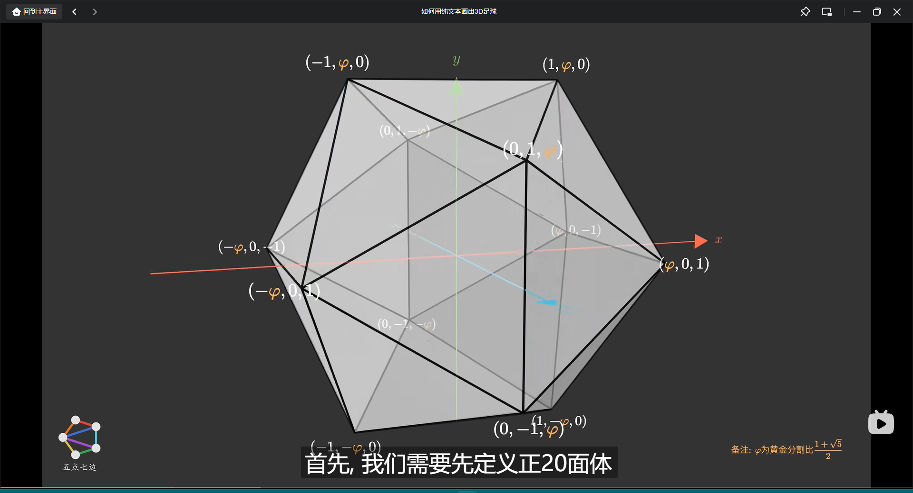
vertex:
0 | 1 | 2 | 3 | 4 | 5
(k, 0, 1) | (k, 0, -1) | (1, k, 0) | (1, -k, 0) | (0, 1, k) | (0, 1, -k)
6 | 7 | 8 | 9 | 10 | 11
(0, -1, -k) | (0, -1, k) | (-k, 0, 1) | (-k, 0, -1) | (-1, k, 0) | (-1, -k, 0)
triangles:
0 | 1 | 2 | 3 | 4 | 5 | 6 | 7 | 8 | 9
0, 1, 2 | 0, 3, 1 | 0, 2, 4 | 0, 4, 7 | 0, 7, 3 | 1, 3, 6 | 1, 6, 5 | 1, 5, 2 | 2, 10, 4 | 10, 2, 5
10 | 11 | 12 | 13 | 14 | 15 | 16 | 17 | 18 | 19
3, 11, 6 | 11, 3, 7 | 8, 10, 9 | 8, 9, 11 | 8, 11, 7 | 8, 7, 4 | 8, 4, 10 | 9, 10, 5 | 9, 5, 6 | 9, 6, 11

$$k=\frac{1+\sqrt{5}}{2}≈1.6180339887498948482045868343656$$
$$R=\sqrt{\frac{5+\sqrt{5}}{2}}≈1.9021130325903071442328786667587$$
1.6180339887498948482045868343656
1.9021130325903071442328786667587
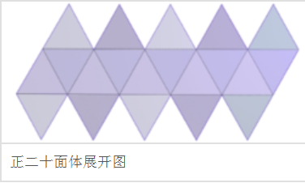

indices.emplace_back(0);
indices.emplace_back(1);
indices.emplace_back(2);

indices.emplace_back(0);
indices.emplace_back(3);
indices.emplace_back(1);

indices.emplace_back(0);
indices.emplace_back(2);
indices.emplace_back(4);

indices.emplace_back(0);
indices.emplace_back(4);
indices.emplace_back(7);

indices.emplace_back(0);
indices.emplace_back(7);
indices.emplace_back(3);

indices.emplace_back(1);
indices.emplace_back(3);
indices.emplace_back(6);

indices.emplace_back(1);
indices.emplace_back(6);
indices.emplace_back(5);

indices.emplace_back(1);
indices.emplace_back(5);
indices.emplace_back(2);

indices.emplace_back(2);
indices.emplace_back(10);
indices.emplace_back(4);

indices.emplace_back(10);
indices.emplace_back(2);
indices.emplace_back(5);

indices.emplace_back(6);
indices.emplace_back(3);
indices.emplace_back(11);

indices.emplace_back(11);
indices.emplace_back(3);
indices.emplace_back(7);

indices.emplace_back(8);
indices.emplace_back(10);
indices.emplace_back(9);

indices.emplace_back(8);
indices.emplace_back(9);
indices.emplace_back(11);

indices.emplace_back(8);
indices.emplace_back(11);
indices.emplace_back(7);

indices.emplace_back(8);
indices.emplace_back(7);
indices.emplace_back(4);

indices.emplace_back(8);
indices.emplace_back(4);
indices.emplace_back(10);

indices.emplace_back(9);
indices.emplace_back(10);
indices.emplace_back(5);

indices.emplace_back(9);
indices.emplace_back(5);
indices.emplace_back(6);

indices.emplace_back(9);
indices.emplace_back(6);
indices.emplace_back(11);

