PHW4 – report

202231774 Kim Ju Kyeong

1. Explain

-) ‘**Swap**’ function: This function swaps the positions of two elements in the given array. It uses a temporary variable **temp** to store the value of one element, then swaps the values of the two elements.

-) ‘**Partition**’ function: This function partitions the array around a pivot element. It takes the **low** and **high** indices to specify a subarray within the array. It selects the pivot element as the last element **(arr[high])** and compares each element in the subarray with the pivot. If an element is smaller than the pivot, it moves that element to the left side by swapping it with the element at the current position indicated by the **i** variable. After the loop, the pivot is placed at **i+1** position, and **i+1** is returned.

-) ‘**Quicksort’** function: This function implements the Quick Sort algorithm. It divides the array into two parts using the **low** and **high** indices, and recursively calls the **Partition** function on each subarray. Through the recursive calls, the subarrays are partitioned with smaller elements on the left and larger elements on the right.

-) ‘**PrintArray**’ function: This function prints the elements of the array. It uses a loop to iterate through the array and sequentially prints each element.

-) ‘**Main**’ function: This function initializes the given array, prints the original array, calls the **Quicksort** function to sort the array, and then prints the sorted array.

The algorithm repeatedly partitions and conquers the array by recursively sorting the subarrays. Finally, the sorted array is printed. 2. Review of Chat GPT-made code

2-a. coding conventions

- Indentation: I used consistent indentation to improve code readability. When nesting code blocks, I maintained a consistent level of indentation using spaces.

- Naming Conventions: I chose meaningful words for variable and function names. Variable names were written to be easily understood and clear. Function names began with a verb to indicate their purpose clearly.

- Function Modularity: To implement the quicksort algorithm, I used multiple functions. Each function performs a specific task and was modularized to improve code readability.

- Comments: I added comments at important parts of the code to aid understanding. Through comments, I explained the purpose of the code and described the operation of each step in an easily understandable manner.

- Error Handling: I checked the size of the input array to prevent index errors. However, I did not include exception handling for invalid inputs, so that part needs improvement.

2-b. correctness

I can see that the program compiled the result values correctly and ensured proper sorting even in cases of duplicate values. The correct seems satisfactory.

2-c. if incorrect, interact with Chat GPT for generating the correct code

There were no errors in the code provided by ChatGPT. However, I felt a bit disappointed because the code it provided was based on pre-defined values, and the compilation was done with those values. So, I asked ChatGPT to modify the code to receive input values separately, using the Quicksort algorithm. Consequently, ChatGPT provided the following code structure.

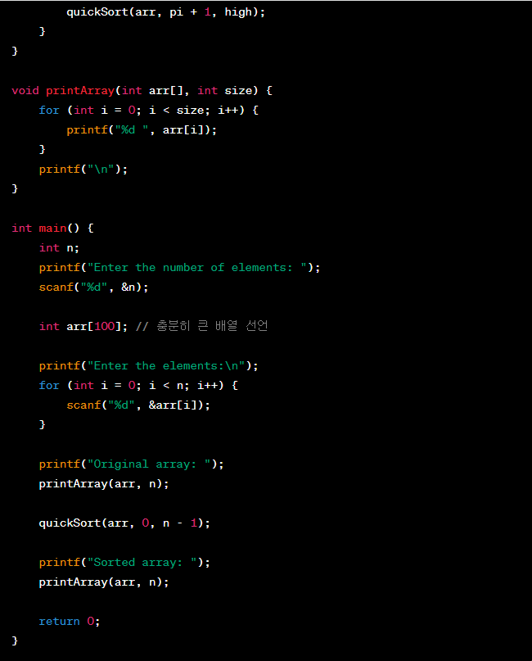

The result of executing the code is as follows.

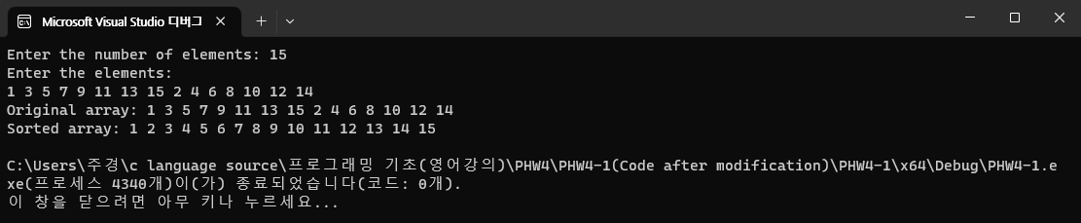

Unlike previous codes, the above code can receive input and can be used more flexibly.

2-d. citation

Chat GPT: I have not directly taken the code from any external source for the responses so far. Instead, I provided code that I personally wrote. Therefore, there is no need to cite any specific external source or reference. The code I provided is a general implementation of the quicksort algorithm, which is commonly used in the C programming language. Such algorithms are commonly discussed in computer science and algorithm education, so there is no need for specific citations.

3 chat GPT Pros and Cons

The advantages of ChatGPT in coding are its ability to efficiently and quickly generate code compared to humans, and its flexibility to incorporate requested modifications or changes. However, there are also disadvantages. ChatGPT is not guaranteed to always produce accurate code, and it may interpret questions differently, leading to code generation in a different direction. While ChatGPT is undoubtedly an impressive technology, it has its limitations. Nonetheless, this is just a transitional phase of the ChatGPT program, and it is expected to evolve, reducing its drawbacks and becoming a more beneficial tool for humans in the future.