Software Design Document

An Accreditation Software for UT-RGV

Omar Carrera

11/11/14

Revision 0

**Table of Contents**

**1** Introduction.............................................................................................................................................3

**1.1** Purpose....................................................................................................................................3

**1.2** Scope.......................................................................................................................................3

**1.3** Definitions, Acronyms, and Abbreviations.............................................................................3

**1.3.1** The Accreditation Software for UT-RGV………………………………………..3

**1.3.2** Customer………......................................................................................................3

**2** Design Overview.....................................................................................................................................4

**2.1** Description of Problem............................................................................................................4

**2.2** Class Structure ........................................................................................................................4

**2.2.1** University...………………………………..…………………………………...…4

**2.2.2** College…………………………………...………………………………………..4

**2.2.3** Department……………………………..………………………………………....4

**2.2.4** Class Diagram……………………………...……………………………………...4

**2.3** System Operation....................................................................................................................5

**3** Project Timeline .....................................................................................................................................5

**1 Introduction**

**1.1 Purpose**

The purpose of this document is to describe the implementation of the Accreditation Software for UT-RGV as detailed in the Software Requirements Specification (SRS) document. The Accreditation Software for UT-RGV is a desktop application that provides information, such as department details, faculty members, degree plans, and course offerings pertaining to UTB-RGV, as well as allow authorized users to input data into database and generate reports.

**1.2 Scope**

This document describes the implementation details of the Accreditation Software for UT-RGV. The Accreditation Software for UT-RGV will consist of two major functions: 1) to allow authorized users to be able to input and delete data to and from a database and 2) to allow authorized users to generate forms based on user’s requests.

**1.3 Definitions, Acronyms, and Abbreviations**

**1.3.1 The Accreditation Software for UT-RGV**

**Personal computer (PC) –** A general-purpose computer whose size, capabilities, and price make it ideal for use by individuals rather than businesses. Such a device is sold directly to the end-user.

**Operating System (OS) –** A collection of software that manages a computer's hardware resources and provides certain services to the software running on said hardware.

**Java Virtual Machine (JVM) –** A machine-independent runtime environment that executes Java bytecode.

**Graphical User Interface (GUI) –** A means of graphical user interaction with the system. This allows for more intuitive operation of the program

**Structured Query Language (SQL)** – The standard programming language for relational database management systems.

**1.3.2 Customer**

**University of Texas-Rio Grande Valley (UT-RGV)** – The end user of the software developed for this project.

**2 Design Overview**

**2.1 Description of Problem**

The customer has requested that we make a general software that automates the process of accreditations for every department in the university.

**2.2 Class Structure**

**2.2.1 University –** a base class that holds data pertaining the the university, which includes: name, mission, logo etc.

**2.2.2 College –** this child class of the University class. This class contains the college name and its vision.

**2.2.3 Department –** in this class, all the information is distributed between multiple classes which includes the faculty members, the name of the department, programs and student information.

**2.3.4 Class Diagram**

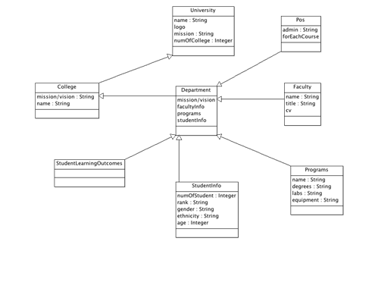

**2.3 System Operation**

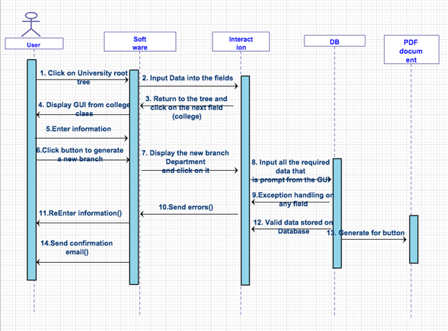

**3. Project Timeline**

|  |  |
| --- | --- |
| **Deliverable** | **Deadline** |
| **● * GUI outline complete, capable of inputting.**  **● * Capability of generating new branches on tree.** | **11/15/14** |
| **\* Software can connect to the database and store data.** | **11/24/14** |
| **\* Software can handle errors from user such as inputting numbers where text**  **should be in etc.** | **11/27/14** |
| **\* Confirmation email functionality and retrieving information from database.** | **12/05/14** |
| **\* Generate forms up and running. Testing complete. Ensure all final product deliverables complete:**  **\* Compile testing data into report**   * **Ensure documentation complete** * **Create final update for specifications, software design diagram, and readme file** | **12/05/14- 12/09/14** |
| **\* Deliver final product with all associated documentation** | **12/11/14** |